Using Pythagoras Activity Record Sheet

Instructions
- Stick your triangle onto a window with the “4” side at the bottom
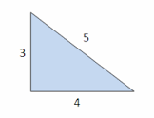
- Pull the strings tight and use the “3” side to check if the object is perpendicular to the base

Record your results
Add more objects that you can see from your window!
Object | Perpendicular ( or )
Building
Tree
Fence

