The IET



Emergency Communications
Teacher Handbook

Could you be our engineer….?

The IET DIY Faraday Challenge Day ‘Emergency Communications’ is based on the Faraday Challenge Day of the same name, a STEM activity day written and delivered by the National Schools Partnership on behalf of the Institution of Engineering and Technology (IET).
The IET Education website hosts a wide range of teaching resources for science, design and technology and maths. These include classroom activities with film clips, online games, posters, careers resources and STEM activity days.

The Institution of Engineering and Technology
IET Education 5-19
Michael Faraday House
Six Hills Way
Stevenage Herts
SG1 2AY
United Kingdom
T: +44 (0)01438 767653
F: +44 (0)01438 765526

The Institution of Engineering and Technology is registered as a Charity in England & Wales (no 211014) and Scotland (no SC038698)

Stay safe
Whether you are a scientist researching a new medicine or an engineer solving climate change, safety always comes first. An adult must always be around and supervising when doing this activity. You are responsible for:
- Ensuring that any equipment used for this activity is in good working condition
- Behaving sensibly and following safety instructions so as not to hurt or injure yourself or others
Please note that in the absence of any negligence or other breach of duty by us, this activity is carried out at your own risk. It is important to take extra care at the stages marked with this symbol: ⚠

Contents

The Faraday Challenge  Details of the challenge | 4
Assessment criteria  Overview on how to score students | 7
Snapshot of the Faraday Challenge Day  A breakdown of the timings for the day | 9
Checklist and tips for running the Faraday Challenge Day | 12
Room layout | 14
Schedule for the day | 15
Risk assessment example | 16
Assessment matrix  Scoring sheet for the Judges | 18
Final test messages – Judges reference sheets | 19
Full list of materials available to purchase, cost and units | 20

The Faraday Challenge: Emergency Communications

Creative problem solving for different ability levels

This cross-curricular Science, Design and Technology, Engineering and Mathematics (STEM) activity day encourages the development of students’ problem solving, team working and communication skills. Students achieve a better understanding of what engineering is and the science, maths and technology elements within engineering, leading to increased engagement in science or technology lessons afterwards.

The challenge has been specifically designed to give students the opportunity to research, design, develop and make creative solutions to genuinely tough engineering problems, independent of their level ability. This activity is therefore suitable for a range of different ability levels.

The Challenge
The Faraday Challenge aim is to help students to realise the ideas and knowledge they have, perhaps without realising it, are key skills in engineering and technology professions.

Engineers are vital when a disaster strikes. When there are floods, hurricanes or earthquakes, it is engineers that are needed. As the engineer rescue team, students are challenged to develop an engineering solution to ensure communications between two towns can be maintained. This challenge will develop the students’ problem solving, team work and communication skills.

Who is it for?
The Faraday Challenge ‘Emergency Communications’ has been designed for six teams of six students (36 students in total) aged between 12-13 years.

The context
Ease of communication is part of our life, we pick up the phone, turn on the radio, TV or internet to get news and information. Wifi network work by radio signals. Your phone, TV and radio signals are transmitted by masts we hardly notice. But when all these are knocked out by natural events how do we communicate?

The scenario
Life was good in the towns of Alpha and Beta. However this year, increased solar activity brought disastrous weather. The solar activity caused radiation effects that have disrupted electricity supplies and radio signals.
Torrential rain caused flooding and mud slides on the steep mountain slopes. These brought down nearly all the radio and phone network masts and washed away roads and the telegraph poles for phone lines.
As a result of these extreme weather conditions, people in the surrounding communities have been severely affected. Beta in particular has been cut off completely and there is serious concern about the health, welfare and safety of the population.

All lines are down . . .

The brief
Students are the engineer rescue team based in the town of Alpha which has been relatively unaffected by the extreme weather.
As the engineer rescue team in town Alpha students will need to do 2 things (and quickly!):
- Design and build a prototype device that will to send coded messages to town Beta
- Create a code to send a message from Alpha across the mountains for decoding in Beta.
There is little time to lose, with a (simulated) helicopter arriving in a matter of hours to transport half of the rescue team to town Beta to set up the system for testing.

Constraints of your prototype device:
- Must include electrical component to achieve full marks.
- Must send the message over a distance of 5 metres under test conditions.
- Practice messages will be provided to test your prototype; however the message you send in the final phase will be unknown to the rescue team.

Terrain Statistics and Information
Distance between town Alpha and Beta | 10 kilometres
Elevation – Height of mountain  (distance between sea level and summit of mountain) | 2,500 metres
Depth of mountain base | 2.5 kilometres
Width of mountain base | 20 kilometres
Angle of slope | 110 degrees

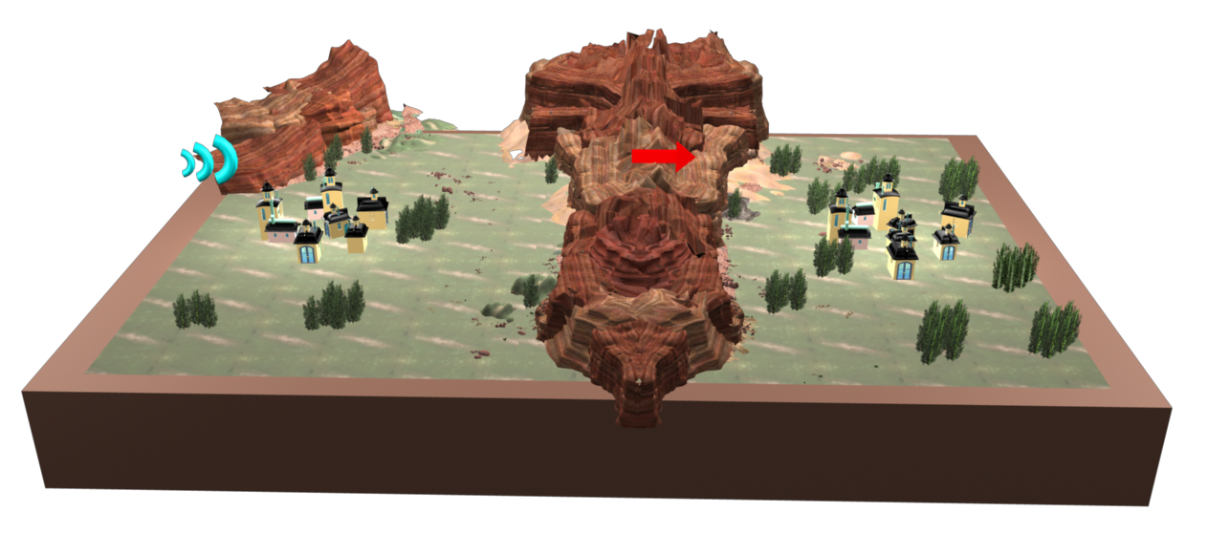
Alpha
Alpha
Beta
Alpha

Assessment Criteria
Students will be judge on in the following areas:

Criteria | Marks
- Planning and research | 15 marks
- Development of communication solution | 20 marks
- Accounting sheet | 15 marks
- Presentation | 15 marks
- Prototype | 15 marks
- Code | 15 marks
- Safe and effective teamwork | 10 marks
 | Total: 105 marks

- Planning and research (15 marks)

Using the planning sheet provided, marks will be awarded for:
- Identification of potential problems, constraints and difficulties (5 marks)
- Development of minimum 2 creative solutions for the prototype (5 marks)
- Development of minimum 2 creative solutions for the code (5 marks)

- Development of communication solution (20 marks)

Using the planning sheet, provided marks will be awarded for:
- Recording your team’s agreed solution - include the mechanical and electrical components of your device and how they work together (7 marks)
- Identification of the code you will be using (7 marks)
- Note of any changes or modifications you make as a team with the reasons you have changed the design. E.g. materials, sizes, manufacture and ease of use etc. (6 marks)

- Accounting sheet (15 marks)

This is a record of all the costs the team has incurred. Marks will be awarded for:
- Accuracy of expenses (10 marks)
- Neatness of records (5 marks)

If there is a tie between teams at the end of the day, the winning team will be the one who has the most Faradays remaining.

- Presentation (15 marks)

Summarising your learnings recorded at each stage, your presentation should communicate:
- Why and how you came up with your team’s solution (5 marks)
- How it could be built in real life (5 marks)
- How Science, Technology and Maths were used in engineering your solution (5 marks)

There is a maximum of 3 minutes allowed. Taking more time loses marks.
Use your planning and reflection sheet to help.

- Prototype (15 marks)

Your solution will be judged on:
- Mobility - must be easily transported without connections or elements of the design breaking (6 marks)
- Quality - must be strong enough to continue to send messages until regular communications are back up and running (3 marks)
- Creativity - design must be unique (3 marks)
- Functionality - must function effectively, easily and as planned (3 marks)

Points will be deducted for not including an electrical component.

- Code (15 marks)

The team based in Alpha will be given an unknown message to be sent in code to the team in Beta 5 metres away.
Beta will immediately need to decode the message and hand to the judges for checking.

Marks are awarded for:
- Creativity of the coding system – must be unique (5 marks)
- Accuracy of relaying the final message to the Judges (5 marks)
- Speed – must be easy and efficient to send and receive (5 marks)

- Safe and effective teamwork (10 marks)

Marks are awarded for:
- How you work as a team in your allocated roles (5 marks)
- Ensuring that your work station and surrounding area enables safe working and is free from hazards at all times (5 marks)

Points will be deducted for not working as a safe and effective team.

Snapshot and tips for the Faraday Challenge Day

SETUP:
08:00  Set up for the day | - Student work stations, Inspiration station, Judges area (room layout and requirements, p. 16).  - Test area (materials and equipment, p. 22-23).  - Materials shop/Technician’s area (materials and equipment p. 22-23).  - Get extra help from colleagues (at least two colleagues).
09:15-9:30  Students arrive | - One team per table (6 teams of 6 students).  - Teams complete registration forms.

INTRODUCTION:
9:30  Introduction | - Introduce the day, discuss context for the challenge, housekeeping (slide 1).  - Show the briefing film (slide 2).  - Re-cap of the challenge (slide 3).  - Re-cap of the final test (slide 4).  - Project development overview - 3 key stages (slide 5).
9:45  Electrical briefing | - Health and safety briefing (slides 6-7).  - Electrical circuit activity - This mini challenge has been designed to introduce/refresh students on the basic principles of circuits. Building a circuit will be crucial to power their prototype.
10:05  Tools to help you | - Provides an overview of how students can seek support throughout the challenge (slides 8-9).
10:10  How to score points | - Overview of how students can win points. A full overview can be found in the student booklet (slide10).
10:15  Role allocation activity | - Each student must take on a specific role to complete the challenge successfully (slide 11). A brief overview of these roles has been provided on page 27 and full job descriptions have been provided in the Students’ Pack.  - Students will need to choose their role within their team.

STAGE 1:
10:20  STAGE 1:  Planning and research | - Brainstorming, planning and research (slides 12-14).  - At the end of this stage, teams should complete stage 1 on their planning and reflections sheet.

STAGE 2:
10:50  STAGE 2: Development and modifications | - The shop opens – you may like to suggest that only the Accountant role is able to go to the shop to purchase materials in avoid the shop manager becoming inundated.  - Students commence development and build of solution (slides 15-16).

11:10 | Short break

11:20  STAGE 2: Development and modifications continued… | - In this session students will continue the build and development of their solution.  - They must also discuss and implement modifications of their solution.  - At the end of this stage, teams should complete stage 2 on their planning and reflections sheet.
12:00  Testing | - Teams should be at a stage where they can start testing their solution (slide19).  - Teams can use the practice messages provided on the Cryptographers job description to help.

12:30 | Lunch - tools down
STAGE 3:
13:00  STAGE 3:  Final build and testing | - Teams are to make final amends to their prototype and ensure that they have everything required to send and decipher a code (slides 21-22).  - Teams to complete final reflections and prepare for 3 minute presentation which focuses on the science, engineering, technology and mathematics skills, knowledge and understanding they have used in developing their communications system.
13:30 | - Slide 24  - Shop closes!  - Sell back unused items.  - Get teams to submit accounting and planning and reflection sheets to Challenge Leader.

STAGE 4 - FINAL TEST:
13:45  STAGE 4: Presentation and sending/receiving of final message | - Team’s present planning and reflections from stages 1, 2 and 3 to the Judges – teams should have a maximum of 3 minutes to present (slides 26-27).  - Demonstration of each team’s communications system using an unknown message – teams should have a maximum of 5 minutes to present.

WRAP-UP:
14:45  Award ceremony | - Highlights strengths and areas for improvement on each teams’ solution.  - Announcement of winning team (slide 30).
15:00  Finish | - Students depart.

Checklist for running the Faraday Challenge Day

Student tables | Quantity | Note
Team station label (1-6) | 1 per table | See Teachers’ Pack.
Student team registration form | 1 per table | See p. 26.
Student Booklet | 1 per table | See Students’ Pack.
Roles and responsibilities – Project Manager, Mechanical Engineer, Electrical Engineer, Accountant and Cryptographer | 1 per role per table | See Students’ Pack. Each team will require 2 Cryptographers.
Planning and Reflections sheet | 1 per table | See Planning Sheet.
Blank paper | 1 per table | Provided by your school.
Starter Pack | 1 per table | See p. 22.
Faraday branded currency | Each team should have F100 with the following breakdown:  - 2x F20  - 3x F10  - 4x F5  - 10x F1 | See p. 24 and Teachers’ Extras Pack.
Teacher | Notes
Teachers Booklet |  | Current document.
PowerPoint Presentation with notes |  | See Teachers’ Pack.
AV pack |  | See Teachers’ Pack.
Audio visual equipment – projector and sound |  | Provided by your school.
Assessment Matrix |  | See p. 20.
Final messages reference sheet |  | See Teachers’ Pack.
Final messages in envelopes | Message sheets will need to be printed and put in envelopes | See Teachers’ Extras Pack.
Certificates | 1 per student | See Teachers’ Extras Pack.

Continued….Challenge Leader checklist

Shop
Materials list for shop manager/technician |  | See p. 22-23.
Materials price tags |  | See Teacher’s Pack.
Shop manager/technician balance sheet |  | See Teacher’s Pack.
Faraday branded currency | Shop change kitty:  - 20x F20  - 20x F10  - 20x F5  - 40x F1 | See Teacher’s Pack.
STEM Consultant name tag |  | See Teacher’s Pack.
STEM Consultant card |  | See Teacher’s Pack.
Signage | Notes
Inspiration station | 1 | See Teacher’s Pack.
Shop | 1 | See Teacher’s Pack.
Alpha/Beta towns | 1 for each town | See Teacher’s Pack.
Judges table | 1 | See Teacher’s Pack.
Cutting station | 1 | See Teacher’s Pack.
Gluing station | 1 | See Teacher’s Pack.
Inspiration Station
Physical items (i.e. megaphone, torches, print outs (Morse code, semaphore) or images (lighthouses, periscopes, coloured lenses etc.) to inspire pupils and get their creative minds working.

Room layout

Each team table requires 6 chairs and the Judges’ table requires 3 chairs.
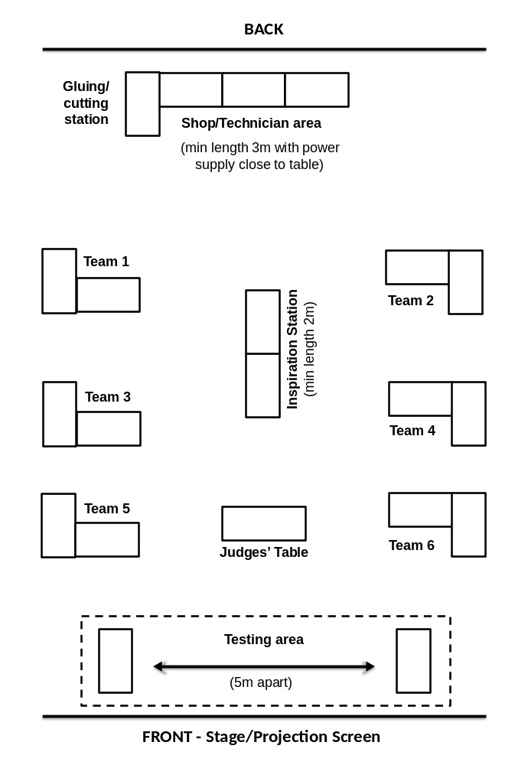

Schedule for the day

0930 | Introduction to the Challenge
0945 | Electrical briefing  - Health and safety briefing  - Electrical circuit activity
1000 | Role allocation activity
1020 | STAGE 1 - Planning and research  - Brainstorming  - Planning research
1050 | STAGE 2 – Development and modifications ⚠  - Development/build of solution  - Modification of solution
1110 | Short break
1120 | Continued STAGE 2 – Development and modifications ⚠  - Development/build of solution  - Modification of solution
1230 | Lunch - tools down
1300 | STAGE 3 - Final build and testing ⚠
1330 | - Shop closes!  - Sell back unused items  - Submit accounting and planning sheets to Challenge Leader
1345 | STAGE 4 - Presentation and sending/receiving of final message ⚠  - Team’s present reflections from Stage 1, 2 and 3 to the Judges  - Demonstration of each team’s communications system using an unknown message
1445 | Award ceremony  - Announcement of winning team  - Final feedback and evaluation of the day
1500 | Finish

Risk assessment example (page 1 of 2)

Risk Assessment and Operating Procedure - IET

Activity: Faraday Challenge Days Emergency Communications
Persons at risk | Students taking part in the Faraday Challenge Day
Maximum Group Size | 36 students | Recommended Staffing/Student Ratio | 1:6
Risk Assessment
Hazards |  | Control Measures
- Basic use of hand tools (files, screwdrivers, scissors, hole punches) – risk of cutting or abrasion. |  | The use of all cutting materials will be supervised by a school technician/teacher at all times and performed in a designated area.
- Use of craft knives – risk of cutting. |  | A member of staff will supervise the use of craft knives to cut any materials. A safety ruler will be provided and safety notes at the designated cutting station.
- Use of glue guns – risk of burning. |  | The use of glue guns will be supervised by a school technician/teacher at all times and performed in a designated area. Glue guns will be low melt which reduces the risk of severe burns.
- Use of electrical equipment – risk of electric shock. |  | All electrical equipment is low voltage.
- Use of electrical equipment – short circuit causing heating. |  | Warn students of the possibility of burns when connecting and disconnecting components. All pupils will receive a briefing about correct use of electrical components.

Risk assessment example (page 2 of 2)

Location issues
(to be completed by Host School)
Further Action Required: 1. Ensure all persons staffing the Faraday Challenge Days are aware of and competent to comply with this risk assessment and the control measures.

Working Practice
Group structure | One Faraday Challenge Day Leader and one member of staff from the host school present during the whole day to oversee use of equipment and to keep order.
Restrictions | Unknown premises.
Emergency  Procedure | Follow the lead from the Host School.  Faraday Challenge Day Leader to be fully briefed on risk assessment procedure prior to the day or on arrival.
Safety Equipment | First aid kit and fire extinguisher (electrical fires) to be provided by Host School.
Name and role of IET Faraday Challenge representative | Keira Sewell  Challenge Day Leader
Name and role of school representative
Signature of the school representative
Date of this Review | July 2012

Assessment Criteria |  | Team  1 | Team  2 | Team  3 | Team  4 | Team  5 | Team  6 | Team  7
Planning and research | 15
Development of solution | 20
Accounting Sheet | 15
Presentation | 15
Prototype | 15
Code | 15
Safe and effective teamwork | 10
Total Score | 105

Assessment matrix

Team | School/Team name
1
2
3
4
5
6
7

Final test messages – Judges reference sheets
‘Secret’ messages to give to each team in the final test stage.

1 | Food Arriving
2 | Transport Now
3 | Engineer Help
4 | Helicopter OK
5 | Help Tomorrow
6 | Solution Done
7 | Rescue Coming
8 | OK Communicate

Two spare messages have been provided.

Message sheets to be printed and put into envelopes to hand out to students may be found in the Teachers’ Extras Pack.

Full list of materials available to purchase, cost and units

STARTER PACK:

Item
1 x stick of White Tak
10 x Elastic bands
1.5 Volt battery D size
1.5 Volt bulb
2 pieces x 30cm of black copper wire
2 pieces x 30cm of red copper wire
Wire strippers
Blue Pen

AVAILABLE TO BUY:

Item | Measurement | Cost | Min/event
Masking tape | 30cm | 5 Faradays | 1 roll
Double-sided tape | 30cm | 8 Faradays | 1 roll
Plastic cups | 1 cup | 1 Faraday | 10
Tin cans | Each | 5 Faradays | 4
A4 plain paper | Each | 1 Faraday | 30 sheets
Coloured card A4 | Each | 1 Faraday | 2 sheets of at least 3 colours
Foil 30cm x 30cm | Each | 5 Faradays | 1 roll
Neoprene Sheets | Half sheet | 5 Faradays | 2 sheets of at least 2 colours
Bubble wrap 25cm x 25cm | Half sheet | 2 Faradays | 2 sheets
Acetate red 35 x 310mm | Half sheet | 5 Faradays | 2 sheets
Acetate blue 35 x 310mm | Half sheet | 5 Faradays | 2 sheets
Mirror 150 x 100mm | 1 mirror | 5 Faradays | 4
Straws | 10 straws | 10 Faradays | 30 bundle
Cardboard tubes | Each | 10 Faradays | 4
Thin sponge | Each | 2 Faradays | 2
String | Per Metre | 1 Faraday | 1 roll
Paper fasteners | 5 fasteners | 1 Faraday | 20
Paper clips | 5 paper clips | 1 Faraday | 20
Elastic bands | 10 bands | 2 Faradays | 50
Steel nail - 10cm | 2 nails | 10 Faradays | 3
Binoculars | Each | 30 Faradays | 2
Stopwatch | Each | 30 Faradays | 3
White Tak | Stick | 5 Faradays | 2 packs
Polyfoam | A4 size | 10 Faradays | 3x A2

ELECTRICAL COMPONENTS:

Item | Measurement | Cost | Min/event
Copper wire - red | Per metre | 10 Faradays | 1 roll
Copper wire - black | Per metre | 10 Faradays | 1 roll
Bare copper wire | Per metre | 10 Faradays | 1 roll
Croc leads - black | Each | 5 Faradays | 10
Croc leads - red | Each | 5 Faradays | 10
Croc clips | Each | 5 Faradays | 15
Terminal blocks | Each | 2 Faradays | 10
1.5 Volt bulbs | Each | 5 Faradays | 24
3.5 Volt bulbs | Each | 5 Faradays | 24
1.5/3.5 Volt bulb holder | Each | 10 Faradays | 15
Batteries - AA size | Each | 2 Faradays | 35
Batteries - D size | Each | 5 Faradays | 15
Battery holder – 1 D cell | Each | 2 Faradays | 15
Battery holder - 3 AA cells | Each | 1 Faraday | 15
Watch battery | Each | 1 Faraday | 3
Buzzers 3 Volt | Each | 5 Faradays | 10
Switches | Each | 5 Faradays | 10
Magnet | Each | 5 Faradays | 2

AVAILABLE TO HIRE:

Item | Measurement | Cost | Min/event
Consultancy Time | 5 minutes | 10 Faradays | 3 cards
Hole punch | 5 minutes | 5 Faradays | 1
Stapler | 5 minutes | 5 Faradays | 1
Screwdriver small | 5 minutes | 1 Faraday | 4
Calculator | 5 minutes | 10 Faradays | 1
Craft Knifes + Technician | n/a | FREE | 4
Glue guns | n/a | FREE | 2

