The IET

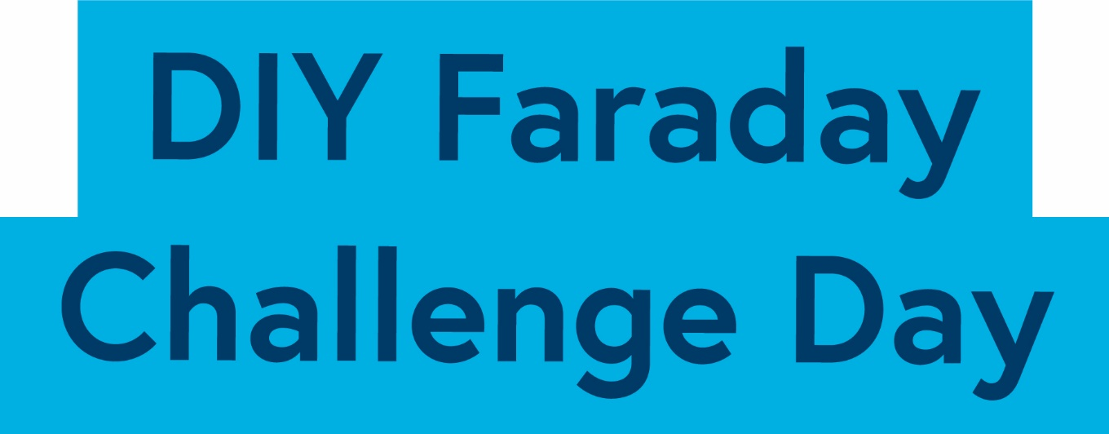

Land Rover BAR

Student Booklet

Could you be our engineer….?

Contents

- The Context …………………………………………………………………………….. 3
- The Brief ………………………………………………………………………………… 4
- Schedule for the day …………………………………………………………………… 5
- Shop resource sheet ………………………………………………………………. 6
- Assessment information and criteria …………………………………………………. 8

The Context

This year Ben Ainslie’s Land Rover BAR team have been competing in the six America’s Cup World Series events held around the world, the preliminaries to the America’s Cup finals starting in Bermuda in May 2017.

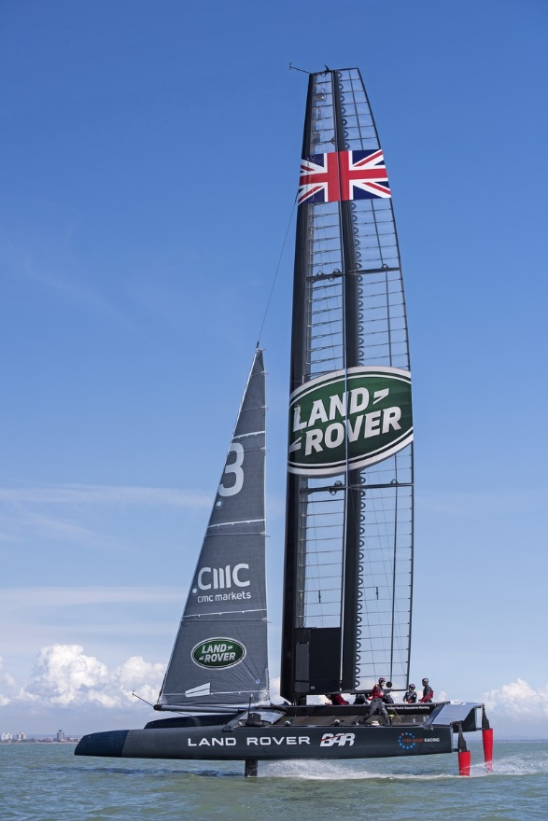

Recent developments in design and engineering have meant the racing has reached new levels with the boats travelling five times as quick as previous generations. This new generation of boats flies across the water!

Land Rover BAR is constantly looking for ways to improve performance and work with a wide range of experts to do this. The role of engineers is crucial and they are looking for future engineers who may be able to contribute to their success.

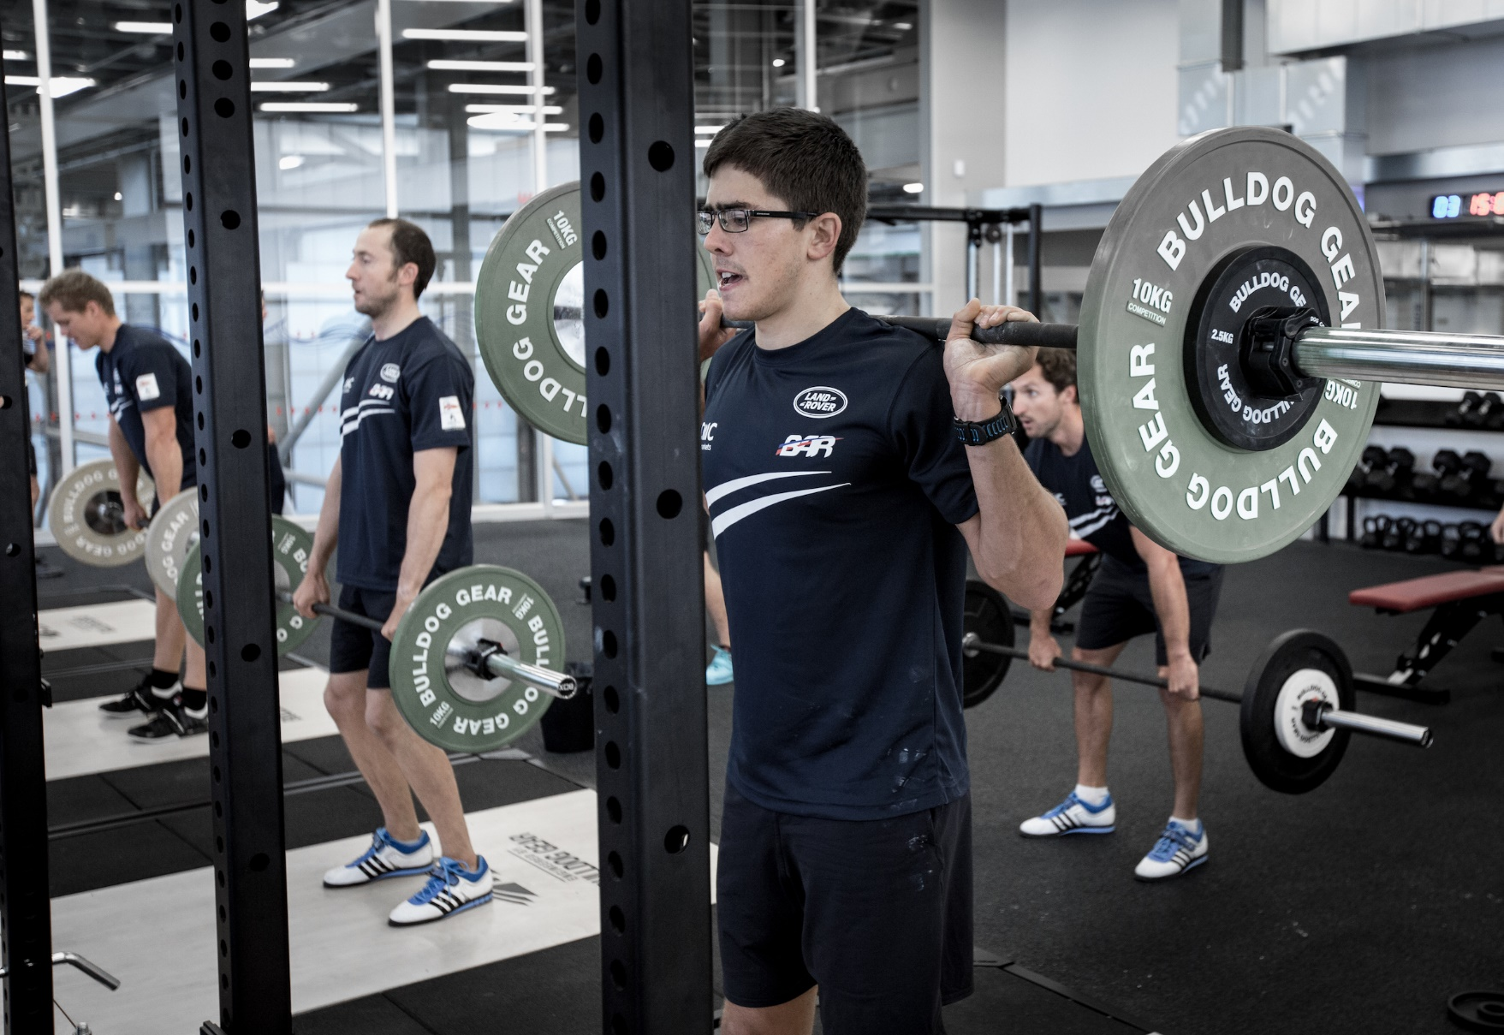

The performance of the crew members is just as important as the performance of the boat and the team needs to work hard to maintain optimum fitness.

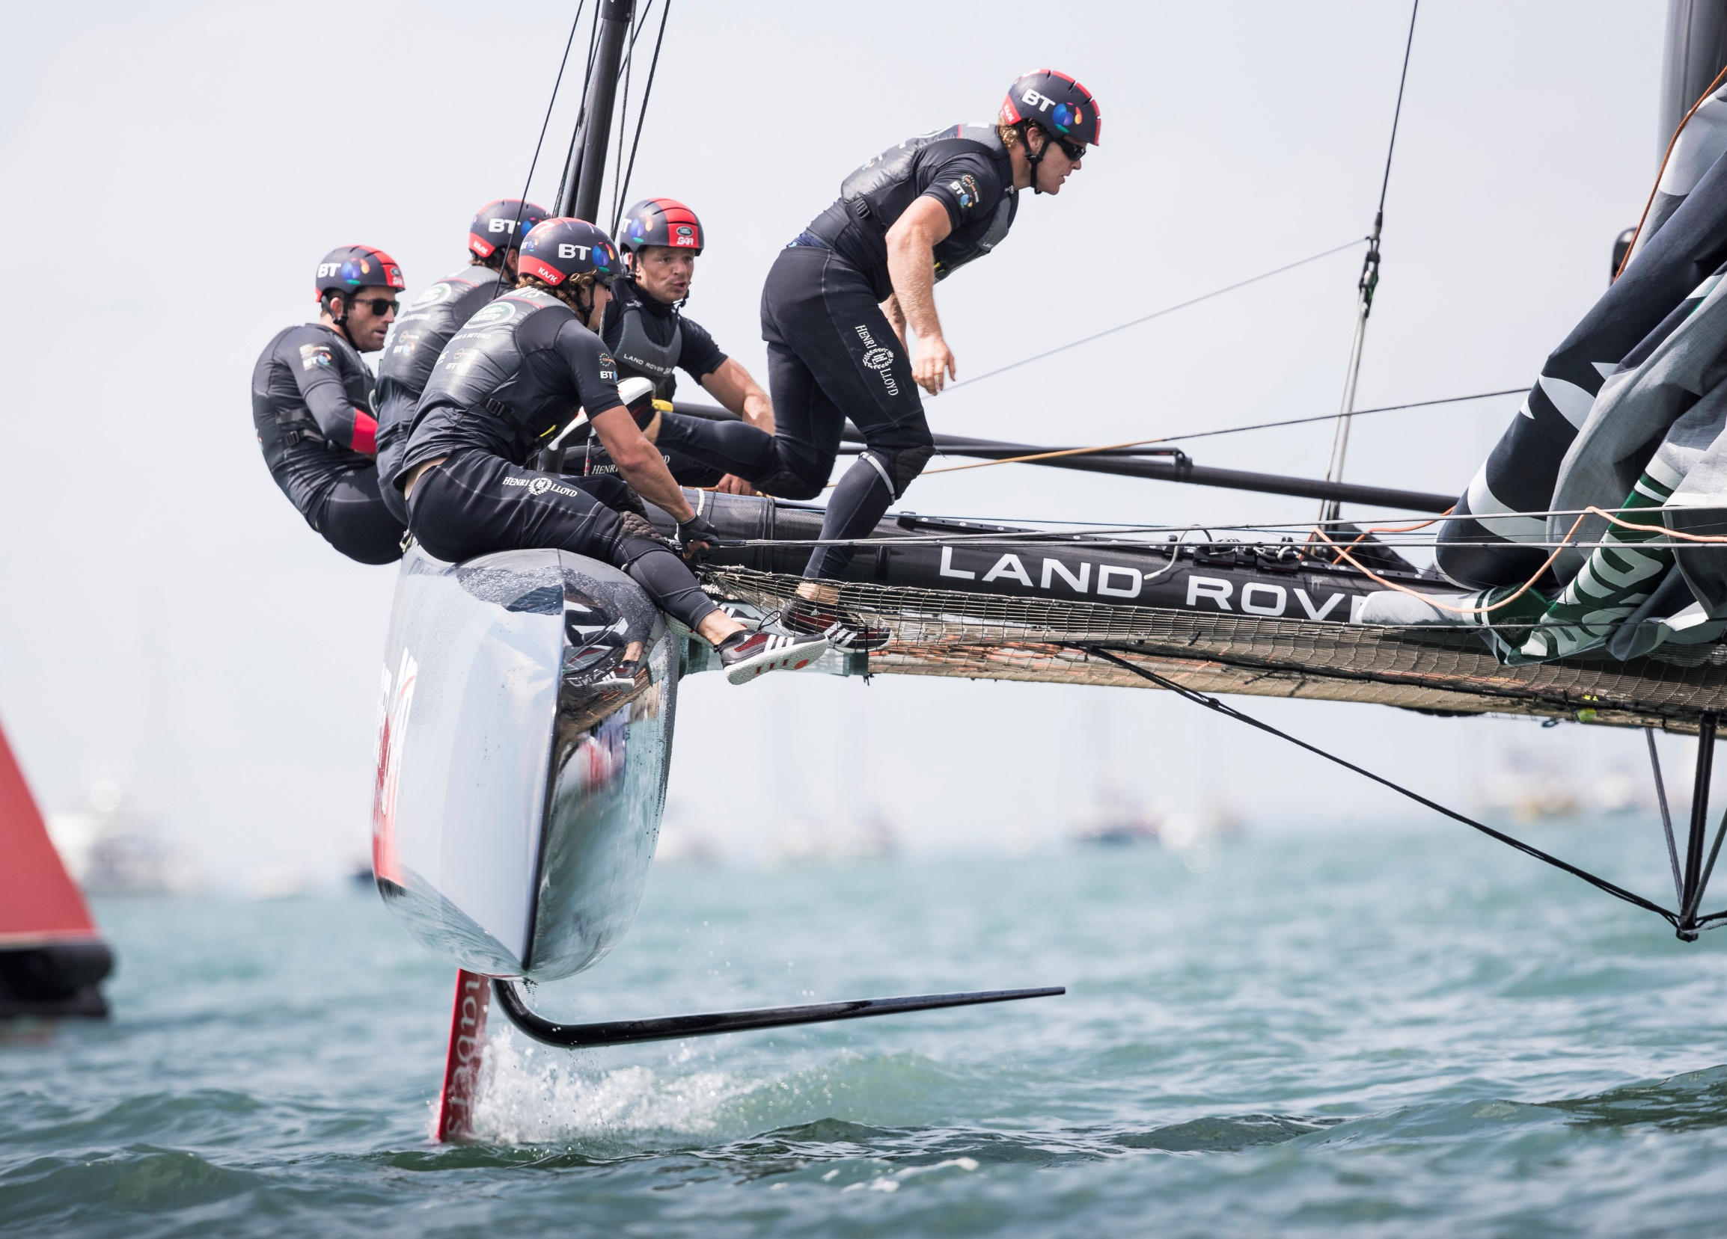

The environment in which they are sailing can mean the difference between success or failure.

Today is your chance to make a difference, could you be our engineer..........?

2. The Brief

The team wants you to focus on three areas:
- Human performance
- Boat performance
- Environment.

Your challenge is to use the micro:bit technology to develop two products which could help improve performance for the Land Rover BAR team. Your products do not need to be in the same area but they do need to help improve performance in at least one of them.

You will need to work effectively as a team. In order to do this your team will need some of you to take on a role in addition to being a Faraday Land Rover BAR Software Engineer. These additional roles will give some of your team the responsibility for managing or marketing the project, budgeting and keeping to time.

You will need to develop a presentation to the Land Rover BAR judges which explains how your products could improve performance.

Your team will need to:

- Identify a range of ideas for improving performance in each of the three areas using the micro:bit.
- Identify the two products that your team are going to put forward. Remember that these do not have to be from the same area but you must be able to demonstrate how they improve performance.
- Code your micro:bit to bring your ideas to life.
- Construct any components you need to add to your micro:bit to make it work effectively.
- Develop your presentation.
- Demonstrate the capabilities of your two ideas by presenting them to the Land Rover BAR judges.

Considerations
Your two Land Rover BAR products must:

- improve performance in at least one of the three areas
- have relevant and useful real-life applications
- demonstrate engineering skills and show creativity and innovation
- be effective and cost efficient.

3. Schedule for the day

09:15 | Register your team
09:30 | Welcome and introduction
09:35 | Introduction to the Faraday Challenge
10:00 | STAGE 1: Identifying the problems and generating initial ideas  - Brainstorming of ideas  - Complete Stage 1 reflections
10.15 | Allocation of roles
10:20 | Coding apprenticeship
10:30 | STAGE 2: Development  - Shop opens  - Agree on final product designs  - Create shopping list
11:10 | Break
11:20 | STAGE 3: Modifications  - Continue to design and code and modify where necessary
12:10 | Briefing for the presentation  - Project and/or marketing managers are briefed on the content of the presentation
12:30 | Lunch – Tools down
13:00 | STAGE 3 continued: Final preparations  - Finalise coding  - Prepare presentation with notes
13:30 | STAGE 4: Presentation  - Shop closes and coding finishes – laptops are removed  - Submit accounting sheet to the Shop keeper  - Practise presentation
14:00 | STAGE 5: Final test  - Teams present their designs to the judges
14:45 | Award ceremony  - Final feedback and evaluation of the day  - Winning team announced
15:00 | Finish - Engineering teams depart

4. Shop resource sheet
Below are the items available to buy in the shop.

Item | Description |  | Unit | Cost
Crocodile leads | 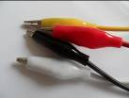 | Lead with crocodile clips at each end | Each | 6 Faradays
Piezo buzzer | 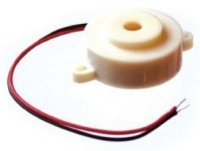 | Connect to the rings in a circuit to give a sound output | Each | 8 Faradays
LED – green | 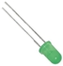 | LED which can be connected to the rings in circuit – green. Must be used with a resistor. | Each | 8 Faradays
Thermistor  + resistor | 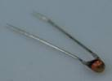 | Component that detects the ambient temperature and changes resistance to allow a current to flow through a circuit. Must be used with a resistor. | Each | 16 Faradays
Light Dependent Resistor + resistor | 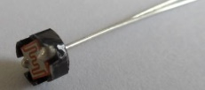 | Component that detects the light level and changes resistance to allow a current to flow through a circuit when it becomes dark. Must be used with a resistor. | Each | 16 Faradays
Moisture sensor | 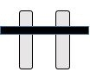 | Component which detects moisture in the surroundings. | Each | 16 Faradays
Servo motor | 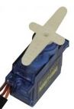 | This is a motor whose angular motion can be controlled. It is used if you want to move something to a specific position. | Each | 16 Faradays
Flex sensor | 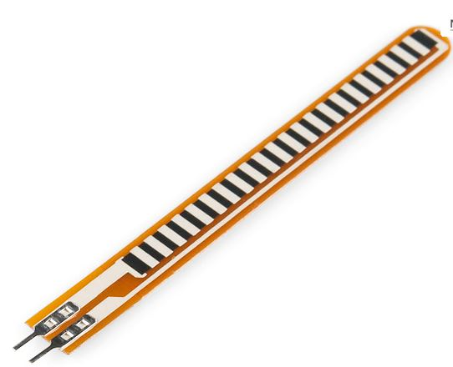 | Used to detect whether a material is bending. | Each | 16 Faradays

Item | Description | Unit |  | Cost
Strapping | Used to strap the BBC micro:bit on for wearable technology products | 30 cm piece |  | 8 Faradays
Tape measure | Used for measuring distance for distance/time or speed calculations | Each | 6 Faradays
Strong clear plastic | Rectangular piece of plastic | Each | 4 Faradays
Dowel | 15cm piece of solid cylindrical wooden rod used to create structures | Each | 6 Faradays
Polyfoam | A5 foam sheet – assorted colours | Each | 12 Faradays
Green wire | Used to connect structures (not for connection to the micro:bit) | 20 cm piece | 4 Faradays
Coloured card | A4 sheet of card – assorted colours | Each | 8 Faradays
Tin foil | A conductive material | 30cm strip | 6 Faradays
Masking tape | Can be used to secure parts in your design - do not stick anything to your BBC micro:bit or it may not work properly. | 30cm piece | 6 Faradays
Thick foam | Can be used to make pressure switches or enhance your design. | Each | 6 Faradays
Cable ties | Can be used to hold your BBC micro:bit onto a background | Each | 4 Faradays
Scissors | Used for soft materials only – do not use to cut wires or any part of your BBC micro:bit. | Each | 4 Faradays
Stapler | Used to staple soft materials only – do not use to staple anything to your BBC micro:bit | Each | 6 Faradays
Hole punch | Used to make small holes in soft materials | Each | 4 Faradays
Rulers | Used to measure any part of your product or additional items | Each | 4 Faradays
String | Can be used as part of your product design | 30cm piece | 6 Faradays

5. Assessment information and criteria

Criteria | Marks
- Planning | 10 marks
- Development of product | 20 marks
- Use of budget | 8 marks
- Functionality of coding | 12 marks
- Functionality of product | 22 marks
- The pitch | 16 marks
- Teamwork | 12 marks
Total | 100 marks
- Planning (10 marks)
Using Stage 1 of the planning sheet provided, marks will be awarded for:
- Identifying at least two ideas in each of the three areas which are appropriate to the challenge (6 marks).
- Demonstrating creativity and innovation in the ideas recorded (4 marks)

- Development of the Land Rover BAR products (20 marks)

Using Stage 2 and 3 of the planning sheet provided, marks will be awarded for:

- Identifying two ideas for products within the three themes which could be developed (4 marks).
- Identifying how each of these products could potentially improve performance (4 marks).
- Providing an honest and accurate description of the problems encountered in developing their products (4 marks).
- Identifying and implementing solutions to the problems encountered (4 marks).
- Providing an honest and reliable description of how effectively the team worked both as a whole and individually (4 marks).
- Use of budget (8 marks)
Using the accountancy sheet, marks will be awarded for:
- Providing an accurate record of spending (3 marks).
- Using the budget creatively to enhance your product and make it work effectively and efficiently (5 marks).

4. Functionality of micro:bit coding (12 marks)
Using the presentation of your products and the judges’ observation of your code, marks will be awarded for:

- Developing two codes which are appropriate for the intended purpose (6 marks)
- Using the functions of the BBC Micro:bit accurately (6 marks)
5. Functionality of the Land Rover BAR products (22 marks)
Using the presentation of your products, marks will be awarded for:

- Engineering of your products, including any external components and packaging (10 marks).
- Functions of the product can improve performance for the Land Rover BAR team (6 marks).
- How well the products work (6 marks).
- The presentation (16 marks)
Using the presentation of your products, marks will be awarded for:

- Explaining your reasons for choosing the area(s) you have worked on and for choosing your final two products (4 marks).
- How effectively you demonstrate the ways in which your products will improve performance for the Land Rover BAR team (4 marks).
- Explaining how you have used your engineering knowledge and skills to produce your two products (4 marks).
- Explaining how the roles you took in your team enabled you to work effectively (2 marks)
- Effective and creative communication of your ideas to the Land Rover BAR team within the time limit (2 marks).

- Teamwork (12 marks)
Using the judges’ observations of your team throughout the day, marks will be awarded for:
- How well you work as a team with all members working together effectively (5 marks).
- Demonstrating resilience and perseverance in the development of your product (5 marks).
- How tidy, safe and organised your working area is kept (2 marks).

