The IET

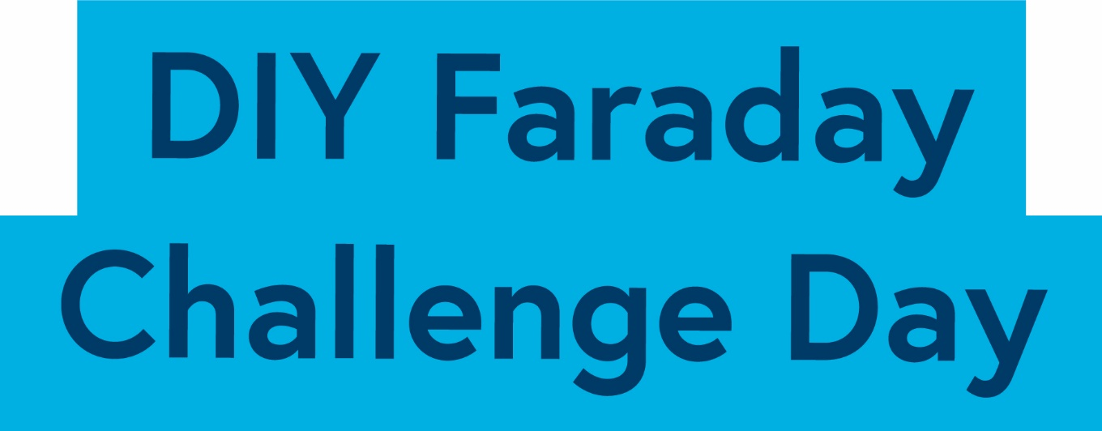

Thorpe Park
Teacher Handbook

Could you be our engineer….?

The IET DIY Faraday Challenge Day ‘Thorpe Park’ is based on the Faraday Challenge Day of the same name, a STEM activity day written and delivered by the Institution of Engineering and Technology (IET).

The IET Education website hosts a wide range of teaching resources for science, design and technology and maths. These include classroom activities with film clips, online games, posters, careers resources and STEM activity days.

The Institution of Engineering and Technology
IET Education 5-19
Michael Faraday House
Six Hills Way Stevenage
Herts
SG1 2AY
United Kingdom
T: +44 (0)01438 767653
F: +44 (0)01438 765526

The Institution of Engineering and Technology is registered as a Charity in England & Wales (no 211014) and Scotland (no SC038698)

Stay safe
Whether you are a scientist researching a new medicine or an engineer solving climate change, safety always comes first. An adult must always be around and supervising when doing this activity. You are responsible for:
- ensuring that any equipment used for this activity is in good working condition
- behaving sensibly and following any safety instructions so as not to hurt or injure
yourself or others

Please note in the absence of any negligence or other breach of duty by us, this activity is
carried out at your own risk. It is important to take extra care at the stages marked with this symbol: ⚠

Contents

- The context 4
- The brief 5
- Checklist 6
- Shop resources 7
- Suppliers 11
- Schedule of the day 12
- Room layout 13
- Assessment matrix 14
- Assessment criteria 15
- Risk Assessment 17

The Context
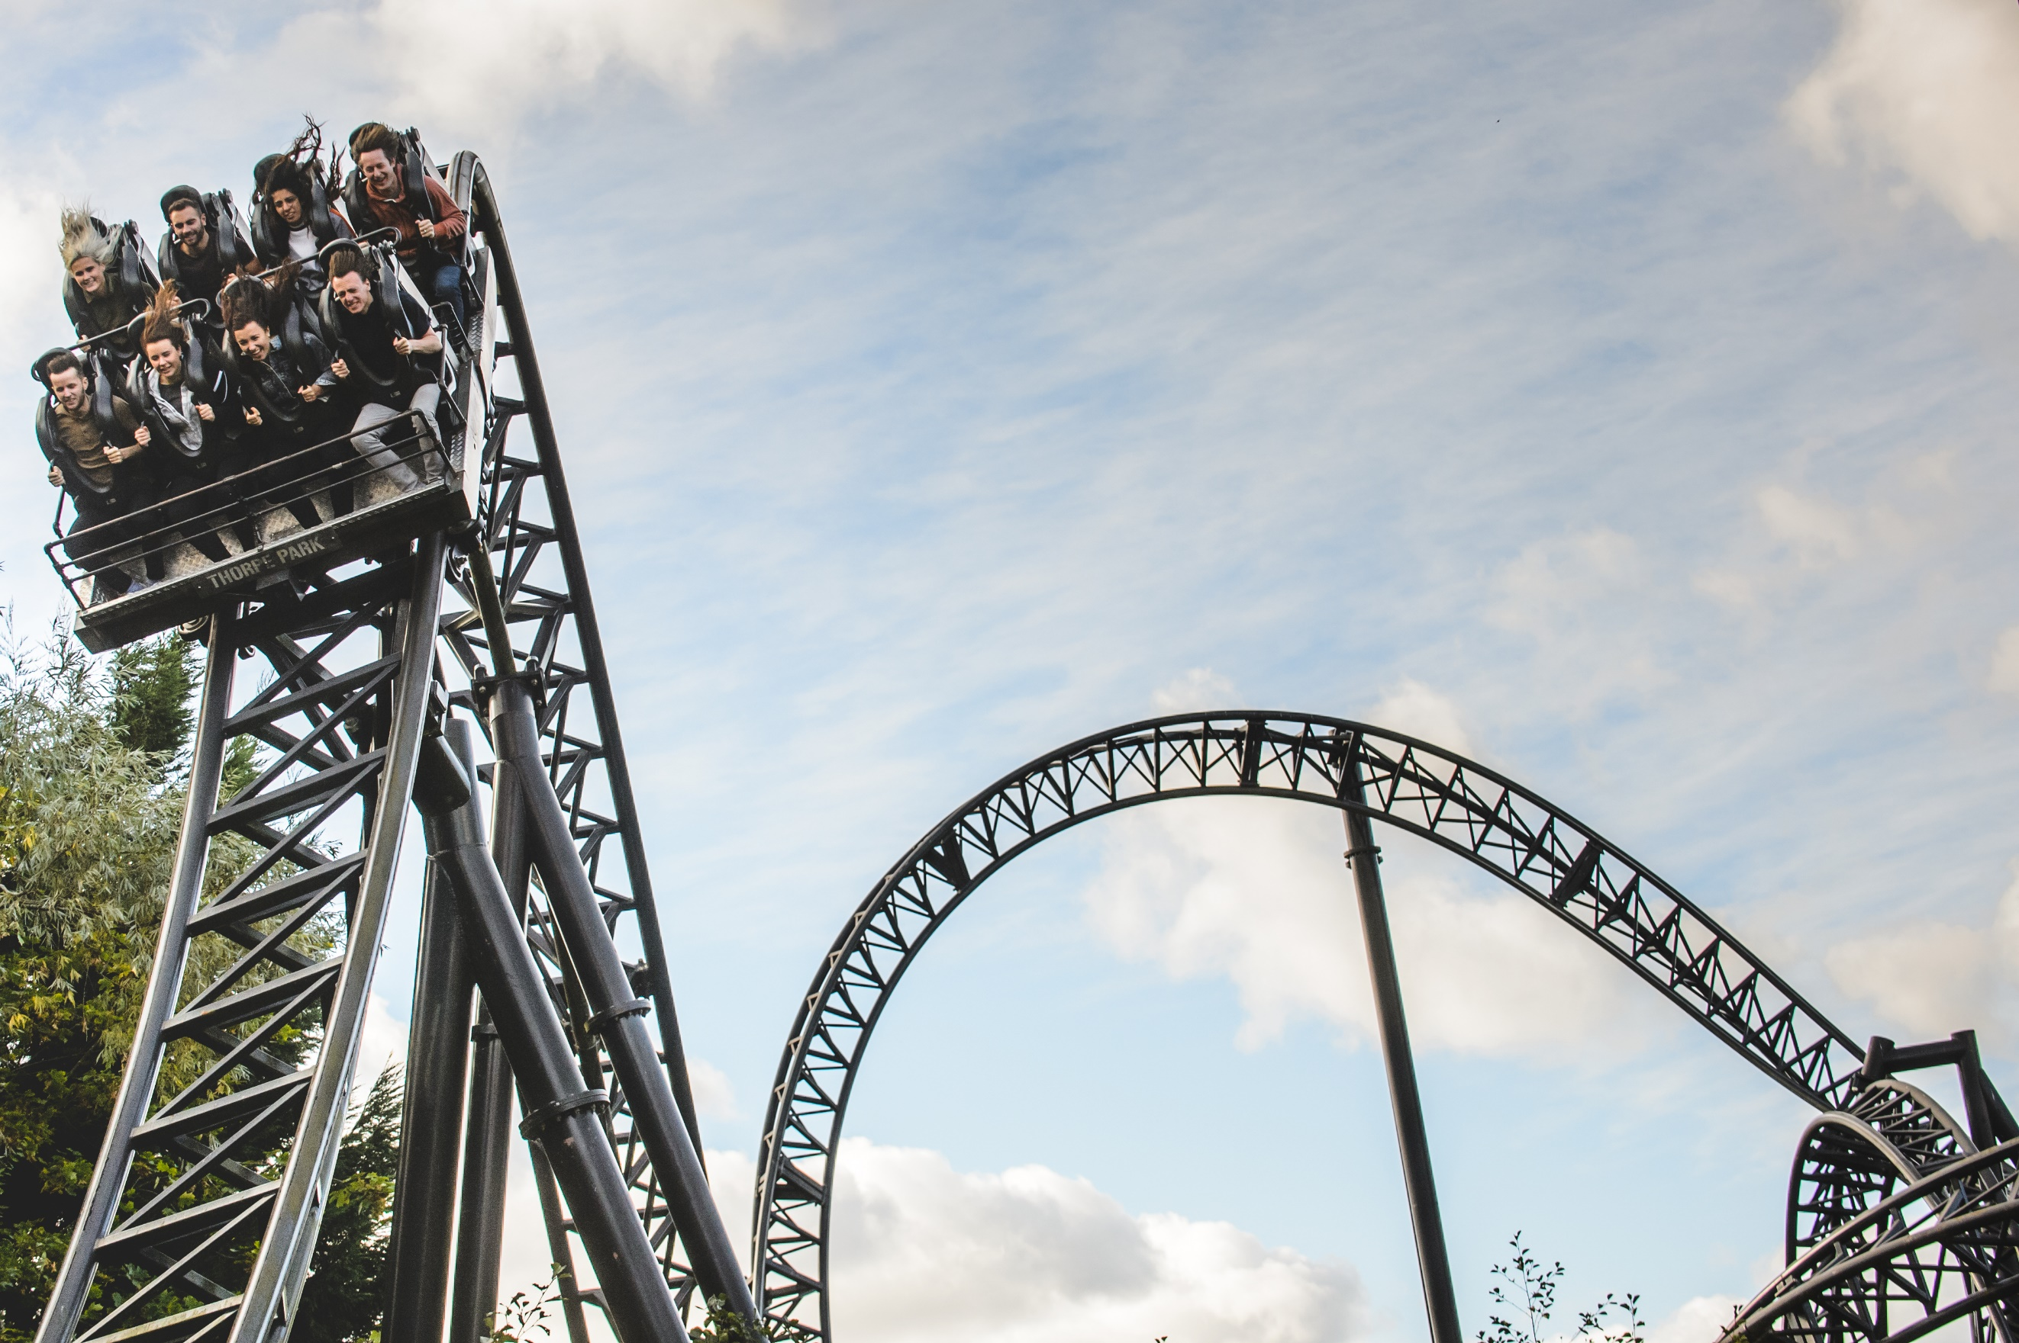
With over 30 thrilling rides, attractions and live events, Thorpe Park Resort attracts visitors from all over the world and they are constantly looking for new ideas. Although many of their visitors come to experience some of the world-class rides such as The Swarm, Stealth and the movie themed coaster, SAW – The Ride, they know that there are some who find the stomach-churning speed and height of these popular rides a little challenging!

Thorpe Park are currently looking to redevelop a part of the park and want your help. Your brief is to design an attraction which could appeal to a wide range of visitors, not just those thrill seekers who currently enjoy our fast and furious rides.

Engineering all the aspects of an attraction takes a long time but you will need to demonstrate that you have the engineering skills Thorpe Park requires by designing a new attraction and constructing one small part of your design.

Remember attractions are more than just the rides. Thorpe Park has shows, exhibitions, a beach, refreshment and food outlets so think carefully about what you could design to complement what is already available and consider how your attraction could be accessible to all.

Today is your chance to make a difference, could you be our engineer..........?

2. The Brief

The Thorpe Park team wants you to:

- Develop a detailed drawing of your attraction and provide ideas for how you could address some of the considerations and restrictions Thorpe Park engineers need to accommodate.

- Design and engineer ONE aspect of your design to include an electronic circuit/component.

- Complete the planning and reflections sheet to show how you have solved problems and how you have worked as a team throughout the project.

- Present the design of your attraction and the element you have engineered to the IET Faraday Thorpe Park judge(s).

You will need to work effectively as a team. In order to do this your team will need some of you to take on a role in addition to being a Faraday Thorpe Park Engineer. These additional roles will give some of your team the responsibility for managing or marketing the project, budgeting and keeping to time.

Considerations:

- Think carefully about what might make your attraction unique both at Thorpe Park and across other theme parks. Remember theme parks are more than just thrill-seeking rides.
- Make sure your attraction complies with the restrictions Thorpe Park must work within.
- It takes years to design and build a ride so think about what you can realistically achieve in the limited time available today.
- Think about the following when deciding on which element to construct:
- Target audience
- Visitor experience
- Visitor accessibility
- Visitor comfort (including queuing)
- Safety (staff and visitor)
- Impact on the environment

Restrictions:

- Attractions and their queues can be no closer than 8 metres to the water’s edge.
- Attractions can be no higher than 30 metres.
- Attractions can be no higher than 100 decibels.

Checklist

Student tables | Notes
Team number sign (laminated) | 1 per table in plastic stand
Student team registration form | 1 per student table
Student booklet | 1 per table
Accounts sheet | 1 per table
A3 Planning and Reflections sheet | 1 per table
Team roles and responsibilities (laminated) | 1 per table on clipboard
Engineering Apprenticeship (laminated) | 2 per table on clipboard
A3 Thorpe Park map (laminated) | 1 per table
Name badge stickers | 6 role stickers per table
Faraday branded currency | Each team - 1 x 20F, 4 x 10F, 6 x 5F, 10 x 1F = F100.00
Engineering apprenticeship pack | 1 per table – box contains 2AA battery pack with battery snap, 3 x crocodile leads, LED and LDR.
Challenge Leader | Notes
Presentation - hard and electronic copy | Best to bring on your own laptop and presentation and video on a memory stick
Clicker for PowerPoint presentation | Carry spare batteries
Assessment matrix | 1 per event
Clipboard | For hard copy of presentation, assessment matrix, etc.
A4 plain paper | Up to 3 sheets free per team for presentation notes
A3 plain paper | 1 sheet per team for drawing attraction
Certificates | 1 per student – give to teachers to write names in and present back at school (NOTE: JPF have their own certificates so ensure you have the correct ones)
Shop | Notes
Shop manager account sheet | 1 per event - Put on a clipboard
Shop manager resources list | Laminated sheets on clipboard
Shop keeper instructions | 2 x laminated sheet to give to shop keepers as briefing for role
Faraday branded currency | Shop change – 2 x 20; 10 x 10; 20 x 5; 20 x 1
All shop items with price tags
Signage – shop
Signage – judges table

4. Shop resources

Electrical components
Item | Description |  | Unit | Cost
Crocodile leads | 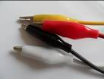 | Lead with crocodile clips at each end | Each | 2 Faradays
Insulated wire – red or black | 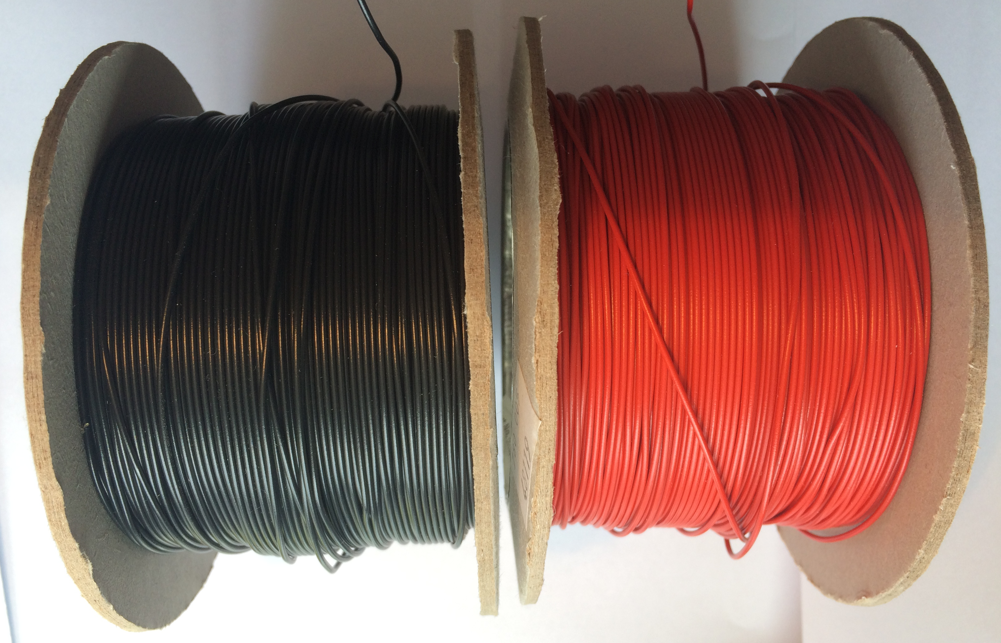 | Can be used to create a circuit using terminal blocks or used for electro-magnets | Per 30 cms | 2 Faradays
Terminal blocks | 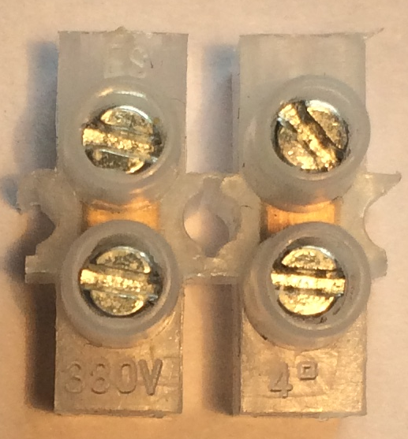 | Can be used to connect insulated wire | Each | 2 Faradays
Piezo buzzer | 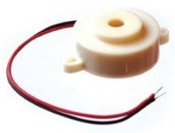 | Connect in a circuit to give a sound output | Each | 6 Faradays
LED – various colours | 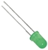 | Light Emitting Diode which lights up when connected in a circuit. Choose from red, orange, green or blue. | Each | 6 Faradays
2.5V Bulb with bulb holder | 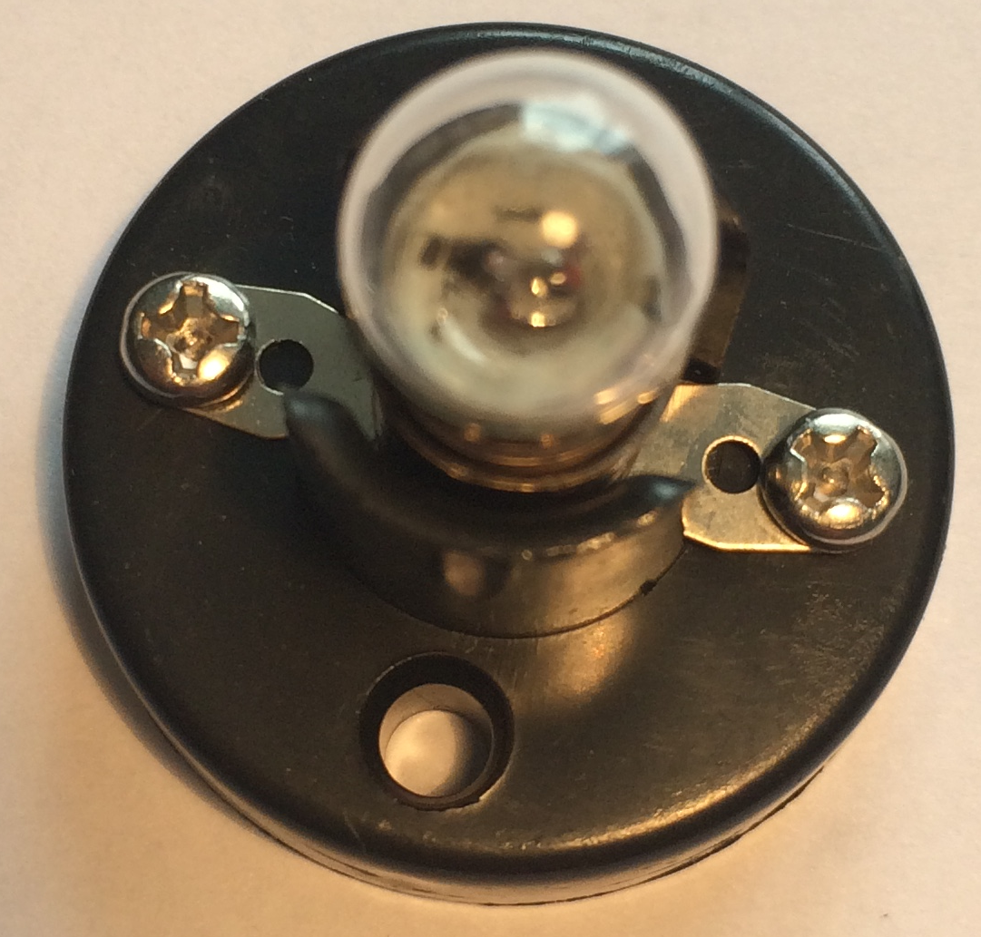 | Used as a light in a circuit. NOTE: Will not work with an LDR | Each | 6 Faradays
Motor | 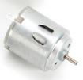 | Connect in a circuit to create clockwise or anti-clockwise movement. | Each | 6 Faradays
Motor holder | 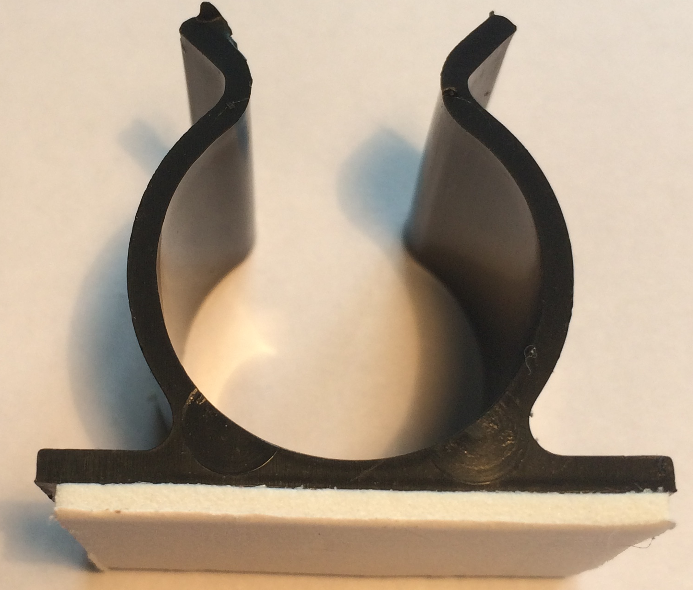 | Used to fix a motor or a syringe in position. NOTE: you will need the insert to connect a syringe. | Each | 4 Faradays
Gear attachment for motor | 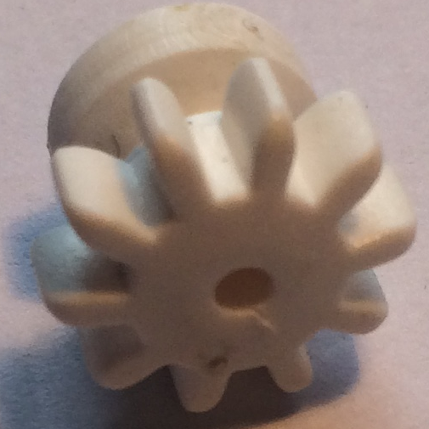 | Used to connect a motor to a cog | Each | 2 Faradays
Pulley attachment for motor | 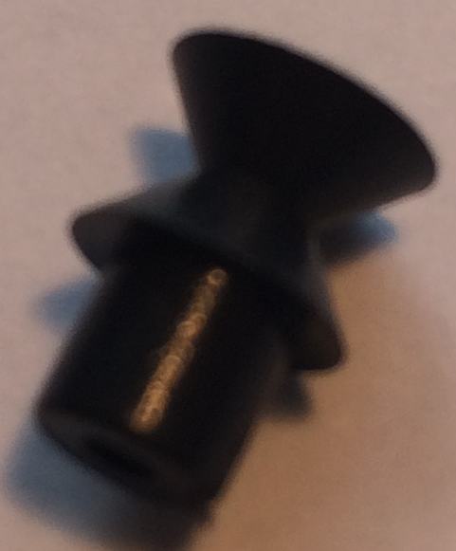 | Used to connect a motor to a pulley wheel – will need connector (e.g. elastic band) | Each | 2 Faradays

Light Dependent Resistor | 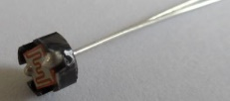 | Component that detects the light level and changes resistance in a circuit. | Each | 8 Faradays
Moisture sensor | 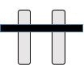 | Component which detects moisture in the surroundings. Can also be used to detect materials which conduct electricity. | Each | 8 Faradays
Potentiometer | 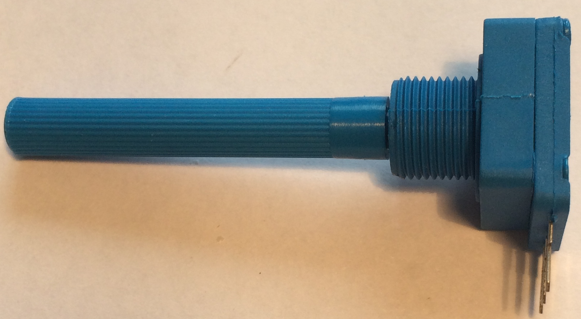  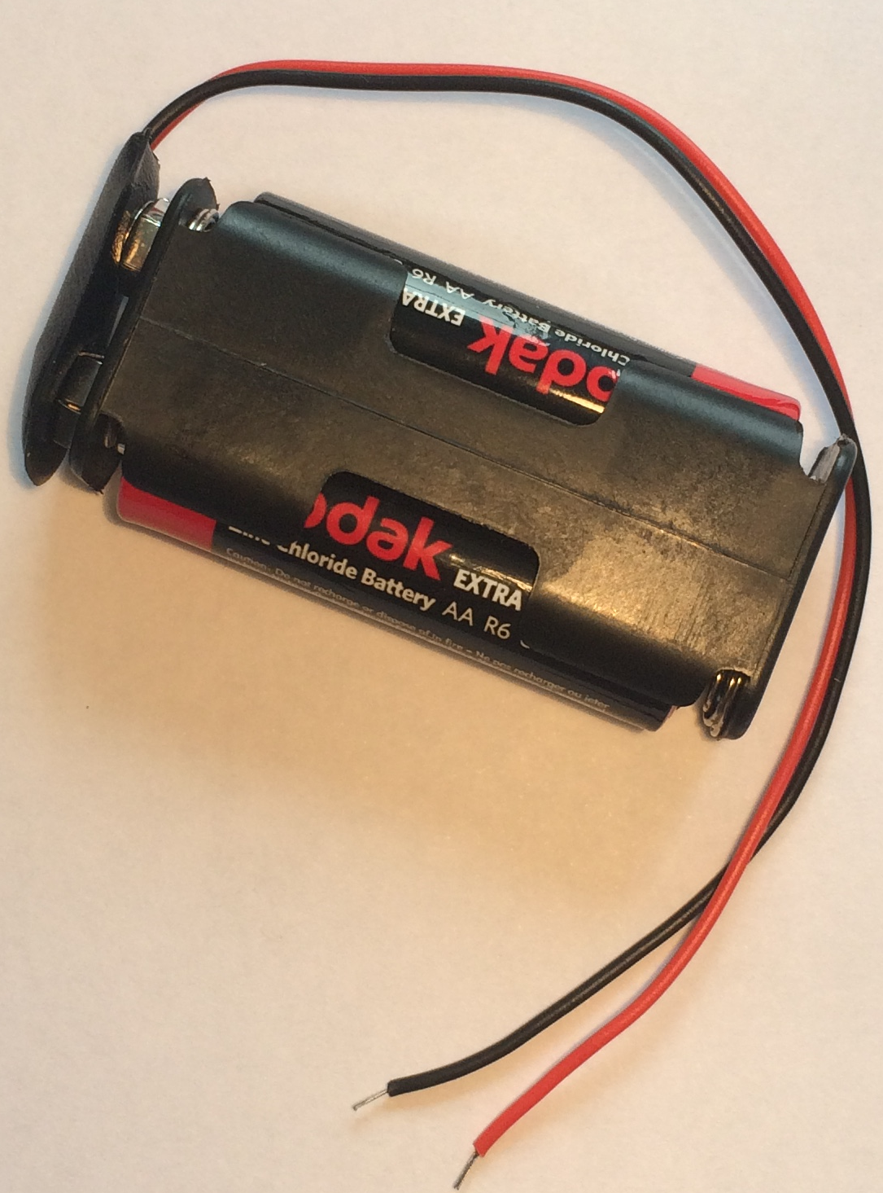 | Can be used to vary the resistance in a circuit | Each | 8 Faradays
2AA cells in battery holder with battery snap |  | Used to provide power for your circuit | Each | 6 Faradays
Push button switch | 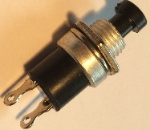 | Connects a circuit when pushed down and breaks the circuit when released. | Each | 6 Faradays

Construction materials
Item | Description | Unit |  | Cost
Correx | Used to create structures | Piece |  | 6 Faradays
Plastic syringes with tube | Used to develop pneumatic system | Pair of syringes with plastic tube | 8 Faradays
Nail | Used to build an electro-magnet | Each | 2 Faradays
Small cog | Used in gear systems with motors | Each | 2 Faradays
Medium cog | Used in gear systems with motors | Each | 2 Faradays
Large cog | Used in gear systems with motors | Each | 4 Faradays
Dowel | Piece of solid cylindrical wooden rod used to create structures | Each | 4 Faradays

Item | Description | Unit | Cost
Straws | Can be used in structures | Each | 2 Faradays
Pulley wheel 54cm | Used to connect to pulley attachments on motor | Each | 6 Faradays
Wooden wheel 54cm | Used with motors to drive something | Each | 4 Faradays
Plastic reel | Used in construction | Each | 4 Faradays
Polyfoam | A5 foam sheet – assorted colours | Each | 4 Faradays
Coloured card | A4 sheet of card – assorted colours | Each | 4 Faradays
Tin foil | A conductive material which can be used to make pressure pads or switches (MUST NOT be used in place of connecting wires) | 10cm strip | 6 Faradays
Masking tape | Can be used to secure light parts in your design. NOTE: excessive use of tape will result in an additional charge | Roll | 6 Faradays
Sponge | Can be used to make pressure switches or enhance your design. | Each | 6 Faradays
Paperclip | Used to create switches or in construction | Each | 1 Faraday
Paper fastener | Used to create switches or in construction | Each | 1 Faraday
Elastic bands | Used to hold or create working parts | Each | 1 Faraday
Cable ties | Can be used to hold your structures in place | Each | 2 Faradays
Green wire | Used to connect structures (MUST NOT be used in your electrical circuit) | 20 cm piece | 4 Faradays
String | Can be used as part of your product design | 30cm piece | 4 Faradays
Access card | Use this to collect various items from the shop – see next page | One per team | 6 Faradays

Available with your access card
These items can be used with your access card. You will need to take it to the shop to get use of one of these items. You may only get one item at a time.

Stapler | Used to staple soft materials only
Hole punch | Used to make small holes in soft materials
Rulers | Used to measure any part of your product or additional items
Scissors | Used for soft materials only
Screwdriver | Used to connect insulated wire in terminal blocks or to bulb holders.
Wire strippers | Used to cut or strip insulated wire.

Free to use

The cutting station – craft knives and junior hacksaws may be used at any point BUT only 3 people will be allowed at this station at any one time. Please take care when using this equipment.

3. Suppliers

Products have come from a range of sources below:

- Kitronik: https://www.kitronik.co.uk (for Piezo buzzers, switches and LDRs)
- Piezo buzzers - https://www.kitronik.co.uk/c3301-piezo-buzzer-with-drive.html
- LDRs https://www.kitronik.co.uk/c3515-standard-ldr.html
- Push button switches - https://www.kitronik.co.uk/c3401-miniature-push-to-make-switch-red.html

- RS components: http://uk.rs-online.com (for LEDs)

- Green diffused LED,L53SGD 25mA 5mm, RS Stock No.247-1678
- Orange diffused LED,L53ND 30mA 5mm, RS Stock No.228-5994
- Red diffused LED,L-53HD 25mA 5mm, RS Stock No.228-5988
- Blue LED Round 5mm, RS Stock No.861-4418

- TTS: tts-group.co.uk: for building materials and electrical components

- Hobby craft: http://www.hobbycraft.co.uk/ (for polyfoam, coloured card, etc.)

- Poundland: http://www.poundland.co.uk/

6. Schedule of the day

09:15 | Register your team
09:30 | Welcome and introduction
09:45 | Project brief: Introduction to the Faraday Challenge
10:05 | Planning: Identifying the problems and generating initial ideas
10:20 | Team role selection: team decides on which roles they need
10:25 | Engineering apprenticeship: teams complete a short engineering task ⚠
10:35 | Development  - Shop opens  - Agree on final product designs
11:00 | Break
11:10 | Development continues ⚠  - Continue to design and modify where necessary
12:10 | Project and/or marketing managers are briefed on the content of the presentation
12:30 | Lunch – Tools down
13:00 | Development: Final preparations ⚠  - Finalise product  - Prepare presentation with notes
13:30 | - Shop closes  - Submit accounting sheet to the Shop keeper  - Practise presentation
14:00 | Presentation ⚠  - Teams present their designs to the judge(s)
14:45 | Award ceremony with final feedback and evaluation of the day

7. Room/hall layout

Notes:
- Each team table will need 6 chairs and be large enough for 6 students to work comfortably. The judges’ table and shop will each need 2 chairs. Table positions do not need to be exact and can be arranged to best accommodate the shape and size of the venue.
- The challenge leader will bring one cutting mat for the cutting station but you must provide more or cover this table with a mat. This table should be a minimum of 3 x 0.5 metres or equivalent area.

BACK
Team 2
FRONT – Projection screen
Team 4
Team 5
Team 6
Shop
Judge’s table
Team 1
Team 3
Team 7 Teachers
Refreshments Table
Presentation table
Cutting station

8. Assessment matrix

Host name: ………………………………………………………. Date: …………………………….
Assessment Criteria |  | Team  1 | Team  2 | Team  3 | Team  4 | Team  5 | Team  6 | Team  7
Planning | 12
Development of product | 27
Use of budget | 10
The product | 21
The presentation | 15
Teamwork | 15
Total score | 100
Faradays spent

Team | School/Team name
1
2
3
4
5
6
7

9. Assessment criteria

Criteria | Marks
- Planning | 12 marks
- Development of product | 27 marks
- Use of budget | 10 marks
- The product | 21 marks
- The presentation | 15 marks
- Teamwork | 15 marks
Total | 100 marks

- Planning (12 marks)
Using the planning and product design section of the Planning and Reflections sheet, marks will be awarded as follows:
- Were there three relevant ideas for the attraction? (6 marks)
- Did they explain how their ideas might meet Thorpe Park’s considerations and restrictions? (6 marks)

- Development of product (27 marks)

Using the Project Design, observations of the team and Reflections 1 and 2 of the Planning and Reflections sheet, marks will be awarded as follows:

- Did they produce a detailed drawing of their product including the electric circuit?
(3 marks)
- Did they explain how their product meets the Thorpe Park brief? (4 marks)
- Did they provide honest and accurate observations relating to teamwork? (5 marks)
- Did they provide honest and accurate observations relating to problems? (5 marks)
- Did they provide honest and accurate observations relating to solutions? (5 marks)
- Was the team flexible in their approach to their developments? (5 marks)

- Use of budget (10 marks)
Using the accountancy sheet, marks will be awarded as follows:
- Was there an accurate record of spending? (4 marks)
- Was the budget used effectively? (6 marks)

4. The product (21 marks)
Using the presentation of your attraction, marks will be awarded for:

- Was the concept of their attraction relevant to the brief? (4 marks)
- Did the product comply with Thorpe Park restrictions and considerations? (4 marks)
- Did the product work? (9 marks)
- Was the product completed as far as possible? (4 marks)

5. The presentation (15 marks)
Using the presentation of your products, marks will be awarded as follows:

- Did the team explain the reasons for selecting their development idea? (3 marks)
- Did the team effectively demonstrate their product? (3 marks)
- Did the team explain how they used their engineering knowledge and skills during the project? (3 marks)
- Did the team explain how they used their roles effectively? (3 marks)
- Was the presentation well organised and rehearsed? (3 marks)

- Teamwork (15 marks)
Using the judges’ observations of your team throughout the day, marks will be awarded as follows:

- Did the team work well together with all members engaged in the project? (5 marks)
- Did the team work tidily and safely? (5 marks)
- Did the team use resilience and perseverance during the project? (5 marks)

10. Risk Assessment
The following risk assessment is given as guidance. It is advised that the school refers to the CLEAPSS Model Risk Assessment Documents for D&T.

Risk Assessment and Operating Procedure - IET
Activity: Faraday Challenge Days Thorpe Park
Persons at risk | Students taking part in the Faraday Challenge Day and adults in the location
Maximum Group Size | 36 students | Recommended Staffing/Student Ratio | 1:6
Risk Assessment
Hazards |  | Control Measures
- Use of electrical equipment – risk of electric shock |  | All electrical equipment is low voltage.
- Use of electrical equipment – short circuit causing heating |  | Warn students of the possibility of burns when connecting and disconnecting components. All pupils will receive a briefing about correct use of electrical components.
- Basic use of hand tools (craft knives, screwdrivers, scissors, hole punches, staplers) – risk of cutting or abrasion |  | Warn students of the risks and advise them of safe working practices. Identify member of staff to supervise area. Inform challenge leader if use of knives in school is restricted.
- Use of water with moisture sensors |  | Ensure students test their moisture sensor using the sponge in a box provided rather than directly in any drink or cup of water to avoid spillage on electrical components.
Location issues (to be completed by Host School)
Further Action Required: 1. Ensure all persons staffing the Faraday Challenge Days are aware of and competent to comply with this risk assessment and the control measures.

Risk Assessment (page 2)

Working Practice
Group structure | One Faraday Challenge Day Leader and one member of staff from the host school to be present during the whole day to oversee use of equipment and to keep order. Teachers bringing groups from other schools must remain in the room and be responsible for their own students.
Restrictions | Unknown premises.
Emergency  Procedure | Follow the lead from the Host School.  Faraday Challenge Day Leader to be fully briefed on risk assessment procedure prior to the day or on arrival.
Safeguarding | The Challenge Leader will carry their DBS and provide it where requested. They will comply with the safeguarding regulations within the school. A representative from the school MUST be present in the rooms at all times when students are present.
Safety Equipment | First aid kit and fire extinguisher (electrical fires) to be provided by Host School.
Name and role of IET Faraday Challenge representative | Keira Sewell  Challenge Day Leader.
Name and role of school representative
Signature of the school representative
Date of this Review | September 2017

