The IET

Thorpe Park

Student Booklet

Could you be our engineer….?

With thanks to our supporters…

Contents

- The Context …………………………………………………………………………….. 4
- The Brief ………………………………………………………………………………… 5
- Schedule for the day …………………………………………………………………… 6
- Shop resource sheet …………………………………………………………………… 7
- Assessment information and criteria …………………………………………………. 11

The Context
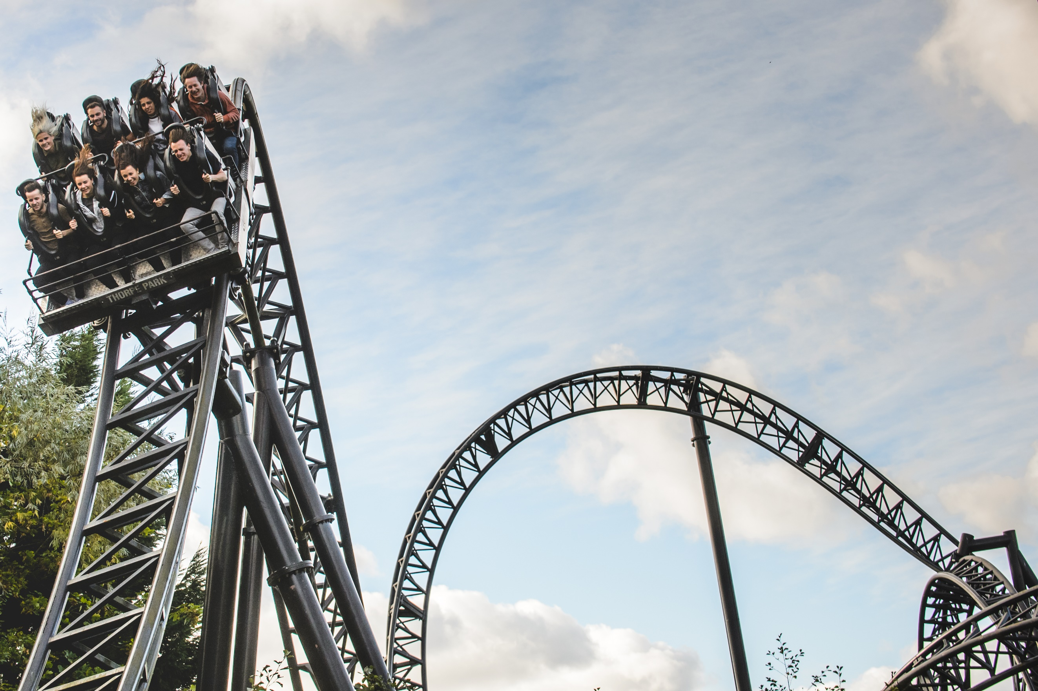
With over 30 thrilling rides, attractions and live events, Thorpe Park Resort attracts visitors from all over the world and they are constantly looking for new ideas. Although many of their visitors come to experience some of the world-class rides such as The Swarm, Stealth and the movie themed coaster, SAW – The Ride, they know that there are some who find the stomach-churning speed and height of these popular rides a little challenging!

Thorpe Park are currently looking to redevelop a part of the park and want your help. Your brief is to design an attraction which could appeal to a wide range of visitors, not just those thrill seekers who currently enjoy our fast and furious rides.

Engineering all the aspects of an attraction takes a long time but you will need to demonstrate that you have the engineering skills Thorpe Park requires by designing a new attraction and constructing one small part of your design.

Remember attractions are more than just the rides. Thorpe Park has shows, exhibitions, a beach, refreshment and food outlets so think carefully about what you could design to complement what is already available and consider how your attraction could be accessible to all.

Today is your chance to make a difference, could you be our engineer..........?

2. The Brief

The Thorpe Park team wants you to:

- Develop a detailed drawing of your attraction and provide ideas for how you could address some of the considerations and restrictions Thorpe Park engineers need to accommodate.

- Design and engineer ONE aspect of your design to include an electronic circuit/component.

- Complete the planning and reflections sheet to show how you have solved problems and how you have worked as a team throughout the project.

- Present the design of your attraction and the element you have engineered to the IET Faraday Thorpe Park judge(s).

You will need to work effectively as a team. In order to do this your team will need some of you to take on a role in addition to being a Faraday Thorpe Park Engineer. These additional roles will give some of your team the responsibility for managing or marketing the project, budgeting and keeping to time.

Considerations:

- Think carefully about what might make your attraction unique both at Thorpe Park and across other theme parks. Remember theme parks are more than just thrill-seeking rides.
- Make sure your attraction complies with the restrictions Thorpe Park must work within.
- It takes years to design and build a ride so think about what you can realistically achieve in the limited time available today.
- Think about the following when deciding on which element to construct:
- Target audience
- Visitor experience
- Visitor accessibility
- Visitor comfort (including queuing)
- Safety (staff and visitor)
- Impact on the environment

Restrictions:

- Attractions and their queues can be no closer than 8 metres to the water’s edge.
- Attractions can be no higher than 30 metres.
- Attractions can be no higher than 100 decibels.

3. Schedule for the day

09:15 | Register your team
09:30 | Welcome and introduction
09:45 | Project brief: Introduction to the Faraday Challenge
10:05 | Planning: Identifying the problems and generating initial ideas
10:20 | Team role selection: team decides on which roles they need
10:25 | Engineering apprenticeship: teams complete a short engineering task
10:35 | Development  - Shop opens  - Agree on final product designs
11:00 | Break
11:10 | Development continues  - Continue to design and modify where necessary
12:10 | Project and/or marketing managers are briefed on the content of the presentation
12:30 | Lunch – Tools down
13:00 | Development: Final preparations  - Finalise product  - Prepare presentation with notes
13:30 | - Shop closes  - Submit accounting sheet to the Shop keeper  - Practise presentation
14:00 | Presentation  - Teams present their designs to the judge(s)
14:45 | Award ceremony with final feedback and evaluation of the day

4. Shop resource sheet

Items to buy

Electrical components
Item | Description |  | Unit | Cost
Crocodile leads | 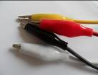 | Lead with crocodile clips at each end | Each | 2 Faradays
Insulated wire – red or black | 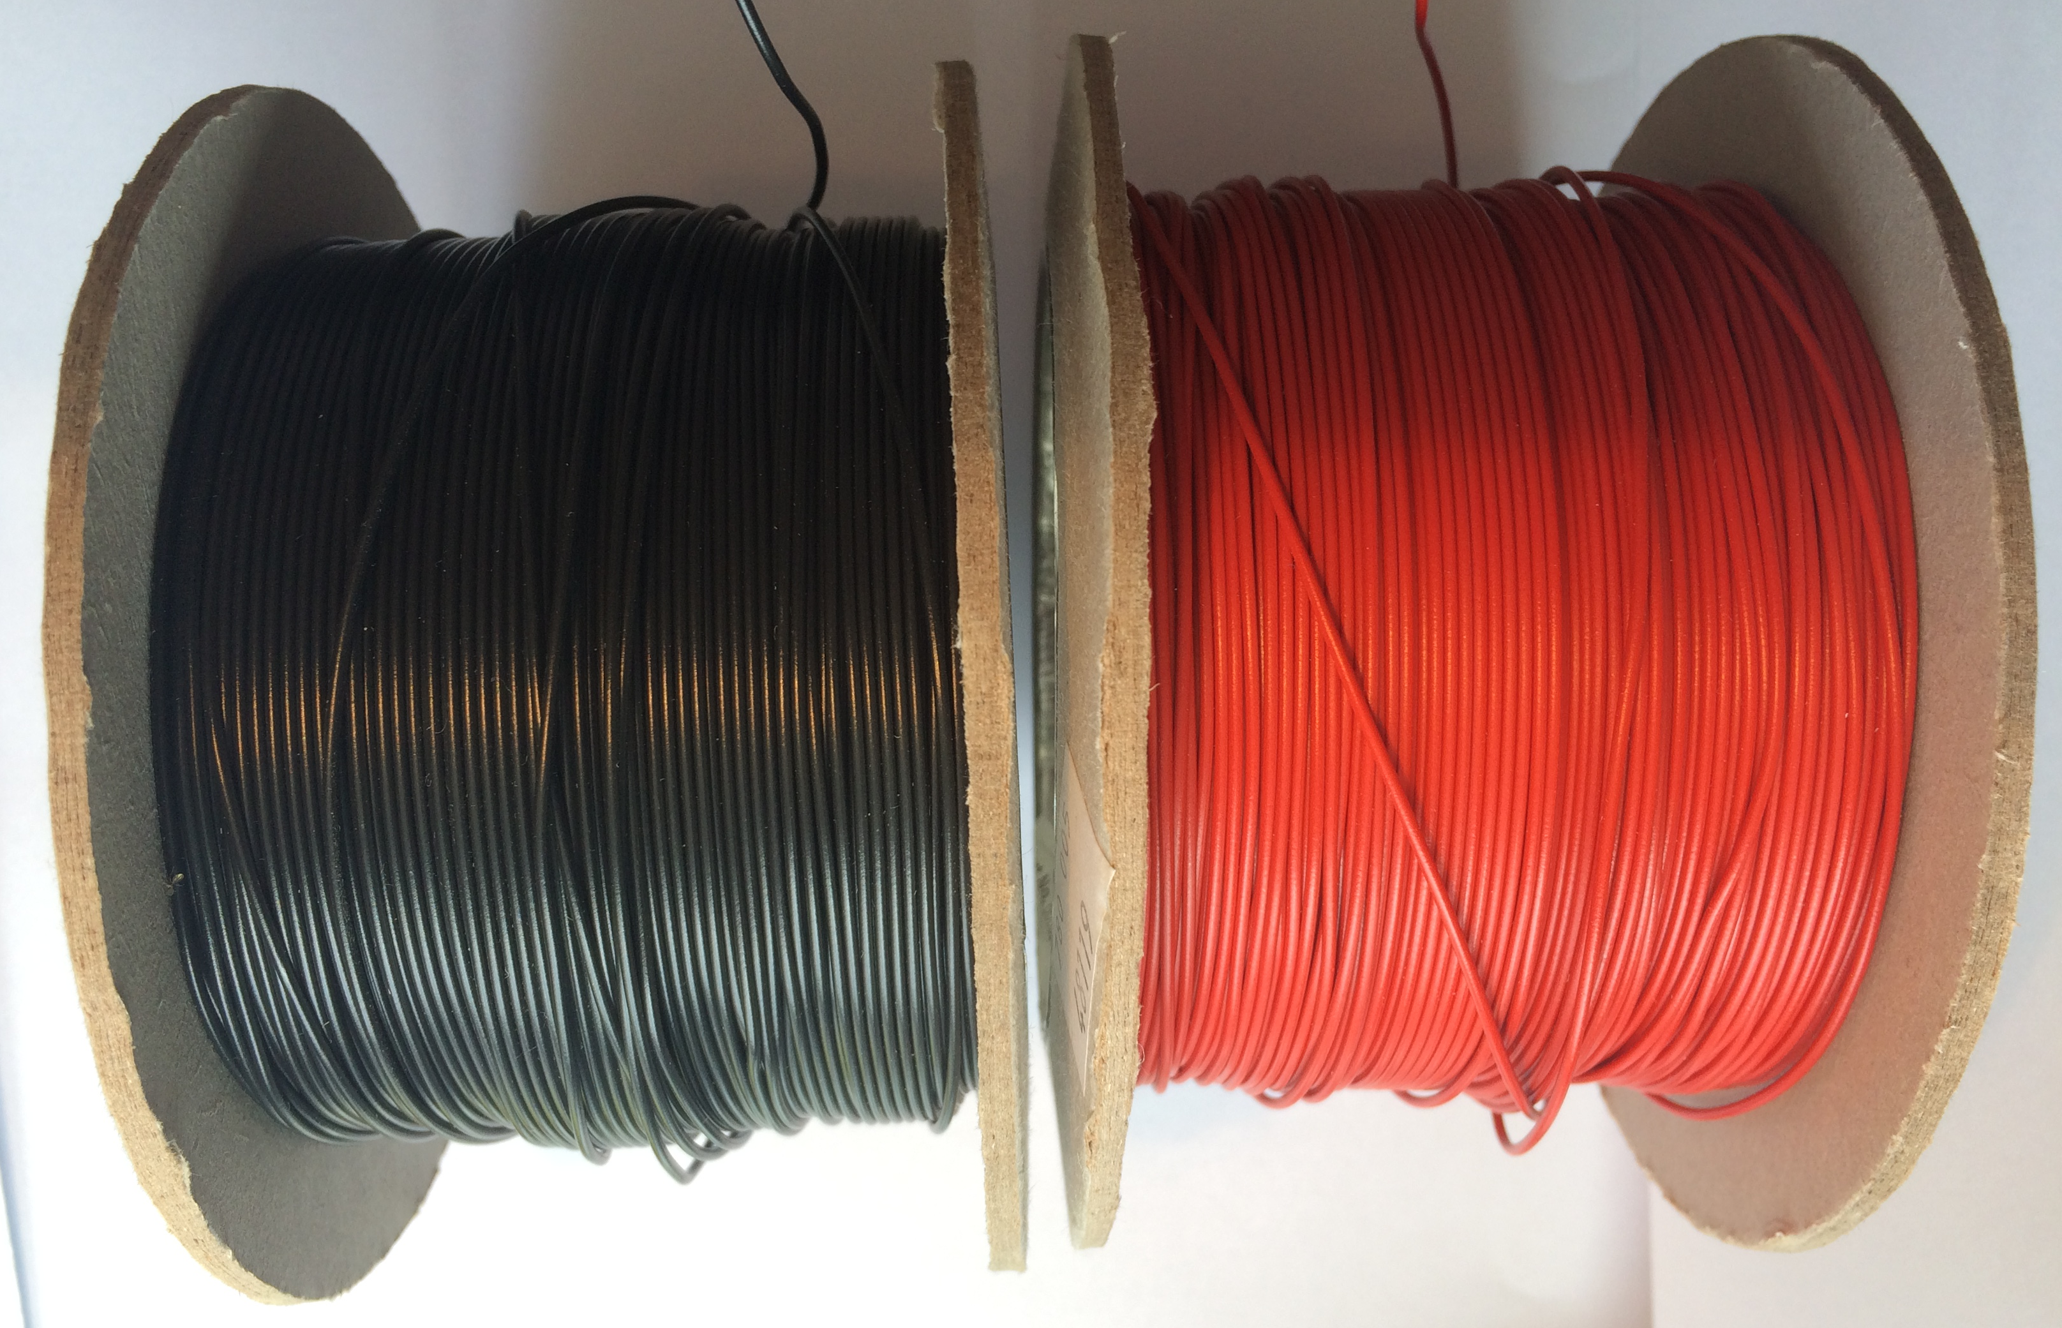 | Can be used to create a circuit using terminal blocks or used for electro-magnets | Per 30 cms | 2 Faradays
Terminal blocks | 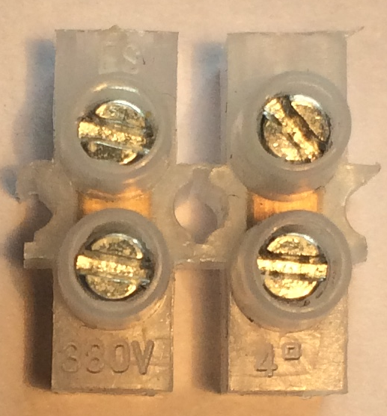 | Can be used to connect insulated wire | Each | 2 Faradays
Piezo buzzer | 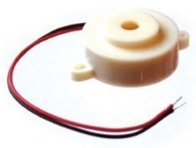 | Connect in a circuit to give a sound output | Each | 6 Faradays
LED – various colours | 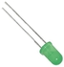 | Light Emitting Diode which lights up when connected in a circuit. Choose from red, orange, green or blue. | Each | 6 Faradays
2.5V Bulb with bulb holder | 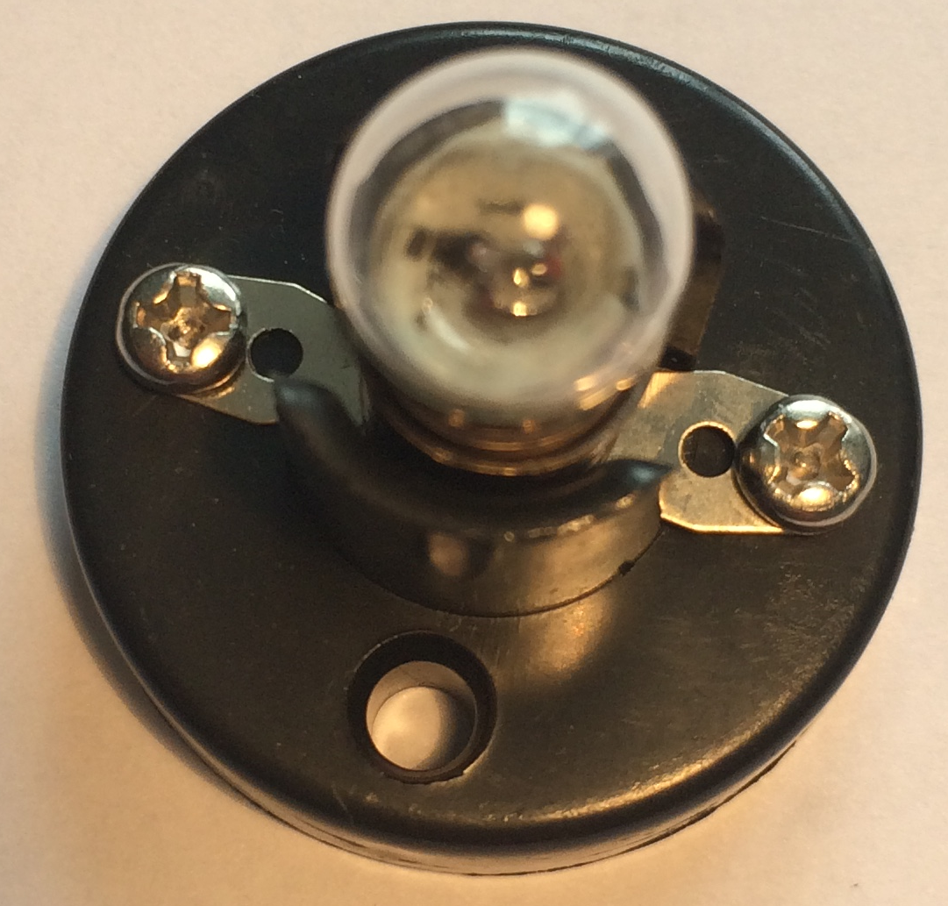 | Used as a light in a circuit. NOTE: Will not work with an LDR | Each | 6 Faradays
Motor | 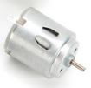 | Connect in a circuit to create clockwise or anti-clockwise movement. | Each | 6 Faradays
Motor holder | 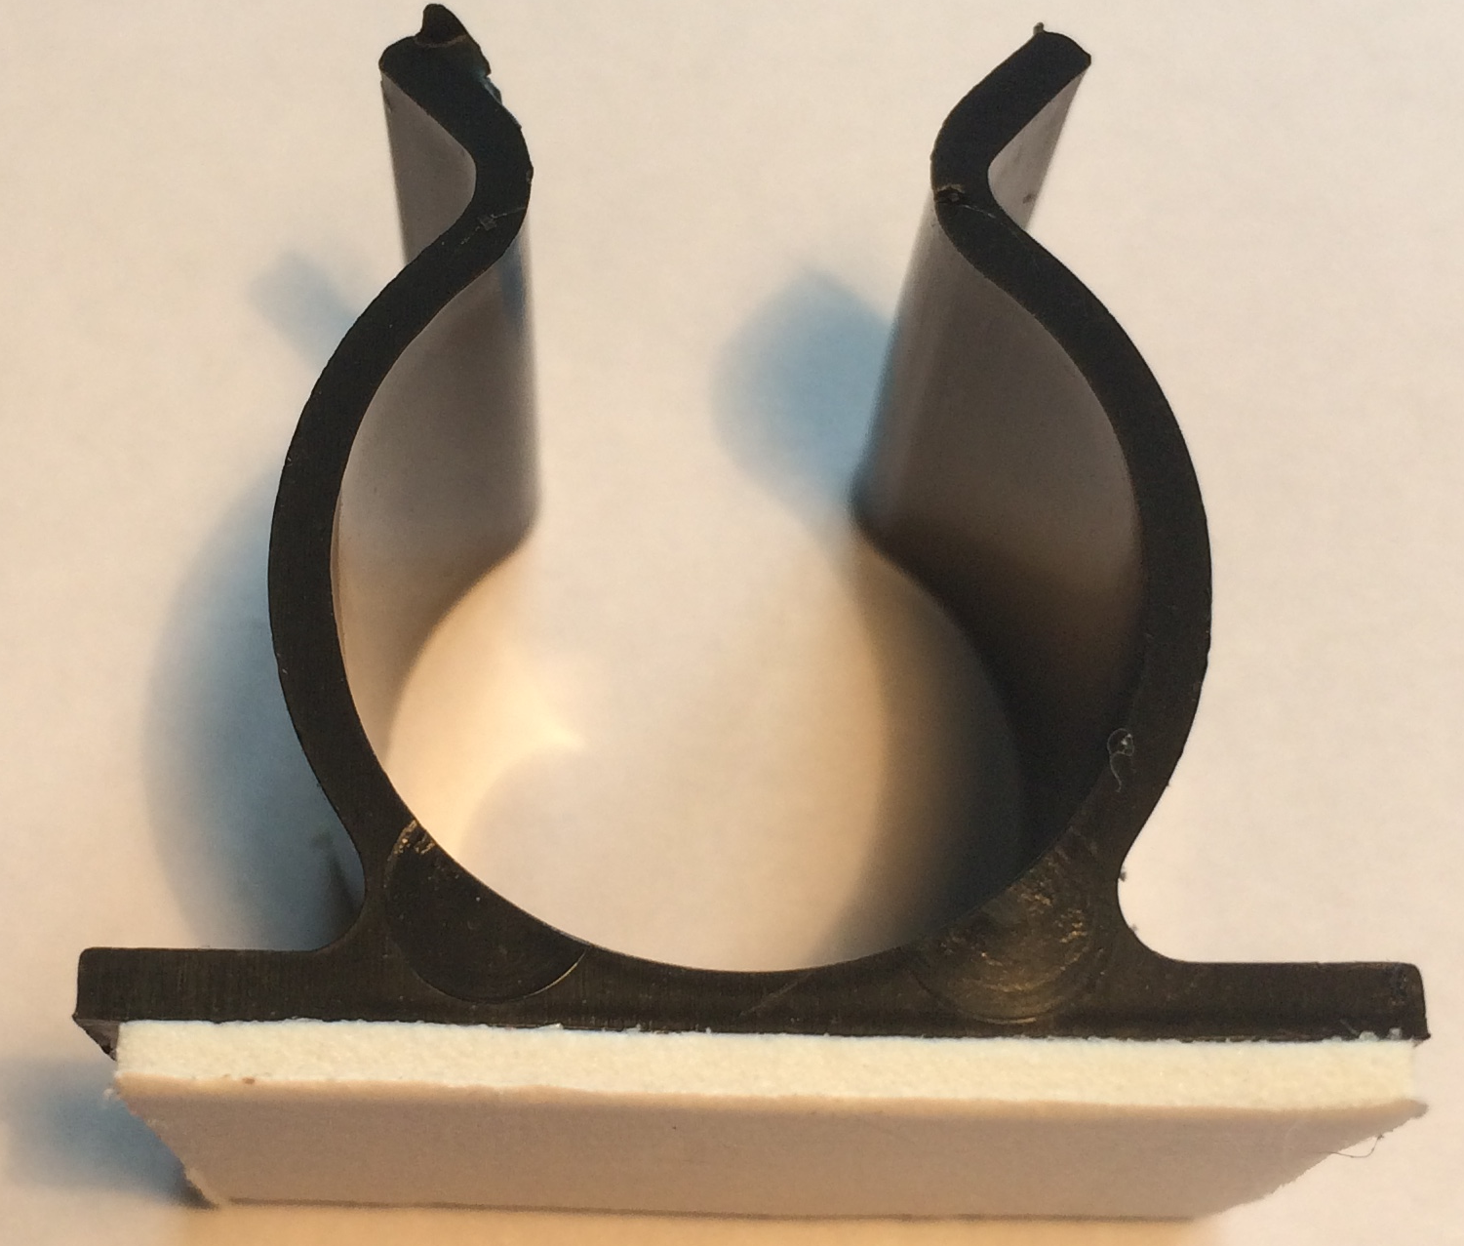 | Used to fix a motor or a syringe in position. NOTE: you will need the insert to connect a syringe. | Each | 4 Faradays
Gear attachment for motor | 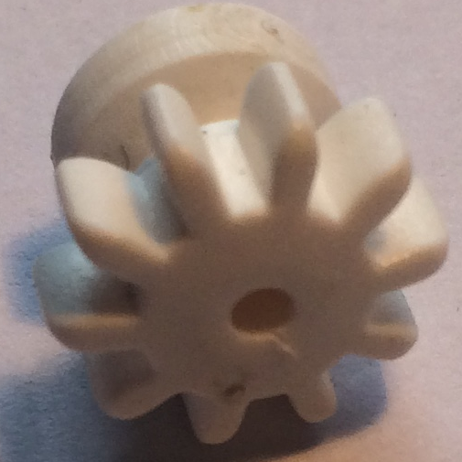 | Used to connect a motor to a cog | Each | 2 Faradays

Pulley attachment for motor | 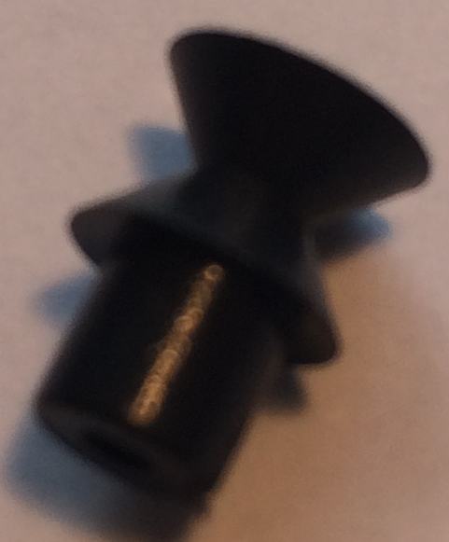 | Used to connect a motor to a pulley wheel – will need connector (e.g. elastic band) | Each | 2 Faradays
Light Dependent Resistor | 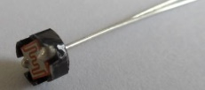 | Component that detects the light level and changes resistance in a circuit. | Each | 8 Faradays
Moisture sensor | 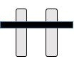 | Component which detects moisture in the surroundings. Can also be used to detect materials which conduct electricity. | Each | 8 Faradays
Potentiometer | 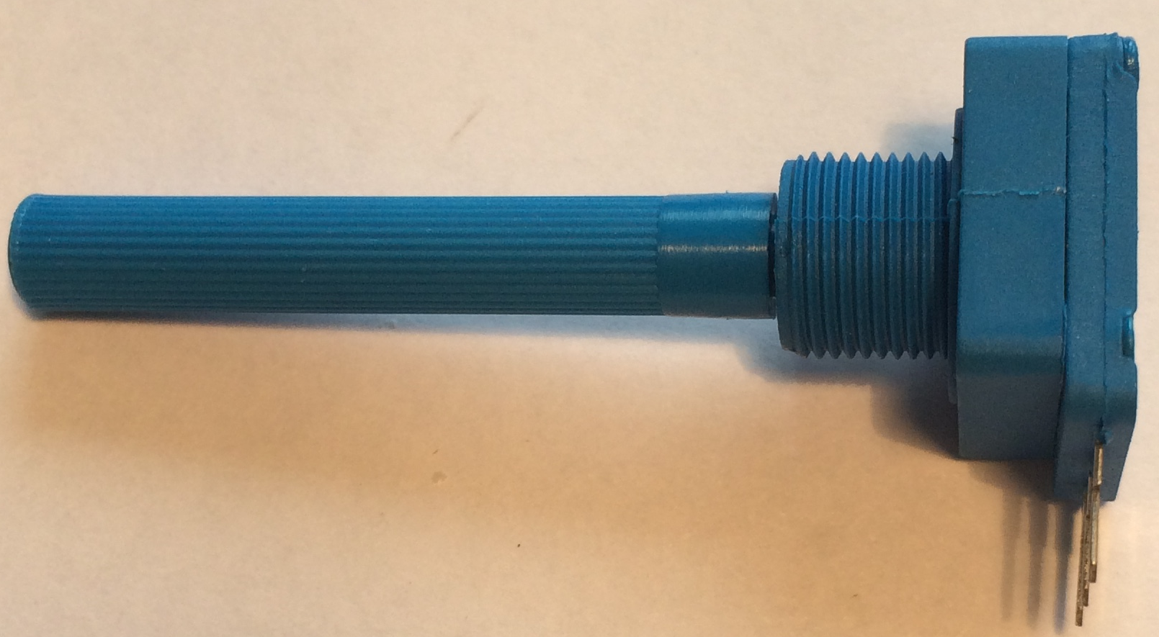  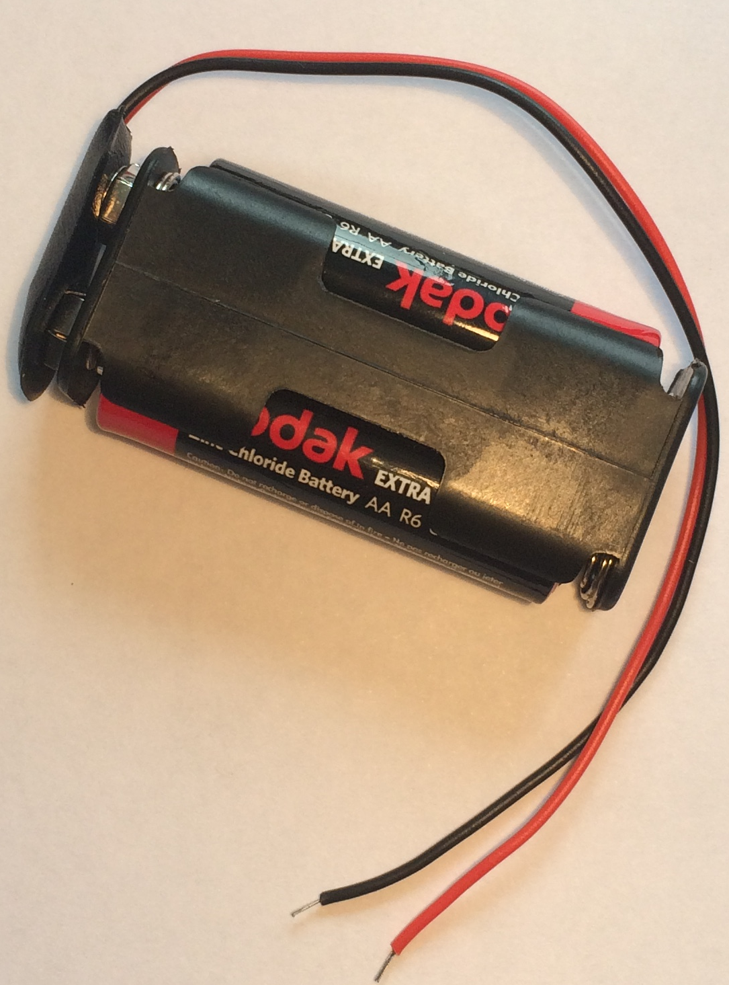 | Can be used to vary the resistance in a circuit | Each | 8 Faradays
2AA cells in battery holder with battery snap |  | Used to provide power for your circuit | Each | 6 Faradays
Push button switch | 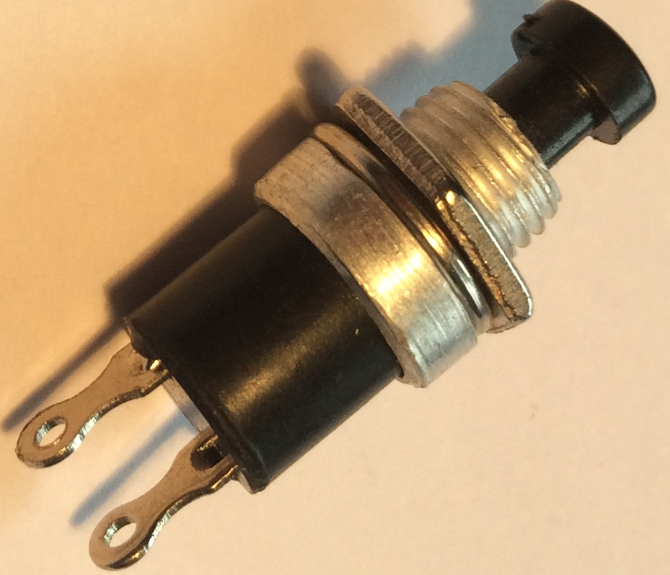 | Connects a circuit when pushed down and breaks the circuit when released. | Each | 6 Faradays

Construction materials
Item | Description | Unit |  | Cost
Correx | Used to create structures | Piece |  | 6 Faradays
Plastic syringes with tube | Used to develop pneumatic system | Pair of syringes with plastic tube | 8 Faradays
Nail | Used to build an electro-magnet | Each | 2 Faradays
Small cog | Used in gear systems with motors | Each | 2 Faradays
Medium cog | Used in gear systems with motors | Each | 2 Faradays
Large cog | Used in gear systems with motors | Each | 4 Faradays
Dowel | Piece of solid cylindrical wooden rod used to create structures | Each | 4 Faradays
Straws | Can be used in structures | Each | 2 Faradays
Pulley wheel 54cm | Used to connect to pulley attachments on motor | Each | 6 Faradays
Wooden wheel 54cm | Used with motors to drive something | Each | 4 Faradays
Plastic reel | Used in construction | Each | 4 Faradays
Polyfoam | A5 foam sheet – assorted colours | Each | 4 Faradays
Coloured card | A4 sheet of card – assorted colours | Each | 4 Faradays
Tin foil | A conductive material which can be used to make pressure pads or switches (MUST NOT be used in place of connecting wires) | 10cm strip | 6 Faradays
Masking tape | Can be used to secure light parts in your design. NOTE: excessive use of tape will result in an additional charge | Roll | 6 Faradays
Sponge | Can be used to make pressure switches or enhance your design. | Each | 6 Faradays
Paperclip | Used to create switches or in construction | Each | 1 Faraday
Paper fastener | Used to create switches or in construction | Each | 1 Faraday
Elastic bands | Used to hold or create working parts | Each | 1 Faraday
Cable ties | Can be used to hold your structures in place | Each | 2 Faradays
Green wire | Used to connect structures (MUST NOT be used in your electrical circuit) | 20 cm piece | 4 Faradays
String | Can be used as part of your product design | 30cm piece | 4 Faradays
Access card | Use this to collect various items from the shop – see next page | One per team | 6 Faradays

Available with your access card
These items can be used with your access card. You will need to take it to the shop to get use of one of these items. You may only get one item at a time.

Stapler | Used to staple soft materials only
Hole punch | Used to make small holes in soft materials
Rulers | Used to measure any part of your product or additional items
Scissors | Used for soft materials only
Screwdriver | Used to connect insulated wire in terminal blocks or to bulb holders.
Wire strippers | Used to cut or strip insulated wire.

Free to use

The cutting station – craft knives and junior hacksaws may be used at any point BUT only 3 people will be allowed at this station at any one time. Please take care when using this equipment.

5. Assessment information and criteria

Criteria | Marks
- Planning | 12 marks
- Development of product | 27 marks
- Use of budget | 10 marks
- The product | 21 marks
- The presentation | 15 marks
- Teamwork | 15 marks
Total | 100 marks

- Planning (12 marks)
Using the planning and product design section of the Planning and Reflections sheet, marks will be awarded as follows:
- Were there three relevant ideas for the attraction? (6 marks)
- Did they explain how their ideas might meet Thorpe Park’s considerations and restrictions? (6 marks)

- Development of product (27 marks)

Using the Project Design, observations of the team and Reflections 1 and 2 of the Planning and Reflections sheet, marks will be awarded as follows:

- Did they produce a detailed drawing of their product including the electric circuit?
(3 marks)
- Did they explain how their product meets the Thorpe Park brief? (4 marks)
- Did they provide honest and accurate observations relating to teamwork? (5 marks)
- Did they provide honest and accurate observations relating to problems? (5 marks)
- Did they provide honest and accurate observations relating to solutions? (5 marks)
- Was the team flexible in their approach to their developments? (5 marks)

- Use of budget (10 marks)
Using the accountancy sheet, marks will be awarded as follows:
- Was there an accurate record of spending? (4 marks)
- Was the budget used effectively? (6 marks)

4. The product (21 marks)
Using the presentation of your attraction, marks will be awarded for:

- Was the concept of their attraction relevant to the brief? (4 marks)
- Did the product comply with Thorpe Park restrictions and considerations? (4 marks)
- Did the product work? (9 marks)
- Was the product completed as far as possible? (4 marks)

5. The presentation (15 marks)
Using the presentation of your products, marks will be awarded as follows:

- Did the team explain the reasons for selecting their development idea? (3 marks)
- Did the team effectively demonstrate their product? (3 marks)
- Did the team explain how they used their engineering knowledge and skills during the project? (3 marks)
- Did the team explain how they used their roles effectively? (3 marks)
- Was the presentation well organised and rehearsed? (3 marks)

- Teamwork (15 marks)
Using the judges’ observations of your team throughout the day, marks will be awarded as follows:

- Did the team work well together with all members engaged in the project? (5 marks)
- Did the team work tidily and safely? (5 marks)
- Did the team use resilience and perseverance during the project? (5 marks)

4. The product (21 marks)
Using the presentation of your attraction, marks will be awarded for:

- Was the concept of their attraction relevant to the brief? (4 marks)
- Did the product comply with Thorpe Park restrictions and considerations? (4 marks)
- Did the product work? (9 marks)
- Was the product completed as far as possible? (4 marks)

5. The presentation (15 marks)
Using the presentation of your products, marks will be awarded as follows:

- Did the team explain the reasons for selecting their development idea? (3 marks)
- Did the team effectively demonstrate their product? (3 marks)
- Did the team explain how they used their engineering knowledge and skills during the project? (3 marks)
- Did the team explain how they used their roles effectively? (3 marks)
- Was the presentation well organised and rehearsed? (3 marks)

- Teamwork (15 marks)
Using the judges’ observations of your team throughout the day, marks will be awarded as follows:

- Did the team work well together with all members engaged in the project? (5 marks)
- Did the team work tidily and safely? (5 marks)
- Did the team use resilience and perseverance during the project? (5 marks)

