The IET

James Webb Space Telescope

Teacher Handbook

Could you be our engineer….?

The IET DIY Faraday Challenge Day ‘James Webb Space Telescope’ is based on the Faraday Challenge Day of the same name, a STEM activity day written and delivered by the Institution of Engineering and Technology (IET).

The IET Education website hosts a wide range of teaching resources for science, design and technology and maths. These include classroom activities with film clips, online games, posters, careers resources and STEM activity days.

The Institution of Engineering and Technology
IET Education 5-19
Michael Faraday House
Six Hills Way Stevenage
Herts
SG1 2AY
United Kingdom
T: +44 (0)01438 767653
F: +44 (0)01438 765526

The Institution of Engineering and Technology is registered as a Charity in England & Wales (no 211014) and Scotland (no SC038698)

Stay safe
Whether you are a scientist researching a new medicine or an engineer solving climate change, safety always comes first. An adult must always be around and supervising when doing this activity. You are responsible for:

- ensuring that any equipment used for this activity is in good working condition
- behaving sensibly and following any safety instructions so as not to hurt or injure yourself or others

Please note that in the absence of any negligence or other breach of duty by us, this activity is carried out at your own risk. It is important to take extra care at the stages marked with this symbol: ⚠

Contents

- The context 4
- The brief 5
- Checklist 6
- Shop resources 7
- Suppliers 11
- Schedule of the day 12
- Room layout 13
- Assessment matrix 14
- Assessment criteria 15
- Risk Assessment 17

Context
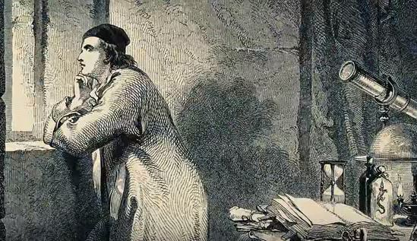
Since the beginning of humankind we have been fascinated by our night skies. When Galileo pointed his telescope to the sky in 1610 and introduced us to the wonders of Saturn’s rings and the moons of Jupiter our ideas about the natural world changed forever.

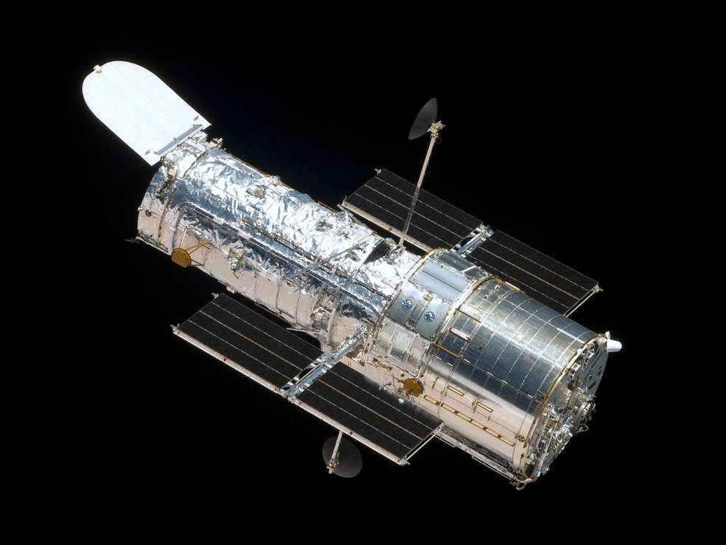
The launch of the Hubble telescope in 1990 allowed us a unique insight in to such wonders as the birth and death of stars and evolution of the galaxies. After over 18 years in space, however, it is now to be joined by the James Webb Space Telescope (or Webb for short), which will allow us to see far deeper into the universe than ever before.

Its development has not been easy. Involving countries around the world, including the United Kingdom, it has presented engineers with many challenges along the way. From keeping parts clean and dust free during development, to transporting the telescope, or parts of it, around the world, to its deployment and operation in space, engineers have had to work together to solve many problems. Webb’s mission will last approximately 10 years and we are looking for engineers to join our team in the future.
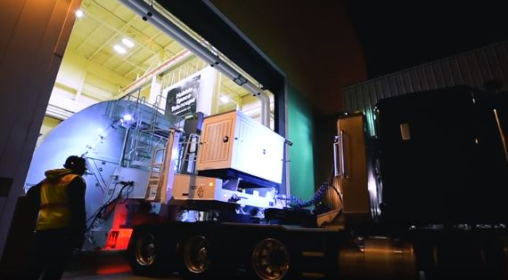
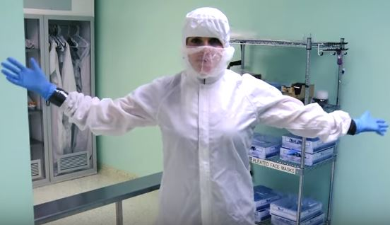

Your brief is provided in the letter from Tim Peake. You will need to demonstrate the skills and attitudes we are looking for so:

- be creative;
- plan carefully;
- work within the resources and the budget available;
- be realistic about what is achievable in the time available;
- be resilient and persevere with problems;
- record your thinking;
- keep to strict deadlines

Today is your chance to make a difference, could you be our engineer..........?

IET Faraday Challenge Day 2018-19
Engineer Brief
Hi Engineers,

Congratulations on being selected as a future engineer for the James Webb Space Telescope. I have seen the wonders of space and want you to be part of our team but you will need to demonstrate whether you have the skills to be one of our engineers of the future.

The brief:
As you have seen, engineers have been involved at all steps along the journey of the James Webb Space Telescope. We want your team to choose an area to work on to demonstrate you have the skills required.

You might choose from the following but feel free to choose another area if you think it will help with our engineering mission.
- The places in which parts of the telescope are built or assembled, such as the clean rooms.
- The ways in which we keep our engineers comfortable, safe and happy whilst they are involved with the project.
- The ways in which parts of the telescope are transported to the different sites for assembly and testing.
- Equipment which may help with the launch of the telescope e.g. launch site, rocket, alerts.
- Deployment of the telescope in space, such as unfolding each section or powering the telescope.
- The ways in which the telescope focuses light by moving the hexagonal sections of the primary mirror or analyses light to study the atmospheres of planets around nearby stars.
Once you have chosen your area you will need to:
- Engineer one aspect to help the team. Your design must include an electric circuit and should be designed as a working prototype.
- ecord your work progress by reporting on the problems, solutions and the ways in which your team has worked together.
- Present your prototype to the representatives of the James Webb Space Telescope team.
Good luck engineers!

Tim Peake

Checklist

Student tables | Notes
Team number sign (laminated) | 1 per table in plastic stand
Student team registration form | 1 per student table
Student booklet | 1 per table
Accounts sheet | 1 per table
A3 Planning and Reflections sheet | 1 per table
A3 JWST ideas sheet (laminated) | 1 per table
Team roles and responsibilities (laminated) | 1 per table on clipboard (printed back to back)
Engineering Apprenticeship (laminated)
Name badge stickers | 6 role stickers (1 sheet) per table
Faraday branded currency | Each team - 1 x 20F, 6 x 10F, 6 x 5F, 10 x 1F = F120.00
Engineering apprenticeship pack | 1 per table – box contains 2AA battery pack with battery snap, 3 x crocodile leads, piezo buzzer and push button switch.
Challenge Leader | Notes
Presentation - hard and soft copy | Best to bring on your own laptop and presentation and video on a memory stick
Clicker for PowerPoint presentation | Carry spare batteries
Assessment matrix | 1 per event
Clipboard | For hard copy of presentation, assessment matrix, etc.
A4 plain paper | Up to 3 sheets free per team for presentation notes
Prizes (if required) | Schools to provide
Certificates | 1 per student
Shop | Notes
Shop manager account sheet | 1 per event - Put on a clipboard
Shop manager resources list | Laminated sheets on clipboard
Shop keeper instructions | 2 x laminated sheet to give to shop keepers as briefing for role
Faraday branded currency | Shop change – 2 x 20; 10 x 10; 20 x 5; 20 x 1
All shop items with price tags
Signage | Notes
Shop
Cutting station rules
Bargain bin | Use cardboard box or similar when you have enough spare items

4. Shop resources

Items to buy

Electrical components
Item | Description |  | Unit | Cost
Crocodile leads | 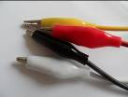 | Lead with crocodile clips at each end | Each | 4 Faradays
Insulated wire – red or black | 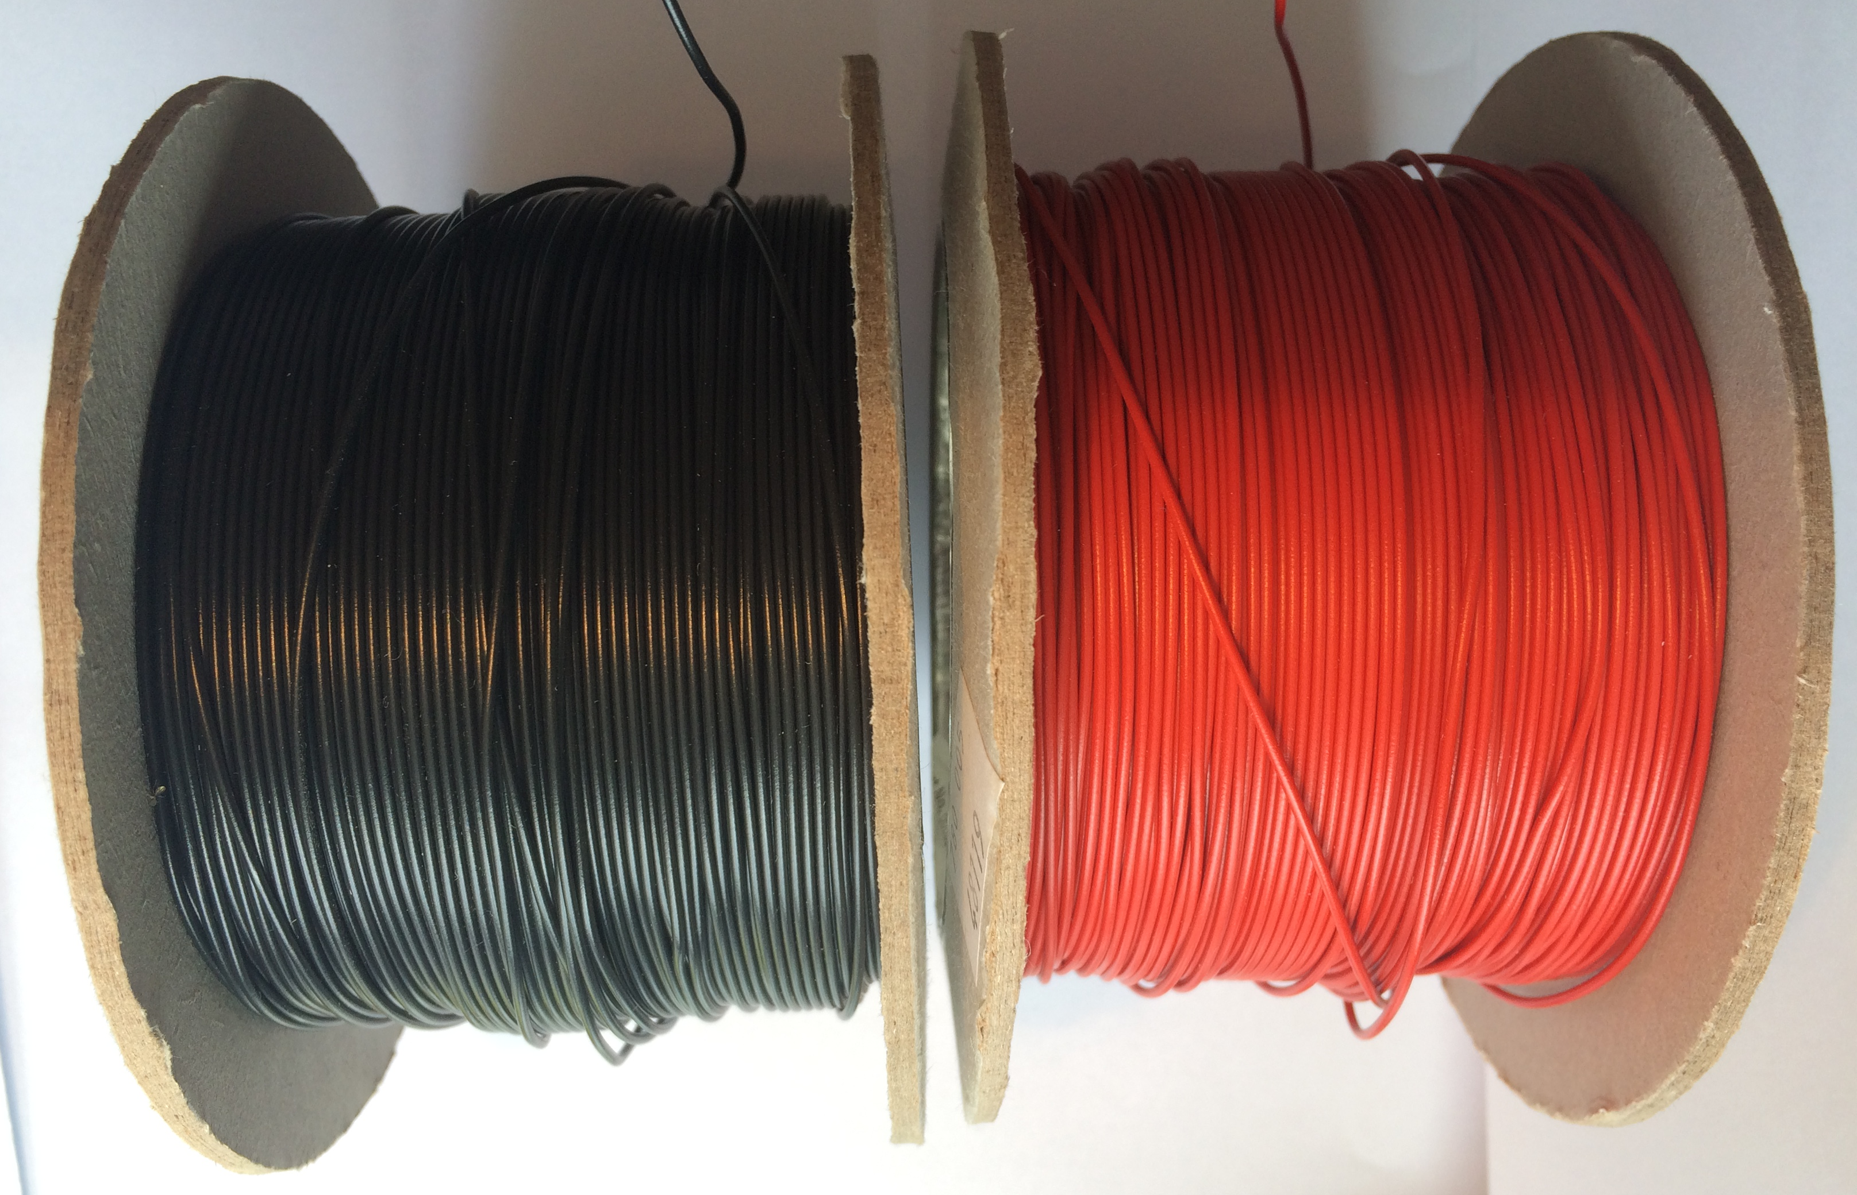 | Can be used to create a circuit using terminal blocks or used for electro-magnets | Per 30 cms | 2 Faradays
Terminal blocks | 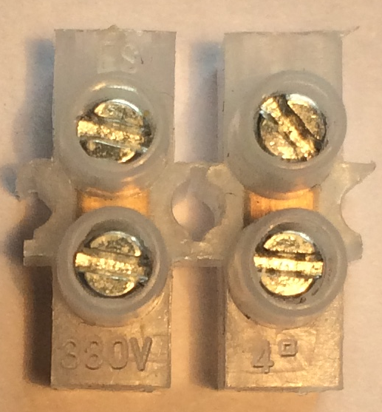 | Can be used to connect insulated wire | Block of 4 | 2 Faradays
Crocodile clips | 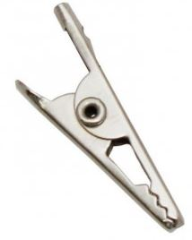 | Used with the insulated wire to create connections | Pair | 1 Faraday
Piezo buzzer | 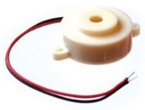 | Connect in a circuit to give a sound output | Each | 6 Faradays
LED – various colours | 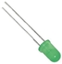 | Light Emitting Diode which lights up when connected in a circuit. Choose from red, orange, green or blue. | Each | 6 Faradays
2.5V Bulb with bulb holder | 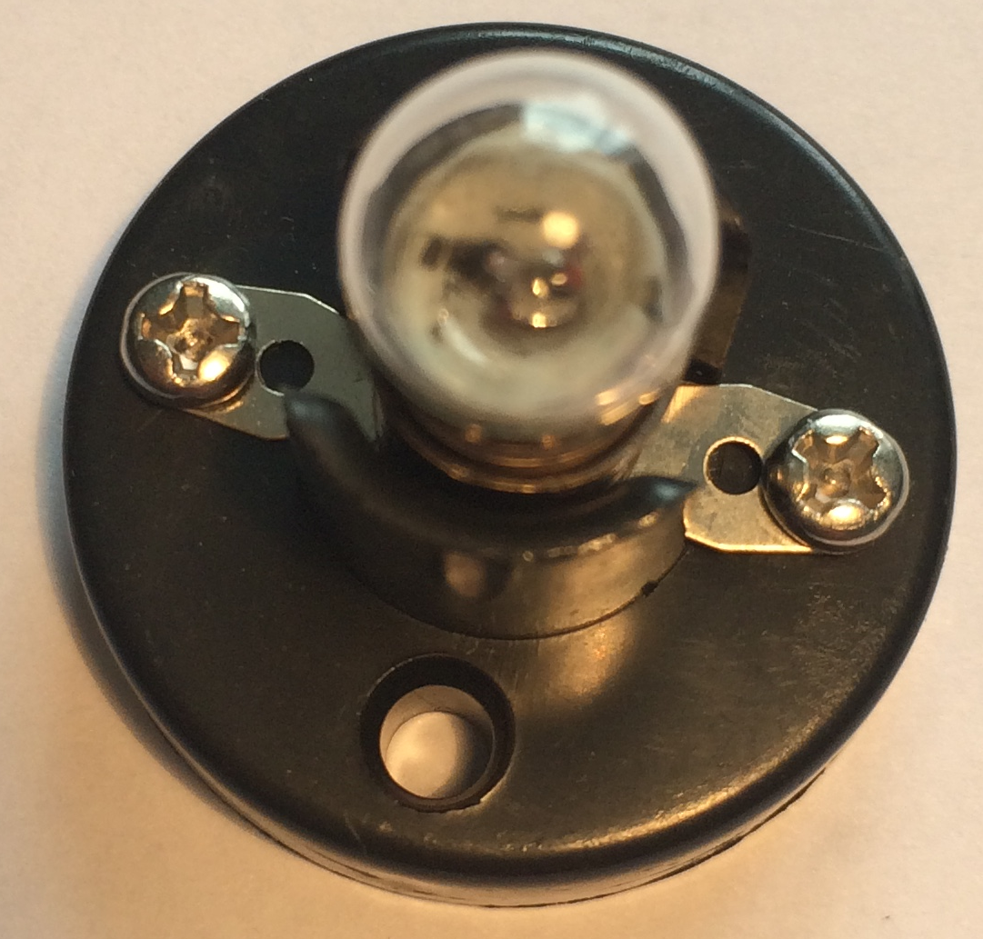 | Used as a light in a circuit. NOTE: Will not work with an LDR | Each | 6 Faradays
Motor | 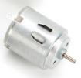 | Connect in a circuit to create clockwise or anti-clockwise movement. Will not work with a solar panel or an LDR. | Each | 6 Faradays
Solar motor | 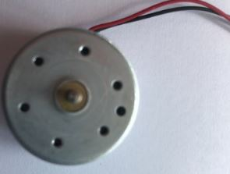 | Connect to a solar panel to create clockwise or anti-clockwise movement | Each | 6 Faradays

Servo motor |  | 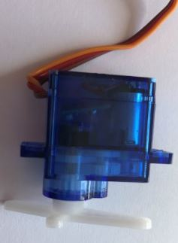 | Use with a servo motor control unit to have automatic movement to degrees or continuous control through 90^{O} |  | Each |  | 6 Faradays
Light Dependent Resistor (LDR) |  | 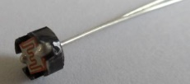 | Component that detects the light level and changes resistance in a circuit. |  | Each |  | 8 Faradays
Push button switch |  | 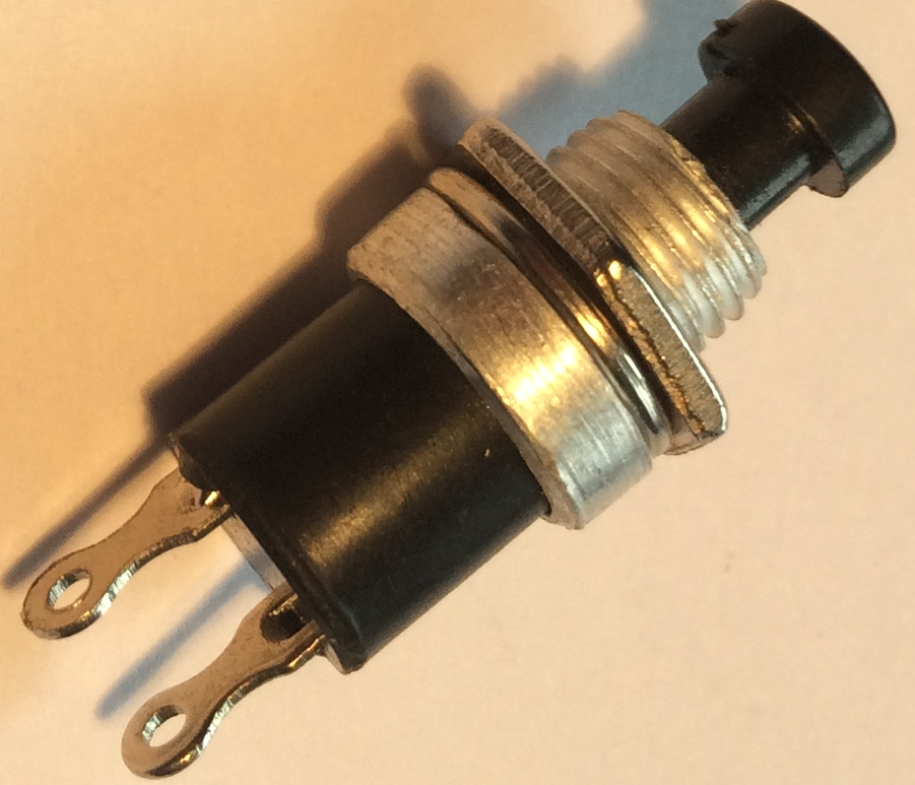 | Connects a circuit when pushed down and breaks the circuit when released. |  | Each |  | 6 Faradays
Moisture sensor |  | 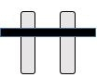 | Component which detects moisture in the surroundings. Can also be used to detect materials which conduct electricity. |  | Each |  | 8 Faradays
Servo motor control unit |  | 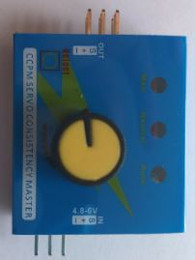 | Use this to control a servo motor. You MUST read the ‘How to …’ sheet before connecting this component. |  | Each |  | 8 Faradays
Motor holder |  | 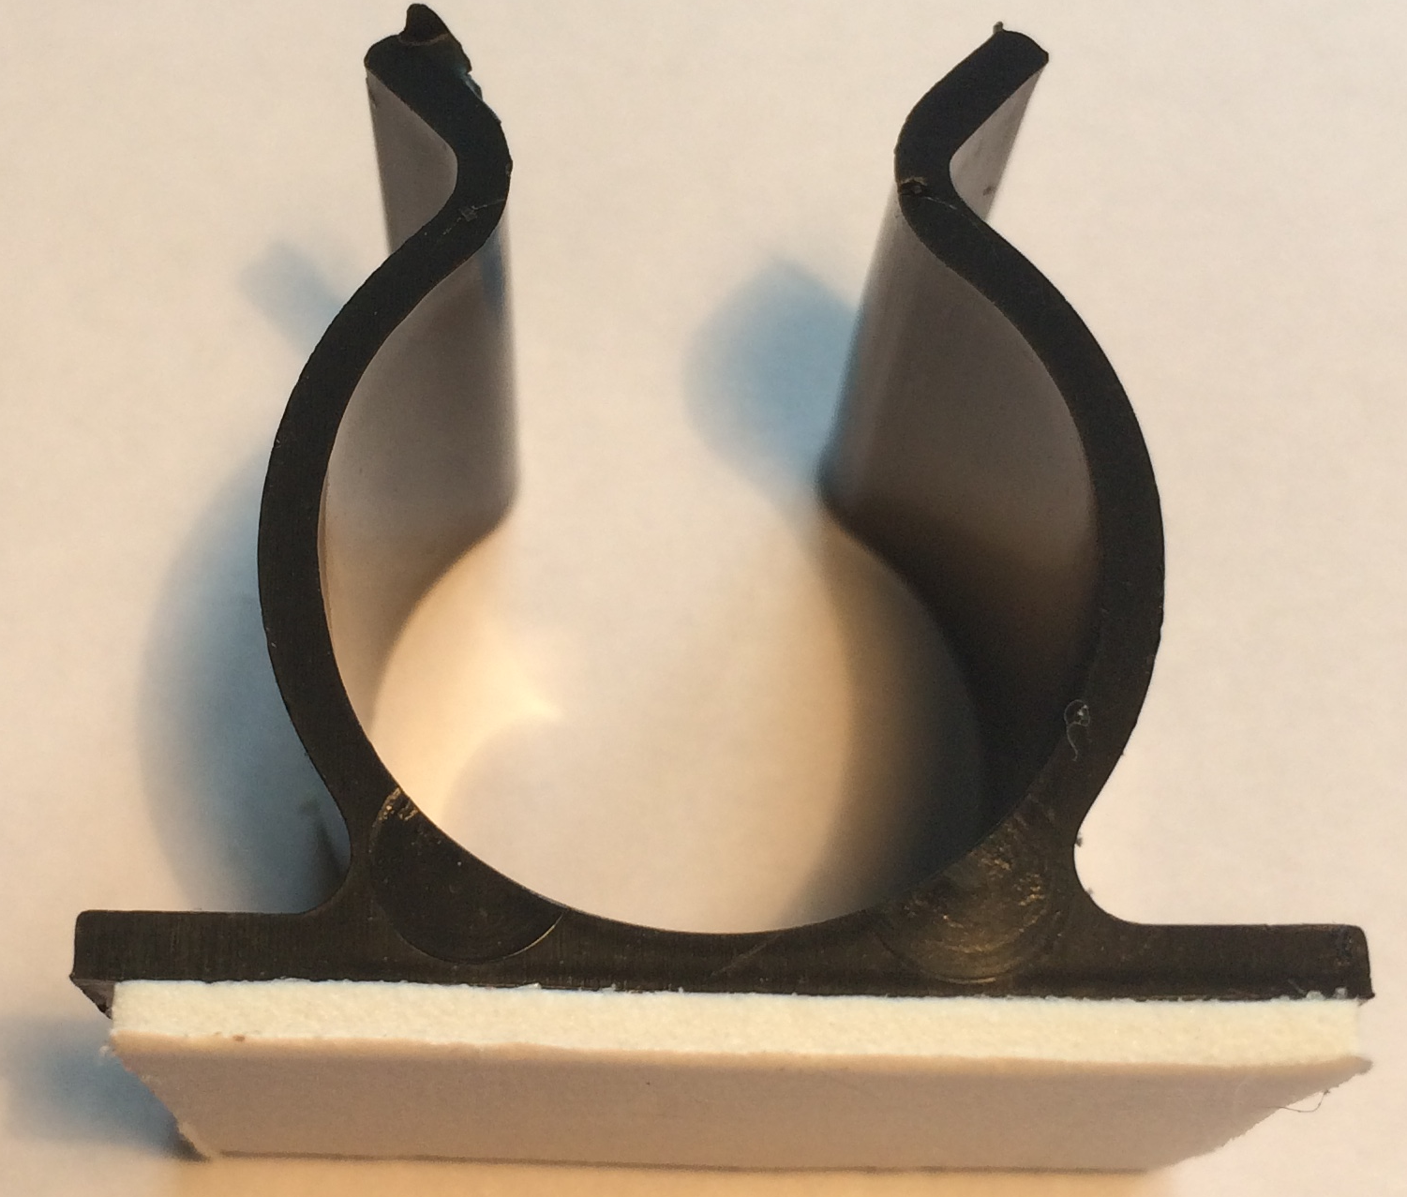 | Used to fix a motor or a syringe in position. NOTE: you will need the insert to connect a syringe. |  | Each |  | 4 Faradays
Gear attachment for motor |  | 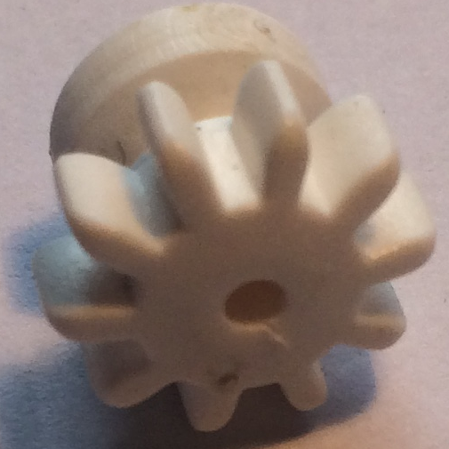 | Used to connect a motor to a cog |  | Each |  | 2 Faradays
Pulley attachment for motor |  | 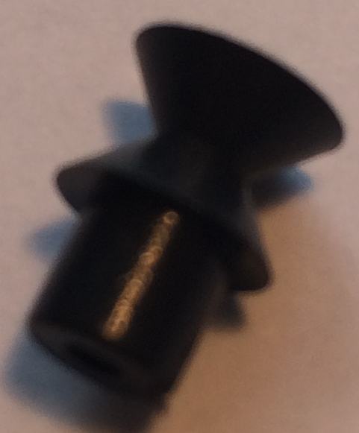 | Used to connect a motor to a pulley wheel – will need connector (e.g. elastic band) |  | Each |  | 2 Faradays
Solar panel |  | 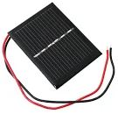  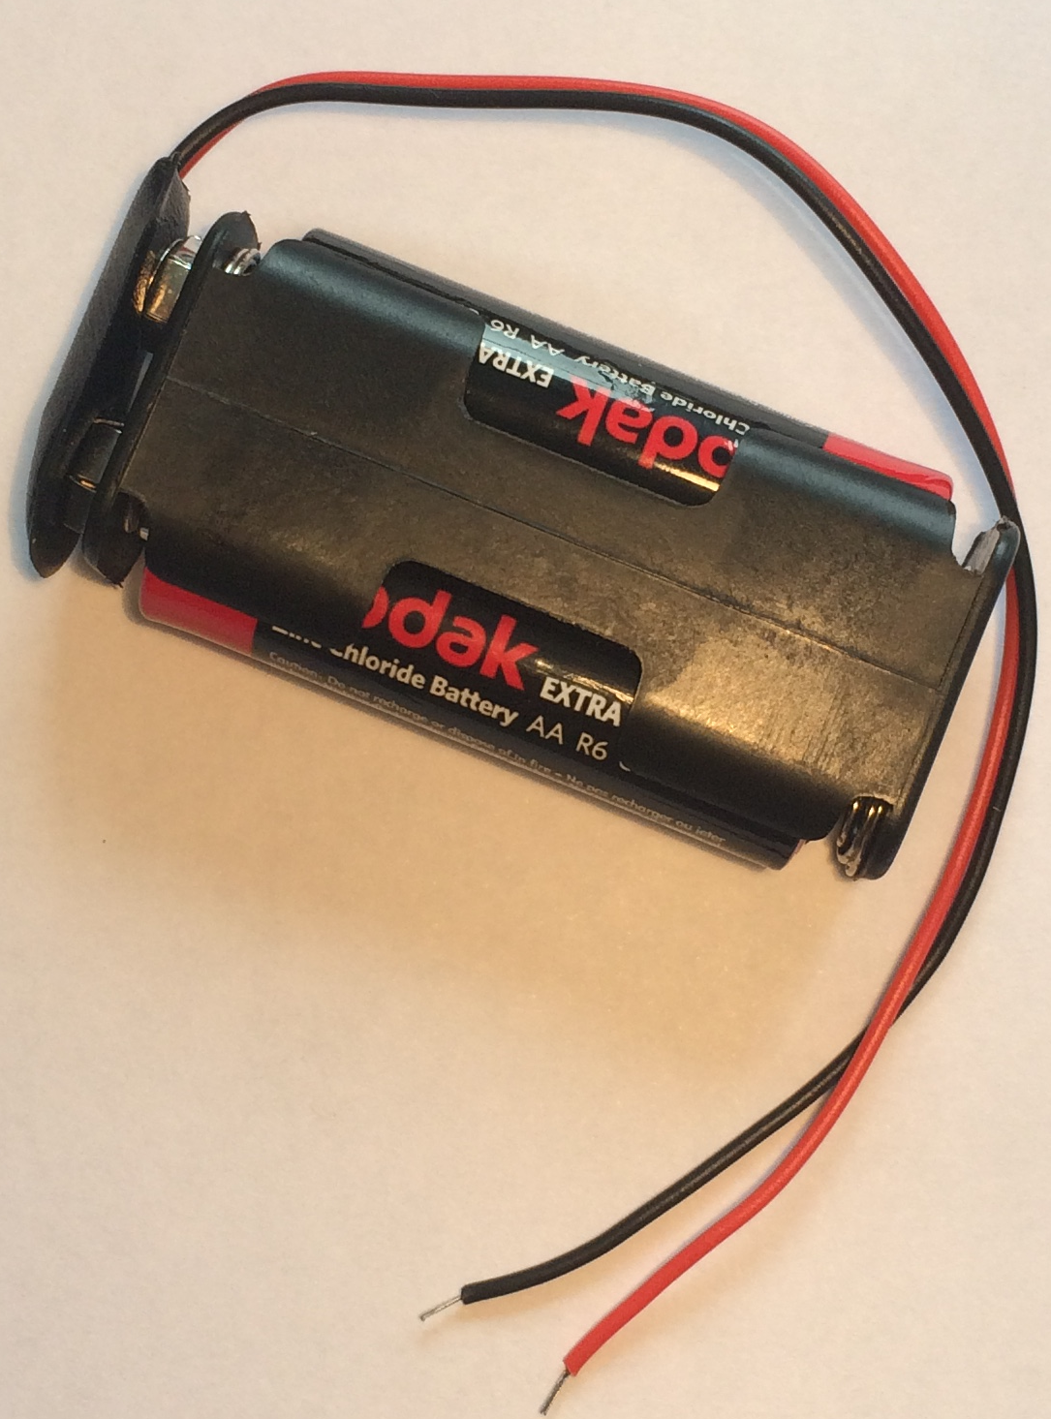 | Used to power components using the power of the sun. You MUST read the ‘How to …’ sheet before connecting this component. |  | Each |  | 6 Faradays
2AA cells in battery holder with battery snap |  |  | Used to provide power for your circuit |  | Each |  | 4 Faradays
4 AA cells in battery holder with jumper leads |  | 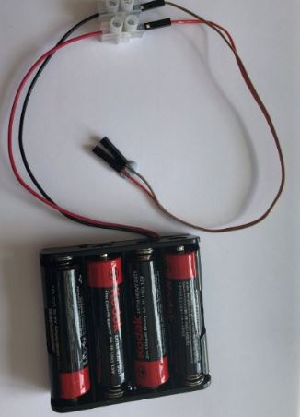 | ONLY to be used with servo motor tester. DO NOT use with LEDs |  | Each |  | 6 Faradays
Construction materials
Item | Description |  |  | Unit |  |  | Cost
Correx | Used to create structures |  |  | Piece |  |  | 6 Faradays
Plastic syringes with tube | Used to develop pneumatic system |  |  | Pair of syringes with plastic tube |  | 6 Faradays
Small cog | Used in gear systems with motors |  |  | Each |  | 2 Faradays
Medium cog | Used in gear systems with motors |  |  | Each |  | 2 Faradays
Large cog | Used in gear systems with motors |  |  | Each |  | 4 Faradays
Dowel | Piece of solid cylindrical wooden rod used to create structures |  |  | Each |  | 4 Faradays
Pulley wheel 54cm | Used to connect to pulley attachments on motor |  |  | Each |  | 6 Faradays
Wooden wheel 54cm | Used with motors to drive something |  |  | Each |  | 4 Faradays
Plastic reel | Used in construction |  |  | Each |  | 4 Faradays
Polyfoam | A5 foam sheet – assorted colours |  |  | Each |  | 4 Faradays
Coloured card | A4 sheet of card – assorted colours |  |  | Each |  | 4 Faradays
Tin foil | A conductive material which can be used to make pressure pads or switches (MUST NOT be used in place of connecting wires) |  |  | 10cm strip |  | 6 Faradays
Masking tape | Can be used to secure light parts in your design. NOTE: excessive use of tape will result in an additional charge |  |  | Roll |  | 6 Faradays
Sponge | Can be used to make pressure switches or enhance your design. |  |  | Each |  | 6 Faradays
Paperclip | Used to create switches or in construction |  |  | Each |  | 1 Faraday
Paper fastener | Used to create switches or in construction |  |  | Each |  | 1 Faraday

Elastic bands | Used to hold or create working parts, including driving pulley wheels | Each | 1 Faraday
Cable ties | Can be used to hold your structures in place | Each | 2 Faradays
String | Can be used as part of your product design | 30cm piece | 4 Faradays
Hire Centre Trade Card | Use this to hire various items from the hire section of the shop – see below for details | One per team | 6 Faradays

Available with your Hire Centre Trade Card

These items can be hired from the shop if you buy a Hire Centre Trade Card. You will need to take it to the shop and show the shopkeeper each time you want to use of one of these items. You may only get one item at a time.

Stapler | Used to staple soft materials only
Hole punch | Used to make small holes in soft materials
Rulers | Used to measure any part of your product or additional items
Scissors | Used for soft materials only
Screwdriver | Used to connect insulated wire in terminal blocks or to bulb holders.
Wire strippers | Used to cut or strip insulated wire.

Free to use

The cutting station – craft knives and junior hacksaws may be used at any point BUT only 3 people will be allowed at this station at any one time. Please take care when using this equipment.

5. Suppliers
The suppliers listed were used for the 2018-19 Faraday Challenge Day season. Suppliers are not provided for general items which were sourced at a variety of shops, including Poundland and supermarkets.

Item | Cost
Crocodile leads | Kitronik - www.kitronik.co.uk/2407-crocodile-leads-pack-of-10.html
Insulated wire – red or black | TTS - www.tts-group.co.uk/connecting-wire/1003736.html
Terminal blocks | Kitronik - www.kitronik.co.uk/2410-12-way-terminal-block-pack-of-10.html
Crocodile clips | Kitronik - www.kitronik.co.uk/2470-28mm-crocodile-clips-pack-of-50.html
Piezo buzzer | Kitronik - www.kitronik.co.uk/c3301-piezo-buzzer-with-drive.html
LED – red | RS - https://uk.rs-online.com/web/p/visible-leds/2285988/?sra=pstk
LED – green | RS - https://uk.rs-online.com/web/p/visible-leds/2471678/?sra=pstk
LED – orange | RS - https://uk.rs-online.com/web/p/visible-leds/2285994/?sra=pstk
LED - blue | RS - https://uk.rs-online.com/web/p/visible-leds/8614418/?sra=pstk
Bulb holder | TTS - www.tts-group.co.uk/simple-bulb-holders/1003743.html
2.5V bulbs | TTS - www.tts-group.co.uk/m.e.s-round-screw-light-bulbs/1003742.html
Motor | Kitronik - www.kitronik.co.uk/c2501-motors-medium-torque.html
Solar motor | Kitronik - www.kitronik.co.uk/2546-low-inertia-solar-motor-1000-rpm.html
Servo motor | Kitronik - https://www.kitronik.co.uk/2565-180-mini-servo.html
Light Dependent Resistor (LDR) | Kitronik - www.kitronik.co.uk/c3515-standard-ldr.html
Push button switch | Kitronik - www.kitronik.co.uk/c3401-miniature-push-to-make-switch-red.html
Moisture sensor | These were made using small nails and a small rectangle of plywood
Servo motor control unit | Can get these from ebay, we used:  UMT media - www.umtmedia.com/products/multi-servo-tester-3ch-ecs-consistency-speed-controler-power-channels-ccpm-ty?variant=58674806804
Motor holder | TTS - www.tts-group.co.uk/motor-mounting-clips/1003735.html
Gear attachment for motor | TTS - www.tts-group.co.uk/plastic-gears-for-motor-20pk/1000432.html

Pulley attachment for motor | TTS - www.tts-group.co.uk/small-plastic-pulleys-10pk/TP-10.html
Solar panel | Kitronik - www.kitronik.co.uk/3604-30v-100ma-polycrystalline-solar-cell.html
2AA cells in battery holder | TTS - www.tts-group.co.uk/2-x-aa-battery-holders-pack/1003710.html
Battery snap | TTS - www.tts-group.co.uk/electrical-battery-snaps/1003717.html
4 AA cells battery holder | Rapid - www.rapidonline.com/keystone-2478-battery-holder-for-4-x-aa-and-flying-leads-18-3695
jumper wires | Kitronik - www.kitronik.co.uk/c4128-jumper-wires-premium-mf.html
Correx | TTS - www.tts-group.co.uk/corrugated-plastic-sheets-500-x-500mm/1000487.html
Plastic syringes with tube | TTS - www.tts-group.co.uk/plastic-syringe-packs/1003942.html  Tube was bought at fish and aquarium shop
Small cog | TTS - www.tts-group.co.uk/assorted-plastic-gears-60pk/1003641.html
Medium cog
Large cog
Dowel (5mm) | TTS - www.tts-group.co.uk/wooden-dowel-packs/1000318.html
Pulley wheel 54cm | TTS - www.tts-group.co.uk/wooden-pulleys-10pk/1000445.html
Wooden wheel 54cm | TTS - www.tts-group.co.uk/wooden-wheel-packs/1000483.html
Plastic reel | TTS - www.tts-group.co.uk/plastic-cotton-reels/1000429.html
Polyfoam | Hobbycraft
Coloured card | Hobbycraft

6. Schedule of the day

08:00 | Challenge Leader arrives to set up
09:15 | Register your team
09:30 | Welcome and introduction
09:50 | Project brief: Introduction to the Faraday Challenge
10:10 | Planning: Identifying the problems and generating initial ideas
10:25 | Team role selection: team decides on which roles they need
10:30 | Engineering apprenticeship: teams complete a short engineering task ⚠
10:40 | Development ⚠  - Shop opens  - Agree on final product designs
11:00 | Break
11:10 | Development continues ⚠  - Continue to design and modify where necessary  - Record progress in event log
12:00 | Teams are briefed on the content of the presentation
12:30 | Lunch – Tools down
13:00 | Development: Final preparations ⚠  - Finalise product  - Prepare presentation with notes
13:30 | - Shop closes  - Submit accounting sheet to the Shop keeper  - Practise presentation
13:50 | Presentation ⚠  - Teams present their designs to the judge(s)
14:45 | Award ceremony with final feedback and evaluation of the day
15:00 | Engineering teams depart
15:45 | Challenge Leader departs by this point (actual time depends on pack up requirements)

7. Room/hall layout

Notes:
- Each team table will need 6 chairs and be large enough for 6 students to work comfortably. The judges’ table and shop will each need 2 chairs. Table positions do not need to be exact and can be arranged to best accommodate the shape and size of the venue.
- We recommend you cover the cutting station with cutting mats or a board to protect the surface.
- The shop table should be a minimum of 3 x 0.5 metres or equivalent area.

BACK
Cutting station (with cover/cutting mats)
Shop (at least 3 x 0.5 m)

Team 7 Teachers
Team 3
Team 4

Team 5
Team 2

Presentation table

Refreshments Table
Team 1
Team 6

Judge’s table

8. Marksheet (overview)

Assessment Criteria |  | Team | Team | Team | Team | Team | Team | Team
 |  | 1 | 2 | 3 | 4 | 5 | 6 | 7
Planning | 13
Development of product* | 20
Use of budget | 10
The product* | 27
The presentation | 15
Teamwork* | 15
Total score | 100
Leader decider (see * for priority scores)
Team | School/Team name
1
2
3
4
5
6
7

9. Assessment information and criteria

Criteria | Marks
- Planning | 13 marks
- Development of product | 20 marks
- Use of budget | 10 marks
- The product | 27 marks
- The presentation | 15 marks
- Teamwork | 15 marks
Total | 100 marks

- Planning (13 marks)
Using the planning section of the Planning and Event Log, marks will be awarded as follows:
- Does the planning diagram detail how the prototype will be constructed? (5 marks)
- Have the electronics for the prototype been detailed? (5 marks)
- Did they explain how their ideas might help the Webb telescope mission? (3 marks)

- Development of product (20 marks)

Using the Engineering Event Log and observations of the team, marks will be awarded as follows:

- Have they provided an accurate and informative event log for entry 1? (4 marks)
- Have they provided an accurate and informative event log for entry 2? (4 marks)
- Have they provided an accurate and informative event log for entry 3? (4 marks)
- Are the priorities identified for the last 30 minutes realistic and appropriate?
(4 marks)
- Have the team utilized the time effectively? (4 marks)

- Use of budget (10 marks)
Using the accountancy sheet and the prototype, marks will be awarded as follows:
- Was there an accurate record of spending? (4 marks)
- Was the budget used effectively? (6 marks)

4. The product (27 marks)
Using the presentation of your prototype, marks will be awarded for:

- Did their prototype meet the brief from the Webb telescope team? (3 marks)
- Was the choice of electronic components appropriate for the prototype? (7 marks)
- Was the choice of materials appropriate for the structure and/or mechanics of the prototype? (7 marks)
- Did the judge(s) see the electronics and structure work together effectively as intended? (7 marks)
- Was the product completed as far as possible with the time available used well?
(3 marks)

5. The presentation (15 marks)
Using the presentation of your prototype, marks will be awarded as follows:

- Did the team explain how their idea might support the Webb engineering team?
(3 marks)
- Did the team effectively demonstrate their prototype? (2 marks)
- Did the team explain how they used their engineering knowledge and skills to develop their prototype? (3 marks)
- Did the team identify what was the most challenging engineering aspect they faced during their development? (2 marks)
- Did the team explain what they did well in their teamwork and what they need to develop? (3 marks)
- Was the presentation well-structured? (2 marks)

- Teamwork (15 marks)
Using the judges’ observations of your team throughout the day, marks will be awarded as follows:

- Did the team work well together with all members engaged in the project?
(5 marks)
- Did the team work tidily and safely? (5 marks)
- Did the team use resilience and perseverance during the project? (5 marks)

10. Risk Assessment
The following risk assessment is given as guidance. It is advised that the school refers to the CLEAPSS Model Risk Assessment Documents for D&T.

Risk Assessment and Operating Procedure - IET
Activity: Faraday Challenge Days James Webb Space Telescope
Persons at risk | Students taking part in the Faraday Challenge Day and adults in the location
Maximum Group Size | 36 students | Recommended Staffing/Student Ratio | 1:6
Risk Assessment
Hazards |  | Control Measures
- Use of electrical equipment – risk of electric shock |  | All electrical equipment is low voltage.
- Use of electrical equipment – short circuit causing heating |  | Warn students of the possibility of burns when connecting and disconnecting components. All pupils will receive a briefing about correct use of electrical components.
- Basic use of hand tools (craft knives, screwdrivers, scissors, hole punches, staplers) – risk of cutting or abrasion |  | Warn students of the risks and advise them of safe working practices. Identify member of staff to supervise area. Inform challenge leader if use of knives in school is restricted.
- Use of water with moisture sensors |  | Ensure students test their moisture sensor using the sponge in a box provided rather than directly in any drink or cup of water to avoid spillage on electrical components.
Location issues (to be completed by Host School)
Further Action Required: 1. Ensure all persons staffing the Faraday Challenge Days are aware of and competent to comply with this risk assessment and the control measures.

Risk Assessment (page 2)

Working Practice
Group structure | One Faraday Challenge Day Leader and one member of staff from the host school to be present during the whole day to oversee use of equipment and to keep order. Teachers bringing groups from other schools must remain in the room and be responsible for their own students.
Restrictions | Unknown premises.
Emergency  Procedure | Follow the lead from the Host School.  Faraday Challenge Day Leader to be fully briefed on risk assessment procedure prior to the day or on arrival.
Safeguarding | The Challenge Leader will carry their DBS and provide it where requested. They will comply with the safeguarding regulations within the school. A representative from the school MUST be present in the rooms at all times when students are present.
Safety Equipment | First aid kit and fire extinguisher (electrical fires) to be provided by Host School.
Name and role of IET Faraday Challenge representative | Keira Sewell  Challenge Day Leader.
Name and role of school representative
Signature of the school representative
Date of this Review | June 2018

