Select the Golden Ball recipient
Use fractions, percentages and averages to decide the best footballer
Subject(s): Maths  Approx time: 45 – 60 minutes |  | Key words / Topics:  - Statistics  - Averages  - Comparison  - Fraction  - Percentage  - Proportion  - Difference
Stay safe
Whether you are a scientist researching a new medicine or an engineer solving climate change, safety always comes first. An adult must always be around and supervising when doing this activity. You are responsible for:
• ensuring that any equipment used for this activity is in good working condition
• behaving sensibly and following any safety instructions so as not to hurt or injure yourself or others
Please note that in the absence of any negligence or other breach of duty by us, this activity is carried out at your own risk. It is important to take extra care at the stages marked with this symbol: ⚠
Suggested learning outcomes
- Pupils interpret data in different ways.
- Pupils use a range of strategies to make comparisons between data presented in different ways.
Introduction
Football players are ranked in different ways and there are a variety of awards that they can be rewarded with. Each year the Ballon D’Or is awarded to the player judged to be the ‘best’. The Golden Ball is given to the best player in the World Cup tournament. In this activity, pupils are presented with data and can use it to decide who they consider to be the best footballer.
Purpose of this activity
The purpose of this activity is to explore statistics and to use them to decide on a ranking of football players. Pupils will compare data and use average scores to find ways of comparing data and making decisions.

Activity |  | Teacher notes
Introduction and discussion:  What makes a good footballer?  Give pupils time to discuss this in class (Slide 2).  Activity 1: Looking at the stats  Introduce some of the data for 25 of the top football players in the world. For this first activity, we will look at the data for 10 of the 25. The full set of data will be introduced in Activity 2.  Give pupils time to look at a selection of the data and see what they notice. A selection of the data is presented on Slide 3 and it is all available on Handout 1 and in the spreadsheet.  - Who is ‘the best’ and why?  Ask pupils to decide who they think is ‘the best’ player and why. This discussion is continued with a mathematical focus in Activity 2.  Activity 2: The best footballer  In the first activity, pupils looked at half of the players listed in alphabetical order by first name.  In this activity, the data for all 25 players is presented in this order and pupils must decide on the strategy they are going to use to decide who is ‘the best’.  Is it fair just to look at the number of goals scored? Is that fair to a defender or goalkeeper?  How else might we come to a decision?  The question on Slide 5 prompts the discussion of what we could do with the data to come up with other ways of measuring success.  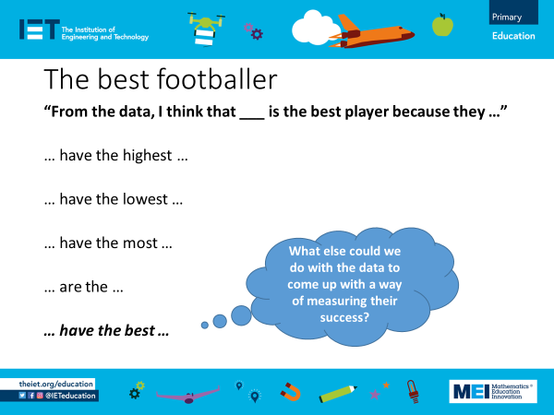  For example:  Comparing the number of international caps with the number of goals scored.  Dividing the number of goals scored by the number of matches to give a scoring rate.  Finding the average of the Pace, Shooting and Defending scores. This calculation has been done on the second sheet in the spreadsheet.  These examples are presented in a concept cartoon on Slide 6 for pupils to discuss if they do come up with these strategies in the lesson, all the better!  Activity 3: Fantasy football  Now is the chance for pupils to pick a team based on their decisions as to who is the best.  They need to make sure that their team includes all the players needed to make a complete team including a goalkeeper (Slide 7).  They can only have a total player average score of up 850 points for their 11 players. They can pick their team based on any other criteria but must keep a total of this score. The average score is the final column on the spreadsheet and in the data handout. |  | Introduction;  If pupils come up with ideas that are not reflected in the data provided then you might want to add in their ideas or use their ideas as an extension to these activities.  Activity 1:  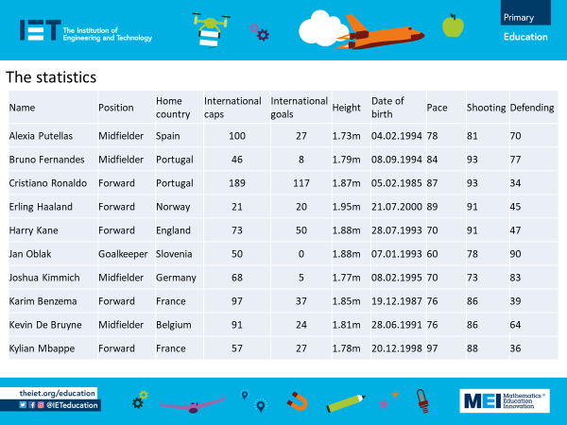  The information is available in the handout document and also in an accompanying spreadsheet where the data can be sorted and filtered.  At this point pupils can discuss any aspect of the data presented. They may talk about which is their favourite and perhaps start a discussion on who is ‘the best’.  For pupils who love and follow football, the best may be their favourite. For pupils who are not keen followers, the data is there for them to make a decision on what they think constitutes ‘the best’.  Activity 2:  The complete data is available on Handout 2 or on the accompanying spreadsheet.  Pupils may look for the highest score in any one aspect of the data.  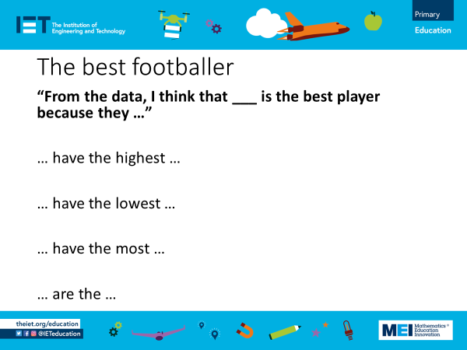  The stem sentence and prompts on Slide 4 can support pupils when structuring their argument:  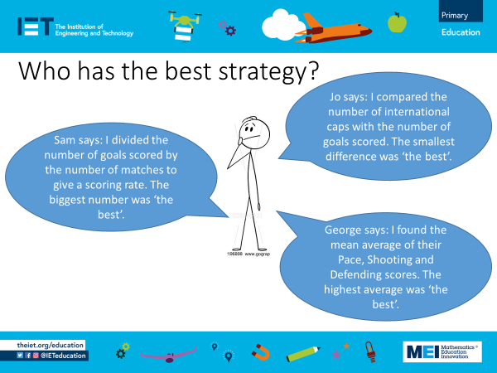  Slide 6  Finding the average could be done with a calculator or by allowing pupils access to the spreadsheet and using a formula.  To support pupils there is a copy of the data with the averages to one decimal place (Handout 3).

Resources |  | Required files
- Activity handouts.  Optional  - Calculator to aid calculation of averages.  - Access to devices to interact with the spreadsheet. |  | Select the Golden Ball recipient – presentation  Select the Golden Ball recipient – activity sheet  Select the Golden Ball recipient – handout  Select the Golden Ball recipient – data
Additional websites
Additional data and information can be found on these websites
- https://www.espn.co.uk/football/blog-espn-fc-united/story/4685632/espn-fc-womens-rank-the-50-best-footballers-in-the-world-today
- https://www.sportsunfold.com/top-20-ranked-football-players-list-in-april-2022/
- https://www.premierleague.com/clubs
- https://www.premierleague.com/stats/top/players/goals

The Engineering Context
- Engineers need to be able to interpret information presented in a range of formats in order to make decisions about the right approach to take for a given situation. This activity allows pupils to discuss different ways of comparing data to reach a conclusion, encouraging flexible thinking which is important when it comes to solving more complex problems.

Curriculum links
England: National Curriculum  The national curriculum for mathematics aims to ensure that all pupils:  - Become fluent in the fundamentals of mathematics, including through varied and frequent practice with increasingly complex problems over time, so that pupils develop conceptual understanding and the ability to recall and apply knowledge rapidly and accurately.  - Reason mathematically by following a line of enquiry, conjecturing relationships and generalisations, and developing an argument, justification or proof using mathematical language.  - Can solve problems by applying their mathematics to a variety of routine and non-routine problems with increasing sophistication, including breaking down problems into a series of simpler steps and persevering in seeking solutions.  Year 6 Statistics  - Calculate and interpret the mean as an average.  KS3 Ratio, proportion and rates of change  - Understand that a multiplicative relationship between two quantities can be expresses as a ratio or a fraction.  Wales  Using data skills  - Use mean, median, mode and range to describe a data set (Year 6).  - Use mean, median, mode and range to compare two distributions (discrete data) (Year 7).  - Find the mean, median, mode and range from ungrouped frequency tables (Year 8). | Scotland  My learning in mathematics enables me to:  - Engage with more abstract mathematical concepts and develop important new kinds of thinking.  - Understand the application of mathematics, its impact on our society past and present, and its potential for the future.  - Apply skills and understanding creatively and logically to solve problems, within a variety of contexts.  - Appreciate how the imaginative and effective use of technologies can enhance the development of skills and concepts.  Data and analysis  Third  - I can work collaboratively, making appropriate use of technology, to source information presented in a range of ways, interpret what it conveys and discuss whether I believe the information to be robust, vague or misleading.  Forth  - I can evaluate and interpret raw and graphical data using a variety of methods, comment on relationships I observe withing the data and communicate my findings to others  - In order to compare numerical information in real-life contexts, I can find the mean, medial, mode and range of sets of numbers.  Northern Ireland: Curriculum  Processes in mathematics  - Making and monitoring decisions.  - Plan and organize their work, learning to work systematically.  - Develop a range of strategies for problem-solving, looking for ways to overcome difficulties.  Communicating mathematically  - Compare their ideas and methods of working with others.  - Present information and results clearly.
Assessment opportunities
- Understanding how averages can be used to make comparisons.
- Understanding how using data and statistics in different ways can give different results.

