Build your own football team
Select your own football team based on data and strategy

Subject(s): Maths  Approx time: 45 – 60 minutes |  | Key words / Topics:  - Number  - Addition  - Subtraction  - Comparison  - Units of measure  - Total  - Sum  - Difference
Stay safe
Whether you are a scientist researching a new medicine or an engineer solving climate change, safety always comes first. An adult must always be around and supervising when doing this activity. You are responsible for:
• ensuring that any equipment used for this activity is in good working condition
• behaving sensibly and following any safety instructions so as not to hurt or injure yourself or others
Please note that in the absence of any negligence or other breach of duty by us, this activity is carried out at your own risk. It is important to take extra care at the stages marked with this symbol: ⚠
Suggested learning outcomes
- Pupils to compare values and find total values.
- Pupils to use place value and different strategies for addition and subtraction.
Introduction
Fantasy football games and football cards are great ways to get involved with football, follow players and enjoy the game even when the match is over. These activities explore the maths of fantasy football and football cards.

Purpose of this activity
The purpose of this activity is to compare numbers and measures, add totals and find differences within the context of exploring the ways that footballers can be compared.

Activity |  | Teacher notes
Activity 1: Who do you want on your team?  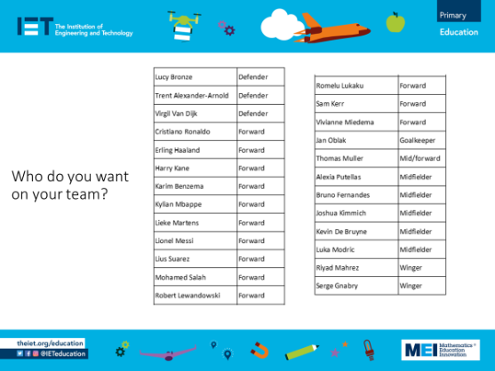  Teacher to introduce the players (Slide 2 and Handout 1) and ask pupils who they would like on their team.  Activity 2: Choosing your team  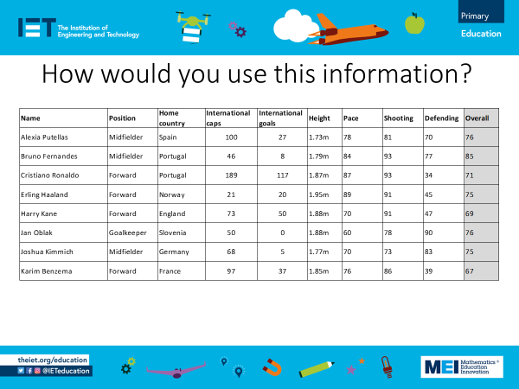  Teachers to give pupils the information about the players and ask how they would use this information to select players.  What information is most useful when you are picking your team?  When they pick a team, pupils have to make sure that they have a balance of the different positions and include a goalkeeper.  There are some criteria that pupils need to stick to when building their team (Slide 5).  They must have a mix of forwards, midfielders, defenders and the goalkeeper.  The total of their overall scores must be under 80 when working with the 1-digit values or under 800 when working with the 2-digit values.  Activity 3: Top Trumps  Pupils have the opportunity to turn their team into Top Trump cards and play to see if they have chosen the best team.  They also need to decide on the correct information to include on the cards.  Slide 6 asks pupils to consider who wins based on date of birth and position in the team. This discussion may help them to customise the design of their cards with the information they want and that makes sense when playing the game.  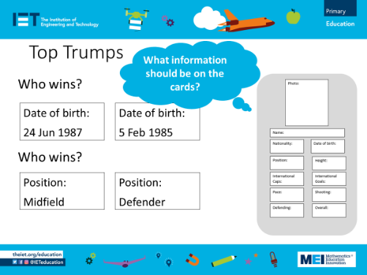  Pupils can use one of the templates provided in Handout 4 and 5 or design their own. They can decide which information they want to include on their cards, perhaps even researching other statistics to enhance the data provided. |  | Activity 1:  Allow the pupils to discuss the list of players and encourage them to think about the sort of information that they might want in order to make a more informed decision.  The information provided in the handouts and on the spreadsheet covers these areas:  - Nationality  - Date of birth  - Height  - Position  - International caps  - International goals  - Figures for:  - Pace  - Shooting  - Defending  - Overall (which is an average of the previous 3).  Activity 2:  A selection of this data is shown on Slides 3 (2-digit values) and Slide 4 (1-digit values).  Handouts 2 and 3 have the player information split up into the different positions.  Handout 2 has the figures for Pace, Shooting, Defending and Overall as 2-digit values. Handout 3 gives these as 1-digit values. The values are the 2-digit scores rounded to the nearest 10 and divided by ten so they are roughly in proportion to the 2-digit values.  Select the data that best suits the attainment of your pupils when it comes to adding the values.  Handout 4 provides a template for the team with a suggestion of the positions and also a blank for those who want to configure their team in a different way.  Activity 3  Handouts 4 and 5 are templates for the Top Trump cards, one with headings and the other blank so that pupils can decide what information to include.  If you decide to use Handout 4 with the headings, pupils can discuss which pieces of information are most and least used when playing the game, as discussed on Slide 6.  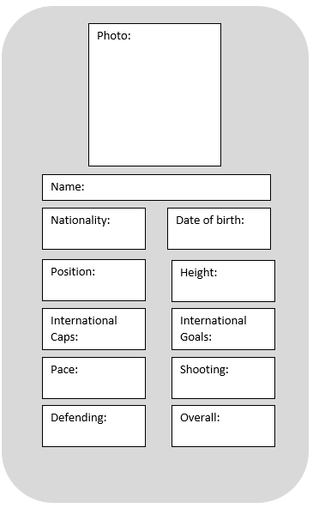  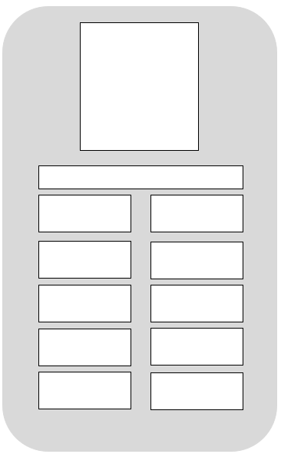
Resources |  | Required files
- Handouts.  - Scissors and glue (if pupils are creating their own Top Trump cards). |  | Build your own football team – presentation  Build your own football team – activity overview  Build your own football team – handout  Build your own football team – data
Additional websites
Additional data and information can be found on these websites
- https://www.espn.co.uk/football/blog-espn-fc-united/story/4685632/espn-fc-womens-rank-the-50-best-footballers-in-the-world-today
- https://www.sportsunfold.com/top-20-ranked-football-players-list-in-april-2022/
- https://www.premierleague.com/clubs
- https://www.premierleague.com/stats/top/players/goals
- https://www.buildlineup.com/
The Engineering Context
- Engineers need to make choices and decisions based on data. These activities allow pupils to consider what information is most important when making decisions and how to make reasonable compromises when looking at a wide range of information.

Curriculum links
England: National Curriculum  The national curriculum for mathematics aims to ensure that all pupils:  - become fluent in the fundamentals of mathematics, including through varied and frequent practice with increasingly complex problems over time, so that pupils develop conceptual understanding and the ability to recall and apply knowledge rapidly and accurately.  - reason mathematically by following a line of enquiry, conjecturing relationships and generalisations, and developing an argument, justification or proof using mathematical language.  - can solve problems by applying their mathematics to a variety of routine and non-routine problems with increasing sophistication, including breaking down problems into a series of simpler steps and persevering in seeking solutions.  Year 3 Number – number and place value  - Compare and order numbers up to 1000.  Year 4 Number – addition and subtraction (non-statutory)  - Pupils continue to practice both mental methods and columnar addition and subtraction with increasingly large numbers to aid fluency.  Scotland  Number, money and measures  - I can use addition, subtraction, multiplication and division when solving problems, making nst use of the mental strategies and written skills I have developed.  Data  - Having discussed the variety of ways and range of media used to present data, I can interpret and draw conclusions from the data displayed, recognizing that the presentation may be misleading. | Northern Ireland Curriculum  Number  - Develop strategies for adding and subtracting mentally up to the addition of two-digit numbers within 100.  Handling Data  - Discuss and interpret the data.  Wales: National Curriculum  Year 3  Using number skills  - Compare and estimate with numbers up to 100.  - Use mental strategies to add and subtract 2-digit numbers.  Data  - Extract and interpret information from charts etc.  Year 4  Using number skills  - Find differences with 1000.  - Add a 2-digit number t, and subtract a 2-digit number from , a 3-digit number using an appropriate mental or written method.  Data  - Extract and interpret information from charts etc.
Assessment opportunities
- Mental and written strategies for adding 1, 2 and 3-digit numbers.
- Interpret data presented in tables.

