Fractions of the squad
Describing your squad and team using fractions and percentages

Subject(s): Maths  Approx time: 45 – 60 minutes |  | Key words / Topics:  - Proportion  - Fractions  - Percentages
Stay safe
Whether you are a scientist researching a new medicine or an engineer solving climate change, safety always comes first. An adult must always be around and supervising when doing this activity. You are responsible for:
• ensuring that any equipment used for this activity is in good working condition
• behaving sensibly and following any safety instructions so as not to hurt or injure yourself or others
Please note that in the absence of any negligence or other breach of duty by us, this activity is carried out at your own risk. It is important to take extra care at the stages marked with this symbol: ⚠
Suggested learning outcomes
- Pupils can use fractions and percentages to describe proportions of the whole.
Introduction
Before a big competition a squad is selected and from that the final team will be chosen. In this activity we describe the squad using fractions and percentages and then select a team. Can someone else work out which team you have selected from the fractions and percentages you have used to describe it?

Purpose of this activity
The purpose of this activity is to deepen understanding of fractions and percentages as ways to describe proportion or parts of a whole. There are opportunities to look at equivalent fractions and equivalence between fractions and percentages.

Activity |  | Teacher notes
Activity 1: My fractions of the squad  Introduce the squad of 26 players selected ahead of some international matches in March 2022 and give pupils time to look at the list and see what they notice. Handout 1 or Spreadsheet 1.  Introduce some fractions and ask pupils to discuss what the fraction relates to in the list of players. Slide 4. There is a stem sentence to support pupils to structure their thinking:  ___ of the squad are ___.  Slide 5 asks if any of the fractions could be replaced with a percentage. Any can be converted but this is to see if pupils spot that 1/2 can quickly be replaced with 50% as this is a known fact. The others would not be whole number percentages.  Activity 2: Your fractions of the squad  The fractions in the first activity all related to the positions of the players. How can you describe the squad if you include their home teams in your fractions?  Encourage pupils to spot if any of their fractions could be replaced with a percentage.  Activity 3: Picking your team  Now is the chance for pupils to pick a team from the squad list. To make the fractions work, pick 12 players to include a substitute. Pupils should make sure they have a mix of different positions and to include a goalkeeper.  Once they have selected their team, they should use fractions to describe the team. The fractions can represent the positions and the home teams of the players.  Activity 4: Whose team is this?  Once students have described their team, they should give their fraction and percentage statements to another pupil or pair. The challenge is to try and work out which 13 players they picked from the statements. |  | Activity 1:  The information can be presented as a handout or pupils can access the spreadsheet which will allow them to sort and filter the information  At this point it doesn’t matter what they notice, it is to give them a chance to look at the information and talk about it.  These fractions all relate to the whole squad of 26 players and the positions they play.  Slide 4 solution  Fractions on Slide 4 relate to:  $\frac{3}{26}$ of the squad are goalkeepers.  $\frac{3}{13}$ of the squad are midfielders.  $\frac{1}{2}$ of the squad are defenders and goalkeepers or midfielders and forwards.  $\frac{10}{26}$ of the squad are defenders.  $\frac{7}{26}$ of the squad are forwards.  Activity 2:  Using the spreadsheet to filter is a useful tool for this activity but it can also be done using the handout with the information.  You might want to sort the information according to club and print it for pupils to use in this activity.  Activity 3  To support pupils there is a template (Handout 2) to construct their team of 11 plus a substitute. If they don’t want this 4, 3, 3 formation, then Handout 2a does not specify the number of players in each position. There are example statements and stem sentences to guide their discussions about the team they have picked.  This could be an individual activity or pairs could work together to come up with fractions to challenge other pupils as was modelled in Activity 1.  Activity 4:  There is an example team description included on Slide 6 and as Handout 3a with the team described on Slide 7 and on Handout 3b.  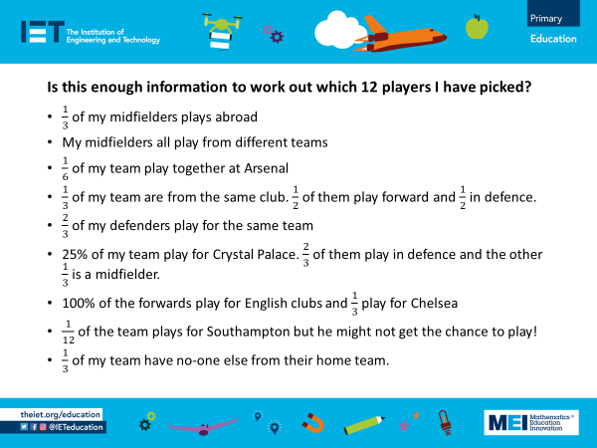  Note for teachers:  The information isn’t complete as the two forwards from Manchester City are chosen from 3 so it is not clear exactly which two have been selected.  Pupils can be challenged to find all the different squads that this information could describe, considering the lack of clarity over who the forwards could be.
Resources |  | Required files
- Activity handouts.  - Optional: Calculators to convert the fractions into decimals. |  | Fractions of the squad – presentation  Fractions of the squad – activity overview  Fractions of the squad – handout  Fractions of the squad – data
Additional websites
Additional data and information can be found on these websites
- https://www.espn.co.uk/football/blog-espn-fc-united/story/4685632/espn-fc-womens-rank-the-50-best-footballers-in-the-world-today
- https://www.sportsunfold.com/top-20-ranked-football-players-list-in-april-2022/
- https://www.premierleague.com/clubs
- https://www.premierleague.com/stats/top/players/goals

The Engineering Context
- Engineers need to be flexible in thinking about and moving between fractions, decimals and percentages when considering different approaches to solving problems.

Curriculum links
England: National Curriculum  The national curriculum for mathematics aims to ensure that all pupils:  - Become fluent in the fundamentals of mathematics, including through varied and frequent practice with increasingly complex problems over time, so that pupils develop conceptual understanding and the ability to recall and apply knowledge rapidly and accurately.  - Reason mathematically by following a line of enquiry, conjecturing relationships and generalisations, and developing an argument, justification or proof using mathematical language.  - Can solve problems by applying their mathematics to a variety of routine and non-routine problems with increasing sophistication, including breaking down problems into a series of simpler steps and persevering in seeking solutions.  Year 5 Fractions  - Identify, name and write equivalent fractions of a given fraction, represented visually, including tenths and hundredths.  Year 6 Fractions  - Recall and use equivalences between simple fractions, decimals and percentages, including in different contexts.  Scotland  My learning in mathematics enables me to:  - Engage with more abstract mathematical concepts and develop important new kinds of thinking.  - Understand the application of mathematics, its impact on our society past and present, and its potential for the future.  - Apply skills and understanding creatively and logically to solve problems, within a variety of contexts.  - Appreciate how the imaginative and effective use of technologies can enhance the development of skills and concepts. | Northern Ireland Curriculum  Processes in mathematics  Making and monitoring decisions  - Plan and organise their work, learning to work systematically.  - Develop a range of strategies for problem-solving, looking for ways to overcome difficulties.  Number  - Understand and use vulgar fraction, decimal fractions and percentages and explore the relationships between them.  Communicating mathematically  - Compare their ideas and methods of working with others.  - Present information and results clearly.  Wales: National Curriculum  Developing numerical reasoning  - Transfer mathematical skills to a variety of contexts and everyday situations.  Using number skills  - Calculate fractional quantities (Year 5).  - Use understanding of simple fraction, decimal and percentage equivalences (Year 6).
Assessment opportunities
- Understanding fractions as describing proportions of a whole.
- Knowing equivalences between simple fractions and percentages.

