Activity title
Reindeer treat reactions
Stay safe
Whether you are a scientist researching a new medicine or an engineer solving climate change, safety always comes first. An adult must always be around and supervising when doing this activity. You are responsible for:

• ensuring that any equipment used for this activity is in good working condition
• behaving sensibly and following any safety instructions so as not to hurt or injure yourself or others

Please note that in the absence of any negligence or other breach of duty by us, this activity is carried out at your own risk. It is important to take extra care at the stages marked with this symbol: ⚠
Time required
30 minutes to 1 hour
Activity summary
It’s fun to leave a snack out for Santa on Christmas Eve – and we sometimes leave a carrot out for Rudolph too! But what if you wanted to give Rudolph something a bit different? Something like a cut up apple?
But you might know that apples tend to discolour when left out in the air which might make the treat look a bit yucky. Is there any way around this? Let’s find out!
What equipment will you need?
- Six cups or small dishes
- An apple
- Salt water
- Lemon juice
- Vinegar
- Milk
- Bicarbonate of soda solution (mixed in water)
- A knife and board for cutting the apple
- Pencil and paper for labels
- Spoon
And have an adult to help.

How to do it
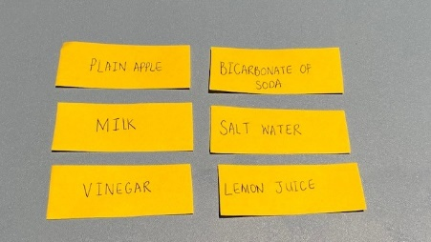
Step 1
Write six labels on the paper – SALT WATER, LEMON JUICE, VINEGAR, MILK, BICARBONATE OF SODA and one that says PLAIN APPLE.
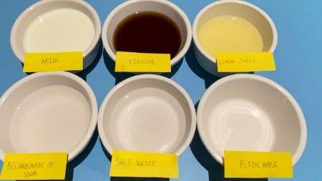
Step 2
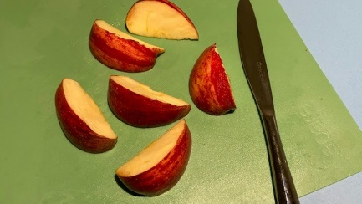
Fill each cup with a different liquid, enough to cover a slice of apple – salt water, lemon juice, vinegar, milk, and bicarbonate of soda solution. Leave the 6th cup empty. Place your labels in front of each cup.
Step 3
Carefully cut your apple into six roughly equal chunks.
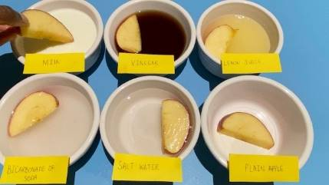
Step 4
Place one chunk in each cup and leave for 15 minutes.

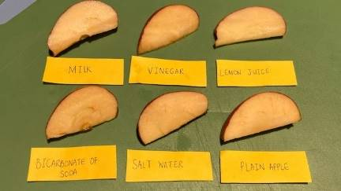
Step 5
Use a spoon to remove each chunk and place on the plastic tray – remember to move your labels to the tray too so you know which is which!
Step 6
Check to see which apple has gone brown the most – and the least - after 10, 20 and 30 minutes.
You should find that the plain apple has browned, and that lemon juice works better than some of the other substances at keeping the apple crisp and white instead of soggy and brown!
Well done – you’ve cracked the Christmas challenge!
So what’s happening with these substances to prevent the apple from discolouring? It’s all to do with something called oxidization.
Here’s the science
Oxygen is all around us, it makes up 21% of Earth’s atmosphere. We breathe it in, and don’t give it a lot of thought but in fact it is an element that will react with certain other substances.
Apples contain an enzyme called polyphenol oxidase or a ‘PPO’. When you slice open an apple, the PPO reacts with the oxygen in the air and the chemical reaction creates a substance called melanin, which is brown in colour. The combination of a substance (the enzyme in our example) with oxygen is known as oxidization. We also have melanin in our bodies, it’s what gives our skin, hair and even eyes their colour!
Lemon juice contains ascorbic acid (which is more commonly known as Vitamin C), which reacts with oxygen too – meaning that there’s less oxygen able to react with the PPO enzyme.
Although vinegar is an acid too, it is ascetic acid and so the reaction is not the same.
Bicarbonate of soda or milk are what we call alkalis which actually add more oxygen into the reaction.
However, milk also contains proteins that slow the oxidization process so can prevent browning a little, but not usually to the same degree as lemon juice.
Acids and alkalis
In this experiment a particular kind of acid in lemon juice helped to keep the apple crisp and white and alkalis such as bicarbonate of soda quickened the process of the apple turning brown. But what ARE acids and alkalis anyway?
Acids have lots of hydrogen atoms, and Alkalis have a lot of hydroxide atoms. Because they have different types of atoms they react with other substances in different ways. They can be helpful – in the right amounts, acids can be good for cleaning, and alkalis can make good soaps. When they are very strong, both acids and alkalis can be harmful. An example of a strong acid is the acid in our stomachs which digests our food. A strong alkali is bleach. The two in the right quantities can neutralise each other. Alkalis are water soluble – so are liquid. Some substances can neutralise acids but are not water soluble – we call these bases.
Acids in the foods we eat are usually sour – like lemon juice and vinegar, whereas alkali substances like the bicarbonate of soda are bitter, like limes or grapefruit.

