Activity title
Colourful paper Christmas tree
Stay safe
Whether you are a scientist researching a new medicine or an engineer solving climate change, safety always comes first. An adult must always be around and supervising when doing this activity. You are responsible for:

• ensuring that any equipment used for this activity is in good working condition
• behaving sensibly and following any safety instructions so as not to hurt or injure yourself or others

Please note that in the absence of any negligence or other breach of duty by us, this activity is carried out at your own risk. It is important to take extra care at the stages marked with this symbol: ⚠
Time required
30 minutes
Activity summary
In this challenge we are going to make fun and colourful Christmas tree decorations and find out more about chromatography – one of the ways we can separate mixtures.
What equipment will you need?
- Coffee filters
- Washable felt tips
- A spray water bottle
- Lolly sticks or wooden pegs
- Yellow or metallic card
- Scissors
- Sticky tape or a glue stick
And have an adult to help.

How to do it
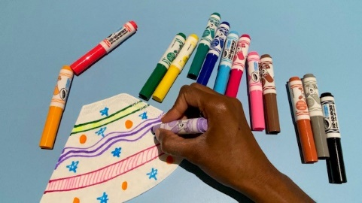
Step 1
Take a coffee filter – fold it flat so it makes a triangle shape and colour it with the felt tips in any way you like – you might like to colour it in totally or leave spaces. You can also experiment with different patterns.
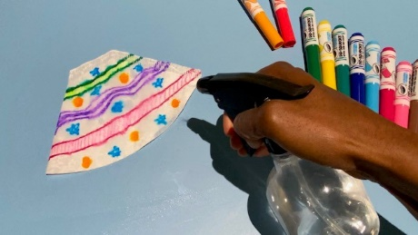
Step 2
Use the spray bottle of water to spray your coffee filter until it is wet – it doesn’t need to be dripping wet – damp is fine!
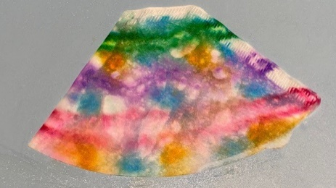
Step 3
Leave your coffee filter to dry. You should see the felt tip markings combine into a colourful pattern.

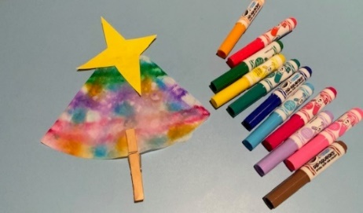
Step 4
You can peg your wooden clothes peg at the bottom to make your Christmas tree trunk or use sticky tape to attach a lolly stick trunk instead.

Step 5
The finishing touch is to add a star made of your yellow or magnetic card.
Well done – you’ve cracked the Christmas challenge!

What’s the science?
In this challenge we saw the way that water affects water soluble coloured felt tips – combining them into interesting patterns. But how does this happen?
Colourful chromatography
Chromatography is a technique used to separate mixtures. A mixture is two or more substances combined together. The mixture is passed through another substance, in this case the filter paper. The different colour ink particles travel at different speeds through the filter paper allowing us to see the constituent colours of the pen ink.
You might be wondering why the different colours move at different speeds – some will have travelled further than others – a bit like runners in a marathon. It’s all to do with the way each colour is made up. Although felt tips might all look alike, in fact the pigment (that’s the colourful ingredient) may itself be more or less soluble than other colours.
If the pigment is more soluble it will combine with the water more easily and travel with the water along the filter paper. If it is less soluble it is more likely to stick to the filter paper and not travel so far.
Although we used chromatography to make a fun Christmas decoration it can be used in all sorts of helpful ways such as analysing blood samples, helping solve crimes, checking the quality of the food we eat and creating and testing new drugs and vaccines.
Puzzling pigments
Pigments are the magic ingredient which give our felt tips and paints their unique colours although anything that is coloured will have pigments.
The pigments used in things like felt tips and paints are usually created synthetically in laboratories but in the past, some would have been sourced from some very strange places!
If you were a painter who wanted black or brown paint, you might have used burnt wood or charcoal. There was even a paint shade called Mummy Brown which was made from ground-up Egyptian mummies. It was sold until 1964 when the manufacturers ran out of mummies!

In the past painters would have used a type of lead for its yellow pigment – which was not a great idea because lead is poisonous. A beautiful blue paint was created from the precious stone Lapis Lazuli – it was so valuable that painters would charge more if their subjects wanted to have that colour in their portrait! One of the rarest colours of all was Tyrian Purple – which was extracted from SNAILS! It was so rare that it was only used for the paintings, or for dyeing the fabric of the clothes of the very rich. A more common colour was carmine – a deep red, which was made from crushing the cochineal beetle. You might think that sounds like something from the past, but carmine is still used today in paints, makeup, drugs and even food!
What pigments can you find?
Have a look in your kitchen cupboards and look at the list of ingredients. Carmine as an additive is listed with the number E120. (Hint – try looking at things that are red in colour!

