Activity title
Parachuting presents
Stay safe
Whether you are a scientist researching a new medicine or an engineer solving climate change, safety always comes first. An adult must always be around and supervising when doing this activity. You are responsible for:

• ensuring that any equipment used for this activity is in good working condition
• behaving sensibly and following any safety instructions so as not to hurt or injure yourself or others

Please note that in the absence of any negligence or other breach of duty by us, this activity is carried out at your own risk. It is important to take extra care at the stages marked with this symbol: ⚠
Time required
30 minutes
Activity summary
It’s Christmas Eve and Santa and Rudolph are ready to set off but he’s left a present on a shelf in the workshop! Can you help design a parachute to assist the elves send it safely and slowly down to the sleigh? In this activity, you will learn about gravity, air resistance and the way the two act against each other.
What equipment will you need?
- Three empty yoghurt pots
- Paper – you can use leftover wrapping paper, newspaper, paper napkin, bin bag or any leftover plastic film or bubble wrap from packaging. This is your parachute material.
- Sticky tape
- Scissors
- String
And have an adult to help.

How to do it
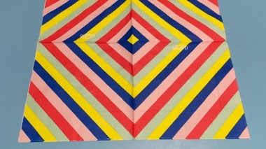
Step 1
Cut a large square from your paper or other parachute material– at least 12 inches square although it can be as big as you like!

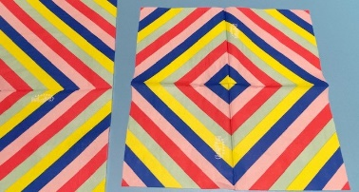
Step 2
Cut a second square roughly half the size of your first.

Step 3
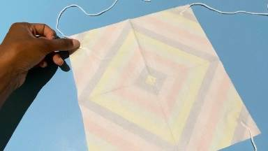
Stick a length of string about 8 inches long to each corner of both squares using your sticky tape.

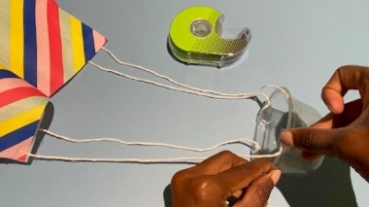
Step 4
Stick the other end of each piece of string equally around the top edge of your yoghurt pot with sticky tape.
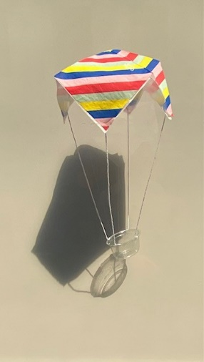
Step 5
You now have two parachutes: one large, one small plus a yoghurt pot without a parachute.
PREDICTION: Which do you think will reach the floor first?
Hold each by the parachute as high as you can and drop them one by one. Then try dropping the yoghurt pot without a parachute.
Step 6
Were you right? The largest parachute should have reached the floor a little more slowly than the smaller one – and the yoghurt pot on its own will reach the floor very quickly.
So, Santa should use a larger parachute if he wants his present to stay safe!
Well done – you’ve cracked the Christmas challenge!
In this challenge we saw how parachutes help falling objects to slow down, so that the object – whether it’s a present or a person - stays safe. But how does it do that? Let’s find out!
Here’s the science
Gravity
Gravity is a pulling force that works across space. On our planet gravity constantly pulls objects - and you, downwards. That's why your feet stay on the ground, and we don't fly off into the air!
Gravity is the force that pulls the yoghurt pot parachute down to the earth.
Air resistance
Air might be invisible, but it’s made up of tiny particles – the atoms and molecules of the gases all around us.
Air resistance is the frictional force which happens when those air particles push against a moving object – for example when you ride your bike quickly down a hill you can feel the wind pressing against your face – and the faster you go the more you will feel the force. The force slows the object down.
The larger the surface of the object is, the greater the air resistance will be and so the slower the object will move. Our large parachute had more surface area for the air to push against and so it went more slowly than the smaller parachute, and the pot without a parachute at all.
Did you know?
If you dropped a feather and a bowling ball in a place with no air, (something we call a vacuum) they would both fall at the same speed as there would be no air resistance at all.

