Freezing point experiment
Stay safe
Whether you are a scientist researching a new medicine or an engineer solving climate change, safety always comes first. An adult must always be around and supervising when doing this activity. You are responsible for:
• ensuring that any equipment used for this activity is in good working condition
• behaving sensibly and following any safety instructions so as not to hurt or injure yourself or others
Please note that in the absence of any negligence or other breach of duty by us, this activity is carried out at your own risk. It is important to take extra care at the stages marked with this symbol: ⚠
Age range: 11-14-year-olds or younger with adult supervision  Approx. time: 45 minutes – 1 hour (plus time to freeze and thaw) |  | Key words / Topics:  - materials  - science  - saturated  - solution  - freezing  - ions  - electrical charge
Introduction
When it’s snowy outside learners might see lorries spreading salt on the roads and people shovelling salt onto pavements. This is to melt the ice, to make the roads safer for the traffic and less slippery for pedestrians. In this activity we find out how and why this works!
Equipment ⚠
- Two jam jars or similar containers
- Something to mark one jar, such as a permanent marker or sticker
- Water
- Table salt (about 2oz)

Instructions ⚠
Step 1
Learners pour water into both jam jars/containers, until they are about half full.

Step 2
In one jar add salt to make a saturated solution. A saturated saltwater solution is made when any further salt added will not dissolve.

Step 3
Mark the saltwater solution with the permanent marker or a sticker so the jars don’t get mixed up!

Step 4
Place both jam jars in the freezer and close the door.

Step 5
Check each hour to see if either jar has frozen. Learners should find that the plain water freezes faster than the saltwater solution.

Step 6
When both have frozen remove from the fridge and leave to thaw. They should find the saltwater similarly thaws more quickly than the plain water.

Illustrations
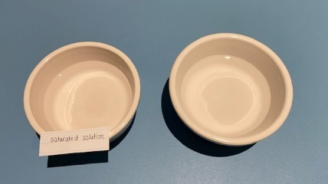
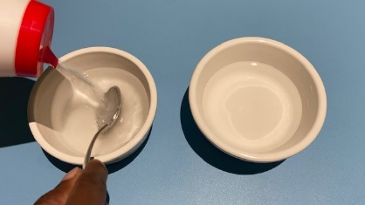
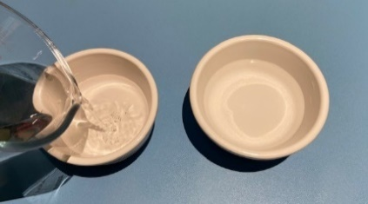

Step 1 Step 2 Step 3

Science and maths
This activity concerns freezing points – the temperatures at which substances turn from a liquid to a solid, for example when water turns into ice. Water has a freezing point of 0 degrees Celsius. Saltwater has a lower freezing point around -2 degrees Celsius. So saltwater needs to be COLDER than plain water in order to freeze, which is why the jam jar with the plain water froze first.
In our road example, the salt mixed with the surface water of the ice – this made the ice need to be colder than 0 degrees in order to remain as a solid, otherwise it will return to liquid form. This is why ice will thaw when salt is spread on it as long as the temperature is not below the freezing point of saltwater – in which case the ice would remain.

The reason salt changes the freezing point is that it contains particles called ions – these are atoms with an electrical charge. The two ions in salt are called Na+ (Sodium) and Cl- (Chlorine). When salt dissolves into the water the ions spread themselves throughout the water and block the water molecules from getting close enough together and in the right orientation to organise into the solid form of ice.
Adding any impurity to a liquid lowers its freezing point. What you put in doesn’t matter, but the number of particles it breaks into in the liquid is important. The more particles that are produced, the greater the freezing point depression. For example, sugar simply dissolves into single sugar molecules, so its effect on the freezing point is less than what you would get adding an equal amount of salt, which as noted above, breaks into two particles. Salts that break into more particles, like magnesium chloride (MgCl₂, which generates three ions) have an even greater effect on lowering the freezing point of water.
Seas are made up of saltwater - that’s why we still get watery waves even when its zero degrees and far too cold for a swim! However, at the North and South Poles the temperatures are so low that the salty water will freeze, making oceans of ice and slow-moving glaciers. Global warming has raised the temperatures in every part of the world including the poles – this means that the icy oceans are at risk of melting.
The Engineering Context
In addition to the application of reducing the risk of slipping on icy surfaces, the freeze–thaw cycle can cause weathering and the slow deterioration of structural stability in rocks and construction materials, particularly when water has seeped into small cracks and crevices. Engineers have to take this into consideration when designing structures for external use, such as bridges.
Curriculum links
England: National Curriculum  - Science: upper KS2  - Demonstrate that dissolving, mixing and changes of state are reversible changes |  | Northern Ireland Curriculum  - Primary: The world around us  - KS1 The effect of heating and cooling some everyday substances.  - KS2 changes that occur to everyday substances, for example, when dissolved in water or heated and cooled.
Scotland: Curriculum for Excellence  - Science: Materials – Properties and uses of substances: Second  - By contributing to investigations into familiar changes in substances to produce other substances, I can describe how their characteristics have changed. |  | Wales: National Curriculum  - Science KS3  - Use a range of apparatus and equipment safely and with skill, taking action to control the risks to themselves and others

