 | Reindeer treat chemical reactions
 | Stay safe
Whether you are a scientist researching a new medicine or an engineer solving climate change, safety always comes first. An adult must always be around and supervising when doing this activity. You are responsible for:
• ensuring that any equipment used for this activity is in good working condition
• behaving sensibly and following any safety instructions so as not to hurt or injure yourself or others
Please note that in the absence of any negligence or other breach of duty by us, this activity is carried out at your own risk. It is important to take extra care at the stages marked with this symbol: ⚠
 | Age range: 11-14-year-olds or younger with adult supervision  Approx. time: 45 minutes – 1 hour |  | Key words / Topics:  - oxidisation  - oxygen  - chemical reaction  - enzyme  - acid  - alkali  - soluble
 | Introduction
 | It’s fun to leave a snack out for Santa on Christmas Eve – and sometimes people leave a carrot out for Rudolph too! However, what if learners wanted to give Rudolph something a bit different, like a cut-up apple. Learners might know that apples tend to discolour when left out in the air, which could make the treat look a bit yucky. In this activity learners will investigate how to prevent this discolouration.
 | Equipment ⚠
- Six cups or small dishes
- An apple
- Saltwater
- Lemon Juice
- Vinegar
- Milk
- Bicarbonate of soda solution (mixed in water)
- A knife and board for cutting the apple
- Pencil and paper for labels
- Spoon

 | Instructions ⚠
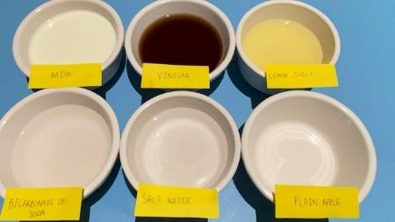
Step 1
Learners write six labels on the paper as follows – SALTWATER, LEMON JUICE, VINEGAR, MILK, BICARBONATE OF SODA and one that says PLAIN APPLE.
Step 2
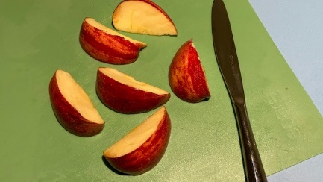
Fill each cup with a different liquid, enough to cover a slice of apple – saltwater, lemon juice, vinegar, milk, and bicarbonate of soda solution. Leave the 6th cup empty. Place labels in front of each cup.
Step 3 ⚠
Carefully cut the apple into six roughly equal chunks.

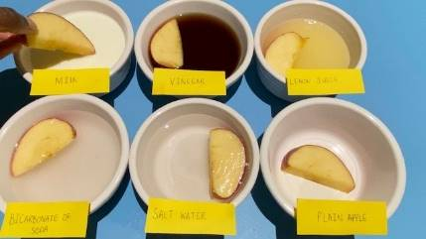
Step 4
Place one chunk in each cup and leave for 15 minutes.

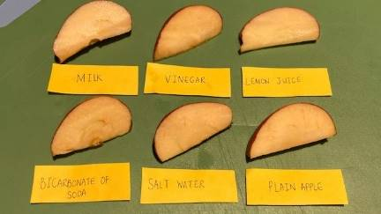
Step 5
Use a spoon to remove each chunk and place on the plastic tray – remember to move the labels to the tray too so learners know which is which!

Step 6
After 10, 20 and 30 minutes, check to see which apple has gone brown the most and which has discoloured the least.
They should find that the plain apple has browned, and that lemon juice works better than some of the other substances at keeping the apple crisp and white instead of soggy and brown.

Science and maths
This activity is focussed on oxidization. Oxygen makes up 21% of Earth’s atmosphere. We must breathe it to live – however, it is a chemical element that will react with certain other substances.
Apples contain an enzyme called polyphenol oxidase (PPO). When you slice open an apple, the PPO reacts with oxygen in the air and the chemical reaction creates a substance called melanin, which is brown in colour. The combination of a substance (the enzyme in our example) with oxygen is known as Oxidisation.
Lemon Juice contains ascorbic acid (vitamin C), which also reacts with oxygen – meaning that there’s less oxygen able to react with the PPO enzyme. Although vinegar is also an acid, it is a different type (acetic acid), so the reaction is not the same. Milk also contains proteins that slow the oxidization process so can prevent browning a little, but not usually to the same degree as lemon juice. Bicarbonate of soda or milk are alkali which actually add more oxygen into the reaction.
Acids have lots of hydrogen atoms, and alkalis have a lot of hydroxide atoms. As they have different types of atoms they react with other substances in different ways. They can be helpful – in the right amounts, acids can be good for cleaning, and alkalis can make good soaps. When they are very strong, both acids and alkalis can be harmful. An example of a strong acid is the acid in our stomachs which digests our food. A strong alkali is bleach. The two in the right quantities can neutralise each other. Alkalis are water soluble – so are liquid. Some substances can neutralise acids but are not water soluble – we call these bases.
Acids in the foods we eat are usually sour – like lemon juice and vinegar, whereas alkali substances like the bicarbonate of soda are bitter, like limes or grapefruit.
The Engineering Context
Engineers use their knowledge of acids and alkalis to design non-corrosive material combinations, car batteries, chemical fertilizers and food preservation techniques. Writing with invisible ink that can be read using an acid/base indicator was commonly used during the American revolution to communicate secret messages between military leaders.
Curriculum links
England: National Curriculum  - Science: upper KS2  - Demonstrate that dissolving, mixing and changes of state are reversible changes. |  | Northern Ireland Curriculum  - Primary: The world around us  - KS2 changes that occur to everyday substances, for example, when dissolved in water or heated and cooled.
Scotland: Curriculum for Excellence  - Science: Materials – Properties and uses of substances: Second  - By contributing to investigations into familiar changes in substances to produce other substances, I can describe how their characteristics have changed. |  | Wales: National Curriculum  - Science KS3  - Use a range of apparatus and equipment safely and with skill, taking action to control the risks to themselves and others

