Create crystals
Stay safe
Whether you are a scientist researching a new medicine or an engineer solving climate change, safety always comes first. An adult must always be around and supervising when doing this activity. You are responsible for:
• ensuring that any equipment used for this activity is in good working condition
• behaving sensibly and following any safety instructions so as not to hurt or injure yourself or others
Please note that in the absence of any negligence or other breach of duty by us, this activity is carried out at your own risk. It is important to take extra care at the stages marked with this symbol: ⚠

Age range: 11-14-year-olds or younger with adult supervision  Approx time: 1 hour (plus several days for the growth) | Key words / Topics:  - saturated  - capillary action  - dissolve  - crystal  - icicle  - geometric  - evaporate  - solution  - solvent
Introduction
It’s hard to imagine a wintery snow scene without crystals and icicles. Drips of icy water freeze into long frozen structures which hang from roofs, windows and from the branches of trees. In this activity learners are going to create crystals without the use of a fridge!
Equipment needed
- A full tub of bicarbonate of soda (baking soda)
- A piece of wool
- Two paper clips
- Two glass jars
- A saucer
- Water

Instructions ⚠
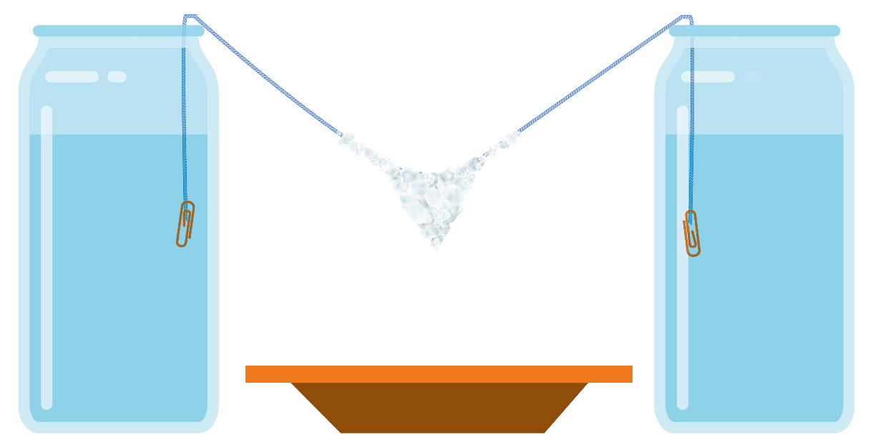
The diagram below shows what the learners will make:

Step 1 ⚠
First, make a saturated solution of bicarbonate of soda and fill both jars with it. A saturated solution is one where learners keep adding bicarbonate of soda to the water until it stops dissolving – there should be a small amount visible in the solution. It can be helpful to gently heat the solution to encourage the bicarbonate of soda to dissolve.

Step 2
Get a piece of wool and tie paper clips to either end.

Step 3
Soak the wool in the bicarbonate solution.

Step 4
Suspend each end of the wool in both jars, with a saucer under the thread and leave to rest. Make sure the middle of the wool is lower than the level of the bicarbonate solution in the jars.

Step 5
As the solution is soaked up and travels along the wool, it will drip down onto the saucer. After a few days learners will see crystals beginning to form along the wool. Crystals are solid structures in a geometric shape.

Step 6
After a few more days, they will see an icicle beginning to grow towards the saucer. The longer they leave it the bigger the icicle!

Science and maths
A solution is two or more substances that are combined in a way that can’t be separated without an additional process taking place – for example by evaporating the solvent. When bicarbonate of soda is dissolved in the water it makes a solution. A saturated solution contains the maximum possible amount of dissolved material – any reduction in the quantity of solvent will result in material being precipitated out of the solution.
Due to the high surface area to volume ratio, the solution soaked in the wool will evaporate faster than the solution in the jars. As it evaporates the bicarbonate of soda precipitates out, forming small crystals. The solution in the jars will try to keep the wool moist, moving along it by capillary action – and bringing more bicarbonate of soda. The solution will try to travel to the lowest point, where it would drip onto the saucer. The drips will also evaporate whilst hanging from the lowest point. It is this build up of deposited bicarbonate of soda that form the crystal icicle.
This process is how stalactites and stalagmites form. Material inside rocks called “calcium carbonate” dissolves into water and then drips out of the ceiling of caves. The stalactites form from the ceiling and stalagmites from on the ground as the material solidifies.
The Engineering Context
Processes using evaporation are widely used in engineering industries – for example, in the food industry to make dehydrated powders (such as milk powder or coffee) or to produce refined sugar. Evaporation is also used in the production of petroleum products to separate more volatile compounds from crude components.
Curriculum links
England: National Curriculum  Science; upper KS2  - know that some materials will dissolve in liquid to form a solution.  - demonstrate that dissolving, mixing and changes of state are reversible changes - explain that some changes result in the formation of new materials, and that this kind of change is not usually reversible. | Northern Ireland Curriculum  - Primary; The world around us  - KS1 The effect of heating and cooling some everyday substances.  - KS2 changes that occur to everyday substances, for example, when dissolved in water or heated and cooled.
Scotland: Curriculum for Excellence  - Science; Materials – Properties and uses of substances; Second  By contributing to investigations into familiar changes in substances to produce other substances, I can describe how their characteristics have changed. | Wales: National Curriculum  - Science KS3 use a range of apparatus and equipment safely and with skill, taking action to control the risks to themselves and others

