1. Chinese Zodiac Code Breaker Maths Activity - Addition and Subtraction
Solve the maths calculations below to spell out some of the Chinese zodiac animals.

A | B | C | D | E | F | G | H | I | J | K | L | M
2465 | 8217 | 3355 | 9238 | 5727 | 4457 | 6812 | 4263 | 6801 | 8521 | 3438 | 9257 | 6232

N | O | P | Q | R | S | T | U | V | W | X | Y | Z
1168 | 3043 | 7269 | 8816 | 3896 | 7752 | 6733 | 7666 | 2049 | 8571 | 3233 | 4851 | 7247

1. | Answer | Letter
5487 + 2265
394 + 774
896 + 1569
2119 + 1319
1036 + 4691
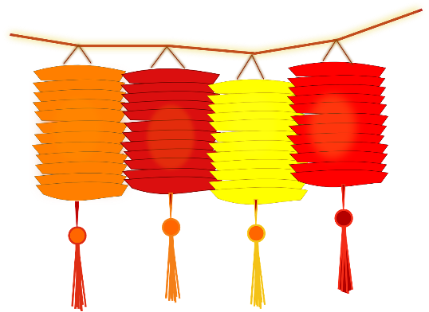
2. | Answer | Letter
544 + 3896
3042 - 577
2206 + 6011
9195 - 978
7850 - 1049
162 + 6571

3. | Answer | Letter
10137 - 899
3019 + 877
3520 - 1055
6149 + 663
3765 - 722
271 + 897

2. Chinese Zodiac Code Breaker Maths Activity – Fractions and Percentages
Solve the maths calculations below to spell out some of the Chinese zodiac animals.

A | B | C | D | E | F | G | H | I | J | K | L | M
5 | 34 | 77 | 4 | 18 | 23 | 57 | 1 | 11 | 37 | 88 | 67 | 56

N | O | P | Q | R | S | T | U | V | W | X | Y | Z
123 | 26 | 9 | 7 | 10 | 12 | 21 | 63 | 86 | 99 | 44 | 28 | 81

1. | Answer | Letter
$\frac{3}{8}$ of 56
$\frac{2}{3}$ of 39
$\frac{3}{4}$ of 76
$\frac{2}{8}$ of 72
$\frac{5}{6}$ of 12
2. | Answer | Letter
12.5% of 8
25% of 88
40% of 25
80% of 15
75% of 24

3. | Answer | Letter
60% of 15
40% of 65
$\frac{1}{9}$ of 513

3. Chinese Zodiac Code Breaker Maths Activity – Multiplication and Division
Solve the maths calculations below to spell out some of the Chinese zodiac animals.

A | B | C | D | E | F | G | H | I | J | K | L | M
872 | 212 | 543 | 822 | 297 | 45 | 388 | 991 | 290 | 342 | 468 | 100 | 972

N | O | P | Q | R | S | T | U | V | W | X | Y | Z
602 | 656 | 500 | 251 | 284 | 912 | 408 | 777 | 388 | 481 | 766 | 93 | 981

1. | Answer | Letter
1704 ÷ 6
82 x 8
1968 ÷ 3
304 x 3
3672 ÷ 9
1188 ÷ 4
71 x 4
2. | Answer | Letter
6804 ÷ 7
7872 ÷ 12
5418 ÷ 9
52 x 9
99 x 3
558 ÷ 6

3. | Answer | Letter
142 x 2
109 x 8
2448 ÷ 6
1. Chinese Zodiac Code Breaker Maths Activity - Addition and Subtraction ANSWERS
1. | Answer | Letter
5487 + 2265 | 7752 | S
394 + 774 | 1168 | N
896 + 1569 | 2465 | A
2119 + 1319 | 3438 | K
1036 + 4691 | 5727 | E

2. | Answer | Letter
544 + 3896 | 3896 | R
3042 - 577 | 2465 | A
2206 + 6011 | 8217 | B
9195 - 978 | 8217 | B
7850 - 1049 | 6801 | I
162 + 6571 | 6733 | T

3. | Answer | Letter
10137 - 899 | 9238 | D
3019 + 877 | 3896 | R
3520 - 1055 | 2465 | A
6149 + 663 | 6812 | G
3765 - 722 | 3043 | O
271 + 897 | 1168 | N

2. Chinese Zodiac Code Breaker Maths Activity – Fractions and Percentages
ANSWERS
1. | Answer | Letter
$\frac{3}{8}$ of 56 | 21 | T
$\frac{2}{3}$ of 39 | 26 | I
$\frac{3}{4}$ of 76 | 57 | G
$\frac{2}{8}$ of 72 | 18 | E
$\frac{5}{6}$ of 12 | 10 | R

2. | Answer | Letter
12.5% of 8 | 1 | H
25% of 88 | 20 | O
40% of 25 | 10 | R
80% of 15 | 12 | S
75% of 24 | 18 | E

3. | Answer | Letter
60% of 15 | 9 | P
40% of 65 | 26 | I
$\frac{1}{9}$ of 513 | 57 | G

3. Chinese Zodiac Code Breaker Maths Activity – Multiplication and Division
ANSWERS
1. | Answer | Letter
1704 ÷ 6 | 284 | R
82 x 8 | 656 | O
1968 ÷ 3 | 656 | O
304 x 3 | 912 | S
3672 ÷ 9 | 408 | T
1188 ÷ 4 | 297 | E
71 x 4 | 284 | R

2. | Answer | Letter
6804 ÷ 7 | 972 | M
7872 ÷ 12 | 656 | O
5418 ÷ 9 | 602 | N
52 x 9 | 468 | K
99 x 3 | 297 | E
558 ÷ 6 | 93 | Y

3. | Answer | Letter
142 x 2 | 284 | R
109 x 8 | 872 | A
2448 ÷ 6 | 408 | T

