Finding the density of materials
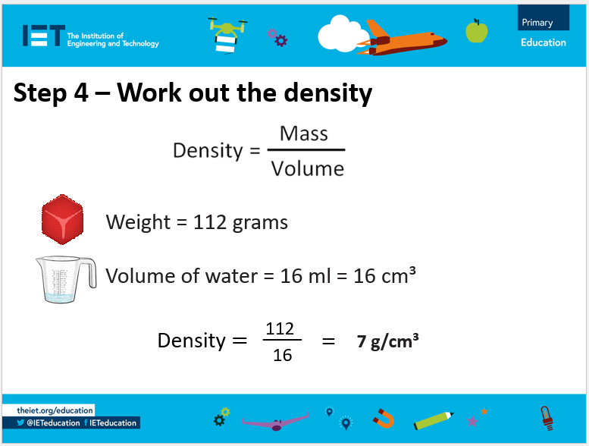

Complete this worksheet for each material you test.
Material | Weight (g) | Volume (ml) | Density (g/cm³)

