How high does it go?
Worksheet
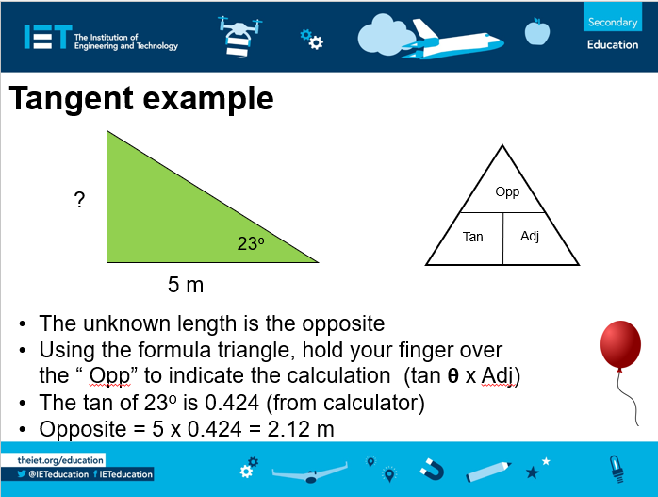

Record your angle results in the table below:
Angle | Gap distance (m) | Height (m)
23º |  | The tan of 23º is 0.424 (from calculator)  Opposite = 5 x 0.424 = 2.12 m

