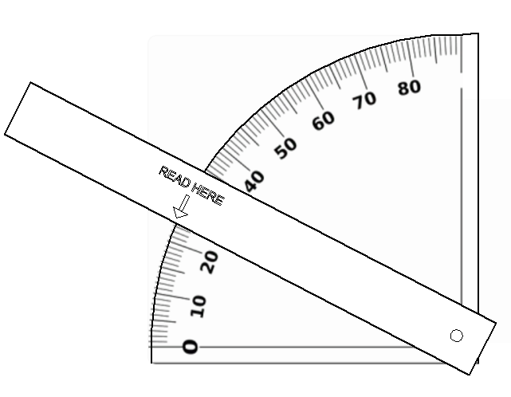
How high does it go?
Instructions

Clinometer

- Print off the worksheet onto thin card.
Punch
a hole
- Carefully cut out, on the solid lines, the outline of clinometer with scissors,
- Punch a hole in the protractor and the slider using a sharp object e.g. a sharp pencil.
- Use a brass paper fastener to join the slider to the protractor.

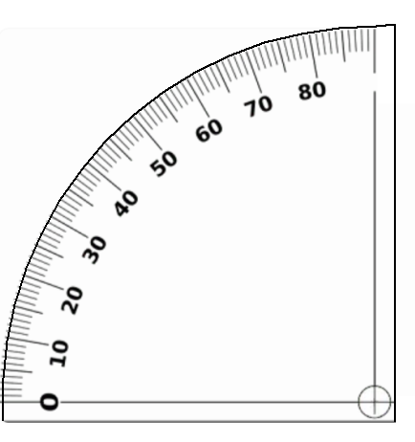

Punch a hole

