Measuring Noise
Typical noise levels are shown in the chart below:
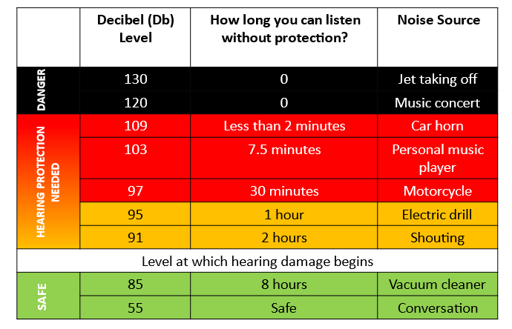

Measure the noise level for the following and write the result in the table:
Activity | Location | Decibel (Db)  Level
A1 | A silent classroom
A2 | Students silent and only the teacher talking
A3 | A group of students talking of shouting at the other side of the classroom
A4 | Your table group talking loudly or shouting
A5 | A noisy classroom (everybody talking or shouting)

