Wearable cockpit worksheet
Use the template below to start your mind map. Alter and add as needed but try to include as much detail as possible.

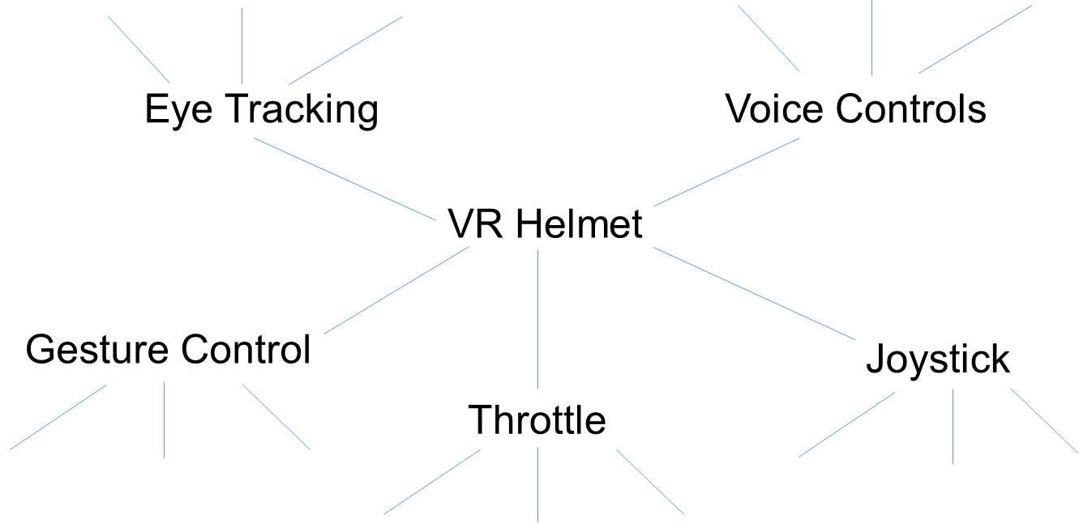

Design Idea for the virtual cockpit display

Designing the Helmet
- Use the templates of faces to help you design your wearable cockpit helmet
- Annotate your idea – what materials will be needed? What does each part do? How does it connect with the user?

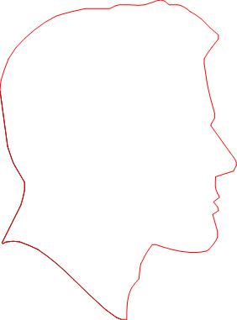

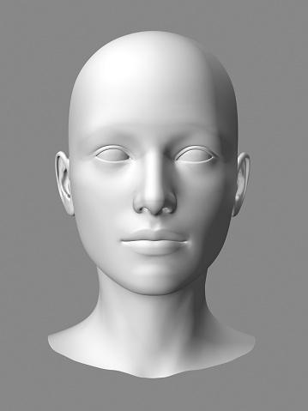

Evaluation
Specification point | Included ( or ) | Reason
Joystick
Throttle
Eye Control
Gesture Control
Voice Control

What went well?

What could be improved?

What are you most proud of?

What makes your design special/unique? What is its USP (unique selling point?)

