**Gear Ratio Activity Sheet**

Cut out the gears and glue them to card.

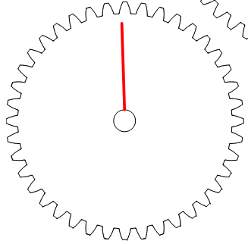

**Can you create the following Gear Ratios using the gears provided?**

|  |  |
| --- | --- |
| **1:5** | **1:2** |
| **1:1.5** | **1:4** |
| **1:3** | **1:2.5** |