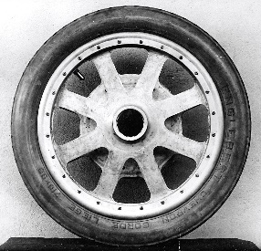
Bugatti Trust Museum and Study Centre
Materials testing
- Test each disc and record the results below:
Material | Weight (g) | Number of Rotations | Time (secs) | Speed (m/s⁻¹)  Disc circumference/time

- Which material produced the highest number of rotations? ______________________________________________
- Which material produced the slowest speed? ______________________________________________
- Explain the factors that may affect the rotation of each material.
____________________________________________________________________________________________________________________________________________________________________________________________________________________________________________

