Activity Sheet - Trainers of the Future
For each of the following trainers, insert an image or sketch and write key points on what impresses you about them:

- Nike self-lacing HyperAdapt 1.0 ™

- Under Armour HOVR Phantom and HOVR Sonic ™

- Digitsole ™

- Xiaomi MiJia smart shoes ™

- Altra Torin IQ ™

Trainer Design – space for creativity!!
Initial ideas x 2
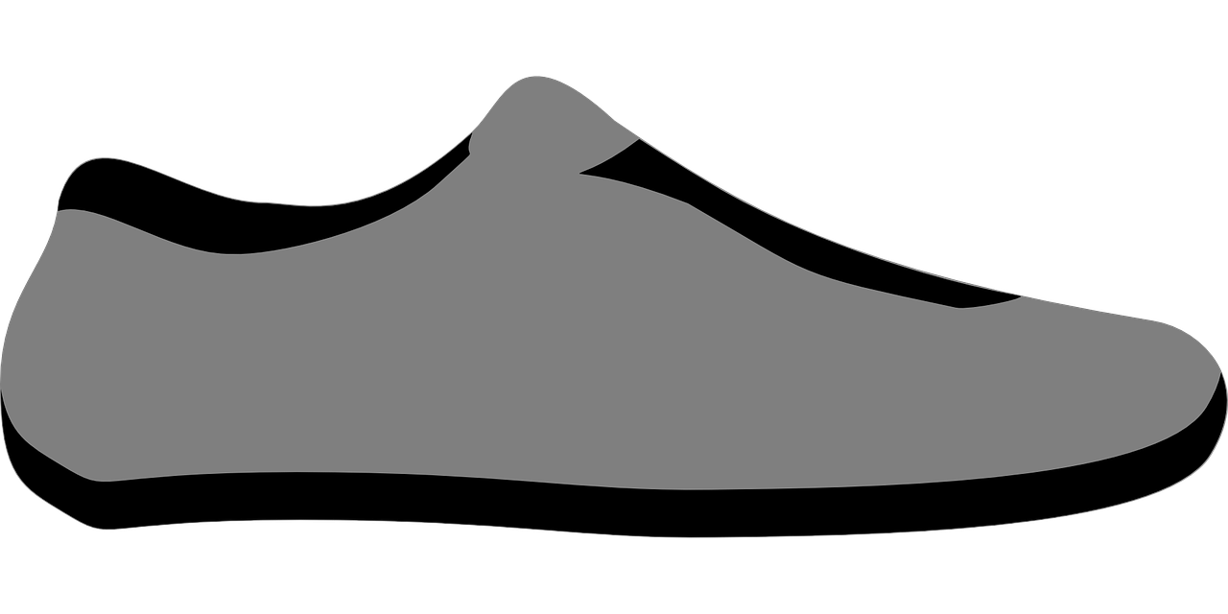

Final Design – Combine the best bits from your initial designs to create your final design. Remember to annotate the key features.

