Activity title
Chocolate catapult
Stay safe
Whether you are a scientist researching a new medicine or an engineer solving climate change, safety always comes first. An adult must always be around and supervising when doing this activity. You are responsible for:

• ensuring that any equipment used for this activity is in good working condition
• behaving sensibly and following any safety instructions so as not to hurt or injure yourself or others

Please note that in the absence of any negligence or other breach of duty by us, this activity is carried out at your own risk. It is important to take extra care at the stages marked with this symbol: ⚠
Time required
1 hour
Activity summary
Ever wondered how a catapult works and wanted to try one out for yourself but didn’t know where to start? Well, now you can make your very own catapult and what’s even better is that you can then fire chocolate from it – all in the name of science!
What equipment will you need?
- Craft sticks (at least 7)
- Small elastic bands (at least 6)
- A teaspoon (metal or plastic)
- Chocolate mini eggs (or similar to use as ammunition!)
How to do it
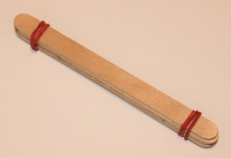
Step 1 – Make your ‘fulcrum’
- Using elastic bands at each end, attach 4 (or 5) craft sticks together
- You will need to wrap the elastic bands around a few times to hold it securely
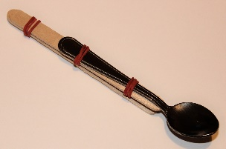
Step 2 – Make your ‘thrower’
- Using two elastic bands, attach the teaspoon to one end of a craft stick
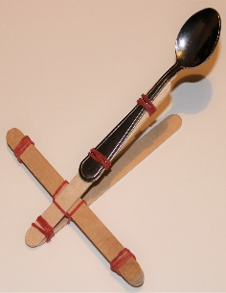
- Using one elastic band, attach a second craft stick to the other end of the first stick

Step 3 – Assembly
- Wedge the block between the two craft sticks of the thrower
- Wrap an elastic band about the point where it touches the craft sticks to hold it in place

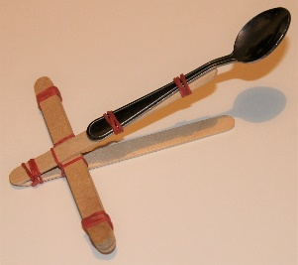
Step 4 – Fire! ⚠
- Using one hand, hold down the catapult at the end
- Place the chocolate mini egg in the spoon
- Pull the spoon back – then release and launch the egg!

Well done – you have made and tested your very own catapult!

Now try this
Why not try out some alternative designs now? For more throwing power, try making a structure using pencils and elastic bands. What else could you use?

Easter jokes
- What so you get when you cross a rabbit with shellfish?
An oyster bunny

- Why was the little girl sad after the Easter egg hunt?
Because an egg beater

- Did you hear about the dirty Easter egg hunt?
It was hosted by a dust bunny

Fun facts
- Before chocolate Easter eggs, eggs were given as a gift to celebrate spring – for more than 2,000 years.
- Chickens are social animals and establish community hierarchies – hence the term ‘pecking order’!
- Chocolate contains over 300 chemicals including a multitude of vitamins, minerals (calcium, iron, potassium, magnesium).

