Activity title
Egg drop challenge
Stay safe
Whether you are a scientist researching a new medicine or an engineer solving climate change, safety always comes first. An adult must always be around and supervising when doing this activity. You are responsible for:

• ensuring that any equipment used for this activity is in good working condition
• behaving sensibly and following any safety instructions so as not to hurt or injure yourself or others

Please note that in the absence of any negligence or other breach of duty by us, this activity is carried out at your own risk. It is important to take extra care at the stages marked with this symbol: ⚠
Time required
1 – 1.5 hours
Activity summary
Have a cracking time with this activity as you try to design a structure with paper tubes to protect your egg when you drop it from a height.
What equipment will you need?
- 6 sheets of A4 paper
- 2 pencils
- Sticky tape
- 1 egg (plus more for testing!)
How to do it
Step 1 – Making tubes
- Roll paper into a tube using pencils
- Stick the outside edge of the paper down with sticky tape and take the pencils out
- Make 6 paper rolls

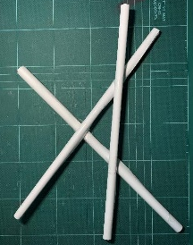
Step 2 – Base frame
- Use sticky tape to join 3 paper rolls as shown
- Make the triangle in the middle a size so that an egg sits on it without falling out
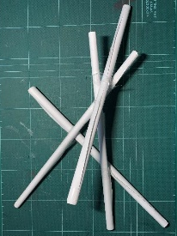
Step 3 – Uprights
- Use sticky tape to attach the last 3 paper rolls to the points shown (image shows the first one attached)
- Don’t join the other ends yet, or your egg will not fit in!

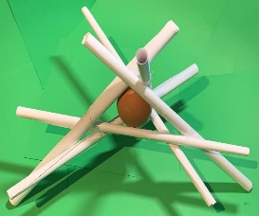
Step 4 – Final assembly
- Add your egg to the centre of the completed frame
- Use sticky tape to join the three loose upright straws so the egg is held in place

Egg drop challenge
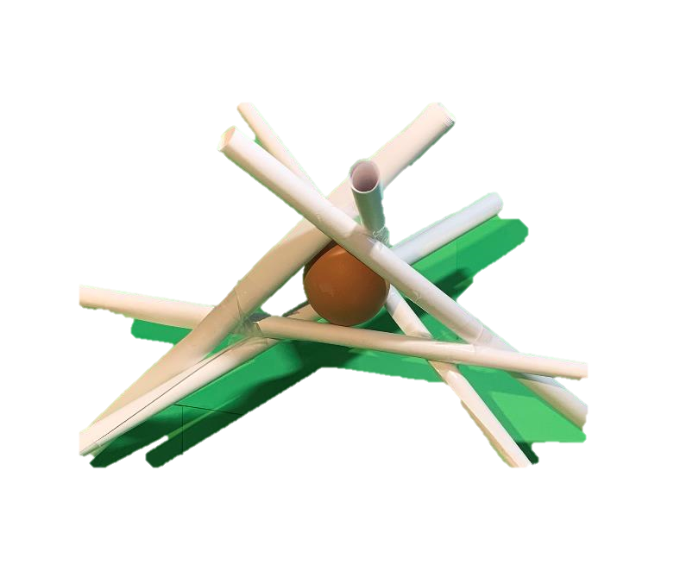
- Hold your egg protector and drop from a height of 0.5m
- Then try 1m height
- From how high can you drop the egg before it breaks?

Other ideas
- How could you change the design to help stop the egg breaking?
- What other materials could you use to help the egg survive?
- Could you add a parachute made from a shopping bag?

Easter jokes
- Why does the Easter bunny want an Olympic medal?
He’s heard it’s 24 carrot.

- What do you call a mischievous egg?
A practical yolker.

- Why was the Easter bunny upset?
It was having a bad hare day!

Fun facts
- In Bermuda, Easter is celebrated with a colourful kite extravaganza on the beach.

- Hens often sing an ‘egg song’ before, during and after laying.

- Before chocolate Easter eggs, eggs were given as a gift to celebrate spring – for more than 2,000 years.

