Activity title
Easter diorama box project
Stay safe
Whether you are a scientist researching a new medicine or an engineer solving climate change, safety always comes first. An adult must always be around and supervising when doing this activity. You are responsible for:

• ensuring that any equipment used for this activity is in good working condition
• behaving sensibly and following any safety instructions so as not to hurt or injure yourself or others

Please note that in the absence of any negligence or other breach of duty by us, this activity is carried out at your own risk. It is important to take extra care at the stages marked with this symbol: ⚠
Time required
1 hour
Activity summary
Instead of a card this year why not make an Easter box to give to your friends and family with a special Easter message inside? These are great fun to make and can be customised to make them more personal to you.
What equipment will you need?
- Easter box templates – sheet 1 & 2
- Easter egg template – sheet 3
- Scissors
- Glue
- Colouring pens/pencils
How to do it
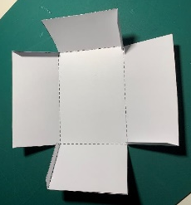
Step 1 – Make your Easter box ⚠
- Cut out the solid lines on the Easter box template sheet 1, then score and fold the dotted lines.
- Glue the tabs and make the box.
Step 2 – Cut out your lid ⚠
- Cut out the lid from template sheet 2
- Fold it in half
- Cut out the egg shape to create a viewing hole

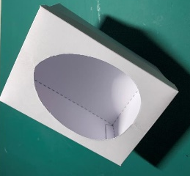
Step 3 – Make your lid ⚠
- Cut the tabs on the solid lines
- Score and fold the dotted lines
- Glue the tabs to make the lid
- Check the lid fits on the box
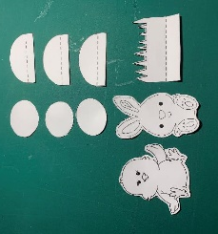

Step 4 – Make the Easter box parts ⚠
- Cut out the solid lines
- Score and fold the dotted lines
- Glue the eggs, bunny and chick to the stands
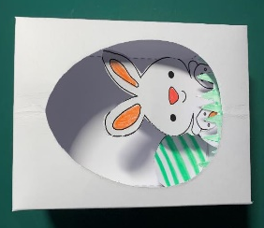
- Colour in the individual parts

Step 5 – Create the scene
- Glue the parts into place to create a diorama
- Add the lid to complete your Easter box

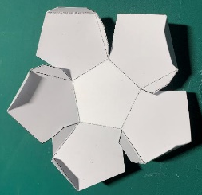

Step 6 – Make your egg base ⚠
- Cut out the solid lines
- Score and fold the dotted lines
- Glue the inner tabs and make the egg base

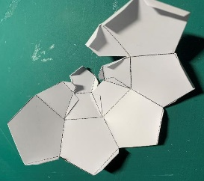

Step 7 – Make the egg top ⚠
- Cut out the solid lines
- Score and fold the dotted lines
- Glue the smaller tabs at the top and join together

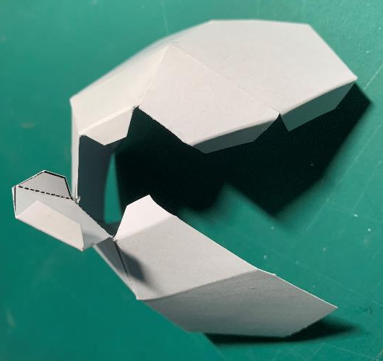

Step 8 – Assemble the egg top
- Glue the side tabs and join the egg top together
- Glue the tabs on the top cover and close

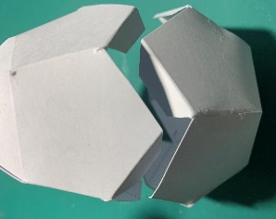
Step 9 – Assemble your egg
- The egg parts may be kept separate or the top placed on the base with the tabs joined together
Step 10 – Create the scene
- Your egg may be placed in the box open or closed

Well done – you have made your Easter box!

Easter jokes
- What kind of stories do Easter eggs tell their children?
Yolk tales

- What is the best way to make Easter easier?
Swap the ‘T’ for an ‘I’

- What is the Easter Bunny’s favourite sport?
Basket-ball of course!

Fun facts
- If you stacked all the Cadbury Crème Eggs made in a year on top of each other, they would create a tower taller than Mount Everest!

- It’s alleged chickens from different countries have their own distant language and accents, just like humans!

- As a hen grows older, she produces larger eggs.

- Recipes for soft- and hard-boiled eggs date back to Egyptian times.

- Containing just 74 calories each, eggs are one of the healthiest foods you can eat.

