Activity title
Test out Galileo's gravity experiment
Stay safe
Whether you are a scientist researching a new medicine or an engineer solving climate change, safety always comes first. An adult must always be around and supervising when doing this activity. You are responsible for:

• ensuring that any equipment used for this activity is in good working condition
• behaving sensibly and following any safety instructions so as not to hurt or injure yourself or others

Please note that in the absence of any negligence or other breach of duty by us, this activity is carried out at your own risk. It is important to take extra care at the stages marked with this symbol: ⚠
Time required
1 hour
Activity summary
Egg rolling is a traditional game played at Easter where hard boiled, decorated eggs are raced downhill. Why not decorate your own eggs before using them to take part in this science experiment?
What equipment will you need?
- A length of channel or guttering
- A tape measure
- A protractor
- A stopwatch
- The results table
- A pen or pencil
- An egg (plastic or boiled or solid)
- Weighing scales (for extension activity 2 only)
How to do it
Step 1 – The set up
- Measure the distance between the ends of the slope
- Measure the angle of the slope using a protractor

Step 2 – The egg roll
- Place the egg at the top of the slope
- Release the egg and measure the time it takes to roll down the slope

Step 3 – Repeat the egg roll
- Repeat the egg roll twice more to get an average speed
Step 4 – Change the angle
- Change the angle of the slope, record the angle and repeat the egg roll

Step 5 – Record your results
- Draw up a table or use the one provided below and add your results to it
- Plot a graph to show your results
- What does this tell you?

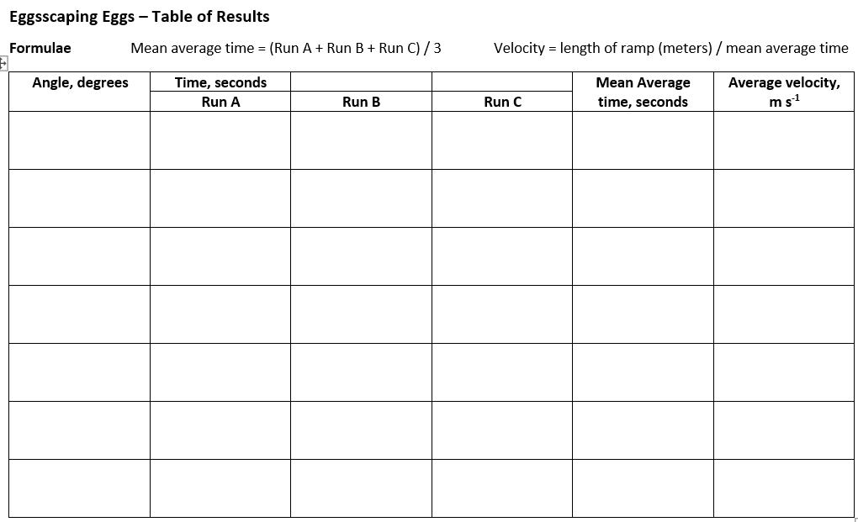

Extension 1
- Calculate the acceleration of the egg:
Acceleration = velocity / mean average time

- Plot the acceleration against the angle of the slope.

- The acceleration due to gravity is 9.81 m s-2.

Explain how this is different from the observed value

Extension 2
- Weigh the egg
- Measure the height from the ground to the release point for the egg
- Calculate the potential energy of the egg: PE = mgh
(where m = the weight of the egg, g = the acceleration due to gravity, 9.8 m s-2, h = height in meters)
- From the principle of the conservation of energy, when it reaches the ground, the kinetic energy of the egg should be equal to the potential energy at the release point
- Kinetic energy = ½ m v2
(where m = the weight of the egg, v = the velocity, m s-1)
- Calculate the theoretical velocity at the bottom of the slope
- Is this the value you found? If it is different, why is this?

Easter jokes
- What do you get if you cross the Easter bunny with Winnie the pooh?
A honey bunny

- Why couldn’t the Easter bunny watch their favourite show?
Because their TV was scrambled.

- What day does an Easter egg hate the most?
Fry-day

Fun facts
- Easter baskets represent birds’ nests and new life and are a great way to keep all your eggs together!

- Easter egg hunts have been a tradition since medieval times. The priest would give a choir boy a hardboiled egg, which would be passed around the choir. The boy holding the egg when the clock struck midnight got to eat it.

- Wearing new clothes at Easter was considered to bring you good luck for the rest of the year.

