**Eggs-actly right: eggs – words 1-10**

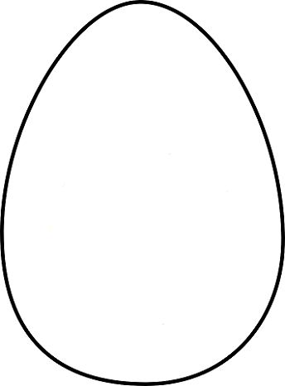

one

nine

three

six

four

two

five

eight

seven

ten

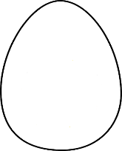

Use scissors to cut out each egg

**Eggs-actly right: eggs – words 20-100**



twenty

one hundred

forty

seventy

fifty

thirty

sixty

ninety

eighty

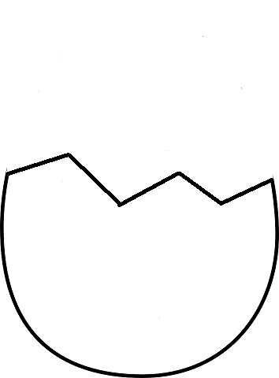**Eggs-actly right: eggs – figures 1-10**

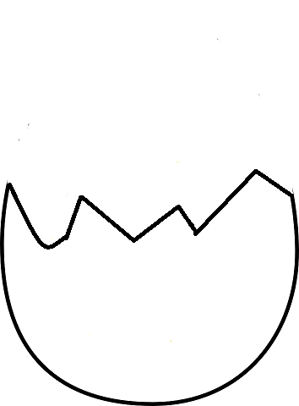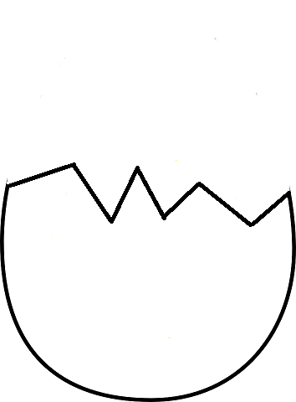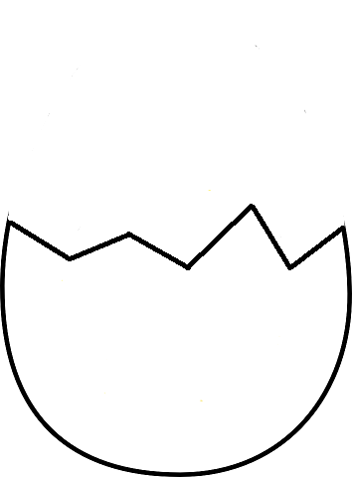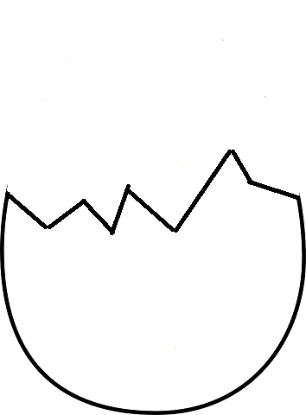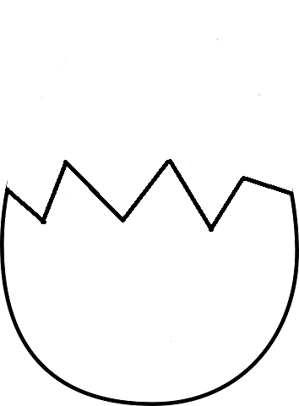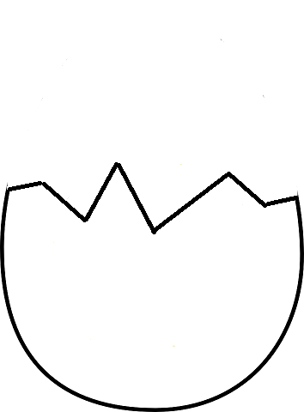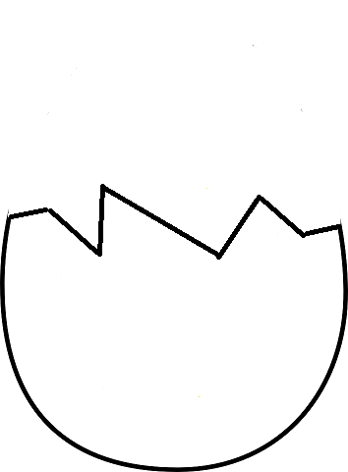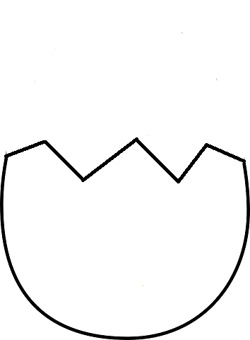

1

3

2

6

4

5

7

9

8

10

**Eggs-actly right: eggs – figures 20-100**





20

40

30

70

50

60

80

100

90

**Mathematical Operators**

equals

plus

minus

divided by

divided by

times