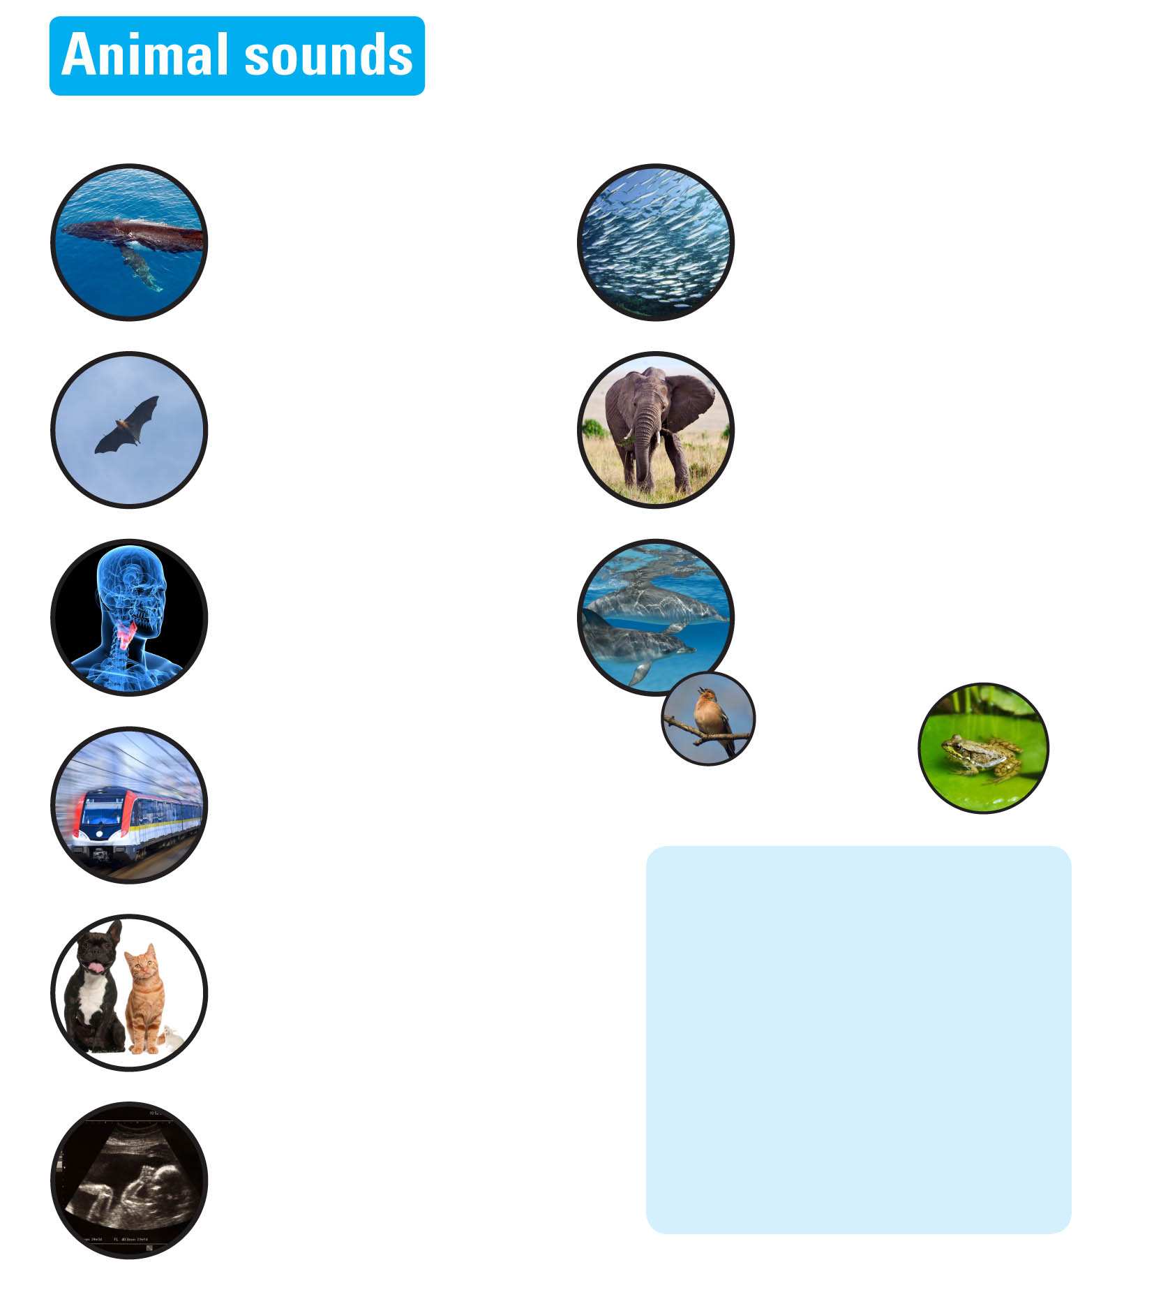


Explore engineering careers at www.tomorrowsengineers.org.uk
Use these pictures to learn what the words at the bottom of the page mean.

Whale song travels hundreds of miles in water. The velocity of sound is four times faster in water than in air.

Bats use echo location in flight. The squeak of a bat bounces back when it hits an insect. The time and direction of the echo tells the bat where the insect is.

Bats and pregnancy clinics use ultrasound for
the same reason. They use it to echo off objects, so you can build up a picture.
When boys grow older, their voices break. This is because the larynx grows and bigger vocal cords make lower-pitched sounds.

A train whistle is at a higher pitch when coming towards you because the wavelength of the sound gets shortened by the motion of the train. This is known as the Doppler Effect. Animals such as bats can use these sound effects to determine whether prey is travelling towards or away from them.

Mice have very high-pitched squeaks. Their vocal chords vibrate very quickly.
Dogs have bigger vocal cords. These make lower pitched barks that can be very loud. Louder sounds have the same pitch but larger amplitude.
Cats modify their meow to communicate different feelings.

Fish release bubbles of gas from their anus when they are scared and this can be quite loud.

Elephants seem like quiet animals that trumpet very occasionally.
But elephants communicate by infrasound,
below the threshold of human hearing.
Sometimes humans hear these elephant ‘belly rumbles’ but they are in fact produced at the base of the trunk, not the belly.

All of these animals use sound to communicate. Bird song often contains signals to attract a mate. Male frogs croak to attract female frogs. Dolphins are real communicators. We know that they talk and pass information to each other but scientists have not deciphered their code yet.

Write a sentence to explain what each of these mean:
Amplitude
Velocity
Ultrasound
Infrasound
Frequency
Wavelength
Communication
Pitch
Echo

