Activity title
Air-powered cars
Stay safe
Whether you are a scientist researching a new medicine or an engineer solving climate change, safety always comes first. An adult must always be around and supervising when doing this activity. You are responsible for:

• ensuring that any equipment used for this activity is in good working condition
• behaving sensibly and following any safety instructions so as not to hurt or injure yourself or others

Please note that in the absence of any negligence or other breach of duty by us, this activity is carried out at your own risk. It is important to take extra care at the stages marked with this symbol: ⚠
Time required
40-60 minutes
Activity summary
Design and make your own Lego® cars before you race them using balloon power!
What equipment will you need?
- Plastic construction bricks, including wheels
- Balloons
- A stopwatch or a stopwatch App on a phone
- If available: a tape measure to measure the distance of the course
- Optional: plastic straws, sticky tape, cardboard strips (for walls for the test track)
How to do it
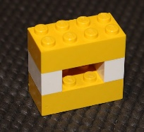
Step 1 – Build your balloon holder
- This is a block to hold the balloon in place
- Keep the space in the middle small – otherwise the balloon will fly out of it!

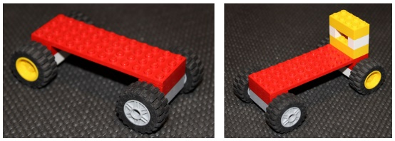
Step 2 – Build your base
- You can have as many wheels as you want – 3? 4? 6? 8?
- Put the balloon holder at the back of the base
- It helps to raise up the balloon holder slightly, to give more space for the balloon

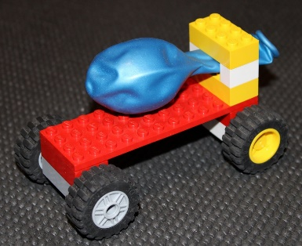
Step 3 – Race!
- Put your balloon in place
- Time how long it takes the car to go the distance
- Calculate the speed of your vehicle by dividing the distance it
travels by the time

Top tip:
- blow up the balloon,
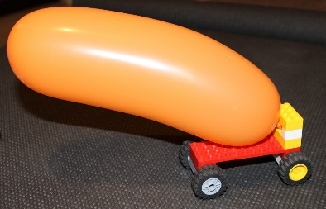
- hold the end,
- lift the top block from the balloon mount,
- put the balloon in place,
- reattach the top block –
- then you are ready to let go of the balloon and race!

Step 4 – Record your results
- Draw up a table to record your results
- Try racing with your friends or family

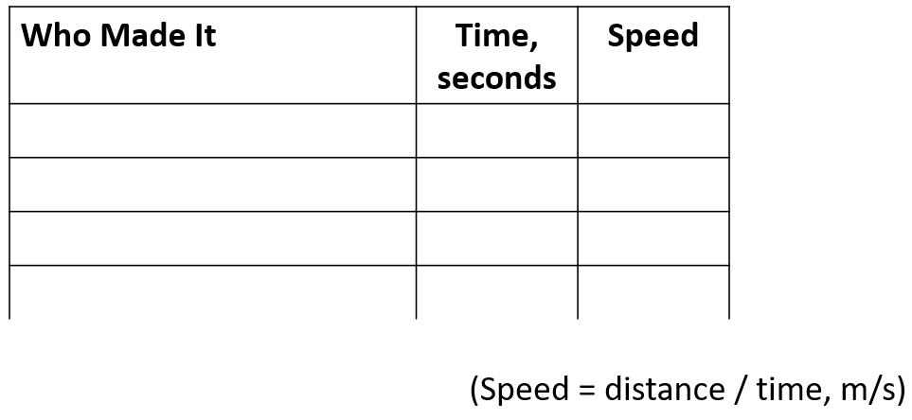

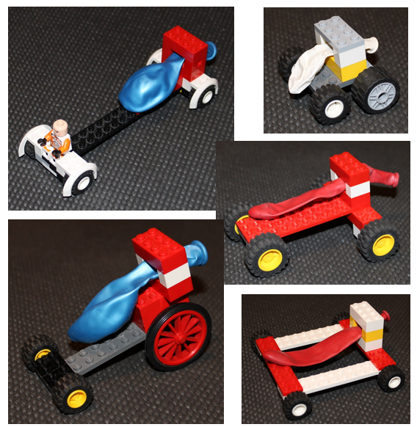
Looking for more?

- Try making different designs of car – which is the fastest? Why?

- Try using different sizes of balloon – do these change how fast the car is?

- Investigate how fast other vehicles move and compare the speed of your car.

Top tip – to compare it to a car:
2.24 x meters/second = miles/hour

Summer jokes
- What do you get when you combine an elephant with a fish?
Swimming trunks!

- Do fish go on holiday?
No, because they are always in school!

- Why did the dolphin cross the beach?
To get to the other tide!

- Why don’t oysters share their pearls?
Because they are shellfish!

Do you know?
- How do plants grow?
Most plants start out as a tiny seed that, when planted and given sunlight and water, will put out roots and start to grow shoot that may eventually grow into a flower, fruit or vegetable.

- Why do birds lay eggs?
The eggs protect the growing chicks as they develop. The mother bird would be too heavy to
fly is she carried her babies inside her until they were big enough to hatch out.

- What makes the sea wavy?
Tides and the effect of the wind blowing over the sea.

- Where does sand come from?
Shells and stones that have been ground down over the years.
