Activity title
Da Vinci bridge
Stay safe
Whether you are a scientist researching a new medicine or an engineer solving climate change, safety always comes first. An adult must always be around and supervising when doing this activity. You are responsible for:

• ensuring that any equipment used for this activity is in good working condition
• behaving sensibly and following any safety instructions so as not to hurt or injure yourself or others

Please note that in the absence of any negligence or other breach of duty by us, this activity is carried out at your own risk. It is important to take extra care at the stages marked with this symbol: ⚠
Time required
60-90 minutes (including after dark activity)
Activity summary
See if you can make a bridge where the parts are not joined together!
What equipment will you need?
- 16 pieces of dowel rod (or craft sticks)
- 32 small elastic bands
How to do it
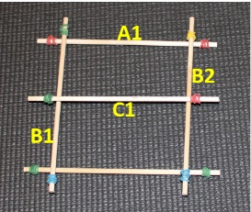
Step 1
- Make the shape shown
- Put the two end cross pieces A1 & A2 down first…
- … then place the two side pieces B1 & B2 on top…
- … then place the middle cross piece C1 on top.
Step 2
- Carefully holding the central piece C1 in place, lift the end cross piece A1 a few mm.
- Slide the sidepieces B3 and B4 over the top of C1 and under A1.

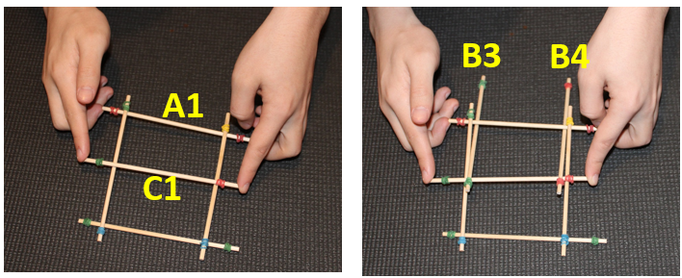

Step 3
- Carefully lift the cross piece A2 a few mm.
- Slide the side pieces B5 and B6 over the top of C1 and under A2.

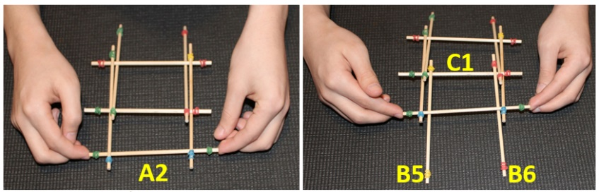

Step 4
- Carefully slide a new cross piece A3 under one end.
- Carefully lift the cross piece A3 a few mm.
- Slide the side pieces B7 and B8 over the top of A2 and under A3.

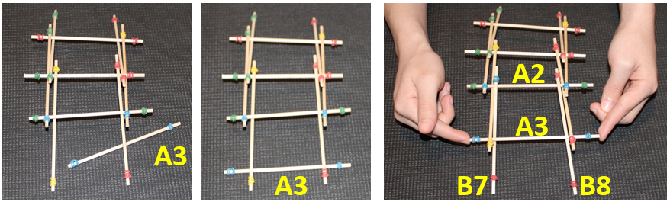

Step 5
- Repeat the method in step 4 to extend the bridge:
  - Carefully slide a new cross piece under the end.
  - Carefully lift the new cross piece a few mm.
  - Slide new side pieces over the top of the previous cross piece and under the new cross piece.
- Repeat until you have at least 6 cross pieces in place.

The finished bridge
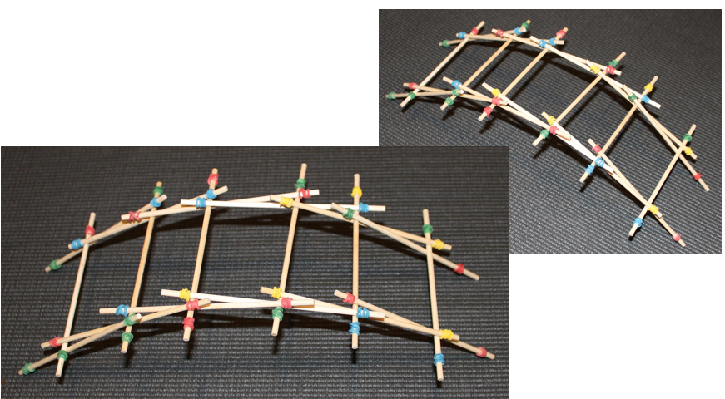

Summer jokes
- What travels all around the world but stays in one corner?
A postage stamp!

- Why are fish never good tennis players?
Because they never get close to the net!

- What’s grey, had 4 legs and a trunk?
A mouse on holiday!

- What do you call a snowman in July?
A puddle!

Do you know?
- What makes the sun so hot?
Powerful reactions inside the sun that make large amounts of heat and light.

- What device collects energy from the sun?
Solar panels make electricity from sunlight.

- Why do different countries use different money?
Because they each have their own currencies. You can exchange money from one currency to another when you travel to a different country.

- How do planes fly?
Planes fly by balancing the forces of drag, thrust, lift and gravity. As an aeroplane flies through the sky, it has to push the air around it.
