Activity title
Erupting volcano experiment
Stay safe
Whether you are a scientist researching a new medicine or an engineer solving climate change, safety always comes first. An adult must always be around and supervising when doing this activity. You are responsible for:

• ensuring that any equipment used for this activity is in good working condition
• behaving sensibly and following any safety instructions so as not to hurt or injure yourself or others

Please note that in the absence of any negligence or other breach of duty by us, this activity is carried out at your own risk. It is important to take extra care at the stages marked with this symbol: ⚠
Time required
40-65 minutes
Activity summary
Make an erupting model of a volcano using sodium bicarbonate and vinegar!
What equipment will you need?
- Small plastic soft drink or water bottles (ideally 200 ml)
- Scissors
- Sticky tape
- A3 thin card
- Paint and brushes
- Coloured pencils

For volcano lava:
- Food colouring
- Water
- Washing-up liquid
- Sodium bicarbonate
- Vinegar
- If available, jugs and funnels

How to do it
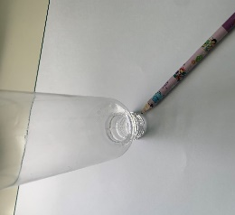
Step 1 – Shape the card ⚠
- Place the bottle upside down in the centre of the A3 thin card
- Trace around the bottle neck
- Carefully cut out the circle with scissors

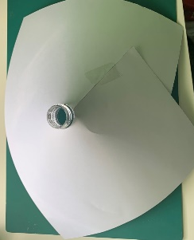

Step 2 – Volcano shape
- Wrap the card around the bottle
- Sticky tape the card in place
- Cut around the cone to make a volcano shape

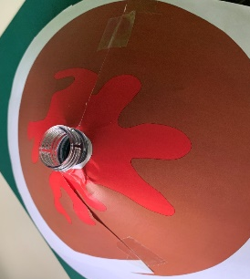

Step 3 – Decorate your volcano

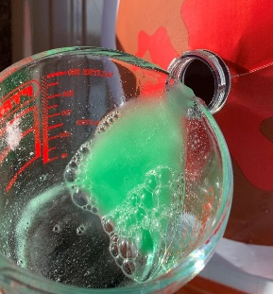
Step 4 – Make the lava ⚠
- Mix one tablespoon each of sodium bicarbonate and washing-up liquid
- Add two tablespoons of water and mix
- Pour the mixture into the bottle

Step 5 – Volcano testing ⚠
- Mix one tablespoon of food colouring with half a cup of vinegar (125 ml)
- Add the mixture to the bottle
- Watch the volcano erupt!
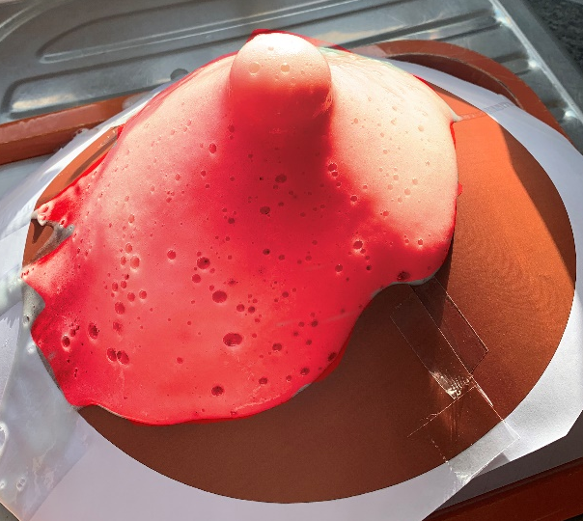

Summer jokes
- What’s black and white and red all over?
A zebra with sunburn!

- Where do sheep go on holiday?
The baa-hamas!

- How can you tell that the ocean is friendly?
It waves!

- Why do fish swim in saltwater?
Because pepper would make them sneeze!

Do you know?
- How is a rainbow formed?
A rainbow can form when both sunshine and water droplets are in the sky. Sunlight is white light, which is a mixture of all visible colours. As sunlight passes through the water droplets, it is bent and split into seven colours: red, orange, yellow, green, blue, indigo, and violet.

- How many noses does a slug have?
4! These are at the end of their tentacles and are used to gather information about their environment.

- How does a frog drink water?
Through it’s skin.

- What does a human and a banana have in common?
Humans share about 50% of their DNA with bananas.

