Activity title
Rubber band helicopter
Stay safe
Whether you are a scientist researching a new medicine or an engineer solving climate change, safety always comes first. An adult must always be around and supervising when doing this activity. You are responsible for:

• ensuring that any equipment used for this activity is in good working condition
• behaving sensibly and following any safety instructions so as not to hurt or injure yourself or others

Please note that in the absence of any negligence or other breach of duty by us, this activity is carried out at your own risk. It is important to take extra care at the stages marked with this symbol: ⚠
Time required
60-90 minutes
Activity summary
Build a working rubber band powered helicopter.
What equipment will you need?
- Printed activity sheets
- Paperclips (30mm)
- 1 bead per pupil (6 to 8 mm)
- Sticky tape
- Pliers (longnose type are best)
- Rubber bands
- Yoghurt pot tops or other thin plastic
- Small card tubes
- Erasers or sticky tack
- Skewers
- Wire/crochet needle/ thread/fishing line to pull rubber band through the tube.
How to do it
Carefully cut out the parts from the handout ⚠

Step 1 – Make the tube
- Roll the tube template around a pencil
- Use sticky tape on the edge of the template to make it stay round
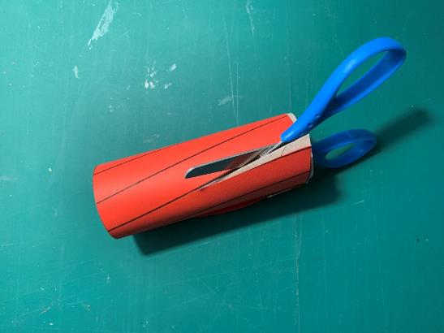
- Remove the pencil

Step 2 – Cut out the propeller ⚠
- Wrap the propeller template around the card tube
- Hold in place with paperclips
- Carefully cut a propeller
- Use a sharp pencil and eraser to make a hole

Step 3 – Propeller wire bending 1 ⚠
- Straighten out a paperclip
- Cut it with pliers, to the size of the template
- Bend the wire using to follow the template, using your hands
- Use pliers to make a small hook

Step 4 - Propeller wire bending 2 ⚠
- Straighten out a paperclip
- Bend the wire to follow the template
- Make a W
- Use pliers to cut the ends

Step 5 – Propeller disc ⚠
- Use a glue stick to attach the disc to yoghurt pot top
- Carefully cut out with scissors
- Carefully use a sharp point to make a hole
- Use a skewer to make the hole larger

Step 6 – Propeller assembly 1 ⚠
- Attach the disc to the wire hook
- Attach the bead to the wire hook
- Bend the wire

Step 7 – Propeller assembly 2 ⚠
- Put hook through centre hole
- Bend the wire with pliers
- Cut off wire with pliers to leave 5mm
- Bend the wire with pliers to hold the propeller

Step 8 – Rubber band assembly ⚠
- Put the rubber band on the W wire
- Use a wire/crochet needle to pull the rubber band through the tube
- The W wire sits at the bottom of the tube

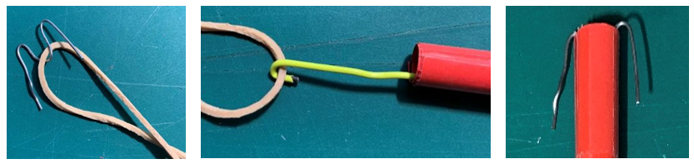

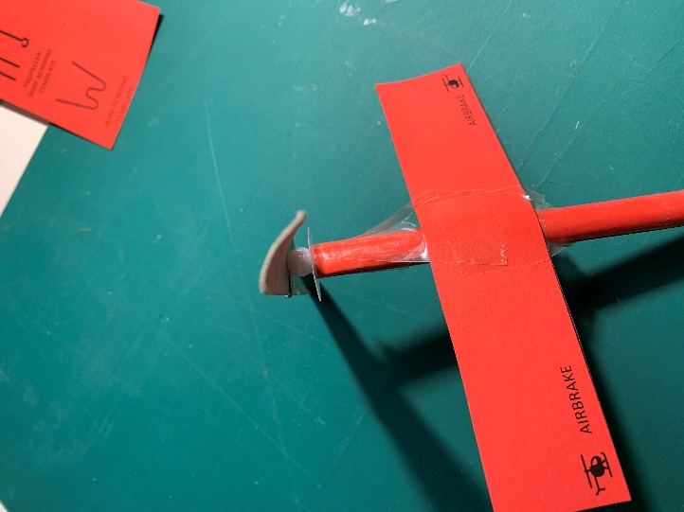
30 mm
Step 9 – Propeller and airbrake
- Connect the propeller to the rubber band
- Measure 30 mm from the top of the tube
- Attach the airbrake with sticky tape

Step 10 – Test flight
- Wind the propeller anti-clockwise, about 50 turns
- Hold vertical and let go of the propeller
- How high will it fly?
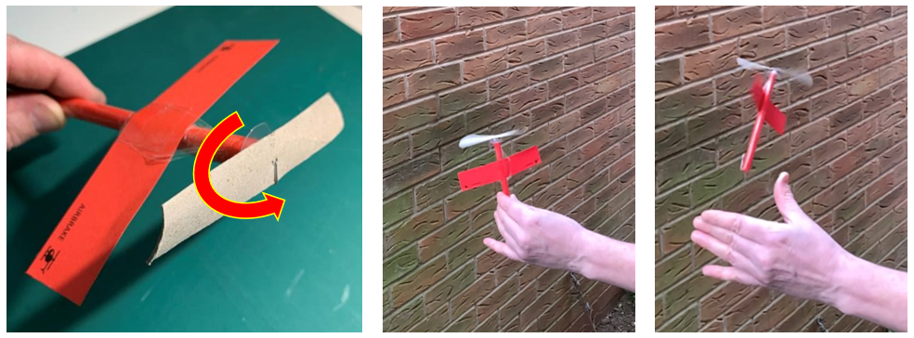

Well done! You have made your own flying rubber band helicopter!

Summer jokes
- Why did the robot go on a summer holiday?
To recharge his batteries!

- Which letter of the alphabet is the coolest?
Iced T!

- Why do fish like to eat worms?
Because they get hooked on them!

- Why should you never blame a dolphin for doing anything wrong?
Because they never do it on porpoise!

Do you know?
- How many eyes does a caterpillar have?
12! They have 6 on either side of their head.

- Do all stars look the same?
Each star is a different colour depending on its temperature.

- How often do we get thunderstorms?
There are nearly 2,000 thunderstorms on Earth every minute.

- How hot is lightning?
A bolt of lightning is five times hotter than the sun.
