Activity title
Stargazing
Stay safe
Whether you are a scientist researching a new medicine or an engineer solving climate change, safety always comes first. An adult must always be around and supervising when doing this activity. You are responsible for:

• ensuring that any equipment used for this activity is in good working condition
• behaving sensibly and following any safety instructions so as not to hurt or injure yourself or others

Please note that in the absence of any negligence or other breach of duty by us, this activity is carried out at your own risk. It is important to take extra care at the stages marked with this symbol: ⚠
Time required
50-60 minutes (including after dark activity)
Activity summary
Discover the key star constellations in the summer night sky. Learn how to use a star chart, a compass to find a direction and find star constellations.

What equipment will you need?
- Printed activity sheets
- UK Star Chart
- Compass
- Thin card
- Pencil
- Eraser
- Binoculars/telescope

How to do it
Star constellations
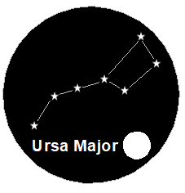
- These are groups of stars
- 18 can be seen in the summer!
- One is Ursa Major, also called the plough

Step 1 – Check the night sky
- Choose a clear night
- Stay away from bright lights
- Allow 20 minutes to let your eyes adjust to the dark
- Use a compass to find North, East, South and West
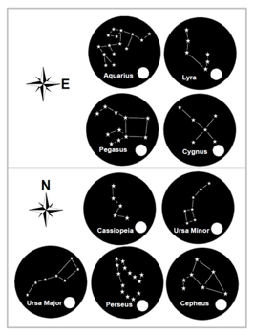

Step 2 – Look for the stars
- Find and look North
- Look carefully for Ursa Major (the plough)

Step 3 – Constellation hunt
- When you find a constellation tick off on your handout
- Find another one in the North
- Then explore East, South and West

Looking for more?

- Use the internet to research the individual constellations and find out where they got their names from.

- Watch YouTube: How to find the Summer Constellations (360⁰): https://www.youtube.com/watch?v=EieqUGAJHMw

- Share your experiences about the stargazing activity. How many constellations did you see? Which stars were the clearest and brightest?

Summer jokes
- What do ghosts like to eat in the summer?
I scream!

- Where do sharks go on holiday?
Finland!

- Why didn’t the sun go to college?
He already had a million degrees!

- What has ears but can’t hear?
A cornfield!

Fun facts
- Kangaroos can’t walk backwards.

- Bees are found everywhere in the world except Antarctica.

- Australia is home to 11 per cent of the world’s 6,300 reptile species making it the continent with the most number of reptiles!

- Human Eyes can detect about 10 million different colours!

