Activity title
Design an item of clothing to withstand UV
Stay safe
Whether you are a scientist researching a new medicine or an engineer solving climate change, safety always comes first. An adult must always be around and supervising when doing this activity. You are responsible for:

• ensuring that any equipment used for this activity is in good working condition
• behaving sensibly and following any safety instructions so as not to hurt or injure yourself or others

Please note that in the absence of any negligence or other breach of duty by us, this activity is carried out at your own risk. It is important to take extra care at the stages marked with this symbol: ⚠
Time required
60-90 minutes
Activity summary
Have fun with this ‘Dragon’s Den’ style activity where you can design your own piece of clothing that can guard against UV radiation. The clothing should provide extra protection to those already wearing sun cream and enable children to play more safely outside in the summer.
What equipment will you need?
- A4 or A3 paper
- Pencils, pens, coloured pencils and sketching tools
How to do it
Step 1 – What is UV and how can it effect people?
- You may want to do some of your own research on this before you begin the activity.

Step 2 – Consider how the effects of UV can be minimised through items of clothing?
- To guard against UV radiation when on holiday in hot climates.
- To provide extra protection when already wearing sun cream.
- For children to play more safely outside in the summer.
- …Can you think of anymore?

Step 3 – Clothing types spider diagram
- Create a spider diagram of different clothing types that could be worn to reduce the effects of UV rays form the sun.
- Discuss who would wear the clothing and the possible target users.
- Has this helped you decide which item you would like to design?

Step 4 – Points to consider
- When designing your item you will need to consider:
- Fabric type
- Who will wear it
- Colour
- Cost
- Durability
- Use of recyclable/recycled fabrics

Step 5 – Produce your design
- Select an item of clothing from your spider diagram.
- Sketch your design for that item.
- Add annotations to show how your design prevents or reduces the effects of UV rays and how it meets additional criteria identified in the spider diagram activity.

Example design 1

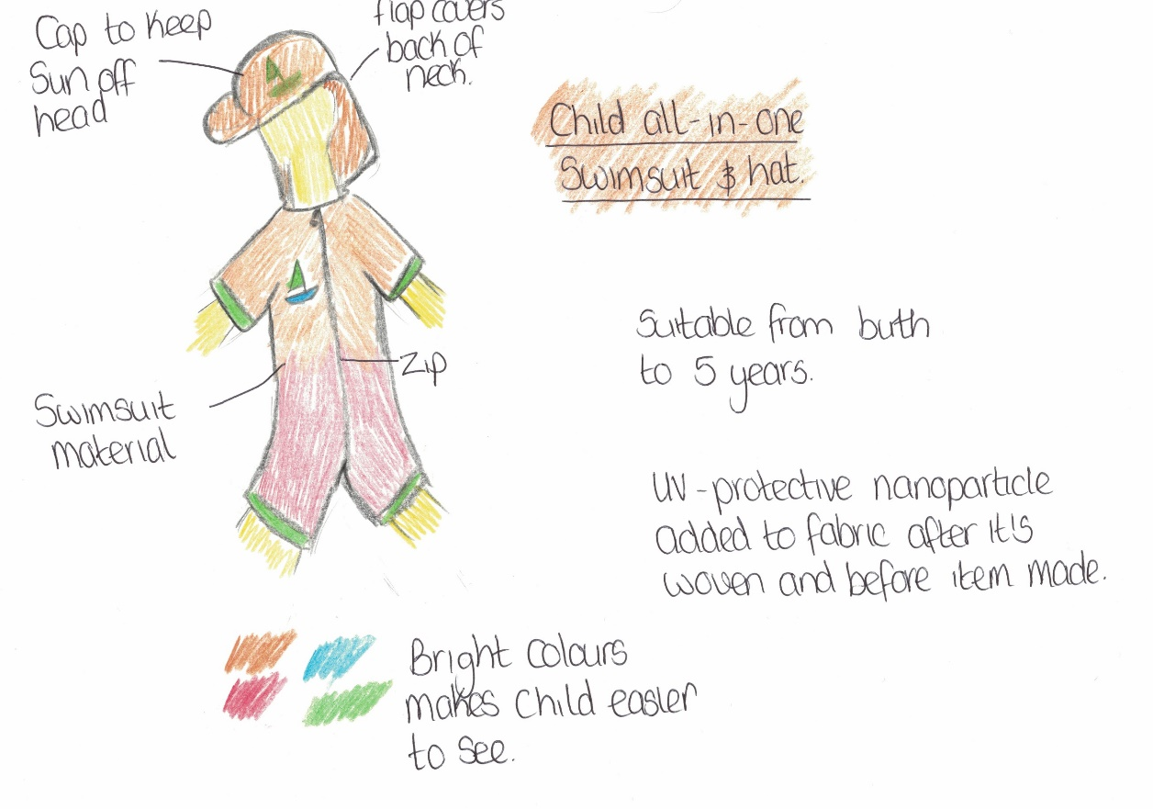

Example design 2
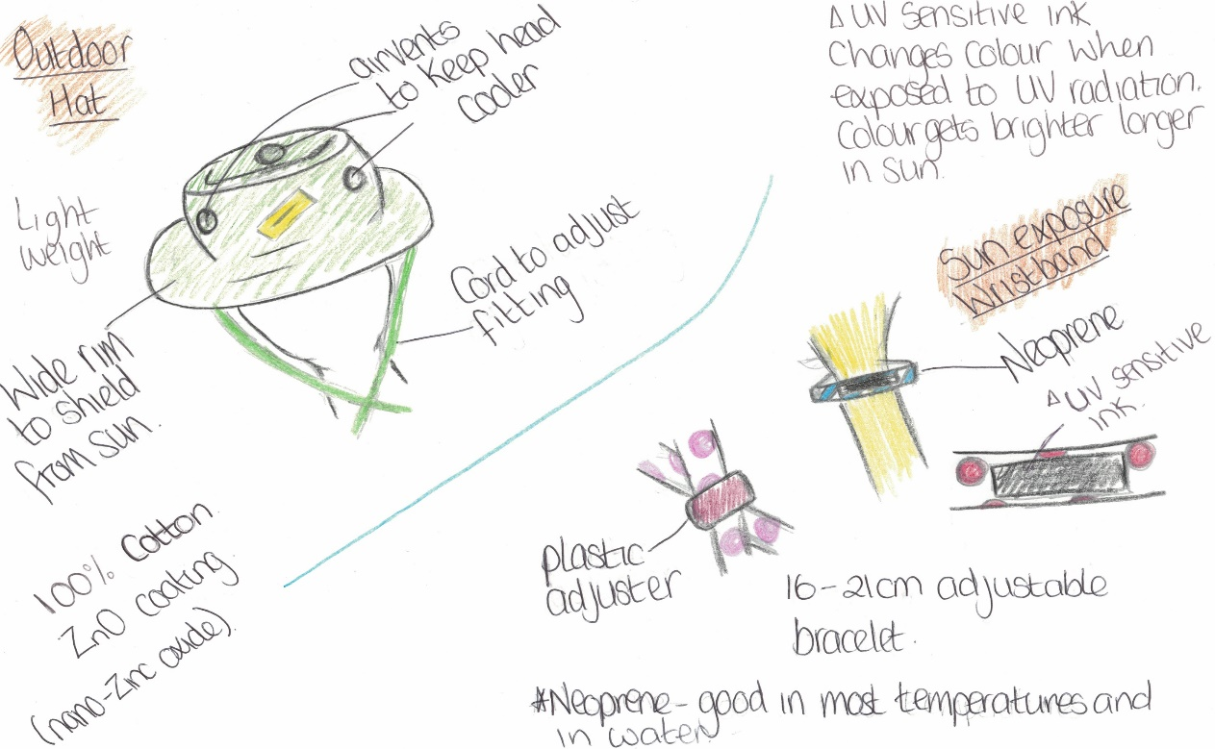

Example design 3
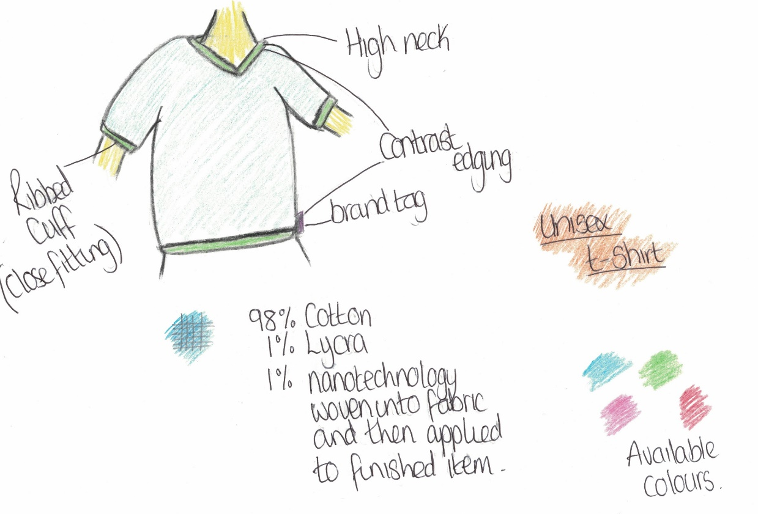

Looking for more?

- Produce a pattern, sample or full prototype of your design.

- Design a range of accessories to compliment your clothing.

- Create a social media advertisement for your designs.

Summer jokes
- What do sheep do on sunny days?
Have a baa-baa-cue!

- How do yellow jackets get to school in the morning?
By school buzz!

- What kind of water cannot freeze?
Hot water!

- Which summer holiday destination allows you to bring pet birds?
The Canary Islands!

Fun facts
- Almost half the world’s bluebell flowers grow in the UK.

- Classic Polaroid cameras have no batteries. Instead, each picture cartridge has a tiny one with just enough power to take the required number of photos.

- A common snail in your garden can have up to 14,000 teeth.

- Tomatoes, cucumbers and avocados are fruits not vegetables.

