Activity title
Make a paper aeroplane
Stay safe
Whether you are a scientist researching a new medicine or an engineer solving climate change, safety always comes first. An adult must always be around and supervising when doing this activity. You are responsible for:

• ensuring that any equipment used for this activity is in good working condition
• behaving sensibly and following any safety instructions so as not to hurt or injure yourself or others

Please note that in the absence of any negligence or other breach of duty by us, this activity is carried out at your own risk. It is important to take extra care at the stages marked with this symbol: ⚠
Time required
30-60 minutes
Activity summary
Have fun with this activity and see if you can design and make a paper aeroplane and then test it to see how long it can stay in the air. Why not race it against your friends’ and have a prize for the winner?
What equipment will you need?
- A4 printed paper aeroplane templates
- Coloured pens/pencils – to add artwork to your aeroplane (optional)
- Stopwatches - to measure flight time during testing
How to do it
Step 1 – Let’s fold
- Follow the numerical order
- Fold and hide each number
- Take your time
- Make sure the creases are flat

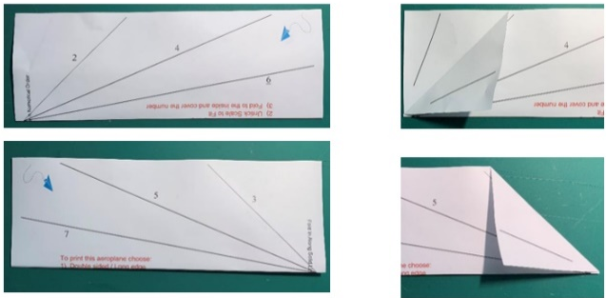
Step 2 – Fold 2 and 3

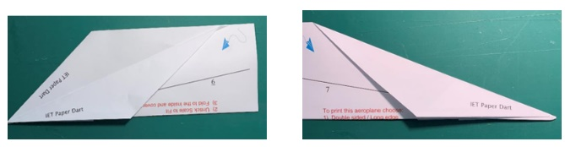
Step 3 – Fold 4 and 5

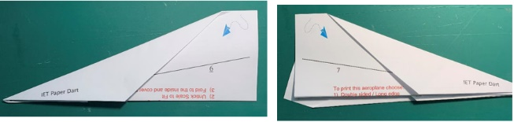
Step 4 – Fold 6 and 7

Step 5 – Ready to fly!
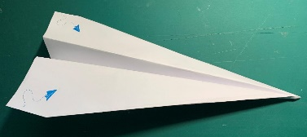

Step 6 – Testing
- If you throw the aeroplane hard and fast (this is thrust) what happens?
- If you throw the aeroplane gently, how does the flight differ?
- How far does the aeroplane fly?
- How long (in time) before the aeroplane lands on the ground?

Well done – you have made and tested your own aeroplane!

Summer jokes
- A photon checks into a hotel and is asked if he needs any help with his luggage. The photo replies “No thanks, I’m travelling light.”

- What kind of tree fits in your hand?

A palm tree!

- What kind of fruit grows at the beach?
Crab apple trees!

- What do you call a witch who lives on the beach?
A sandwitch!

Fun facts
- Slugs have four noses.

- There is a tree called the Idiot Fruit that grows in the Australian rainforest.

- There are 2,000 thunderstorms on earth every minute.

- The wind is silent until it blows against something.

