Activity title
Make a paper house
Stay safe
Whether you are a scientist researching a new medicine or an engineer solving climate change, safety always comes first. An adult must always be around and supervising when doing this activity. You are responsible for:

• ensuring that any equipment used for this activity is in good working condition
• behaving sensibly and following any safety instructions so as not to hurt or injure yourself or others

Please note that in the absence of any negligence or other breach of duty by us, this activity is carried out at your own risk. It is important to take extra care at the stages marked with this symbol: ⚠
Time required
60-90 minutes
Activity summary
Ever dreamt of building your own house? Well now you can in this activity where you will design, make and assemble a fold-out pop-up structure that shows a self-contained, four room dwelling.
What equipment will you need?
- Scissors
- Paper or Card
- Glue
- Rulers
- Pens, coloured pencils or paint
- paperclips
- Optional: three pre-made rooms
- Optional: a pre-made assembled example
How to do it
Step 1 – Cut out the four rooms of your house ⚠
- Carefully cut paper or card into squares
- Fold each square into quarters

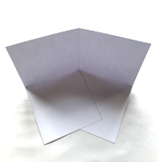
Step 2 ⚠
- Cut along one line of fold into the middle of your square
- Fold two squares into triangles as shown in the middle picture then fold back out flat
- each piece should be able to stand up as shown in the last picture
- Repeat steps 1 and 2 a total of 4 times

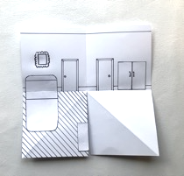
Step 3 – Design your house
- Choose which rooms you want in your house
- Draw your doors in first
- Draw the furniture you would like – televisions, beds, sofas, baths etc.
- Draw the floor on one of the bottom squares only
- If you would like to colour your house you can do that now

Top tip: if you want to make the doors open, make sure they line up with the door to the room that will be next door

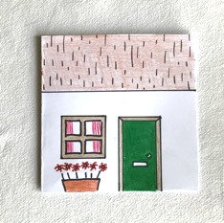
Step 4 – Make the house front ⚠
- Cut a square the same size as step 1, then cut in half
- Draw on the features you can see from outside - a front door, windows, roof etc.
- Add colour if you want to

Step 5 – Construct your house
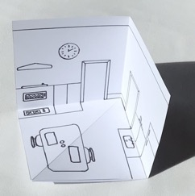
- Fold the floor area of each room over the blank square and glue carefully in place, as in the first picture. Allow the glue to dry.
- When dry, gently fold each room flat by pushing up the fold in the floor
- Once folded, stick the rooms together by gluing three sets of walls to each other
- Fold the whole house flat (like a book) then glue the house front in place

Further activities

Option 1 – Opening doors ⚠
- Customise your house with doors that open

Option 2 – Pop-up furntiture
- Add pop-up furniture that you can make from pieces of card. These will fold down when you close the room. When positioning the pop-ups make sure you stick them to a wall or only one triangle on the floor.

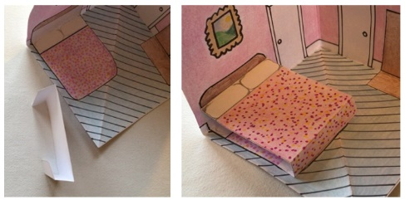
Create a bed
- Cut out a rectangle of paper or card
- Make three folds as pictured
- Add colour and details
- Glue in place at the top and bottom of the bed along the folds, press flat and fold room shut, allow to dry.

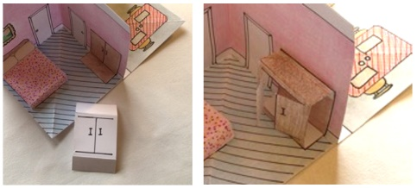
Create a wardrobe
- Cut out a rectangle of paper or card
- Make three folds as pictured
- Add colour and details, cut out doors and fold so they open
- Glue in place at the top and bottom of the wardrobe along the folds, press flat and fold room closed
- Allow to dry.

Example of a finished house with colour

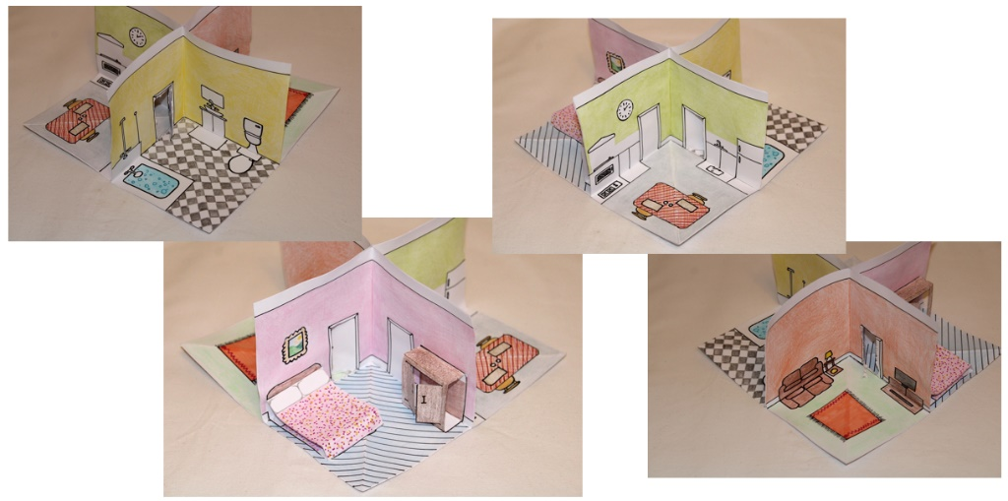

Well done!

You have made your
own 4-roomed house!

Extension
- You could also make people or animals to live in your house!

Summer jokes
- What do you call a labrador at the beach in August?
A hot dog!

- What holds the sun up in the sky?
Sunbeams!

- Why did the gymnast put extra salt on her food?
So she could do summer salts!

- What did the ocean say to the sailboat?
Nothing, it just waved!

Fun facts
- Yuma, Arizona, USA gets over 4000 hours of sunshine every year and is the sunniest place on Earth.

- If the sun was the size of an average 3-seater sofa, the earth would be the size of a 20p coin. 1 million Earths could fit inside the sun!

- The Earths core is hotter than the sun!

- Mosquitoes are attracted to blonds more than brunettes and children more than adults.

