Activity title
Tie dyeing a picnic blanket
Stay safe
Whether you are a scientist researching a new medicine or an engineer solving climate change, safety always comes first. An adult must always be around and supervising when doing this activity. You are responsible for:

• ensuring that any equipment used for this activity is in good working condition
• behaving sensibly and following any safety instructions so as not to hurt or injure yourself or others

Please note that in the absence of any negligence or other breach of duty by us, this activity is carried out at your own risk. It is important to take extra care at the stages marked with this symbol: ⚠
Time required
70-100 minutes
Activity summary
Free your creativity in this fun activity where you can create your own design on a picnic blanket by tie dyeing then use it over the summer holidays to impress your family and friends!
What equipment will you need?
- Squeezy bottles
- Fabric dye
- Elastic bands/string
- Plastic gloves
- If available: washing up bowl
- If required: salt
Sample patterns and how to achieve them
Sample 1 - Folding
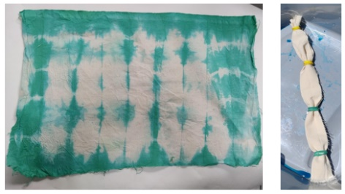
Start at one end, fold the material like a fan, secure with string/elastic bands.

Can dye using one colour, or with each segment a different colour.

Sample 2 - Bullseye
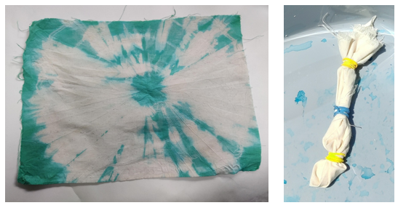
Pinch the fabric in the middle, or where you would like the middle of the pattern. Pull up the material and place rubber bands tightly around the material, as close or as far apart as you wish.

Keep the fabric damp/re-apply dye if the design is bulky.

Sample 3 - Knotting
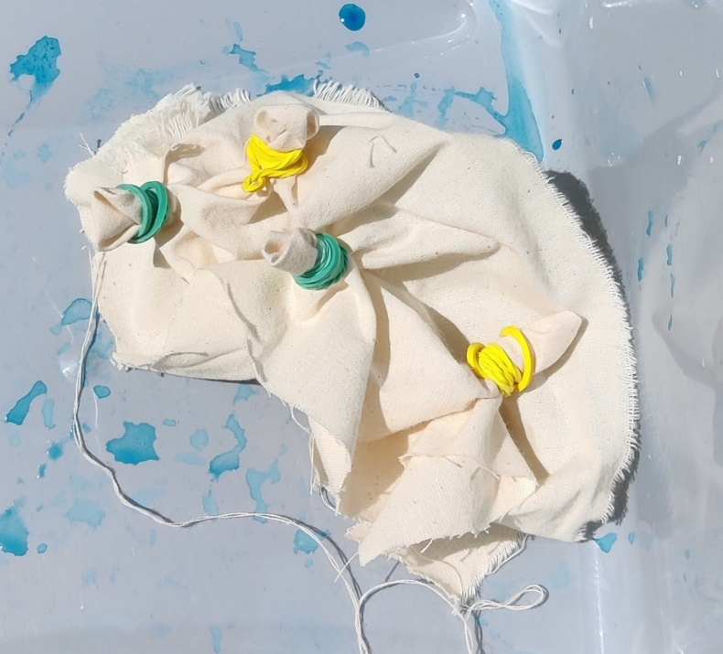
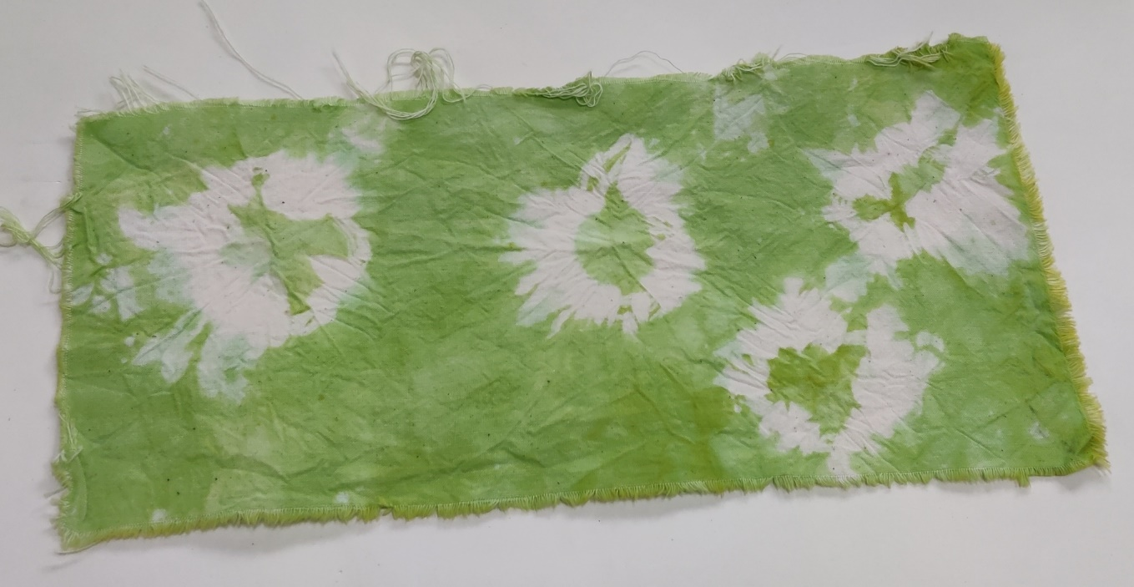

Pull up the area of material where
you want the knot, secure with the
elastic band. Repeat as required.

How to do it
You will need to consider the final pattern you want to create, the colour of fabric and the colours of dye to be used.
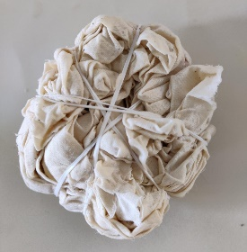

Step 1 – Create the pattern on the fabric using the elastic bands/string

Step 2 – Make up the dye according to the instructions

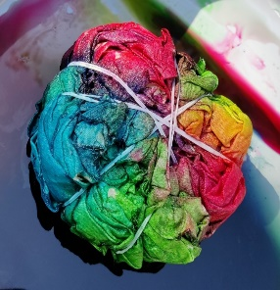
Step 3 – Add dye to the fabric from the bottles
- Make sure you flip the material over and add the same dye shades to the same sections
- Leave the material to soak for 6 to 8 hours

Step 4 – Rinse the material in cool water
- Wash separately in a washing machine

Looking for more?

- Picnic blankets often go onto damp grass. How could you make the blanket waterproof?
- What could be added to the blanket to make it more appealing?
- Design a range of accessories to compliment your blanket.
- What other textile products could you tie dye?

Summer jokes
- Which swimming stroke to sheep enjoy?
The baaaackstroke!

- In which race can you not run?
A swimming race!

- A fisherman’s fishing line got tangled. What did he say?
Something a-piers wrong here!

- What’s the best day to visit the beach?
SUN-day!

Fun facts
- Frogs swallow their food whole. What they can eat is determined by the size of their mouth and stomach.

- The dawn chorus is made up of individual birds doing the equivalent of a vocal warm up so they can sing better during the rest of the day.

- Japanese honeybees kill hornets by enclosing them in a ball of bees and vibrating their flight muscles so fast it increases the temperature to about 40c, which is enough to kill the hornet.

- Petrichor is the smell left after it rains for the first time in a while.

