**Finding the Density of Materials**

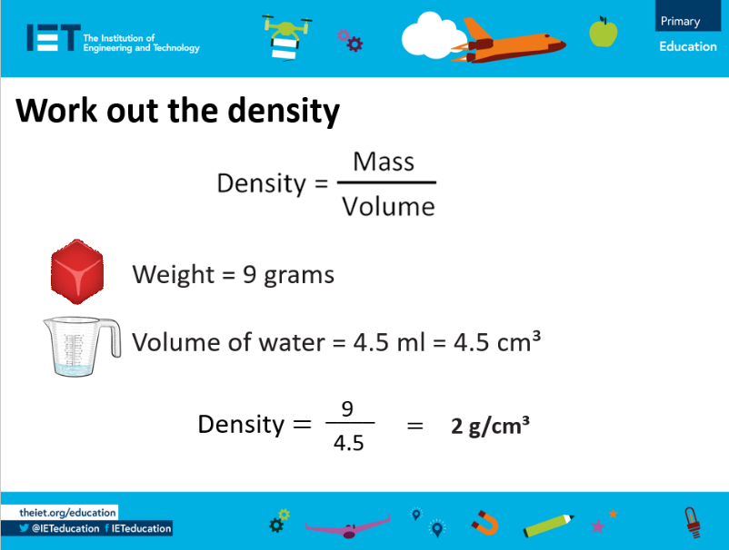

1. Complete this worksheet for each object you test.

|  |  |  |  |
| --- | --- | --- | --- |
| **Object** | **Weight (g)** | **Volume (ml)** | **Density (g/cm3)** |
|  |  |  |  |
|  |  |  |  |
|  |  |  |  |
|  |  |  |  |
|  |  |  |  |
|  |  |  |  |
|  |  |  |  |

1. The object with the lowest density: _____________________
2. The object with the highest density: _____________________