Sports logo design worksheet

1. Select a sports image | 2. Make the image black | 3. Add simple patterns to give the illusion of movement
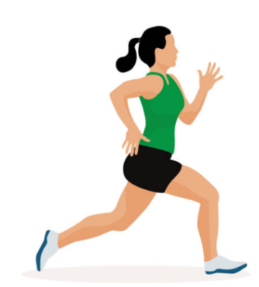 | 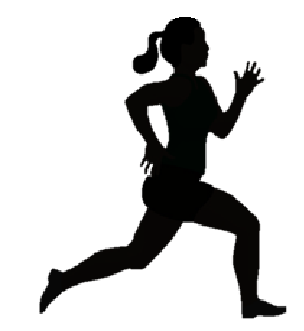
4. Adding colour patterns to an image gives the illusion of energy and movement.

5. Now try converting this image yourself.
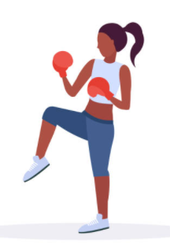

Use this space to sketch your idea for your sports logo.
Don’t forget to annotate your design to show how it meets the design criteria!

Sports logo design

