Motorsport data analysis
Interpret a graph to answer questions on speed and distance

Potential GCSE content covered
- Interpreting Graphs/Data
- Speed/distance/time
- Estimating
In the classroom

Allow the students some time to read the task and think about the questions. You may wish to give the students a paper copy of the graph. The first four bullet points can be answered by correctly interpreting the graph.
- How many km is a lap of the track?
- How many bends do you think are on the track?
- Do you think this was the 1st lap, or a later lap?
- What is the maximum speed?
- A race is 300 km long, how many laps would that be?

Problem Solving

Students will need to interpret and read the graph to answer the questions. They will need to consider what the information displayed in the graph can tell them about the race.

For the final task the students will need to find 107% of 1hr 20min. One approach would be to convert the time to minutes, before finding 107%, other students may work with 1 1/3 hours.

After working out that the car has (5.6min) left, they need to use this information to calculate the distance remaining.

The winner completes 300km in 80mins = 3.75km/m or 225km/hr.

This could then be used as a basis for an estimate. (5.6 x 3.75 = 21km).

Discussion Points

Encourage discussion about the answers to the bullet points. Compare the different assumptions they have made and the approaches they have used, particularly with the final task.

Extending the problem

You could ask the students to make a commentary to accompany the graph, or examine GCSE questions which ask for this to be done. You could consider using graphs which show more than one vehicle and introduce overtaking and other features. The traffic software accompanying lesson A5 from “Improving Learning In Mathematics” the standards unit ISBN: 1-84478-537-X, would be an excellent extension. This is freely available from the STEM e-Library https://www.stem.org.uk/resources
Also https://www.Geogebra.org/m/AjWXqFVM

Answers

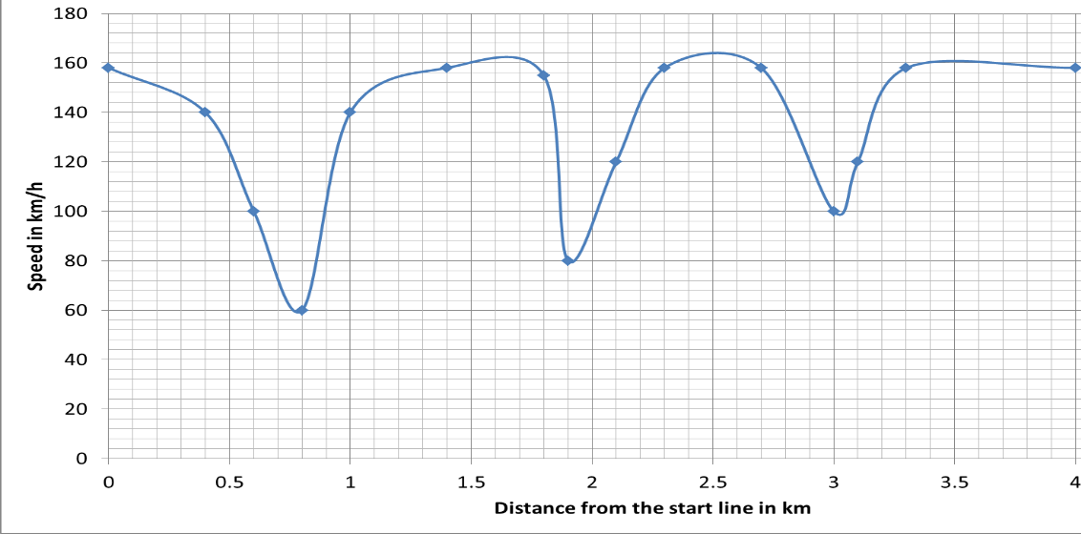
- How many km is a lap of the track? (4km)
- How many bends do you think are on the track? (3 bends) At approximately 0.8km, 1.9km, and 3km from the start respectively
- Do you think this was the 1st lap, or a later lap? (A later lap) as the car has a speed at starting line.
- What is the maximum speed? (Approximately 162km/h)
- 300km / 4km = (75 laps)
Slide 2
The slower car will take 1.07 x 80 = 85.6 mins to finish the race, 5.6 minutes longer than the race winner (5.6 mins).

The remaining distance can be estimated in a number of ways. One example is given below.

The winner completes 300km in 80mins = 3.75km/m or 225km/hr.

This could then be used as a basis for an estimate. (5.6 x 3.75 = 21km).

Curriculum

England | Northern Ireland
> RP 11. Use compound units such as speed, rates of pay, unit pricing, density and pressure  > A 14. Plot and interpret graphs (including reciprocal graphs and exponential graphs) and graphs of non-standard functions in real contexts, to find approximate solutions to problems such as simple kinematic problems involving distance, speed and acceleration | > T5 - Discuss, plot and interpret graphs (which may be non-linear) modelling real situations
Northern Ireland | Wales
> MNU 3-10a Using simple time periods, I can work out how long a journey will take, the speed travelled at or distance covered, using my knowledge of the link between time, speed and distance  > MNU 4-10b I can use the link between time, speed and distance to carry out related calculations | Using Measurement Skills  > Y10 - Understand and use a variety of compound measures, including speed, density and population density  Using Algebra Skills  > Y11 - Draw inferences from distance–time graphs

