Future Flight Challenge

Teacher Handbook

The IET Faraday® DIY Challenge Day ‘Future Flight Challenge’ is based on the IET Faraday® Challenge Day of the same name, a STEM activity day written and delivered by the Institution of Engineering and Technology (IET).

The IET Education website hosts a wide range of teaching resources for science, design and technology and maths. These include classroom activities with film clips, online games, posters, careers resources and STEM activity days.

The Institution of Engineering and Technology
IET Education
Futures Place
Kings Way
Stevenage
Herts
SG1 2UA
United Kingdom
T: +44 (0)01438 767653
F: +44 (0)01438 765526

The Institution of Engineering and Technology is registered as a Charity in England & Wales (no 211014) and Scotland (no SC038698)

Stay safe
Whether you are a scientist researching a new medicine or an engineer solving climate change, safety always comes first. An adult must always be around and supervising when doing this activity. You are responsible for:

- ensuring that any equipment used for this activity is in good working condition
- behaving sensibly and following any safety instructions so as not to hurt or injure yourself or others

Please note that in the absence of any negligence or other breach of duty by us, this activity is carried out at your own risk. It is important to take extra care at the stages marked with this symbol: ⚠

Contents

- The context 4
- The brief 5
- Checklist 6
- Shop resources 7
- Suppliers 11
- Schedule of the day 14
- Room layout 15
- Assessment matrix 16
- Assessment criteria 17
- Risk Assessment 19

Context

Since time began we have been fascinated by the idea of flight. From flying kites in China over 1600 years ago we have looked for ways we can soar through the air. When Orville and Wilbur Wright made the first controlled, sustained flight of a powered, heavier-than-air aircraft in 1903 our relationship with flight made huge progress and, at the point, the skies opened to new possibilities.
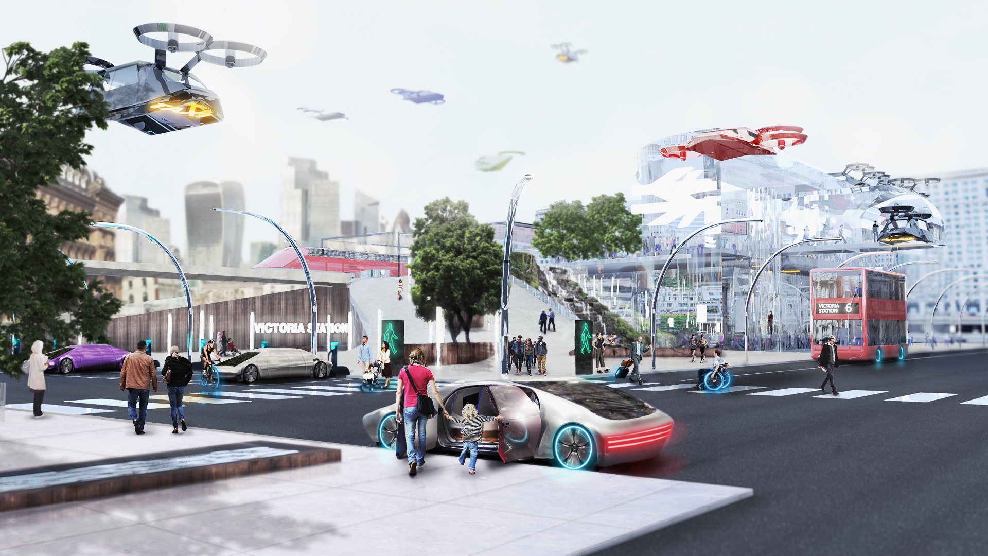

Nowadays flight seems almost everyday, but new possibilities are on the horizon and we want you to be a part of it. In the future, travel and transport will use our airspace as much as they do our ground space. Person operated electric aircraft will share the airways with self-drive aircraft and drones.

No longer will your airports or your delivery companies need to have huge buildings which sprawl across large areas of land. Soon they will go upwards into the skies to allow entry and exit on many different levels. Exciting times, but how can we ensure everyone has equal access to these new environments?
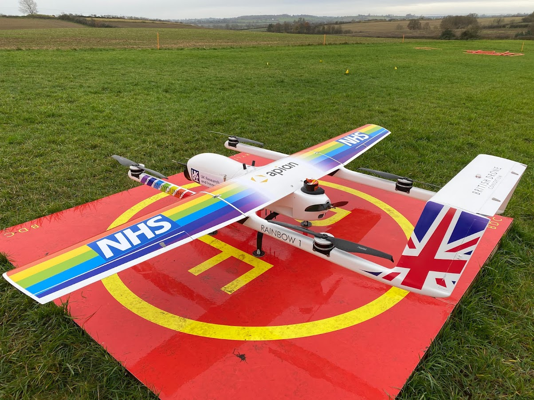
The buildings around us, including your home, will need to be adapted to accommodate the ways in which you move around and receive deliveries. For example, how would our doctor’s surgery receive delivery of important medical equipment or drugs by drone? Would they need to wait at the door or could the package be delivered automatically and the staff alerted remotely?

What will we need to design to ensure deliveries arrive with us safely? How will we protect contents on their journey across the skies, particularly when the weather is bad?

The potential of this changing landscape, not only for us in our own homes, but for others, such as those in hospitals, in disaster zones, in times of need, is huge. Those of us who live or work in hard to reach places, such as remote rural areas and islands, or even in the middle of the sea, will get huge benefit from this future thinking.

We want you to design something to help people in these exciting times. The possibilities are endless and the only limit is your imagination.

2. The Brief

      - Design and build ONE prototype which could be developed by the Future Flight Challenge Team under one of the following themes:

- Accessibility and ease of use
- Safety
- Impact on the environment.

- Complete the planning and events log to show how you have designed your idea and solved problems and worked as a team throughout the project.

- Present your prototype to the Future Flight Challenge judge(s).

You will need to demonstrate the skills and attitudes we are looking for so:

- be creative.
- plan carefully.
- work within the resources and the budget available.
- be realistic about what is achievable in the time available.
- be resilient and persevere with problems.
- record your thinking.
- keep to strict deadlines.

Remember, engineering is about people. Today is your chance to make a difference, could you be our engineer...?
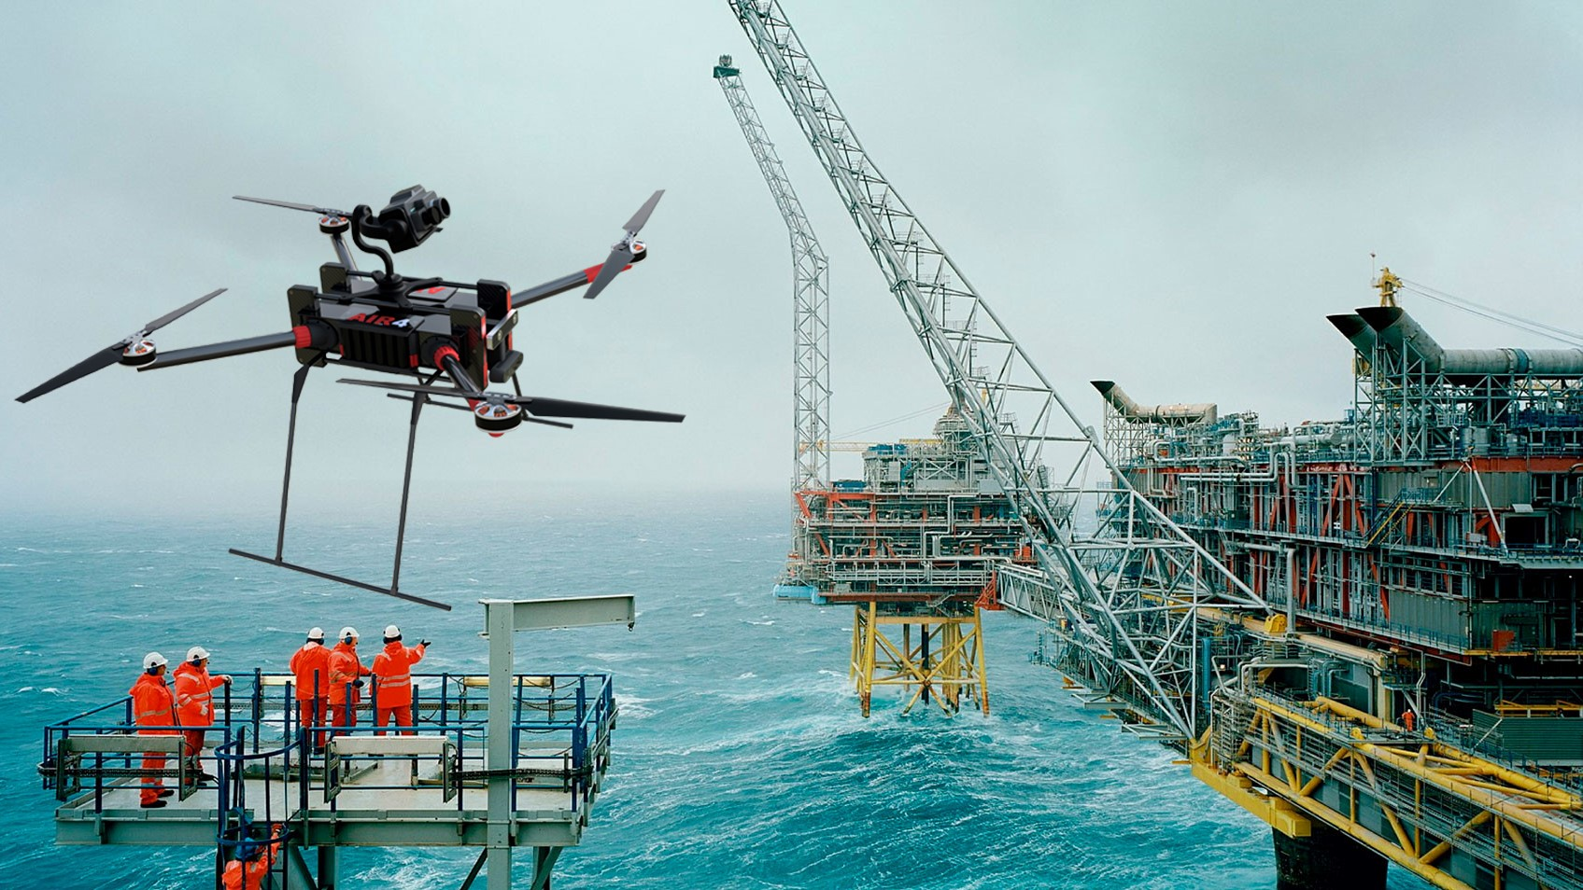
3. Checklist

We hope you find this checklist useful to help you prepare for the day.

Student tables | Notes
Team number sign (laminated) | 1 per table
Student team registration form | 1 per table
Student booklet | 1 per table
Accounts sheet | 1 per table
A3 Planning and Events Log | 1 per table
Faraday money | Per table 120 Faradays (1 x 20F, 6 x 10F, 6 x 5F, 10 x 1 F)
Engineering apprenticeship pack | 1 per table – box contains 2 x AA battery pack with battery snap, 3 x crocodile leads, piezo buzzer and light dependent resistor.
Challenge Leader | Notes
Presentation - hard and soft copy | Best to bring on your own laptop and presentation and video on a memory stick
Clicker for PowerPoint presentation | Carry spare batteries
Assessment matrix | 1 per event
Clipboard | For hard copy of presentation, assessment matrix, etc.
A4 plain paper | For presentation notes if students don’t have paper.
Prizes (if required) | Schools to provide
Certificates | 1 per student
Shop | Notes
Shop manager account sheet | 1 per event - Put on a clipboard
Shop manager resources list | Laminated sheets on clipboard
Shop manager guidance | 2 x laminated sheet to give to shop keepers as briefing for role
All shop items with price tags
Hire centre trade card | 1 for each team to purchase, laminated
Signage | Notes
Shop | Put on shop
Cutting station rules | Put on cutting station
Solar light safety reminder | Put with solar lamp
Additional items | Notes
‘How to …’ sheets | 3 of each sheet, laminated on a table
Solar lamp | Small desk lamp with halogen bulb to work with solar panels on a table.

- Shop resources

Items to buy

Electrical components
Item | Description |  | Unit | Cost
Crocodile leads | 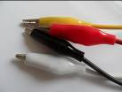 | Lead with crocodile clips at each end | Each | 4 Faradays
Piezo buzzer | 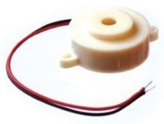 | Connect in a circuit to give a sound output | Each | 6 Faradays
LED – various colours | 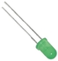 | Light Emitting Diode which lights up when connected in a circuit. Choose from red, orange, green or blue. | Each | 6 Faradays
Motor | 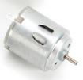 | Connect in a circuit to create clockwise or anti-clockwise movement. Will not work with a solar panel or an LDR. | Each | 6 Faradays
Solar motor | 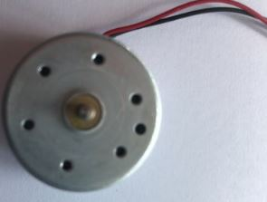 | Connect to a solar panel to create clockwise or anti-clockwise movement. | Each | 6 Faradays
Servo motor  (0 to 90 degrees) | 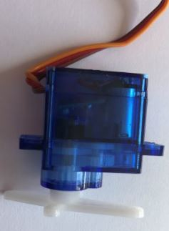 | Use with a servo motor control unit to control movement from 0º to 90º | Each | 6 Faradays
Servo motor (continuous) |  | Use with a servo motor control unit to control continuous movement through 360º | Each | 6 Faradays
Light Dependent Resistor (LDR) | 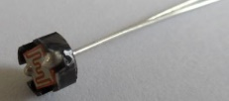 | Component that detects the light level and changes resistance in a circuit. | Each | 8 Faradays
Push to make switch | 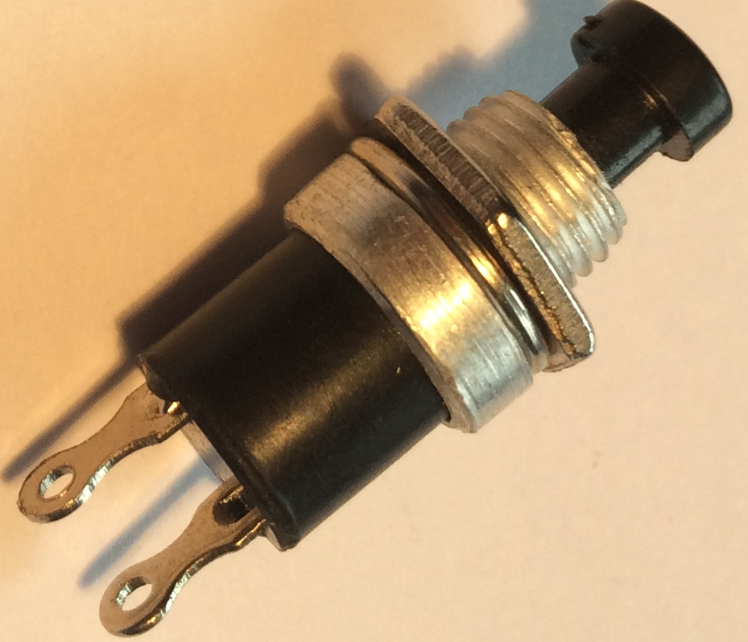 | Connects a circuit when pushed down and breaks the circuit when released. | Each | 6 Faradays

Servo motor control unit | 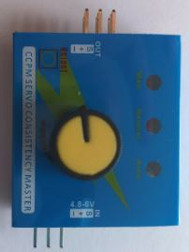 | Use this to control a servo motor. You MUST read the ‘How to …’ sheet before connecting this component. | Each | 8 Faradays
Motor holder | 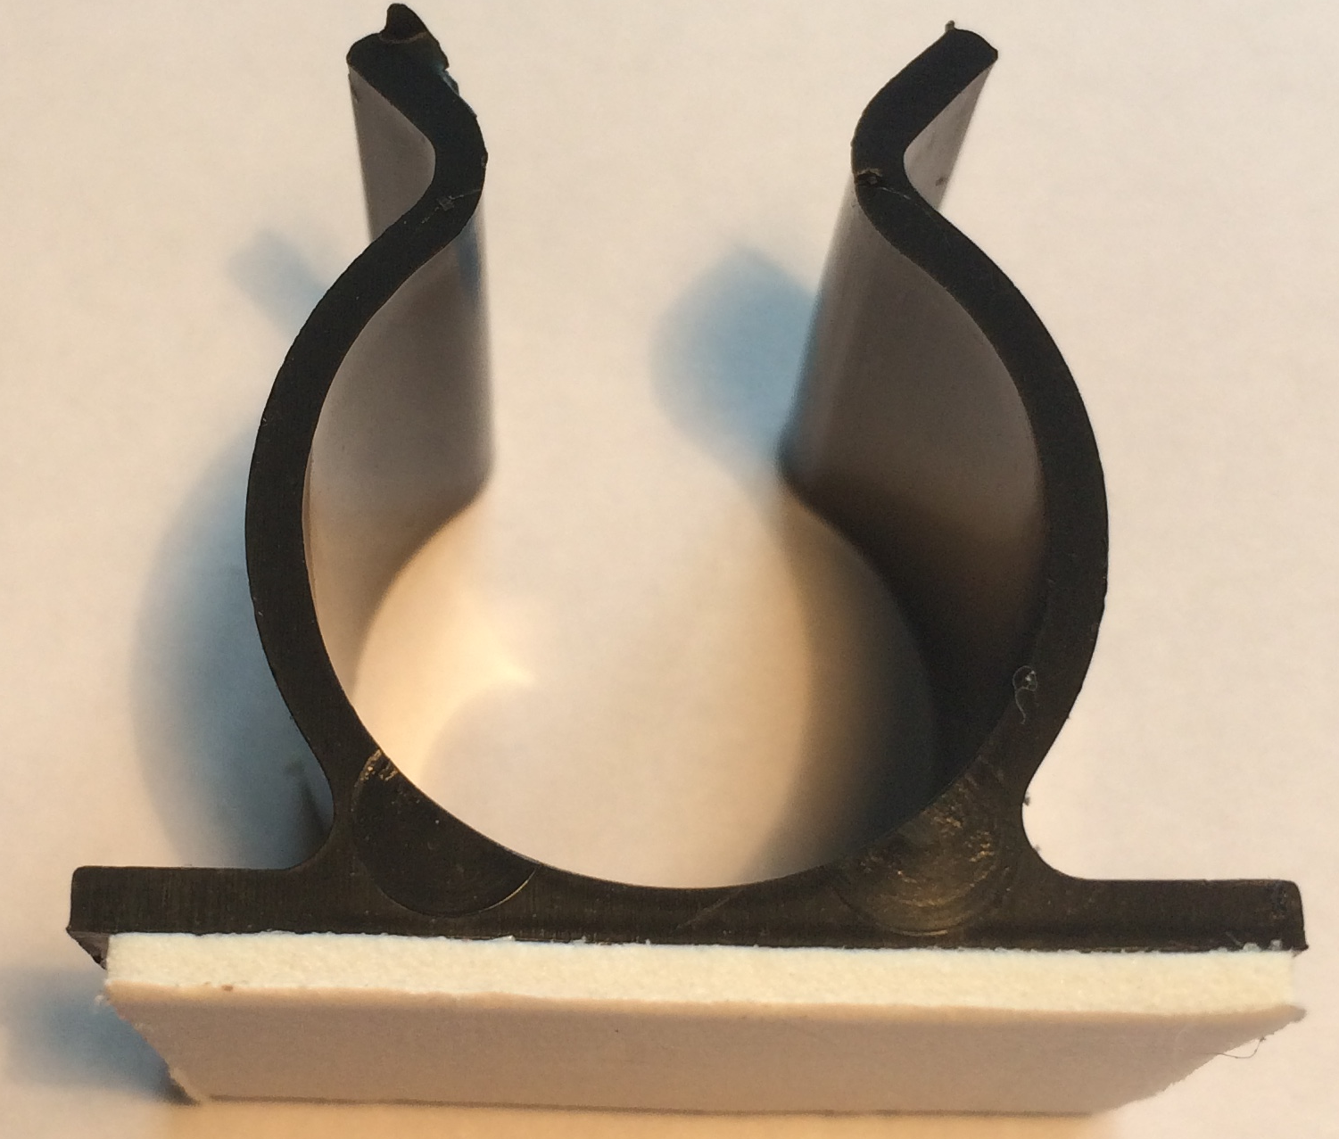 | Used to fix a motor or a syringe in position. NOTE: you will need the insert to connect a syringe. | Each | 4 Faradays
Gear attachment for motor |  | Used to connect a motor to a cog. | Each | 2 Faradays
Pulley attachment for motor | 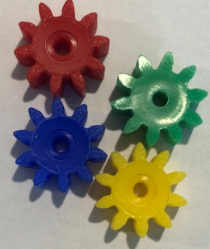  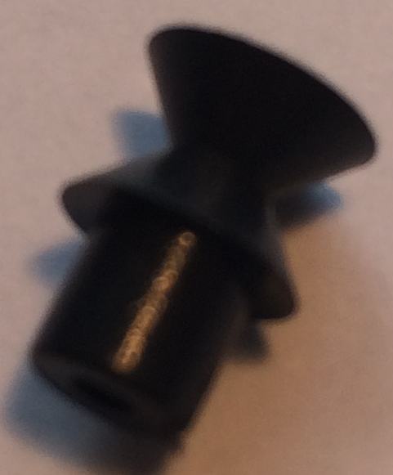 | Used to connect a motor to a pulley wheel – will need connector (e.g. elastic band) | Each | 2 Faradays
Solar panel | 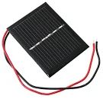  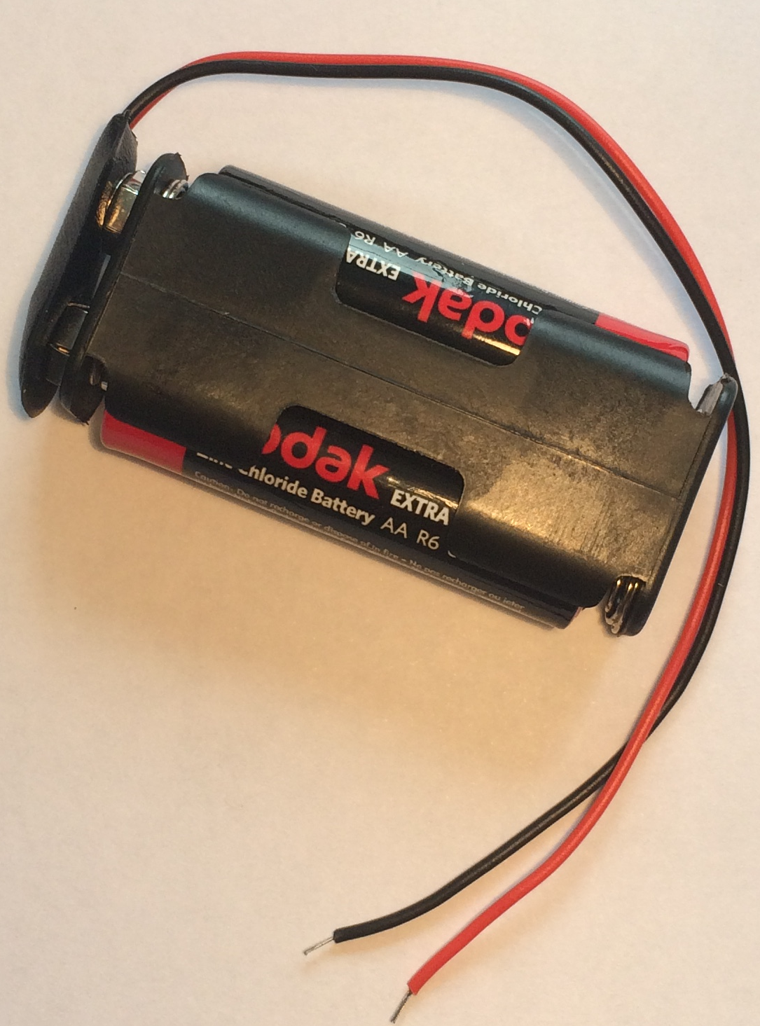 | Used to power components using the power of the sun. You MUST read the ‘How to …’ sheet before using. | Each | 6 Faradays
2AA cells in battery holder with battery snap |  | Used to provide power for your circuit | Each | 4 Faradays
4 AA cells in battery holder with jumper leads | 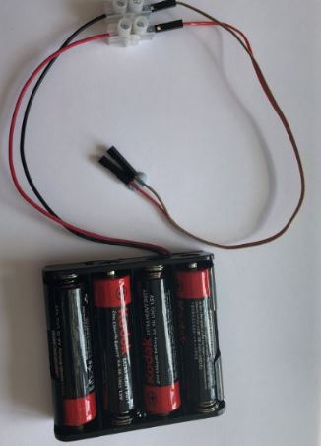 | ONLY to be used with servo motor control unit. | Each | 6 Faradays

Construction materials
Item | Description | Unit |  | Cost
Correx | Used to create structures | Piece |  | 6 Faradays
Plastic syringes with tube | Used to develop pneumatic system | Pair of syringes with plastic tube | 6 Faradays
Small cog | Used in gear systems with motors | Each | 2 Faradays
Medium cog | Used in gear systems with motors | Each | 2 Faradays

Large cog | Used in gear systems with motors | Each | 4 Faradays
Nail | Used for making moisture sensor | Pair | 2 Faradays
Dowel | Piece of solid cylindrical wooden rod used to create structures | Each | 4 Faradays
Pulley wheel | Used to connect to pulley attachments on motor | Each | 6 Faradays
Wooden wheel | Used with motors to drive something | Each | 4 Faradays
Plastic reel | Used in construction | Each | 4 Faradays
Coloured card | A4 sheet of card – assorted colours | Each | 4 Faradays
Aluminium foil | A conductive material which can be used to make pressure pads or switches (MUST NOT be used in place of connecting wires) | 10cm strip | 6 Faradays
Masking tape | Can be used to secure light parts in your design. NOTE: excessive use of tape will result in an additional charge | Roll | 6 Faradays
Sponge | Can be used to make pressure switches or enhance your design. | Each | 6 Faradays
Paperclip | Used to create switches or in construction | Each | 1 Faraday
Paper fastener | Used to create switches or in construction | Each | 1 Faraday
Elastic bands | Used to hold or create working parts, including driving pulley wheels | Each | 1 Faraday
Cable ties | Can be used to hold your structures in place | Each | 2 Faradays
String | Can be used as part of your product design | 30cm piece | 4 Faradays
Polyfoam | Can be used as part of your product design | A5 piece | 4 Faradays
Wooden lolly sticks | Can be used as part of your product design | Each | 4 Faradays
Hire Centre Trade Card | Use this to hire various items from the hire section of the shop – see next page for details | One per team | 6 Faradays

Hire Centre

These items can be hired from the shop if the students buy a Hire Centre Trade Card.

Stapler | Used to staple soft materials only
Hole punch | Used to make small holes in soft materials
Ruler | Used to measure any part of your product or additional items
Scissors | Used for soft materials only

Cutting station

The cutting station is free to use when the shop is open.

Craft knife | 2 Used to cut correx or shapes in polyfoam
Metal rules | Used with a craft knife
Junior hacksaw | Used to cut dowel or wooden lollipop sticks
Bench hook | Used to hold materials in place when cutting with hacksaw

- Suppliers

Description | Quantity each FCD | P/N | Link
Crocodile leads | 40 | 17-0350 | https://www.rapidonline.com/rvfm-17-0350-pack-of-ten-crocodile-leads-17-0350
Piezo buzzer | 6 | 35-0115 | https://www.rapidonline.com/rvfm-35-0115-piezo-buzzer-miniature-12v-35-0115
LED – green | 6 | 55-0105 | https://www.rapidonline.com/kingbright-l-7104gd-3mm-green-led-30mcd-55-0105
LED - orange | 5 | 55-0095 | https://www.rapidonline.com/kingbright-l-7104ed-3mm-orange-led-20mcd-55-0095
LED – red | 5 | 55-0102 | https://www.rapidonline.com/kingbright-l-7104hd-3mm-red-led-3mcd-55-0102
Motor | 4 | 37-0142 | https://www.rapidonline.com/trumotion-e0142-miniature-motor-3v-5240-rpm-37-0142
Solar motor | 4 | 37-0441 | https://www.rapidonline.com/trumotion-wrf-300ca-08430-18-5-miniature-low-inertia-solar-motor-2v-1540-rpm-37-0441
Servo motor (0-90 degrees) | 4 | 37-1339 | https://www.rapidonline.com/feetech-fs90-mini-servo-120-9g-37-1339
Servo motor (continuous) | 4 | 37-1335 | https://www.rapidonline.com/feetech-fs90r-360-continuous-rotation-micro-servo-37-1335
Light Dependent Resistor (LDR) | 6 | 850-200 | https://www.jprelec.co.uk/categories/components/optoelectronics-and-lamps/light-dependent-resistors/light-dependent-resistor-norps-12-ldr/product/norps-12-ldr/850-200~850-200
Push to make switch | 3 | 78-0100 | https://www.rapidonline.com/r-tech-780520-miniature-push-to-make-switch-red-78-0520
Servo motor control units | 6 |  | These can be bought at a range of online sources such as Amazon. Prices vary greatly so search for servo motor testers.
Motor holder | 6 | 37-0360 | https://www.rapidonline.com/rapid-37-0360-rvfm-self-adhesive-motor-mounts-pack-of-10-37-0360
Gear attachment for motor | 6 | GGO-MSGEAR | https://www.tts-group.co.uk/plastic-gears-for-motor-20pk/1000432.html
Pulley attachment for motor | 6 | TP-10 | https://www.tts-group.co.uk/plastic-motor-pulleys-10pk/1003745.html
Solar panel | 4 | 56-0124 | https://www.rapidonline.com/truopto-opl30a10101-solar-module-3v-100ma-0-3w-60x48x3mm-with-20cm-flying-leads-56-0124
2AA cells in battery holder with battery snap (see below) | 6 | 18-0125 | https://www.rapidonline.com/trupower-bh-322-1b-2-x-aa-press-stud-battery-holder-18-0125
Battery snaps | 6 | 18-0105 | https://www.rapidonline.com/trupower-18-0105-battery-clip-for-pp3-pp6-battery-150mm-18-0105
4 AA cells in battery holder with jumper leads (need to be made up with 2 items below) | 6 | 18-3695 | https://www.rapidonline.com/keystone-2478-battery-holder-for-4-x-aa-and-flying-leads-18-3695
Jumper leads (pack of 10) | 2 | 34-0679 | https://www.rapidonline.com/rapid-jw-d1-mf-jumper-wires-dupont-cable-m-f-26awg-1-pin-2-54mm-pitch-15cm-pk10-34-0679
Terminal blocks | 2 | 21-4269 | https://www.rapidonline.com/hylec-hyks-02412pp-12-pole-kwik-snap-terminal-block-450v-24a-wire-2-5mm2-21-4269
AA batteries (pack of 40) | 1 | 18-2112 | https://www.rapidonline.com/gp-gppca15au007-pca15au007-ultra-alkaline-aa-batteries-pack-of-40-18-2112
Correx Plastic Sheets (each sheet cut into 9 equal squares) | 15 squares per FCD | 37-3315 | https://www.rapidonline.com/rapid-ep700ppfldb-rvfm-corrugated-plastic-605-x-605-x-4mm-pack-of-10-37-3315
Plastic syringes with tube (see below) | 6 | 06-9969 | https://www.rapidonline.com/rapid-64399-10ml-syringe-pack-of-10-06-9969
Tubing 15cm piece | 3 | 37-1289 | https://www.rapidonline.com/rapid-pen-0035-rvfm-tubing-3-5mm-clear-25m-coil-37-1289
Small, medium and large cogs | 6 of each size | GGO-GEARS | https://www.tts-group.co.uk/assorted-plastic-gears-60pk/1003641.html
Round wire nails 30mm | 12 | 84-8988 | https://www.rapidonline.com/forgefix-500nlrh25b-round-head-nail-bright-finish-25mm-bag-of-500g-84-8988
Dowel (5mm diameter) | 12 | 06-119 | https://www.rapidonline.com/Catalogue/Product?Id=06-1197
Pulley wheel 54mm | 4 | PUL-54 | https://www.tts-group.co.uk/wooden-pulleys-10pk/1000445.html
Wooden wheel 54mm | 12 | TMDF-54 | https://www.tts-group.co.uk/wooden-wheel-packs/1000483.html
Plastic reel | 3 | 06-0630 | https://www.rapidonline.com/major-brushes-7060-100-cotton-reels-pack-of-100-06-0630
Coloured card | 10 | 06-0953 | https://www.rapidonline.com/rapid-re03-a4-assorted-bright-coloured-card-220gsm-pack-of-30-06-0953
Aluminium foil | 1 | 06-0921 | https://www.rapidonline.com/rapid-tx7539-rvfm-aluminium-foil-450mm-18-x-75m-06-0921
Masking tape | 4 | 87-1927 | https://www.rapidonline.com/ultratape-00552450ulrp-masking-tape-25mm-x-50m-87-1927
Sponge | 8 |  | Buy 1cm deep upholstery foam in sheet and cut into pieces as required for each event.
Paperclip | 8 | 34-3980 | https://www.rapidonline.com/rapid-is3100-rvfm-plain-paper-clips-pk1000-34-3980
Paper fastener | 6 | 34-3704 | https://www.rapidonline.com/rapid-503050-rvfm-paper-fasteners-20mm-box-of-200-34-3704
Elastic bands (Number 16 work best) | 12 | 34-9973 | https://www.rapidonline.com/rapid-34-9973-rvfm-rubber-band-no-16-63-5-x-1-6mm-2-1-2-x-1-16in-454g-34-9973
Cable ties (assorted/ 8cm minimum length) | 20 | 89-1648 | https://www.rapidonline.com/sealey-ct200-cable-ties-100-x-2-4mm-pack-of-200-89-1648
String | 1 | 06-9272 | https://www.rapidonline.com/major-brushes-78700-thin-cotton-string-250g-reel-06-9272
Baking parchment | 1 | 52-9443 | https://www.rapidonline.com/rvfm-wf014-baking-parchment-paper-18in-x-75m-52-9443
Wooden lolly sticks | 12 | 06-1195 | https://www.rapidonline.com/major-brushes-7066-200-wooden-lollysticks-pack-of-200-06-1195

- Schedule for the day

08:00 | Challenge Leader arrives to set up
09:15 | Register your team (All visiting schools should have arrived by this point)
09:30 | Welcome and introduction
09:50 | Project brief: Introduction to the IET Faraday® Challenge Day
10:10 | Planning: Identifying the problems and generating initial ideas
10:25 | Team role selection: team decides on which roles they need
10:30 | Engineering apprenticeship: teams complete a short engineering task ⚠
10:40 | Development ⚠  - Shop opens  - Agree on final product designs
11:00 | Break
11:10 | Development continues ⚠  - Continue to design and modify where necessary  - Record progress in event log
12:15 | Teams are briefed on the content of the presentation
12:30 | Lunch – Tools down
13:00 | Development: Final preparations ⚠  - Finalise product  - Prepare presentation with notes
13:30 | - Shop closes  - Submit accounting sheet to the Shop keeper  - Practise presentation
13:50 | Presentation ⚠  - Teams present their designs to the judge(s)
14:45 | Award ceremony with final feedback and evaluation of the day
15:00 | Engineering teams depart
15:45 | Challenge Leader departs by this point (actual time depends on pack up requirements)

7. Host school – Room/hall layout

Notes:
- Each team table will need 6 chairs and be large enough for 6 students to work comfortably. The judges’ table and shop will each need 1 chair.
- Table positions do not need to be exact and can be arranged to best accommodate the shape and size of the venue. If you are running the Challenge Day for just your school, you will not need a teachers’ team table.
- We strongly recommend you cover the cutting station with cutting mats or a board to protect the surface.

BACK
Cutting station (with cover/cutting mats)
Shop (at least 3 m x 0.5 m)

Team 7 Teachers
(only if other schools invited)

Team 3
Team 4

Team 5
Team 2

Presentation table

Refreshments Table
Team 1
Team 6

Judge’s table

FRONT – Projection screen

8. Assessment matrix

Assessment Criteria |  | Team | Team | Team | Team | Team | Team | Team
 |  | 1 | 2 | 3 | 4 | 5 | 6 | 7
Planning | 13
Development of product* | 17
Use of budget | 8
Product engineering* | 32
The presentation | 15
Teamwork* | 15
Total score | 100
Leader decider (see * for priority scores)
Team | School/Team name
1
2
3
4
5
6
7

9. Assessment criteria

Criteria | Marks
- Planning | 13 marks
- Development of product | 17 marks
- Use of budget | 8 marks
- Product engineering | 32 marks
- The presentation | 15 marks
- Teamwork | 15 marks
Total | 100 marks
- Planning (13 marks)
Using the planning section of the Planning and Event Log, marks will be awarded as follows:
- Did they explain how their idea might support the work of the Future Flight Challenge team? (3 marks)
- Does the planning diagram detail how the prototype will be constructed? (5 marks)
- Have they drawn the circuit diagram(s)? (5 marks)

- Development of product (17 marks)

Using the Engineering Event Log and observations of the team, marks will be awarded as follows:

- Event log 1 - Have they provided an accurate and informative record of development beyond a simple description including any problems and solutions? (4 marks)
- Event log 2 - Have they provided an accurate and informative record of development beyond a simple description including any problems and solutions? (4 marks)
- Event log 3 - Have they provided an accurate and informative record of development beyond a simple description including any problems and solutions? (4 marks)
- Have they listed realistic and appropriate engineering priorities for the last 30 minutes and allocated tasks to team members? (5 marks)

- Use of budget (8 marks)
Using the accountancy sheet and the prototype, marks will be awarded as follows:
- Was there an accurate record of spending? (3 marks)
- Was the budget used effectively? (5 marks)

4. Product engineering (32 marks)
Using the presentation of your prototype and what we have seen during the development period, marks will be awarded for:

- Did their final prototype meet the brief from the Future Flight Challenge team? (4 marks)
- Was the choice of electronic components appropriate for their intended design?
(4 marks)
- Was the choice of materials appropriate for the structure and/or mechanics of their intended design? (4 marks)
- Was the final prototype engineered well with all elements coming together in a well-structured and fit for intended purpose product? (7 marks)
- Did the judge(s) see the electronics and structure work together effectively as intended? (7 marks)
- Did the team push themselves to achieve a level of complexity relevant to the brief? (6 marks)

5. The presentation (15 marks)
Using the presentation of your prototype, marks will be awarded as follows:

- Did the team explain how their prototype works, including details of how and why they used the electronics and the mechanics in their design? (6 marks)
- Did the team identify the most challenging engineering aspect they faced during their development and how they overcame this challenge? (3 marks)
- Did the team explain what they did well in their teamwork and what aspects they could have improved? (4 marks)
- Did the team effectively demonstrate their prototype? (2 marks)

- Teamwork (15 marks)
Using the judges’ observations of your team throughout the day, marks will be awarded as follows:

- Did the team work together with all members engaged in the project and any conflicts successfully resolved? (6 marks)
- Did the team work tidily and safely within the health and safety rules? (3 marks)
- Did the team persevere to resolve issues during the project and work largely independently? (6 marks)

10. Risk Assessment
The following risk assessment is given as guidance. It is advised that the school refers to the CLEAPSS Model Risk Assessment Documents for D&T.

Risk Assessment and Operating Procedure – IET Faraday®
Activity: IET Faraday® Challenge Day

Persons at risk | Students taking part in the IET Faraday® Challenge Day and adults in the location
Maximum Group Size | 36 students | Recommended Staffing/Student Ratio | 1:18
Risk Assessment
Hazards |  | Control Measures
- Room size |  | Ensure room is large enough to accommodate layout once all students and staff are present with their belongings. Challenge Leaders will not deliver the challenge if they and the students cannot move around safely.
- Use of electrical equipment – risk of electric shock |  | All electrical equipment is low voltage.
- Use of electrical equipment – short circuit causing heating |  | Warn students of the possibility of burns when connecting and disconnecting components. All pupils will receive a briefing about correct use of electrical components.
- Basic use of hand tools (craft knives, scissors, hole punches, staplers) – risk of cutting or abrasion |  | Warn students of the risks and advise them of safe working practices. Identify member of staff to supervise area. Inform challenge leader if use of knives in school is restricted.
- Use of water with moisture sensors |  | Ensure students test their moisture sensor using a sponge in a small tub rather than directly in any drink or cup of water to avoid spillage on electrical components.
- Risk of burning when using solar panels with lamp |  | Warn students not to hold solar panels too close to the lamp bulb and to turn off the lamp when not in use to avoid it becoming too hot.
Location issues (to be completed by Host School)
Further Action Required: 1. Ensure all persons staffing the IET Faraday® Challenge Days are aware of and competent to comply with this risk assessment and the control measures.

Risk Assessment (page 2)

Working Practice
Group structure | One Challenge Leader and one teacher and one other responsible adult from the host school to be present during the whole day to oversee use of equipment and to keep order. Teachers bringing groups from other schools must remain in the room and be responsible for their own students.
Restrictions | Unknown premises.
Emergency  Procedure | Follow the lead from the Host School.  Challenge Leader to be fully briefed on risk assessment procedure prior to the day or on arrival.
Safeguarding | The Challenge Leader will carry their DBS and provide it where requested. They will comply with the safeguarding regulations within the school. A member of staff from the school MUST be present in the rooms at all times students are present.
Safety Equipment | First aid kit and fire extinguisher (electrical fires) to be provided by Host School.
Covid 19 | Please inform us of any restrictions or expectations which still apply on receipt of this pack.
Name and role of IET Faraday® Challenge representative | Keira Sewell  Challenge Day Leader
Name and role of school representative
Signature of the school representative
Date of this Review | May 2022

