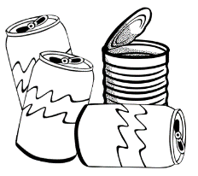
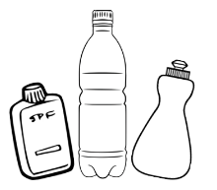
Testing the Density of Materials
Complete this worksheet for each material you test.

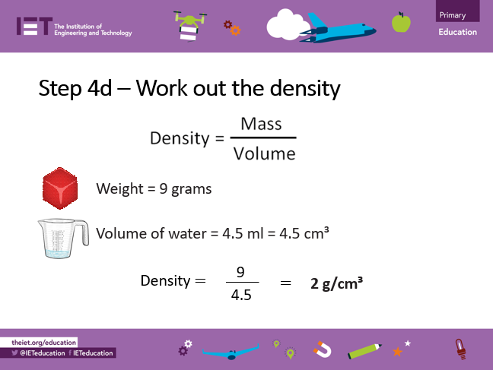

Material | Weight (g) | Volume (ml) | Density (g/cm³)

The material with the lowest density: ___________________________________

The material with the highest density: ___________________________________

