The IET

Network Rail

Teacher Handbook

Could you be our engineer….?

The IET DIY Faraday Challenge Day ‘Network Rail’ is based on the Faraday Challenge Day of the same name, a STEM activity day written and delivered by the Institution of Engineering and Technology (IET).

The IET Education website hosts a wide range of teaching resources for science, design and technology and maths. These include classroom activities with film clips, online games, posters, careers resources and STEM activity days.

The Institution of Engineering and Technology
IET Education 5-19
Michael Faraday House
Six Hills Way Stevenage
Herts
SG1 2AY
United Kingdom
T: +44 (0)01438 767653
F: +44 (0)01438 765526

The Institution of Engineering and Technology is registered as a Charity in England & Wales (no 211014) and Scotland (no SC038698)

Stay safe
Whether you are a scientist researching a new medicine or an engineer solving climate change, safety always comes first. An adult must always be around and supervising when doing this activity. You are responsible for:

- ensuring that any equipment used for this activity is in good working condition
- behaving sensibly and following any safety instructions so as not to hurt or injure yourself or others

Please note that in the absence of any negligence or other breach of duty by us, this activity is carried out at your own risk. It is important to take extra care at the stages marked with this symbol: ⚠

Contents

- The context 4
- The brief 5
- Checklist 6
- Shop resources 7
- Suppliers 11
- Schedule of the day 14
- Room layout 15
- Assessment matrix 16
- Assessment criteria 17
- Risk Assessment 19

Context

Our railways help us to get to work, to go on days out, to travel to our favourite sports and meet up with friends and family. They also help transport things we use in our daily lives, our food, our post, even our vehicles. Without them our lives would be very different.
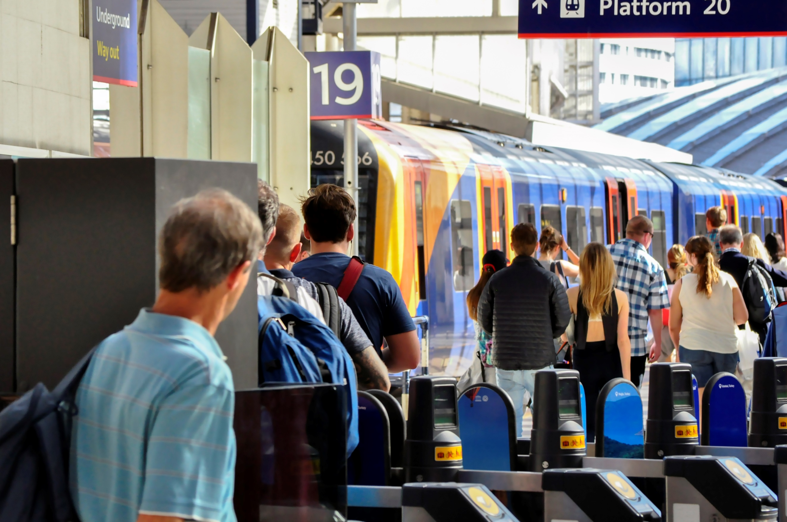

In the past decade rail travel has become ever more popular. Stations like London Waterloo and London Victoria now handle more passengers than the UK’s busiest airports and the numbers continue to rise.

Network Rail owns, operates and develops Britain’s railway structure, including 20,000 miles of track, 30,000 bridges, tunnels and viaducts and thousands of signals and level crossings. We also manage 20 of the UK’s largest stations and it is here that we need your help.

The rate of increase in rail passengers coming through our stations means we have to manage more waste, keep more passengers safe, comfortable and happy and ensure everyone can access the railway network.

We need to make sure that passengers can use the rail network and the stations to do the things they want to do and to move in the ways which suit them. Some want to get to their destination quickly whilst others prefer to take their time, perhaps have lunch along the way or chat with friends. They may be carrying heavy luggage or have a child in a pushchair or even be taking their pet with them. Some may have mobility issues which make it more difficult for them to move around the station or get onto trains from the platform.
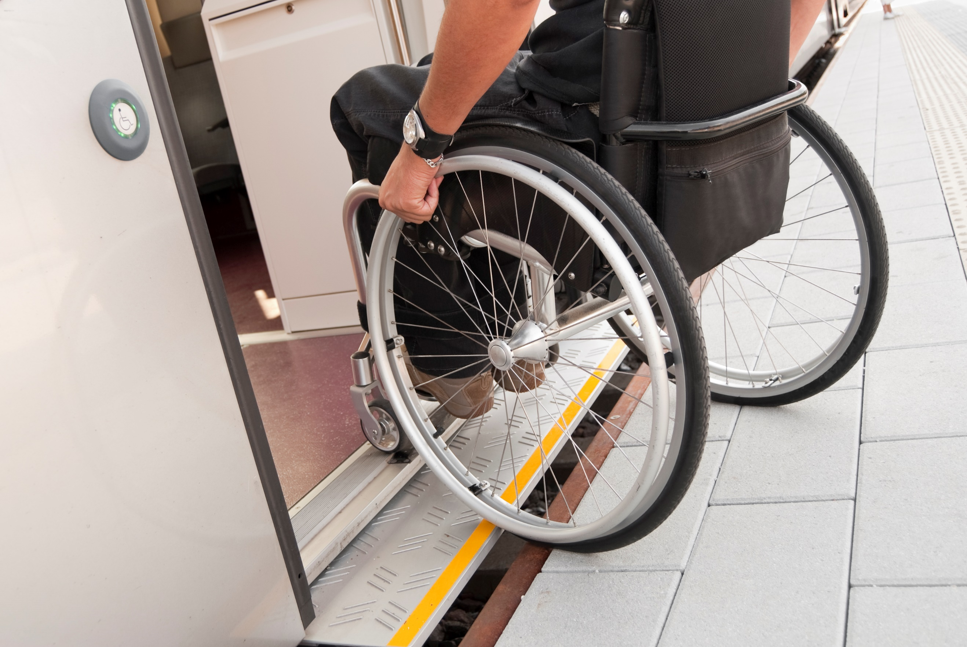

Here at Network Rail we want to make sure that our railway is fit for the future, no matter who you are and what you want it to do. We need your help.

Remember, engineering is about people. Today is your chance to make a difference, could you be our engineer...?

2. The Brief

The Network Rail team wants you to:

- Design and engineer ONE prototype which will help manage one aspect of increased passenger use on their stations. Your design MUST include at least one electronic circuit.

- Complete the planning and events log to show how you have designed your idea, and solved problems and worked as a team throughout the project.

- Present your prototype to the IET Network Rail judge(s).

You will need to demonstrate the skills and attitudes we are looking for so:

- be creative;
- plan carefully;
- work within the resources and the budget available;
- be realistic about what is achievable in the time available;
- be resilient and persevere with problems;
- record your thinking;
- keep to strict deadlines.

Considerations:

- Energy – how can we decrease the amount used and what sources do we have available to us?
- Sustainability – what materials can we use to ensure we are not contributing to global environmental issues?
- Capacity for growth – how can we make sure we can continue to increase the number of passengers?

Checklist

Student tables | Notes
Team number sign (laminated) | 1 per table
Student team registration form | 1 per table
Student booklet | 1 per table
Accounts sheet | 1 per table
A3 Planning and Events Log | 1 per table
Faraday credit card | 1 per table (120 Faraday spend limit)
Engineering apprenticeship pack | 1 per table – box contains 2AA battery pack with battery snap, 3 x crocodile leads, piezo buzzer and light dependent resistor.
Challenge Leader | Notes
Presentation - hard and soft copy | Best to bring on your own laptop and presentation and video on a memory stick
Clicker for PowerPoint presentation | Carry spare batteries
Assessment matrix | 1 per event
Stickers – red and yellow (if using) | 1 of each colour for each team. Red sticker for project manager, yellow sticker for accountant.
Clipboard | For hard copy of presentation, assessment matrix, etc.
A4 plain paper | Up to 3 sheets free per team for presentation notes
Prizes (if required) | Schools to provide
Certificates | 1 per student
Shop | Notes
Shop manager account sheet | 1 per event - Put on a clipboard
Shop manager resources list | Laminated sheets on clipboard
Shop manager guidance | 2 x laminated sheet to give to shop keepers as briefing for role
All shop items with price tags
Signage | Notes
Shop
Cutting station rules

- Shop manager resource sheet

Items to buy

Electrical components
Item | Description |  | Unit | Cost
Crocodile leads | 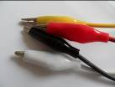 | Lead with crocodile clips at each end | Each | 4 Faradays
Piezo buzzer | 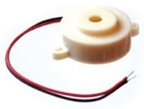 | Connect in a circuit to give a sound output | Each | 6 Faradays
LED – various colours | 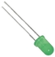 | Light Emitting Diode which lights up when connected in a circuit. Choose from red, orange, green or blue. | Each | 6 Faradays
Motor | 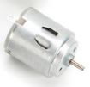 | Connect in a circuit to create clockwise or anti-clockwise movement. Will not work with a solar panel or an LDR. | Each | 6 Faradays
Solar motor | 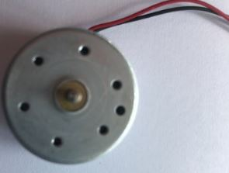 | Connect to a solar panel to create clockwise or anti-clockwise movement. | Each | 6 Faradays
Servo motor  (0 to 90 degrees) | 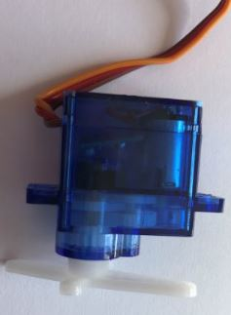 | Use with a servo motor control unit to control movement from 0º to 90º | Each | 6 Faradays
Servo motor (continuous) |  | Use with a servo motor control unit to control continuous movement through 360º | Each | 6 Faradays
Light Dependent Resistor (LDR) | 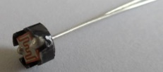 | Component that detects the light level and changes resistance in a circuit. | Each | 8 Faradays
Push to make switch | 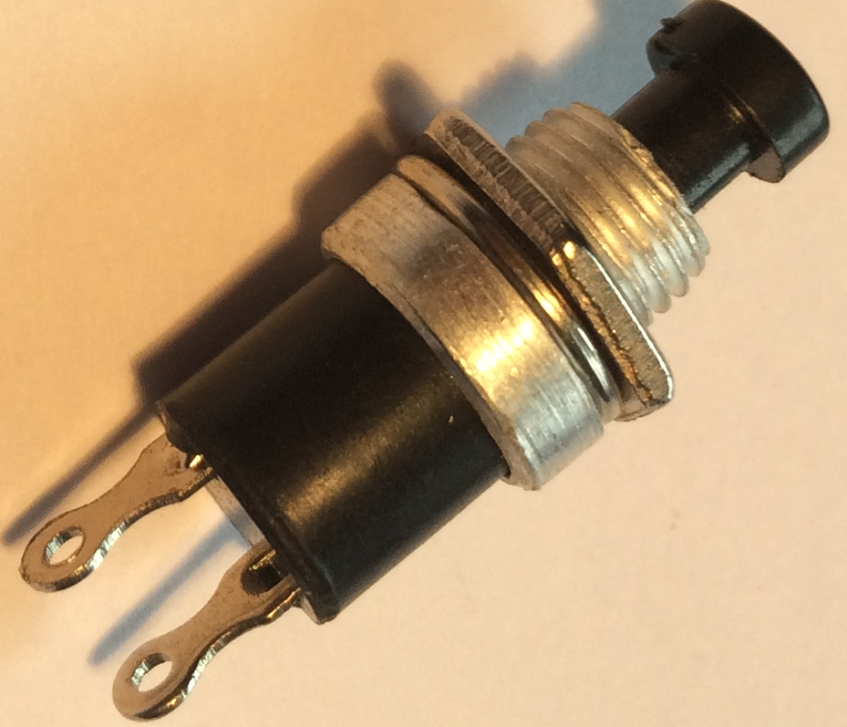 | Connects a circuit when pushed down and breaks the circuit when released. | Each | 6 Faradays

Servo motor control unit | 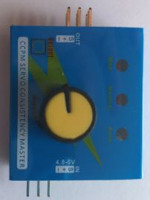 | Use this to control a servo motor. You MUST read the ‘How to …’ sheet before connecting this component. | Each | 8 Faradays
Motor holder | 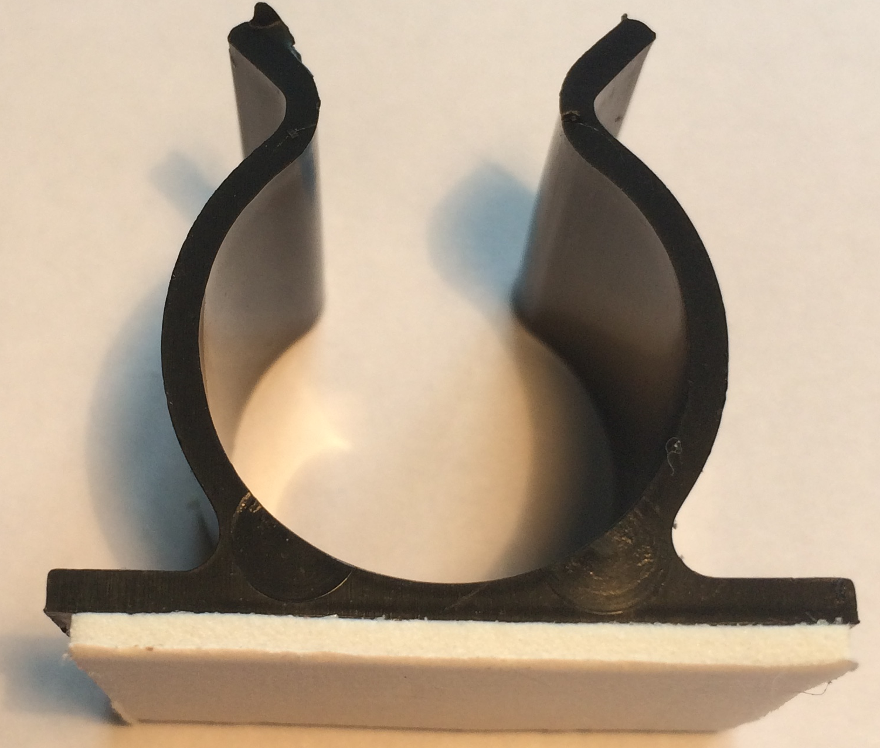 | Used to fix a motor or a syringe in position. NOTE: you will need the insert to connect a syringe. | Each | 4 Faradays
Gear attachment for motor |  | Used to connect a motor to a cog. | Each | 2 Faradays
Pulley attachment for motor | 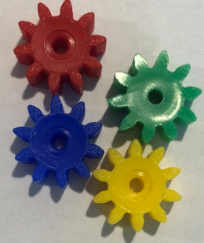  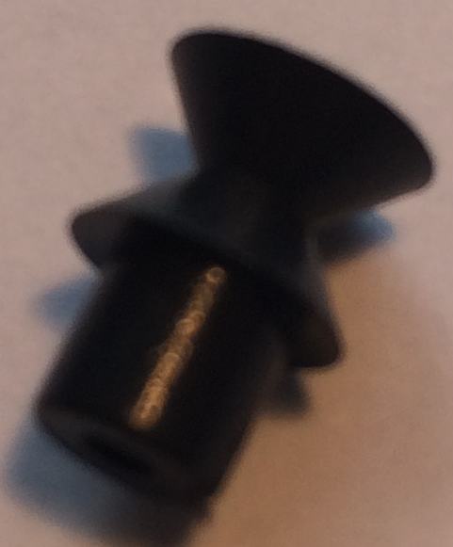 | Used to connect a motor to a pulley wheel – will need connector (e.g. elastic band) | Each | 2 Faradays
Solar panel | 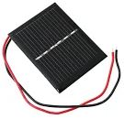  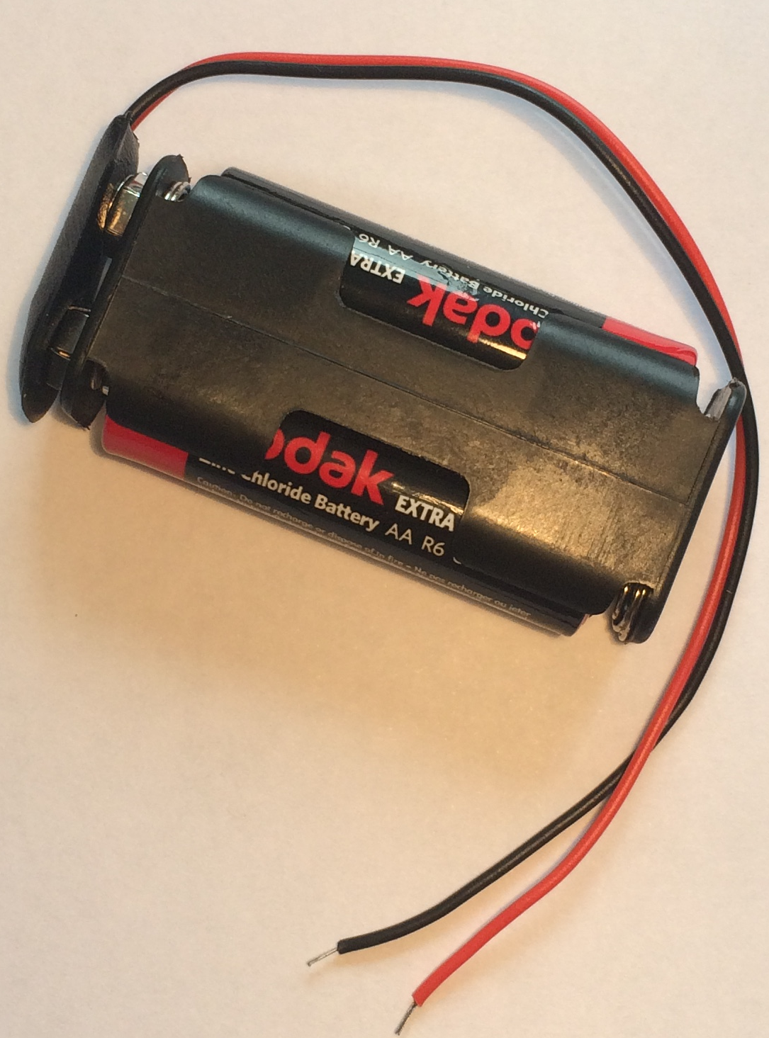 | Used to power components using the power of the sun. You MUST read the ‘How to …’ sheet before using. | Each | 6 Faradays
2AA cells in battery holder with battery snap |  | Used to provide power for your circuit | Each | 4 Faradays
4 AA cells in battery holder with jumper leads | 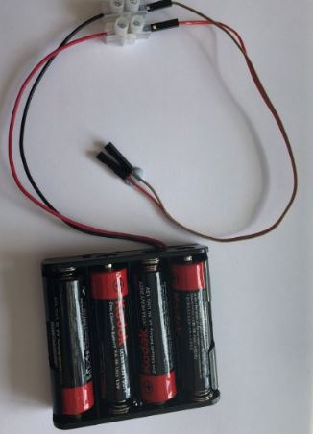 | ONLY to be used with servo motor control unit. | Each | 6 Faradays

Construction materials
Item | Description | Unit |  | Cost
Correx | Used to create structures | Piece |  | 6 Faradays
Plastic syringes with tube | Used to develop pneumatic system | Pair of syringes with plastic tube | 6 Faradays
Small cog | Used in gear systems with motors | Each | 2 Faradays
Medium cog | Used in gear systems with motors | Each | 2 Faradays

Large cog | Used in gear systems with motors | Each | 4 Faradays
Nail | Used for making moisture sensor | Pair | 2 Faradays
Dowel | Piece of solid cylindrical wooden rod used to create structures | Each | 4 Faradays
Pulley wheel | Used to connect to pulley attachments on motor | Each | 6 Faradays
Wooden wheel | Used with motors to drive something | Each | 4 Faradays
Plastic reel | Used in construction | Each | 4 Faradays
Coloured card | A4 sheet of card – assorted colours | Each | 4 Faradays
Aluminium foil | A conductive material which can be used to make pressure pads or switches (MUST NOT be used in place of connecting wires) | 10cm strip | 6 Faradays
Masking tape | Can be used to secure light parts in your design. NOTE: excessive use of tape will result in an additional charge | Roll | 6 Faradays
Sponge | Can be used to make pressure switches or enhance your design. | Each | 6 Faradays
Paperclip | Used to create switches or in construction | Each | 1 Faraday
Paper fastener | Used to create switches or in construction | Each | 1 Faraday
Elastic bands | Used to hold or create working parts, including driving pulley wheels | Each | 1 Faraday
Cable ties | Can be used to hold your structures in place | Each | 2 Faradays
String | Can be used as part of your product design | 30cm piece | 4 Faradays
Baking parchment | Can be used as part of your product design | 10cm strip | 6 Faradays
Wooden lolly sticks | Can be used as part of your product design | Each | 4 Faradays
Hire Centre Trade Card | Use this to hire various items from the hire section of the shop – see next page for details | One per team | 6 Faradays

Available with your Hire Centre Trade Card

These items can be hired from the shop if you buy a Hire Centre Trade Card. You will need to take it to the shop and show the shopkeeper each time you want to use of one of these items. You may only get one item at a time.

Stapler | Used to staple soft materials only
Hole punch | Used to make small holes in soft materials
Ruler | Used to measure any part of your product or additional items
Scissors | Used for soft materials only

Free to use

The cutting station may be used at any point BUT only 3 people will be allowed at this station at any one time. Please take care when using this equipment.

- Kit Inventory List
Description | Quantity | P/N
Wooden lolly sticks | 12 | 06-1195 |  | Link
Cable ties (assorted/ 8cm minimum length) | 20 | 89-1648 |  | https://www.rapidonline.com/major-brushes-7066-200-wooden-lollysticks-pack-of-200-06-1195
Round wire nails 30mm | 12 | 84-8988 |  | https://www.rapidonline.com/sealey-ct200-cable-ties-100-x-2-4mm-pack-of-200-89-1648
Pulley attachment for motor | 6 | 37-0342 |  | https://www.rapidonline.com/forgefix-500nlrh25b-round-head-nail-bright-finish-25mm-bag-of-500g-84-8988
LED – green | 6 | 55-0105 |  | https://www.rapidonline.com/trumotion-tg2-010-pulley-black-10mm-for-2mm-shaft-37-0342
Push to make switch | 3 | 78-0100 |  | https://www.rapidonline.com/kingbright-l-7104gd-3mm-green-led-30mcd-55-0105
LED - orange | 5 | 55-0095 |  | https://www.rapidonline.com/rvfm-us-101-a-red-cap-miniature-red-push-to-make-switch-78-0100
LED – red | 5 | 55-0102 |  | https://www.rapidonline.com/kingbright-l-7104ed-3mm-orange-led-20mcd-55-0095
String Reel | 1 | 06-9272 |  | https://www.rapidonline.com/kingbright-l-7104hd-3mm-red-led-3mcd-55-0102
4 AA cells in battery holder with jumper leads | 6 | 18-3695 |  | https://www.rapidonline.com/major-brushes-78700-thin-cotton-string-250g-reel-06-9272
AA batteries (pack of 40) | 1 | 18-2112 |  | https://www.rapidonline.com/keystone-2478-battery-holder-for-4-x-aa-and-flying-leads-18-3695
Coloured card | 10 | 06-0953 |  | https://www.rapidonline.com/gp-gppca15au007-pca15au007-ultra-alkaline-aa-batteries-pack-of-40-18-2112
Battery snaps | 6 | 18-0105 |  | https://www.rapidonline.com/rapid-re03-a4-assorted-bright-coloured-card-220gsm-pack-of-30-06-0953
Motor | 4 | 37-0142 |  | https://www.rapidonline.com/trupower-18-0105-battery-clip-for-pp3-pp6-battery-150mm-18-0105
Piezo buzzer | 6 | 35-0115 |  | https://www.rapidonline.com/trumotion-e0142-miniature-motor-3v-5240-rpm-37-0142
Light Dependent Resistor (LDR) | 6 | 58-0132 |  | https://www.rapidonline.com/rvfm-35-0115-piezo-buzzer-miniature-12v-35-0115
Solar motor | 4 | 37-0441 |  | https://www.rapidonline.com/silonex-norps12-light-dependent-resistor-58-0132
Aluminium foil | 1 | 06-0921 |  | https://www.rapidonline.com/trumotion-wrf-300ca-08430-18-5-miniature-low-inertia-solar-motor-2v-1540-rpm-37-0441
Solar panel | 4 | 56-0124 |  | https://www.rapidonline.com/rapid-tx7539-rvfm-aluminium-foil-450mm-18-x-75m-06-0921
Motor holder | 6 | 37-0360 |  | https://www.rapidonline.com/truopto-opl30a10101-solar-module-3v-100ma-0-3w-60x48x3mm-with-20cm-flying-leads-56-0124
Paperclip | 8 | 34-3980 |  | https://www.rapidonline.com/rapid-37-0360-rvfm-self-adhesive-motor-mounts-pack-of-10-37-0360
Pulley wheel 54mm | 4 | 37-0411 |  | https://www.rapidonline.com/rapid-is3100-rvfm-plain-paper-clips-pk1000-34-3980
Servo motor (0-90 degrees) | 4 | 37-1339 |  | https://www.rapidonline.com/rapid-37-0411-rvfm-wooden-pulleys-50mm-pack-of-10-37-0411
Servo motor (continuous) | 4 | 37-1335 |  | https://www.rapidonline.com/feetech-fs90-mini-servo-120-9g-37-1339
Paper fastener | 6 | 34-3704 |  | https://www.rapidonline.com/feetech-fs90r-360-continuous-rotation-micro-servo-37-1335
Elastic bands (Number 16 work best) | 12 | 34-9973 |  | https://www.rapidonline.com/rapid-503050-rvfm-paper-fasteners-20mm-box-of-200-34-3704
Plastic syringes with tube | 6 | 06-9969 |  | https://www.rapidonline.com/rapid-34-9973-rvfm-rubber-band-no-16-63-5-x-1-6mm-2-1-2-x-1-16in-454g-34-9973
Jumper leads Pack of 10) | 2 | 34-0679 |  | https://www.rapidonline.com/rapid-64399-10ml-syringe-pack-of-10-06-9969
Terminal blocks | 2 | 21-4269 |  | https://www.rapidonline.com/rapid-jw-d1-mf-jumper-wires-dupont-cable-m-f-26awg-1-pin-2-54mm-pitch-15cm-pk10-34-0679
Sponge (pack of 5) | 1 | 85-4960 |  | https://www.rapidonline.com/hylec-hyks-02412pp-12-pole-kwik-snap-terminal-block-450v-24a-wire-2-5mm2-21-4269
Tubing 15cm piece | 3 | 37-1289 |  | https://www.rapidonline.com/weller-t0052241999-tip-cleaning-sponge-soldering-iron-stands-pack-of-5-85-4960
Small, medium and large cogs | 30 | 37-0280 |  | https://www.rapidonline.com/rapid-pen-0035-rvfm-tubing-3-5mm-clear-25m-coil-37-1289
Crocodile leads | 3 | 17-0350 |  | https://www.rapidonline.com/rapid-rap-4910-rvfm-gear-pack-100-37-0280
2AA cells in battery holder with battery snap | 6 | 18-0125 |  | https://www.rapidonline.com/rvfm-17-0350-pack-of-ten-crocodile-leads-17-0350
Correx Plastic Sheets | 2 | 37-3315 |  | https://www.rapidonline.com/trupower-bh-322-1b-2-x-aa-press-stud-battery-holder-18-0125
Plastic cotton reel | 3 | 06-0630 |  | https://www.rapidonline.com/rapid-ep700ppfldb-rvfm-corrugated-plastic-605-x-605-x-4mm-pack-of-10-37-3315
Masking tape | 4 | 87-1927 |  | https://www.rapidonline.com/major-brushes-7060-100-cotton-reels-pack-of-100-06-0630
Baking parchment | 1 | 52-9443 |  | https://www.rapidonline.com/ultratape-00552450ulrp-masking-tape-25mm-x-50m-87-1927
Dowel | 12 | 06-0765 |  | https://www.rapidonline.com/rvfm-wf014-baking-parchment-paper-18in-x-75m-52-9443
Wooden wheel 54mm | 12 | 06-0715 |  | https://www.rapidonline.com/rapid-06-0765-rvfm-dowel-4mm-x-600mm-pack-of-100-06-0765
 |  |  |  | https://www.rapidonline.com/rapid-06-0715-rvfm-50mm-mdf-wheels-pack-of-100-06-0715

Servo motor control units | 6 | These can be purchased from a range of online sources such as Amazon.
 |  | https://www.amazon.co.uk/dp/B086TXYTPY/ref=sspa_dk_detail_4?psc=1&pd_rd_i=B086TXYTPY&pd_rd_w=ldVw3&pf_rd_p=1055d8b2-c10c-4d7d-b50d-96300553e15d&pd_rd_wg=f0j6p&pf_rd_r=GX3XCWM2RYMQPZX8D171&pd_rd_r=31819c89-d77b-432d-817f-f33a197d2912&spLa=ZW5jcnlwdGVkUXVhbGlmaWVyPUExMEZLNEZVR0JXVTk5JmVuY3J5cHRlZElkPUEwNjE3MzEwMVI2R0JPNUh

- Schedule for the day
08:00 | Challenge Leader arrives to set up
09:15 | Register your teams
09:30 | Welcome and introduction
09:50 | Project brief: Introduction to the Faraday Challenge
10:10 | Planning: Identifying the problems and generating initial ideas
10:25 | Team role selection: team decides on which roles they need
10:30 | Engineering apprenticeship: teams complete a short engineering task ⚠
10:40 | Development ⚠  - Shop opens  - Agree on final product designs
11:00 | Break
11:10 | Development continues ⚠  - Continue to design and modify where necessary  - Record progress in event log
12:20 | Teams are briefed on the content of the presentation
12:30 | Lunch – Tools down
13:00 | Development: Final preparations ⚠  - Finalise product  - Prepare presentation with notes
13:30 | - Shop closes  - Submit accounting sheet to the Shop keeper  - Practise presentation
13:50 | Presentation ⚠  - Teams present their designs to the judge(s)
14:45 | Award ceremony with final feedback and evaluation of the day
15:00 | Engineering teams depart
15:45 | Challenge Leader departs by this point (actual time depends on pack up requirements)

7. Layout of the room

We understand that many of you will be doing this during lesson times and will need to lay the room out accordingly but we have provided our usual layout for reference. Feel free to organise this in whatever way suits the space available and the time you have scheduled in there.

BACK
Cutting station (with cover/cutting mats)
Shop (at least 3 m x 0.5 m)

Team 3
Team 4

Team 5

Team 2

Presentation table

Team 6
Refreshments Table

Team 1

Judge’s table

FRONT – Projection screen

8. Marksheet (overview)

Assessment Criteria |  | Team | Team | Team | Team | Team | Team | Team
 |  | 1 | 2 | 3 | 4 | 5 | 6 | 7
Planning | 13
Development of product* | 20
Use of budget | 8
Product engineering* | 30
The presentation | 15
Teamwork* | 14
Total score | 100
Leader decider (see * for priority scores)
Team | School/Team name
1
2
3
4
5
6
7

9. Assessment information and criteria

Criteria | Marks
- Planning | 13 marks
- Development of product | 20 marks
- Use of budget | 8 marks
- Product engineering | 30 marks
- The presentation | 15 marks
- Teamwork | 14 marks
Total | 100 marks
- Planning (13 marks)
Using the planning section of the Planning and Event Log, marks will be awarded as follows:
- Did they explain how their idea might help Network Rail manage the increasing numbers of passengers on their stations? (3 marks)
- Does the planning diagram detail how the prototype will be constructed? (5 marks)
- Have the electronics for the prototype been detailed? (5 marks)

- Development of product (20 marks)

Using the Engineering Event Log and observations of the team, marks will be awarded as follows:

- Event log 1 - Have they provided an accurate and informative record of development beyond a simple description including any problems and solutions? (5 marks)
- Event log 2 - Have they provided an accurate and informative record of development beyond a simple description including any problems and solutions? (5 marks)
- Event log 3 - Have they provided an accurate and informative record of development beyond a simple description including any problems and solutions? (5 marks)
- Are the priorities identified for the last 30 minutes realistic and appropriate?
(5 marks)

- Use of budget (8 marks)
Using the accountancy sheet and the prototype, marks will be awarded as follows:
- Was there an accurate record of spending? (3 marks)
- Was the budget used effectively? (5 marks)

4. Product engineering (30 marks)
Using the presentation of your prototype and what we have seen during the development period, marks will be awarded for:

- Did their prototype provide a realistic solution to the brief from Network Rail? (4 marks)
- Was the choice of electronic components appropriate for their intended design?
(4 marks)
- Was the choice of materials appropriate for the structure and/or mechanics of their intended design? (4 marks)
- Was the final prototype engineered well with all elements coming together in a well-structured and fit for intended purpose product? (6 marks)
- Did the judge(s) see the electronics and structure work together effectively as intended? (6 marks)
- Did the team push themselves beyond the minimum brief and incorporate at least two processes? (6 marks)

5. The presentation (15 marks)
Using the presentation of your prototype, marks will be awarded as follows:

- Did the team explain how their prototype works, including details of how and why they used the electronics and the mechanics in their design? (6 marks)
- Did the team identify the most challenging engineering aspect they faced during their development and how they overcame this challenge? (3 marks)
- Did the team explain what they did well in their teamwork and what aspects they could have improved? (4 marks)
- Did the team effectively demonstrate their prototype? (2 marks)

- Teamwork (14 marks)
Using the judges’ observations of your team throughout the day, marks will be awarded as follows:

- Did the team work well together with all members engaged in the project and any conflicts successfully resolved? (5 marks)
- Did the team work tidily and safely within the health and safety rules? (3 marks)
- Did the team persevere to resolve issues during the project and work largely independently? (6 marks)

10. Risk Assessment
The following risk assessment is given as guidance. It is advised that the school refers to the CLEAPSS Model Risk Assessment Documents for D&T.

Risk Assessment and Operating Procedure – IET Faraday
Activity: Faraday Challenge Day Network Rail

Persons at risk | Students taking part in the Faraday Challenge Day and adults in the location
Maximum Group Size | 36 students | Recommended Staffing/Student Ratio | 1:18
Risk Assessment
Hazards |  | Control Measures
- Use of electrical equipment – risk of electric shock |  | All electrical equipment is low voltage.
- Use of electrical equipment – short circuit causing heating |  | Warn students of the possibility of burns when connecting and disconnecting components. All pupils will receive a briefing about correct use of electrical components.
- Basic use of hand tools (craft knives, scissors, hole punches, staplers) – risk of cutting or abrasion |  | Warn students of the risks and advise them of safe working practices. Identify member of staff to supervise area. Inform challenge leader if use of knives in school is restricted.
- Use of water with moisture sensors |  | Ensure students test their moisture sensor using a sponge in a small tub rather than directly in any drink or cup of water to avoid spillage on electrical components.
Location issues (to be completed by Host School)
Further Action Required: 1. Ensure all persons staffing the Faraday Challenge Days are aware of and competent to comply with this risk assessment and the control measures.

Risk Assessment (page 2)

Working Practice
Group structure | One Faraday Challenge Day Leader and one teacher and one technician from the host school to be present during the whole day to oversee use of equipment and to keep order. Teachers bringing groups from other schools must remain in the room and be responsible for their own students.
Restrictions | Unknown premises.
Emergency  Procedure | Follow the lead from the Host School.  Faraday Challenge Day Leader to be fully briefed on risk assessment procedure prior to the day or on arrival.
Safeguarding | The Challenge Leader will carry their DBS and provide it where requested. They will comply with the safeguarding regulations within the school. A member of staff from the school MUST be present in the rooms at all times when students are present.
Safety Equipment | First aid kit and fire extinguisher (electrical fires) to be provided by Host School.
Covid 19 | Please refer to the separate paper ‘Safety during the COVID-19 pandemic’ and inform us of any actions or expectations as appropriate.
Name and role of IET Faraday Challenge representative | Keira Sewell  Challenge Day Leader.
Name and role of school representative
Signature of the school representative
Date of this Review | October 2020

