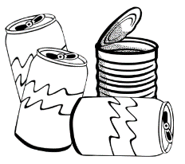
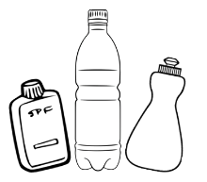
Testing Material Properties

Test the material as follows:
Magnetism test: Place a magnet onto the material. Does the magnet attract and stick to the material, yes or no? If it does the material is magnetic.
Flexible test: How much will the material bend before it breaks? Try to bend the material gently between your hands. Award a mark of 1 to 5: 1 mark for not being very flexible and 5 for being very flexible and easy to bend.
Transparency test: Can you see through the material, yes or no? Hold the material up to the light and check. If you can see clearly through it is transparent.
Density test: Make sure you have the same size of each material. Use activity sheet 2 to help you record the
Testing Results Table
Record your results.
Material | Material Properties
 | Magnetic  Y or N | Flexibility  1 to 5 | Transparency  1 to 5 | Density  g/cm³

