Activity title
Dress the elf maths activity
Stay safe
Whether you are a scientist researching a new medicine or an engineer solving climate change, safety always comes first. An adult must always be around and supervising when doing this activity. You are responsible for:

• ensuring that any equipment used for this activity is in good working condition
• behaving sensibly and following any safety instructions so as not to hurt or injure yourself or others

Please note that in the absence of any negligence or other breach of duty by us, this activity is carried out at your own risk. It is important to take extra care at the stages marked with this symbol: ⚠
Time required
30 minutes to 1 hour
Activity summary
The little elves who live at the North Pole are feeling rather fed up. All the hard work they put in throughout the year has worn out their clothes!

They’ve told Santa they need a brand new uniform and he’s counting on you to come up with some brilliant designs. He also wants you to work out how many outfit combinations you’ve created, so that he can let his elves know! Get ready to practice your counting, colouring and practical skills!
What equipment will you need?
- An A4 printout of the ‘Dress the elf’ activity sheet
- Some sheets of A4 paper
- Thin card for your elf model (you could use an old cereal box)
- Coloured crayons or pencils
- Safety scissors
- Sticky tack, double-sided tape or a glue stick

How to do it
Step 1: Print the template

- Download the ‘Dress the elf’ template
- Print it out on A4 paper

Step 2: Create your elf model

- Use scissors safely to cut out the elf ⚠
- Place your paper elf on some thin card and draw around it
- Cut out your card elf ⚠

Step 3: Design your elf uniform

- Colour in the elf’s clothes
- You might also like to jazz them up by adding your own designs

Step 4: Dress your elf

- Try the clothes on your card elf, using the tabs and sticky tack (don’t use the glue just yet!)
- Try out lots of different outfit combinations

Step 5: Work out the number of possible combinations

Well done. You’ve made your elf a brand new uniform with a set number of clothes:
- 2 hats (1 pointy + 1 droopy)
- 2 tops (1 Santa top + 1 dress)
- 2 pairs of shorts (1 plain, one stripy)

Use multiplication to work out the number of possible combinations:
2 x 2 x 2 = 8

Your elf has 8 different outfits!

Step 6: Check for yoursELF!

This information table provides a great way to show the eight different outfit combinations you’ve created.
Try them all out on your card elf, to check for yoursELF!

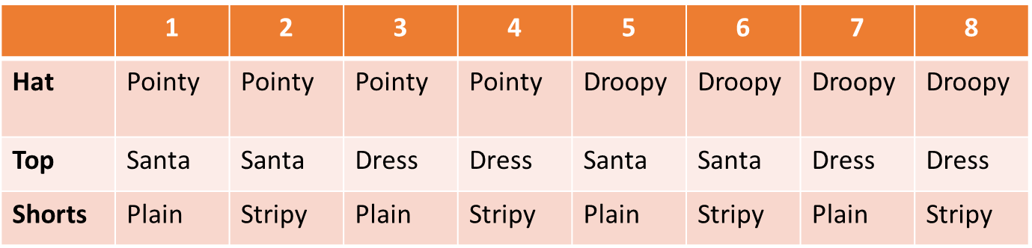

Three Christmas kisses and a wish
It’s always great to reflect on a job well done. Show your elf uniform creation to a friend or family member and ask them to tell you three good things about it, and one thing that could be improved.

You could then use their feedback on your design to make another elf uniform that’s even better than the first.

Practice makes perfect…
Festive fun
After all that hard work, here are some cracking jokes to make you smile:

- What type of music do elves prefer?
Wrap

- What do elves like doing on holiday?
Taking elfies

- What do you call an elf who refuses to share?
Elfish
Did you know?
Although modern elves are usually well-behaved, the elves of old were rather naughty and got up to all sorts of mischief. People used to blame elves for lots of everyday problems – for example, “elf locks” was the name they gave to tangled or knotted hair!

Bonus activity – Make yourself a cone-shaped elf hat
Making an elf hat is easy… but remember to add some really big ears, for the full elf effect!
Here’s what you’ll need:
- Scissors
- Red or green a4 craft paper
- Glue stick
- Sticky tape
- Hole punch
- Elastic
- Skin-coloured craft paper (half a4 should do)
- Pen or pencil
- Cotton wool ball
How to do it
Step 1: Prepare to make your cone
- Practise making a cone shape using your red or green craft paper
- Add a line of glue down one short edge

Step 2: Stick your cone together
- Make the cone shape again and press down the glued edge
- You’ll see an exposed paper corner towards the top of the cone – glue this down too

Step 3: Neaten up your cone
- Use scissors safely to cut round the bottom of your cone and make it look like a party hat ⚠

Step 4: Prepare the holes for the elastic strap
- Cut a 4cm piece of sticky tape. ⚠
- Stick the tape to the bottom of your cone so that half is on the outside and half is folded inside
- Make a hole through the sticky tape (the tape will make the hole stronger)
- Repeat this process on the opposite side

Step 5: Add the elastic strap
- Tie a knot at one end of the elastic
- Feed the elastic through one hole (make sure the knot is inside the cone)
- Feed it through the other hole, starting from the outside of the cone
- Try the hat on and decide where to add the second knot on the elastic
- Take the hat off and tie the knot (make sure it’s inside the cone)
- Take the hat off and cut away the spare elastic ⚠

Step 6: Add the finishing touches
- Draw two pointy ears on a skin-coloured piece of craft paper – the ear size and shape is up to you!
- Draw a spiral shape on each ear
- Cut out the ears ⚠
- Place an ear onto one of the holes where you inserted the elastic. Staple it in place
- Repeat the process for the other ear
- Glue a cotton wool ball on the top of the cone

And there you have it – a simple and stylish elf hat, made in a matter of minutes!
Imagine you’re an elf!
Father Christmas relies on his hard-working team of elves all year round. They do all sorts of important jobs, from making presents, toys and sweets to sorting children’s letters, looking after the reindeer and keeping the magic sleigh in tip-top condition.

Imagine you’re an elf applying for a job in the North Pole. What’s your new elf name? And what will you tell Father Christmas about yourself, to make sure he picks you for the job?
Elf application form
- Elf name:

- Elf age:

- Job location: North Pole

- Do you like Christmas? YES/NO

- Are you good at keeping secrets? YES/NO

- Why do you want to join the elf team?

- Which elf task would you most like to do?

- Which skills will you use, to help Father Christmas deliver his magic?

- Which three words describe you best?

- Draw yourself as an elf.

