Learning about levers through beam and mass – Exploring Moments

Aim

A metre rule (or wooden beam with tape measure attached) is attached to a hinge support at one end. A luggage scale is used to measure the reaction at the other end. The aim is to predict this reaction when a mass is attached at various positions along the beam.
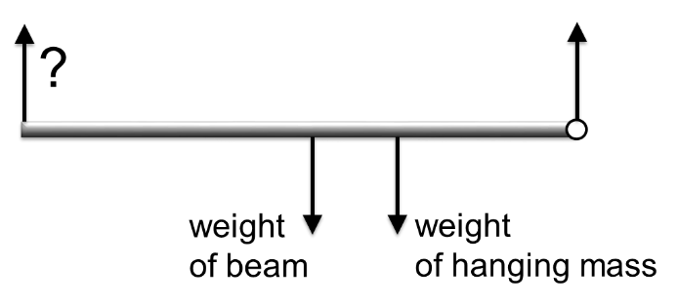
pivot at this end
luggage scale at this end

Summary of the experiment

- Use the scales to measure and record the mass of the beam or metre rule and the mass of the hanging object (bag of sugar).
- Attach a foldback clip to the end of the beam and slide a pencil between the loops.
- Rest the pencil on two tables placed with a small gap between them so the beam is free to move.
- Attach a luggage scale to the other end of the beam and use it to lift the beam into a horizontal position.
- Make calculations (see below) to predict the reading on the scale when the hanging mass is placed at various positions along the beam.
- Place the mass at each of these positions and record the reading on the scale at each.
- Compare and discuss the results.

Typical calculations

Draw a force diagram showing all of the forces acting on the beam. The weight of an object is its mass in kg times the acceleration due to gravity, g, in ms⁻². For instance a 250 gram mass has a weight of 0.25g Newtons. We don’t substitute for g to begin with as it often cancels out, but we’ll take g to be 9.8 when needed. It’s important to include the weight of the beam itself, which we treat as acting at its centre. Here’s how it looks for the beam used in the video, with the 1 kg mass placed at 25 cm from the pivot.

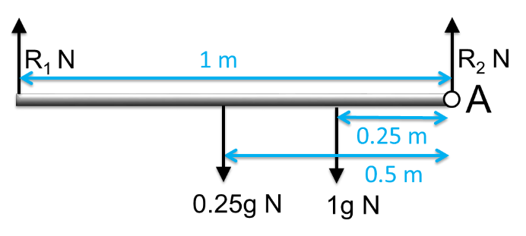
To find the reaction force R₁ we will need to take moments about a point. We can take moments about any point and, since the beam is in equilibrium, the sum of the moments about that point will be zero. This can also be written as ‘total clockwise moment = total anticlockwise moment’. The moment of a force is equal to the magnitude of the force times the perpendicular distance of the line of action of the force from the chosen point. We are going to choose point A so that the force R₂ does not appear in our equation (because the distance is 0). Here’s the moment balance equation for this case.
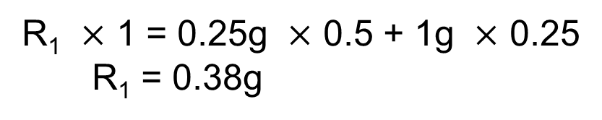
The predicted reaction force is therefore 0.38g Newtons. Although the luggage scale measures force, it converts this to an equivalent mass in kg. Working backwards this means that the predicted reading on the scale is 0.38 kg.

Suggested points for discussion

Look at the modelling assumptions and any factors affecting the accuracy to see whether these account for any difference in results. A good approach is to ask the students and then discuss the ideas they raise, prompting for any key ideas that they miss. It should be possible to get a good match between results, but here are some suggested lines of discussion.
We have assumed that the beam is uniform along its length. This is often a good assumption, but natural materials often have more variation than manufactured materials. Think of some cases when it might not be a good assumption.
How accurately were the measurements made? It may depend upon the scales used, but we could generally expect digital scales to give an accurate enough reading not to affect this kind of experiment.

Extending the task

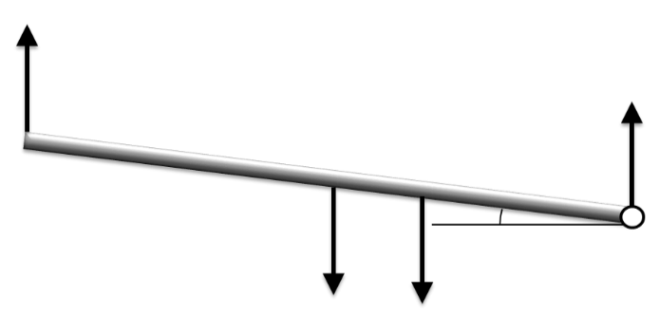
Try lifting the beam to an angle above the horizontal. How will your calculations change? What do you find?

Applications

Understanding and working with moments is essential in structural engineering applications such as designing and constructing buildings and bridges. Some interesting examples are:
- the Heatherwick rolling bridge youtube.com/watch?v=x0Dj7XA77hw;
- the Shard building.
Moments are also essential in understanding how levers work. Some examples are using a see-saw or wheelbarrow, or lifting weights using your biceps.

