The Faraday Battery Challenge

2024-2025
Student Booklet

Could you be our engineer….?



Contents

- The Context …………………………………………………………………………….. 4
- The Brief ………………………………………………………………………………… 5
- Schedule for the day ………………………………………………………………….. 6
- Engineering apprenticeship …………………………………………………………… 7
- Shop resource sheet …………………………………………………………………… 8
- Assessment information and criteria …………………………………………………. 12

With thanks to all our supporters and this season’s theme partners…



To find out more information on the 2024-2025 IET Faraday® Challenge Day supporters visit our website, theiet.org/faraday.

Context
The Faraday Battery Challenge, delivered by Innovate UK, has a budget of £610m to develop new battery technologies. Their journey began back in 2017 and since then they have funded many projects in the UK. The past few years have seen some fantastic developments. However, up to now, their projects have focused on research, development and production of batteries and now they want to move forward in considering the use of these batteries in all our lives.
Their work is driven by the need to be net carbon zero by 2050. Developing more sustainable ways of getting around the UK is one of the key reasons so much time and research is being put into developing batteries for our future. As we move away from fossil fuels, such as coal, oil and gas, towards renewable sources, such as wind and solar, we need to find ways to ensure we can maintain a stable and consistent energy supply. Developing better battery technologies will mean they charge faster and run for longer than ever before.
These new batteries can be small, a single cell, or huge, where multiple cells are joined together, or anything in between. They can power small objects, such as your games console, all the way up to cars and trucks. Research and development currently underway will allow us to power aeroplanes and ships in the future.

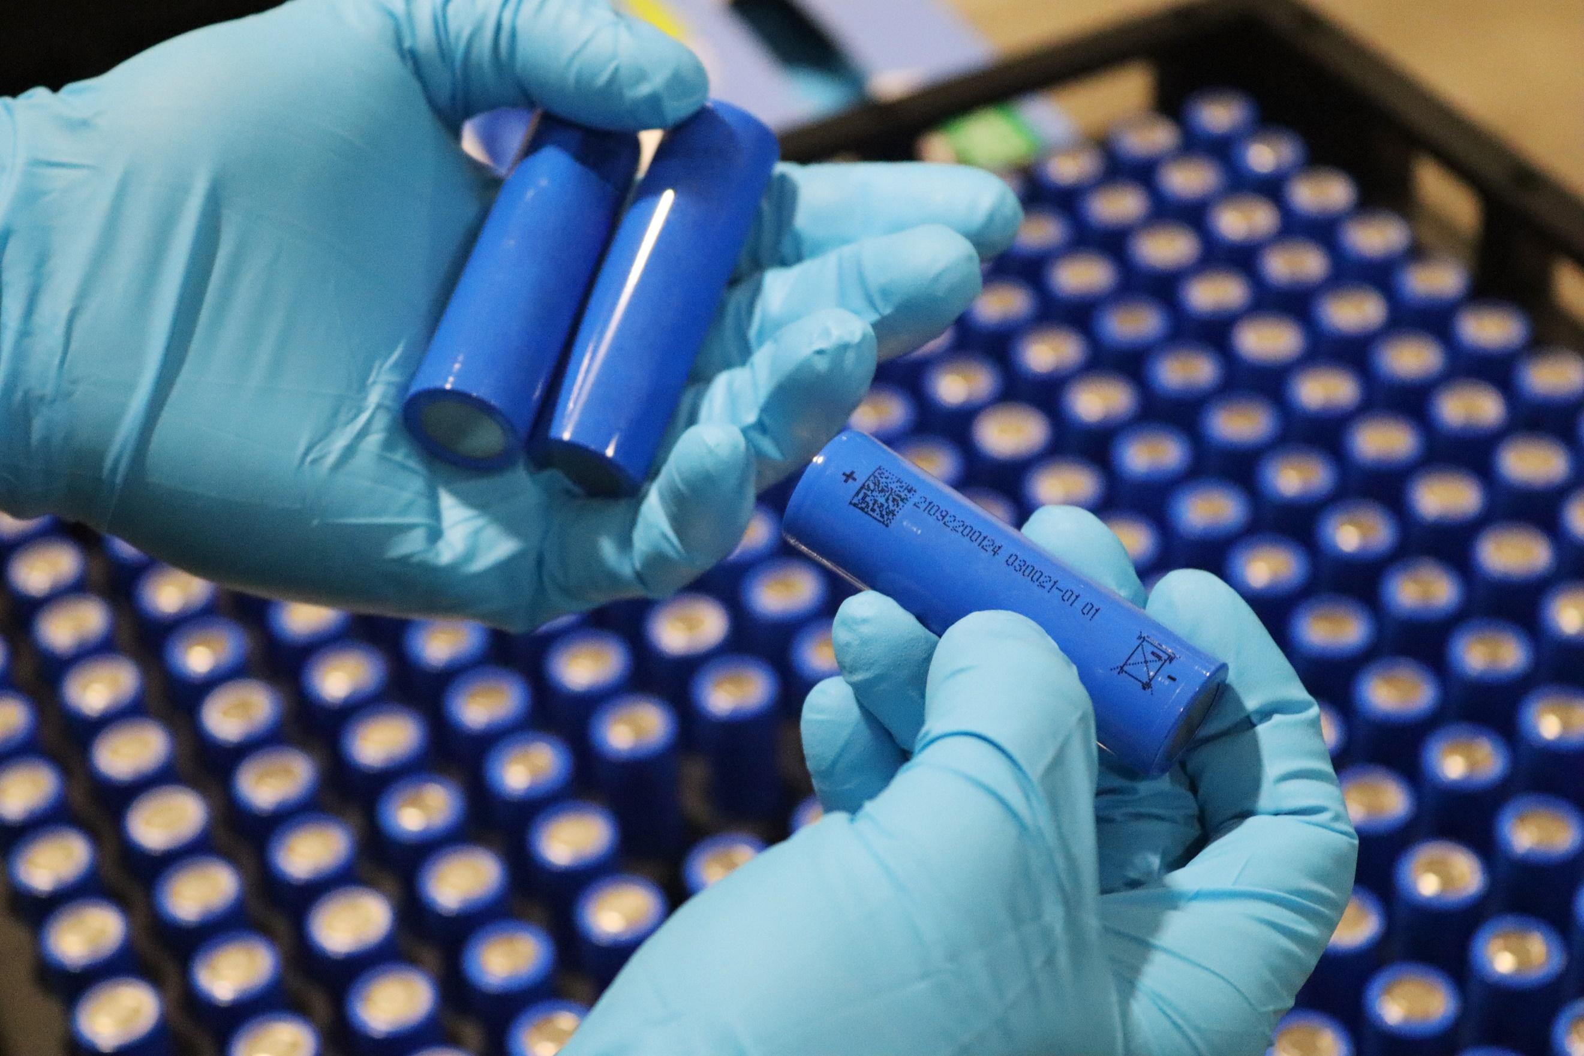
The UK Battery Industrialisation Centre was opened so that businesses could develop their battery manufacturing processes at the scale they need to move to industrial production and where those working in the industry can develop new skills by working on the production line, alongside UKBIC’s specialist teams.
However, developing battery technology is not without its problems. Firstly, they will need people with the skills required to create, develop and build new technologies. It is estimated that we will need over 90,000 talented people in all kinds of battery jobs from marketing to working in the factory, to supporting future breakthroughs. Secondly, chemicals used in battery production need to be mined and this has environmental impact. Thirdly, we need to think about how to recharge batteries. Finally, although developing technologies mean we can recharge batteries many times, they will eventually need replacing. To avoid these just becoming part of landfill, we need to invest in ways of recycling or repurposing batteries.
By working together to solve these challenges we open up huge opportunities for our society and The Faraday Battery Challenge team need your ideas.
- 3 -

2. The Brief

Design and build ONE prototype which:
- is capable of using a battery or batteries;

- can help someone from one of the following:
- a person with a disability or specific need;
- an educational toy for a child aged 2 to 5 years old;
- someone who takes part in a sport or outdoor activity.

Your prototype MUST contain at least one working electric component.

You must also show how you have considered all the following in your final design:
- the sustainability of your product design, including how you will recharge your battery:
- how long your battery will last between charges:
- how you will dispose of your battery at the end of its lifespan.

- Complete the planning and events log.

- Present your prototype to the IET Faraday Challenge® judge.

You will need to demonstrate the skills and attitudes we are looking for so:

- be creative.
- plan carefully.
- work within the resources and the budget available.
- be realistic about what is achievable in the time available.
- be resilient and persevere with problems.
- record your thinking.
- keep to strict deadlines.

Remember, engineering is about people. Today is your chance to make a difference, could you be our engineer...?
- 4 -

- 4 -

Challenge schedule

08:00 | Challenge Leader arrives to set up
09:15 | Register your team (All visiting schools should have arrived by this point)
09:30 | Welcome and introduction
09:50 | Engineering apprenticeship: teams complete a short engineering task
10:00 | Project brief: Introduction to the IET Faraday® Challenge
10:20 | Planning: Identifying the problems and generating initial ideas
10:35 | Team role selection: team decides on which roles they need
10:40 | Development  - Shop opens  - Agree on final product designs
11:00 | Break
11:10 | Development continues  - Continue to design and modify where necessary  - Record progress in event log
12:15 | Teams are briefed on the engineering priorities and the presentation
12:30 | Lunch – Tools down
13:00 | Development: Final preparations  - Finalise product  - Prepare presentation with notes
13:30 | - Shop closes  - Submit accounting sheet to the Shop keeper  - Practise presentation
13:50 | Presentation  - Teams present their designs to the judge(s)
14:45 | Award ceremony with final feedback and evaluation of the day
15:00 | Engineering teams depart
15:45 | Challenge Leader departs by this point (actual time depends on pack up requirements)

- 5 -
4. Engineering apprenticeship

In this circuit you are going to make a light dimmer or brighter depending on the level of resistance in a circuit.

Connect the circuit as shown below.

Crocodile lead
Crocodile lead
Battery pack

Crocodile lead

Light Dependent Resistor (LDR)
Piezo buzzer

Top tips:

- The LDR must be connected to the positive terminal of the battery (red wire).
- The red wire of the piezo buzzer must be connected next in the circuit on the positive terminal side of the battery pack.

Hold your hand over the Light Dependent Resistor (LDR) and listen to what happens to the buzzer.

Your Challenge leader will show you what happens when you shine a torch on the LDR

5. Shop resource sheet
- 6 -

Items to buy

Electrical components
Item | Description |  | Unit | Cost
Crocodile leads | 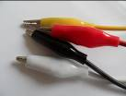 | Lead with crocodile clips at each end | Each | 4 Faradays
Piezo buzzer | 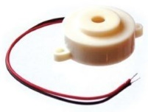 | Connect in a circuit to give a sound output | Each | 6 Faradays
LED – various colours | 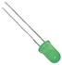 | Light Emitting Diode which lights up when connected in a circuit. Choose from red, orange, green or blue. | Each | 6 Faradays
Motor | 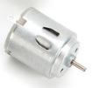 | Connect in a circuit to create clockwise or anti-clockwise movement. Will not work with a solar panel or an LDR. | Each | 6 Faradays
Solar motor | 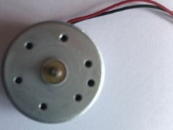 | Connect to a solar panel to create clockwise or anti-clockwise movement. | Each | 6 Faradays
Servo motor  (0 to 90 degrees) | 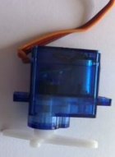 | Use with a servo motor control unit to control movement from 0º to 90º | Each | 6 Faradays
Servo motor (continuous) |  | Use with a servo motor control unit to control continuous movement through 360º | Each | 6 Faradays
Light Dependent Resistor (LDR) | 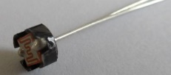 | Component that detects the light level and changes resistance in a circuit. | Each | 8 Faradays
Push to make switch | 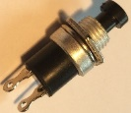 | Connects a circuit when pushed down and breaks the circuit when released. | Each | 6 Faradays
- 7 -

Servo motor control unit | 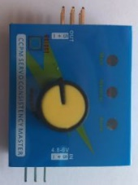 | Use this to control a servo motor. You MUST read the ‘How to …’ sheet before connecting this component. | Each | 8 Faradays
Motor holder | 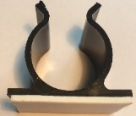 | Used to fix a motor or a syringe in position. NOTE: you will need the insert to connect a syringe. | Each | 4 Faradays
Gear attachment for motor |  | Used to connect a motor to a cog. | Each | 2 Faradays
Pulley attachment for motor | 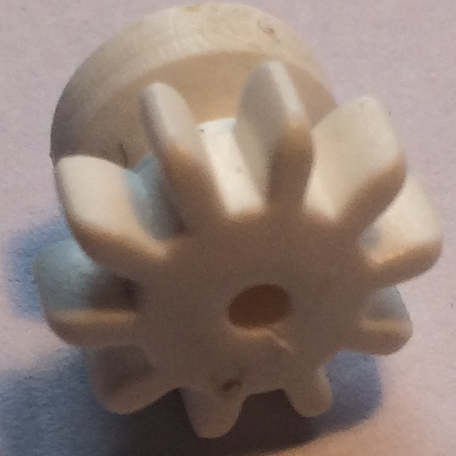  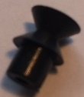 | Used to connect a motor to a pulley wheel – will need connector (e.g. elastic band) | Each | 2 Faradays
Solar panel | 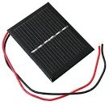  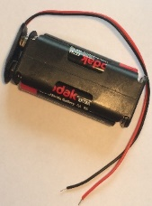 | Used to power components using the power of the sun. You MUST read the ‘How to …’ sheet before using. | Each | 6 Faradays
2AA cells in battery holder with battery snap |  | Used to provide power for your circuit | Each | 4 Faradays
4 AA cells in battery holder with jumper leads | 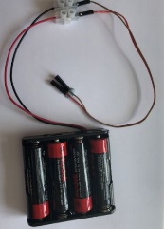 | ONLY to be used with servo motor control unit. | Each | 6 Faradays

Construction materials
Item | Description | Unit |  | Cost
Correx | Used to create structures | Piece |  | 6 Faradays
Plastic syringes with tube | Used to develop pneumatic system | Pair of syringes with plastic tube | 6 Faradays
Small cog | Used in gear systems with motors | Each | 2 Faradays
Medium cog | Used in gear systems with motors | Each | 2 Faradays
- 8 -

Large cog | Used in gear systems with motors | Each | 4 Faradays
Nail | Used for making moisture sensor | Pair | 2 Faradays
Dowel | Piece of solid cylindrical wooden rod used to create structures | Each | 4 Faradays
Pulley wheel | Used to connect to pulley attachments on motor | Each | 6 Faradays
Wooden wheel | Used with motors to drive something | Each | 4 Faradays
Plastic reel | Used in construction | Each | 4 Faradays
Coloured card | A4 sheet of card – assorted colours | Each | 4 Faradays
Aluminium foil | A conductive material which can be used to make pressure pads or switches (MUST NOT be used in place of connecting wires) | 10cm strip | 6 Faradays
Masking tape | Can be used to secure light parts in your design. NOTE: excessive use of tape will result in an additional charge | Roll | 6 Faradays
Sponge | Can be used to make pressure switches or enhance your design. | Each | 6 Faradays
Polyfoam | Can be used as part of your product design | Piece | 4 Faradays
Paperclip | Used to create switches or in construction | Each | 1 Faraday
Paper fastener | Used to create switches or in construction | Each | 1 Faraday
Elastic bands | Used to hold or create working parts, including driving pulley wheels | Each | 1 Faraday
Cable ties | Can be used to hold your structures in place | Each | 2 Faradays
String | Can be used as part of your product design | 30cm piece | 4 Faradays
Wooden lolly sticks | Can be used as part of your product design | Each | 4 Faradays
Hire Centre Trade Card | Use this to hire various items from the hire section of the shop – see next page for details | One per team | 6 Faradays
- 9 -

Available with your Hire Centre Trade Card

These items can be hired from the shop if you buy a Hire Centre Trade Card.

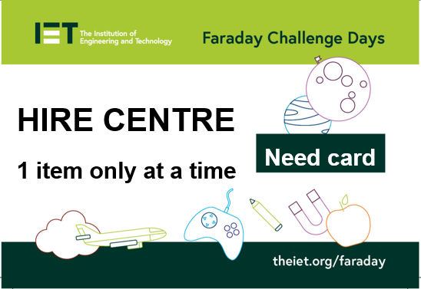

You will need to take it to the shop and show the shopkeeper each time you want to use of one of these items. You may only get one item at a time.

Stapler | Used to staple soft materials only
Hole punch | Used to make small holes in soft materials
Ruler | Used to measure any part of your product or additional items
Scissors | Used for soft materials only

Cutting Station

Free to use whenever the shop is open BUT only 3 people will be allowed at this station at any one time. Please take care when using this equipment and do not take anything away from this table.

- 10 -

- 11 -

6. Assessment information and criteria

Criteria | Marks
- Planning | 13 marks
- Development of product | 17 marks
- Use of budget | 8 marks
- Product engineering | 32 marks
- The presentation | 15 marks
- Teamwork | 15 marks
Total | 100 marks
- Planning (13 marks)
Using the planning section of the Planning and Event Log, marks will be awarded as follows:
- Did they explain how their idea might support the work of the Faraday Battery Challenge team? (3 marks)
- Does the planning diagram detail how the prototype will be constructed? (5 marks)
- Have they drawn the circuit diagram(s)? (5 marks)

- Development of product (17 marks)

Using the Engineering Event Log and observations of the team, marks will be awarded as follows:

- Event log 1 - Have they provided an accurate and informative record of development beyond a simple description including any problems and solutions? (4 marks)
- Event log 2 - Have they provided an accurate and informative record of development beyond a simple description including any problems and solutions? (4 marks)
- Event log 3 - Have they provided an accurate and informative record of development beyond a simple description including any problems and solutions? (4 marks)
- Have they listed realistic and appropriate engineering priorities for the last 30 minutes and allocated tasks to team members? (5 marks)

- Use of budget (8 marks)
Using the accountancy sheet and the prototype, marks will be awarded as follows:
- Was there an accurate record of spending? (3 marks)
- Was the budget used effectively? (5 marks)
4. Product engineering (32 marks)
Using the presentation of your prototype and what we have seen during the development period, marks will be awarded for:

- To what extent did their final prototype meet the brief from the Faraday Battery Challenge team? (4 marks)
- Was the choice of electronic components appropriate for their intended design?
(4 marks)
- Was the choice of materials appropriate for the structure and/or mechanics of their intended design? (4 marks)
- Was the final prototype engineered well with all elements coming together in a well-structured and fit for intended purpose product? (7 marks)
- Did the judge(s) see the electronics and structure work together effectively as intended? (7 marks)
- Did the team push themselves to achieve a level of complexity relevant to the brief? (6 marks)

5. The presentation (15 marks)
Using the presentation of your prototype, marks will be awarded as follows:

- Did the team explain what their prototype is and how it works, including details of the electronic and mechanical designs? (5 marks)
- Did the team explain how their prototype meets the key considerations of sustainability, time between charges and disposal? (4 marks)
- Did the team identify the most challenging engineering aspect(s) they faced during their development and how they overcame the challenge(s)? (3 marks)
- Did the team explain what they did well in their teamwork and what aspects they could have improved? (3 marks)

- Teamwork (15 marks)
Using the judges’ observations of your team throughout the day, marks will be awarded as follows:

- Did the team work together with all members engaged in the project and any conflicts successfully resolved? (6 marks)
- Did the team work tidily and safely within the health and safety rules? (3 marks)
- Did the team persevere to resolve issues productively and work largely independently? (6 marks)

- 12 -

These blank pages are for you to write your presentation notes. Don’t forget to look at the assessment criteria.

