Underground sewage systems
Discuss the link between volume of sewage and underground sewage systems

Subject(s): Science, Design & Technology, Mathematics  Approx time: 60-90 mins |  |  | Key words / Topics:  - human impact  - environment  - water use  - waste water  - calculations  - volume of cylinder  - volume of cone  - approximation  - estimation  - experimentation  - estimation of volumes
Suggested Learning Outcomes
- To develop an insight into the representation of large volumes
- To recognise that discrepancies in data can and do exist, and to begin to develop an understanding of possible causes
- To determine and select variables, then apply mathematical formulae to solve real-life problems
Introduction
This activity challenges students to move beyond an ‘out of sight, out of mind’ approach to sewage as they use and develop their mathematical process skills within the real-world contexts presented.

Purpose
This starter activity provides a quick, engaging introduction to a lesson, focusing on the link between sewage and the underground tunnel system.

It encourages students to think about the role of engineers in providing us with underground sewage systems, and the reasons why different regions require different systems depending on the numbers within each population.

Activity |  |  | Teacher notes
What is sewage?  ‘Sewage is a form of wastewater … often collected in sewer systems … mostly composed of about 95% pure water and the rest faeces and urine. … The sewage is then taken to places where it can be safely disposed or filtered for reuse.’  Starter  Class discussion on how much sewage is created per person per day.  Then show Slide 5 from the ‘Sewage Tunnels’ (Presentation).  Why might people in the South East use more water than people in other regions?  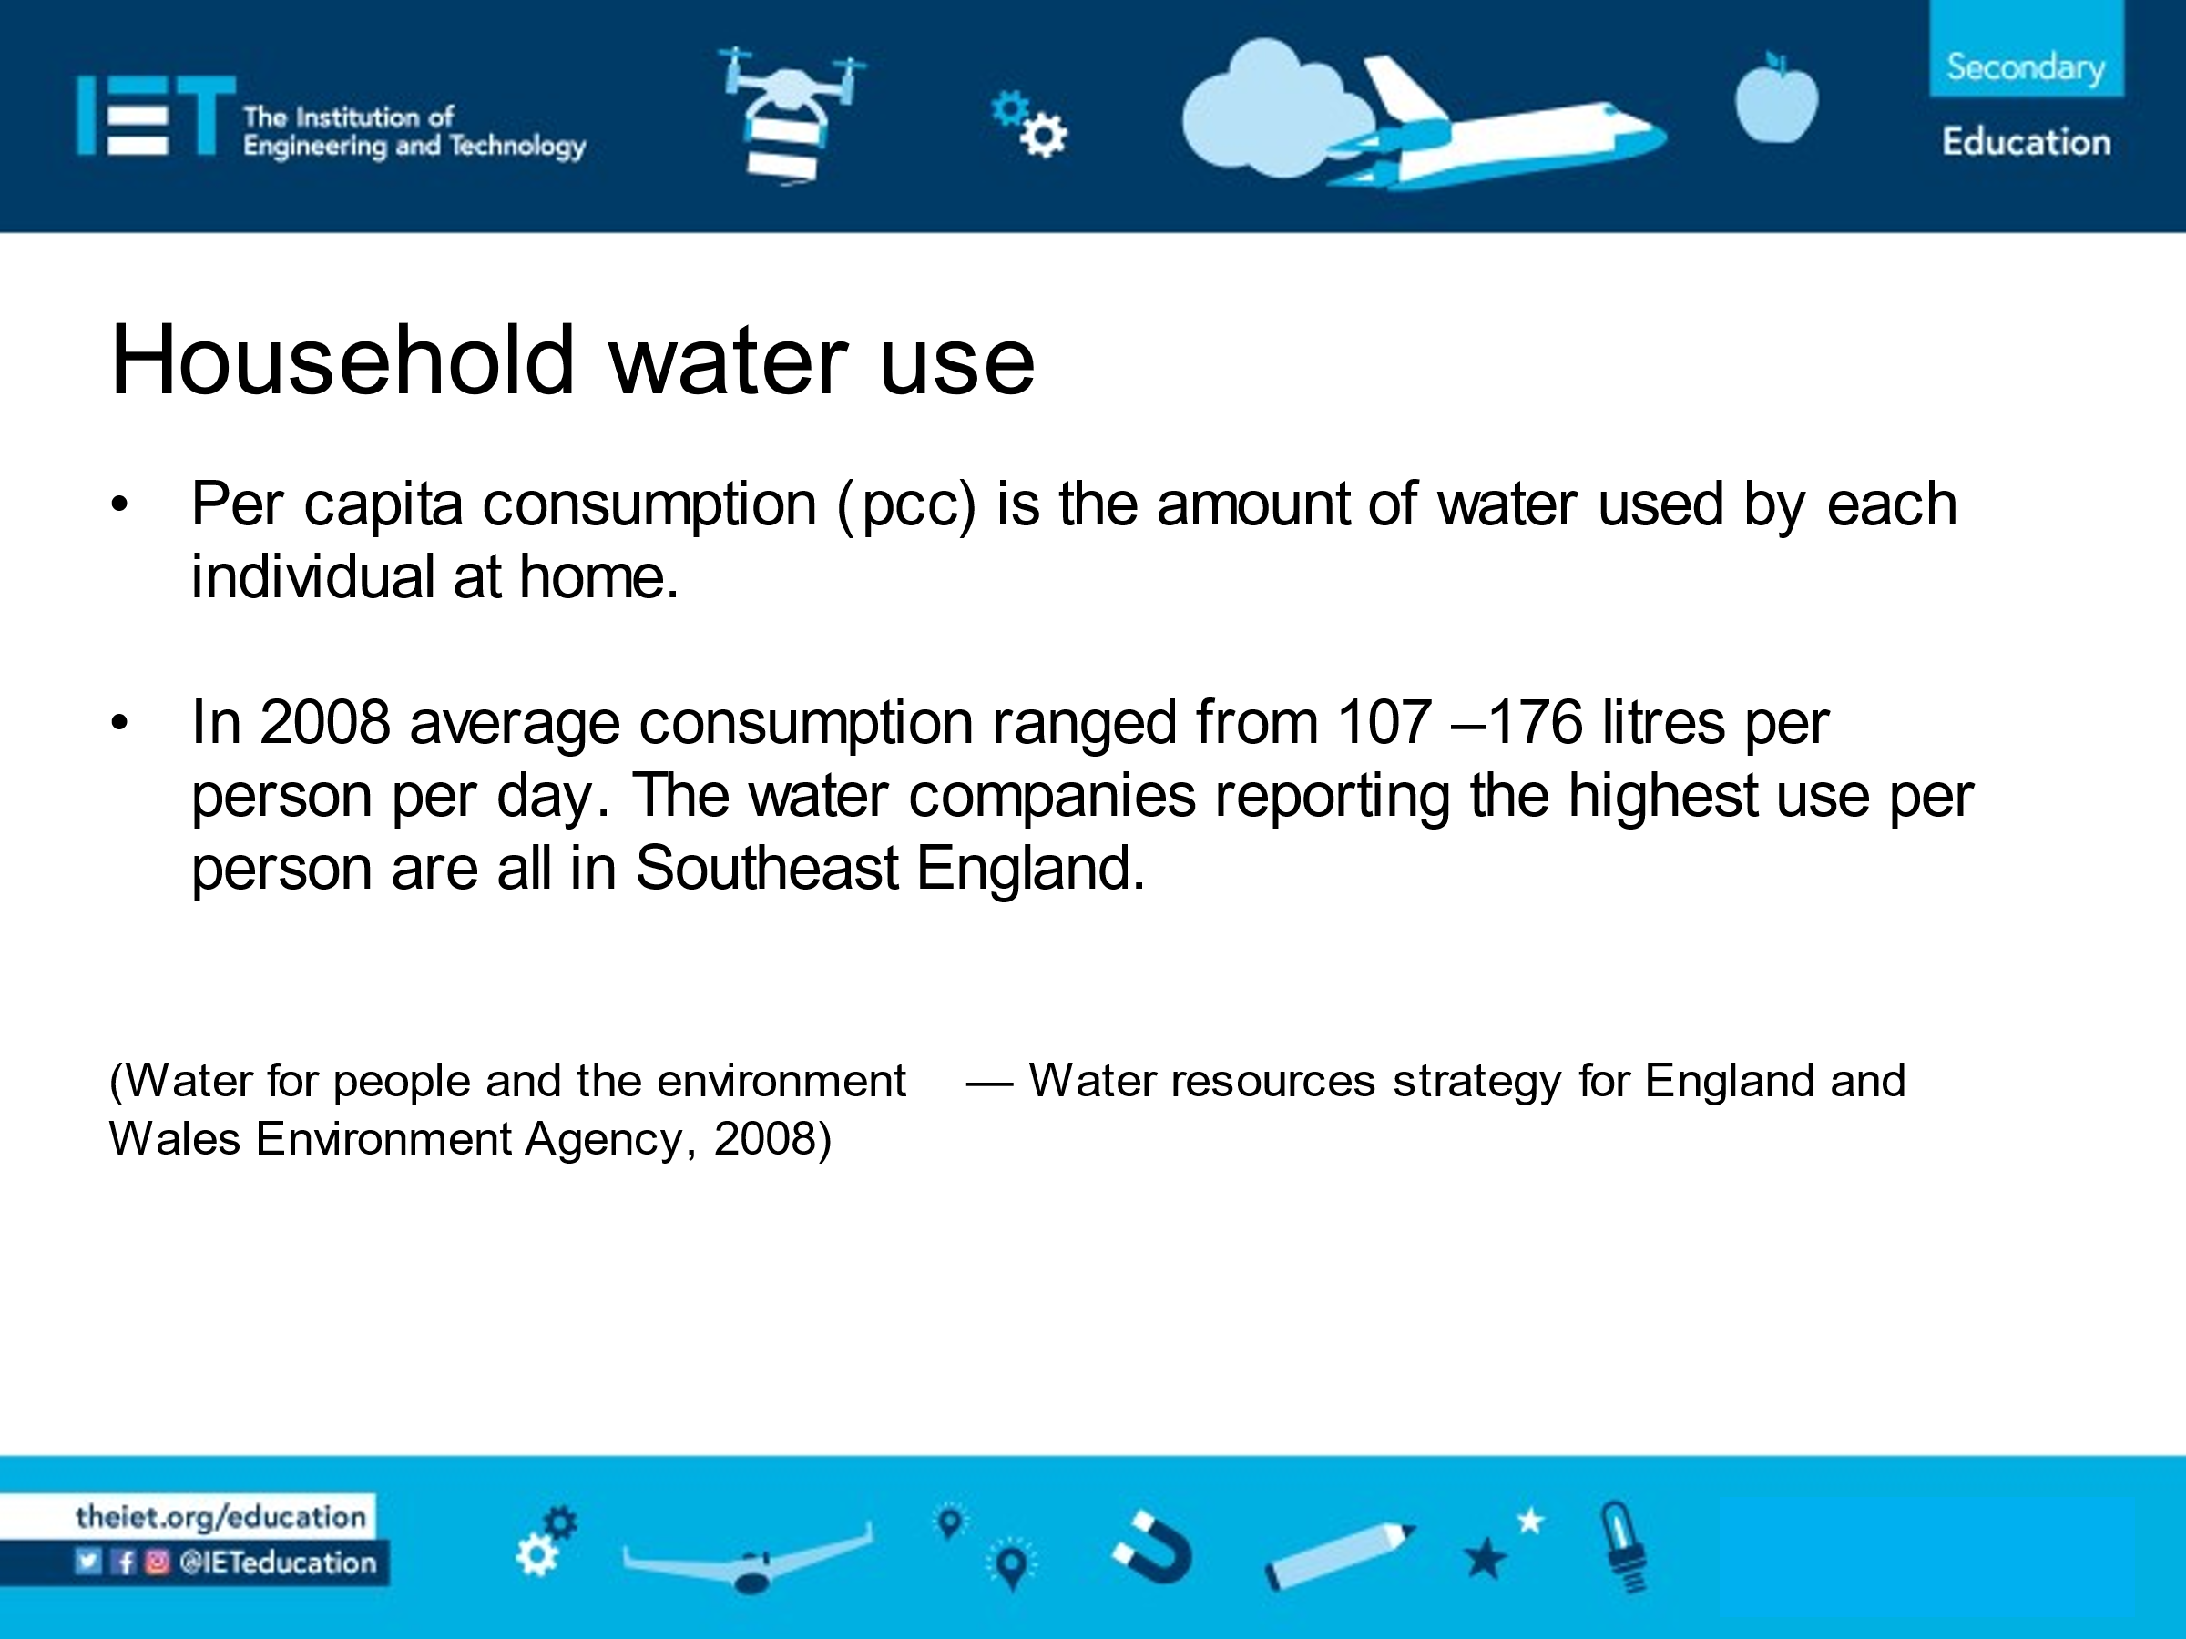  Now show the information from Wessex Water on slide 1 of the ‘Sewage Tunnels’ (Presentation). Does the information match? Have students work in groups to come up with as many reasons as they can for why such discrepancies might occur.  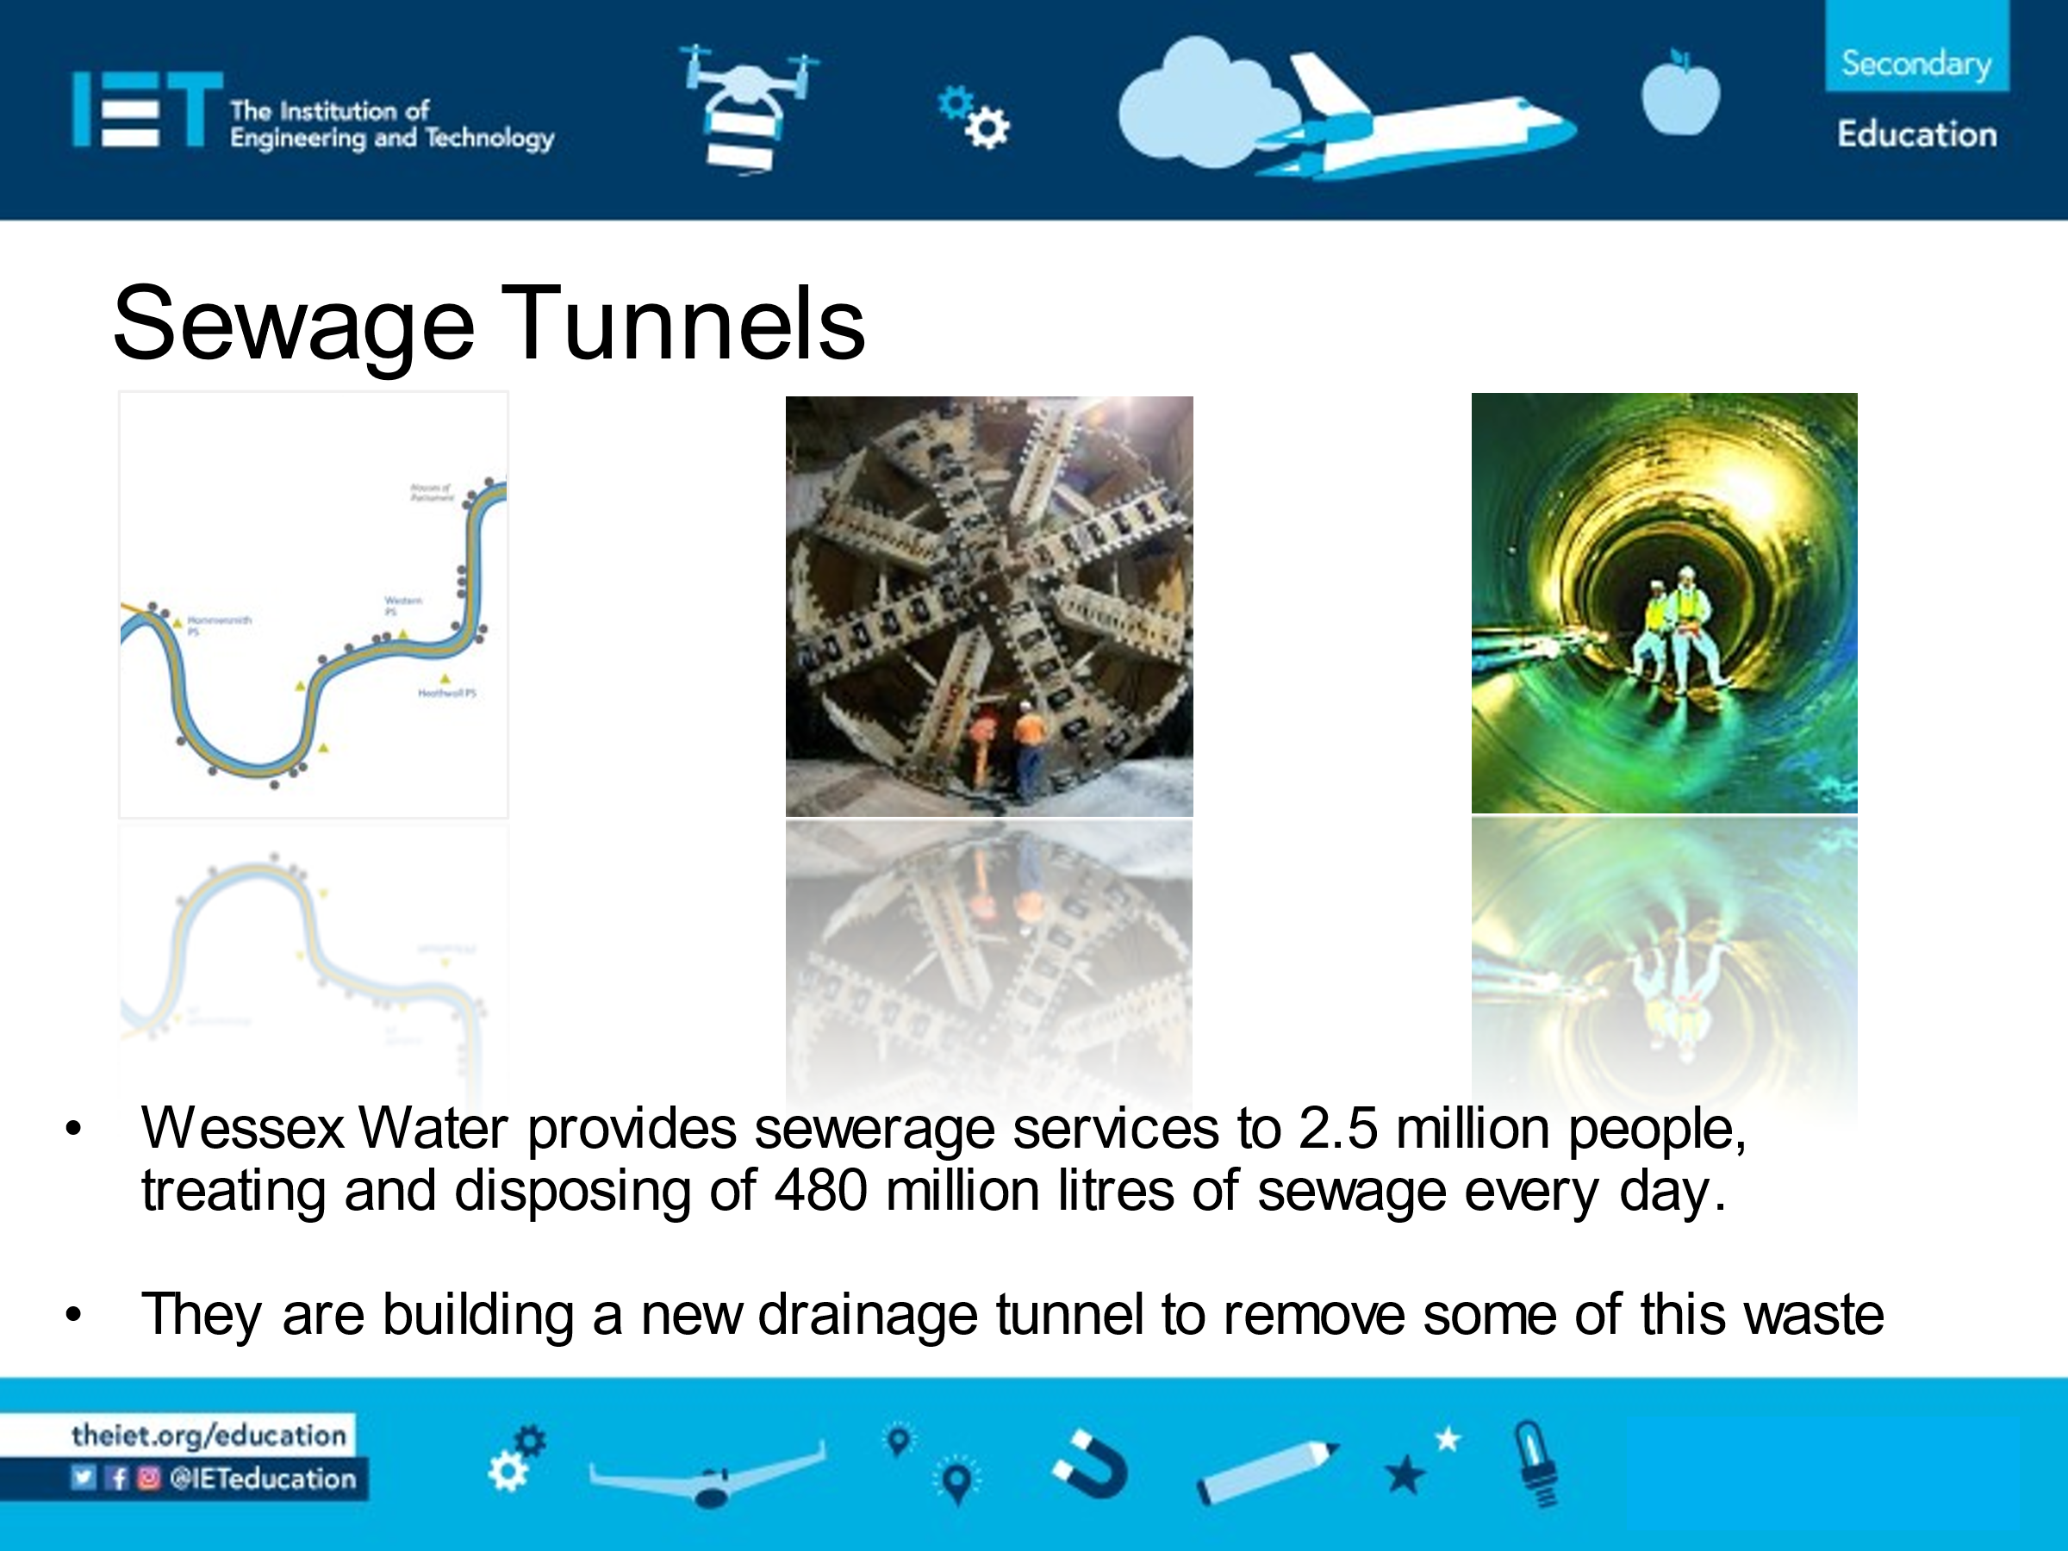  Main Activity 1  Watch the Shifting Sewage film of the Tideway Tunnel, which explains why a new sewage tunnel needs to be dug under London.  Now show PowerPoint Slides 2 and 3.  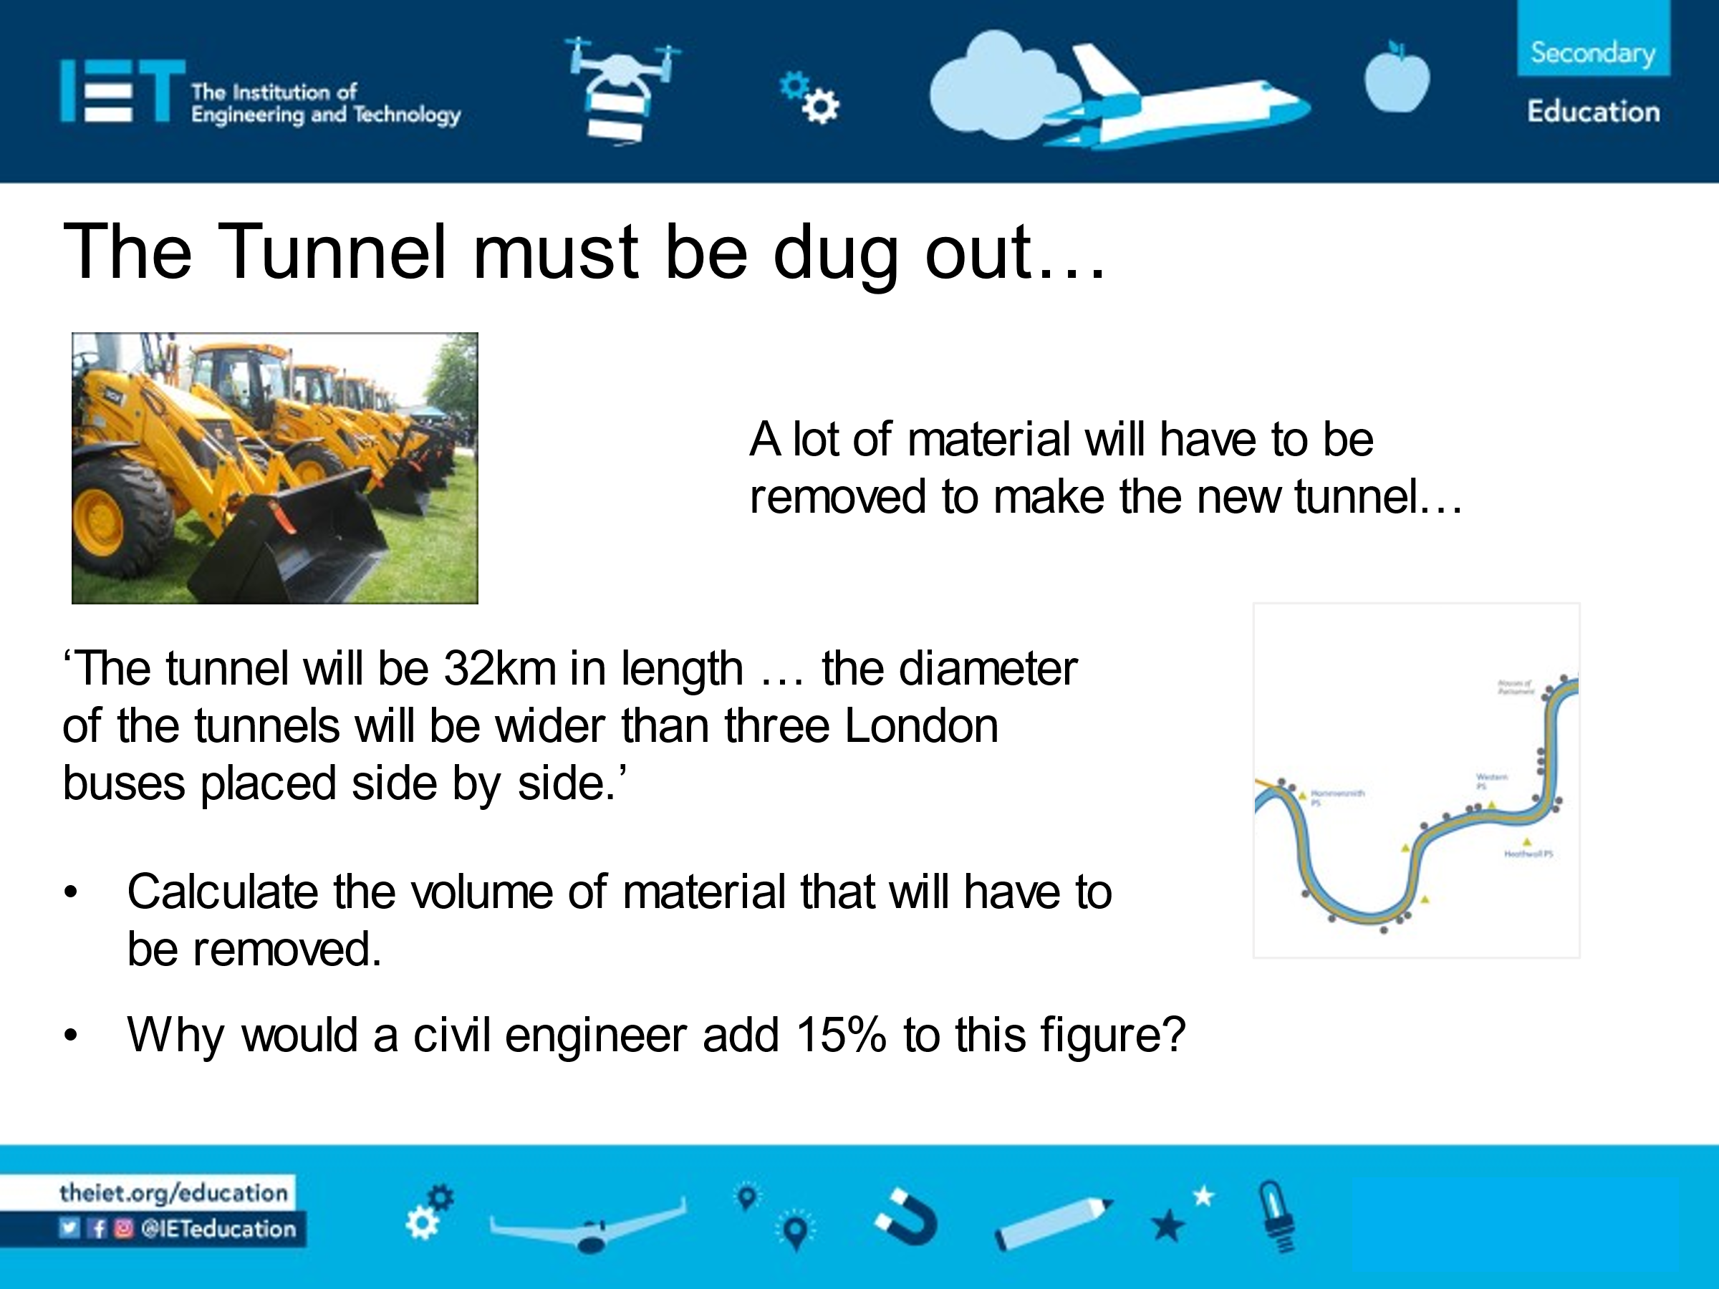  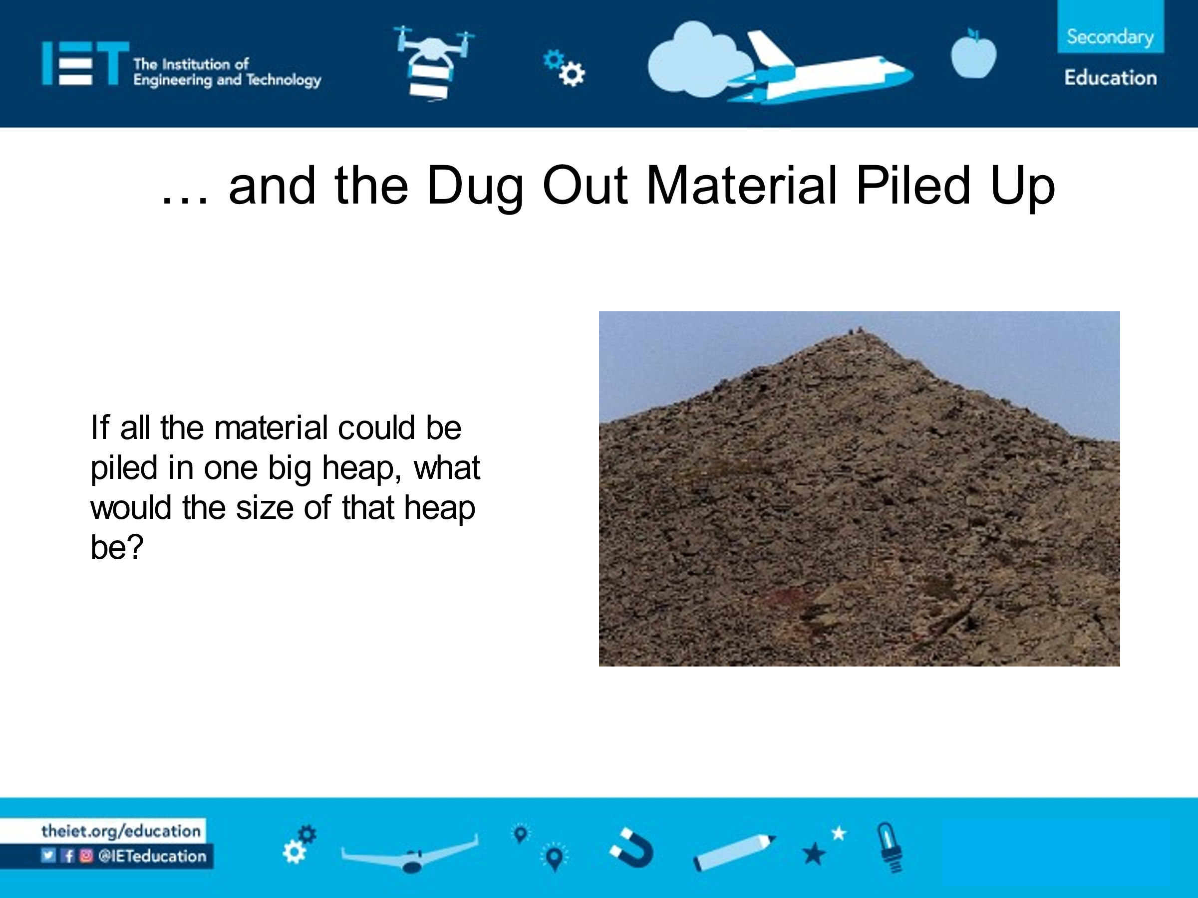  Ask what information students need to be able to answer these questions. They should then attempt to do so.  They can research the width of a London bus (one source gives a Routemaster bus as about 8 feet, or 2.44 metres, wide), which will then allow them to find the volume of material to be removed from the tunnel.  Why does 15% need to be added to the volume of material removed? (When considering storage, engineers add about 15% to the volume since compacted soil will normally expand when excavated – this could form the basis of an interesting scientific experiment using soil or rock.)  Determining the size of the heap is challenging since it depends upon the material’s internal angle of friction (known as the angle of repose). Use trays and sand to work out an estimate. See the notes opposite.  Extension  Comparisons to everyday life are often given to support understanding, e.g. ‘32 million cubic metres is enough to fill the O2 almost 15 times.’ Ask students to research different volumes, such as the volume of a bus, and use ICT to create posters that clarify this figure of 32 million cubic metres of diluted sewage each year.  The proposed tunnel is 32km in length – the map (Slide 3) shows just how ‘bendy’ the proposed route is. |  |  | Discuss how waste water is generated, e.g. washing clothes, brushing teeth, etc., then ask students to work in groups to estimate how much waste water each person generates in total per day. They may have little or no concept of realistic figures. Encourage them to make educated guesses by thinking, for example, about how many times they flush a toilet each day and how much water that might use.  High population density and less annual rainfall; possibly high water-leakage; more rainwater discharged from house roofs and road drainage, etc., directly into the sewers — all of which needs treatment. Densely populated urban areas are likely to discharge a greater proportion of rainwater directly to the sewers than rural areas where there are fewer houses, more of the houses use soakaways, and there are fewer large roads with sewer drainage. Rainwater discharged straight to sewers is not available for use without extensive treatment, unlike that which naturally drains into reservoirs and rivers, so it decreases readily available supplies.  Does the information from Wessex Water match that shown from the Environment Agency? (480 ÷ 2.5 = 192, which is higher than the maximum of 176 litres shown by the Environment Agency.) Why might this discrepancy occur? (Possible factors include: one set of data older than the other; how the data was collected, such as estimates from customers as opposed to actual usage; seasonal variations not taken into account; etc.).  The video notes state that the current sewer system discharges 32 million cubic metres of diluted sewage each year. Understanding the size of this discharge is difficult; what does 32 million cubic metres look like? Support students in visualising one cubic metre, then the volume of the classroom and any other structures which they can see. (This is an opportunity to consolidate volume and units of measurement. The homework activity builds on developing this understanding and could include standard index form.)  Students measure separate quantities (1kg is recommended but it could be more, or less), each of different materials, e.g. salt, sand, and small stones, and pour each out to create a heap. What are the dimensions of the heaps formed? How do they change if water is added to the material and the wet material is poured again? (The angle of repose for sand is about 30°, for crushed rock it is about 40°.)  If needed, give students the formula for the volume of a cone (V = ⅓π r² h). Ask them to use their knowledge of circle formulae to form the equation for the volume of a cylinder (V = π R² L), and then to form an equation representing the relationship between the area of the cone and the volume of the tunnel, i.e. ⅓π r² h = 1.15 × π R² L (where r = radius of cone’s base, h = height of cone, R = radius of tunnel, and L = tunnel length).  Students then choose for themselves the mathematics to use (e.g. trigonometry, Pythagoras, scale drawing, similarity), substituting their estimated measurements.  How long would the tunnel be if engineers could create a tunnel that was completely straight? Why can’t they? Students can research estimated costs for tunnelling through different strata, and use geological maps to estimate the cost of different routes for this tunnel. This information is not too easily found on the web and it might be easier to have students find an optimal solution for a hypothetical situation.  Should you wish to continue with London there is a geological map listed in ‘Additional Websites’ section.
Differentiation
Basic |  |  |  |  | Extension
Guide students towards scale drawings in order to work out the height of the pile following experimentation |  |  |  |  | Remove some of the scaffolding from the task. Tell students what modelling equipment is available to them should they wish to use it.
Resources |  |  |  |  | Required files
Shifting Sewage film  - Projector/Whiteboard  - Access to a computer or other source of information for  research (which can be undertaken at home)  - A quantity (about 1kg or less) of each of 3 different  materials, e.g. sand, salt, small stones  - Measuring equipment |  |  |  |  | Sewage Tunnels (Presentation)
Additional websites
- An interactive 1883 map that students could use: http://www.davidrumsey.com/luna/servlet/detail/RUMSEY~8~1~31375~1150322:Geological-map-of-the-environs-of-L
- Thames Tideway Tunnel: https://www.tideway.london/

Related activities (to build a full lesson)
Starters (Options)  - ACTIVITY: Expanding Populations  - ACTIVITY: Properties of rocks  - ACTIVITY: How Much Waste?  Main (Options)  - ACTIVITY: Sewage Tunnels |  |  |  | Extension (Options)  - ACTIVITY: How Much Sewage?  Plenary  - Opportunities within activity for presentations, peer/self-assessment  - Reflection on Objectives and PLTS skills used

The Engineering Context
- The story Shifting Sewage/Controlling Floods
- How it works? Infrastructure Complexity
- Who makes it work? Sian Thomas

Curriculum links and PLTS
England  Design and Technology  - KS3 3d  Mathematics  - KS3 1a, 1b, 1e, 1g, 3a, 3b, 4a, 4d, 4l, 4o, 6a, 7a, 7n (dependent upon the methodology chosen) | Northern Ireland  Technology & Design  (Objective 2) Developing pupils as Contributors to Society  - Explore technical inventions and designs that have met a social need cost-effectively.  (Objective 3) Developing pupils as Contributors to the Economy and the Environment  - Identify product needs and pursue sustainable harmonious design solutions in a local outdoor/indoor context  - Education for Sustainable Development  Learning Outcomes  - Research and manage information effectively to investigate design issues, using Mathematics and ICT where appropriate
Scotland  Technologies  - TCH 3-02a | Wales  Design & Technology  - 3.1
GCSE D&T  AQA D&T  - 3.1.1, 3.2.1, 3.2.3, 3.3.2  Edexcel D&T  - 1.14  Eduqas D&T  - 2.1 Core: 2  - 2.2 Core: 4  OCR D&T  - 1.1a iii, 3.3a i/iii/iv, 5.2c, 5.3c, e | GCSE Engineering  AQA Engineering  - 3.5
GCSE Mathematics

AQA Mathematics

- A2, R1, G14, G16, G17, N14

Edexcel Mathematics

- A2, R1, G14, G16, G17, N14

Eduqas Mathematics

- FA2, HA2, FR1, HR1, FG12, HG14, HG16, FG14, HG17, FG15, FN14, HN14

OCR Mathematics
- 4.01b, 6.02b, 6.02d, 10.01a, 10.04

Assessment opportunities
- APP – Space and Measure
Personal, learning & thinking skills (PLTS)
> Creative thinker

